Transit Methodology
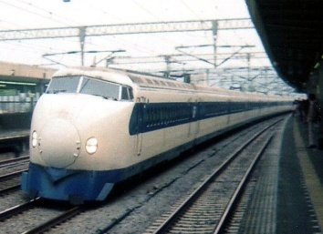
Light-Rail and Streetcar Concept
Streetcars operate exclusively on city streets. Light-rail transit (LRT) started as a modification, separating streetcar operation from street traffic to allow higher speeds.
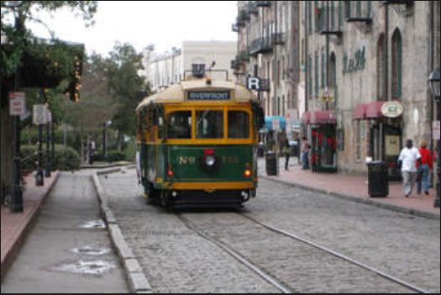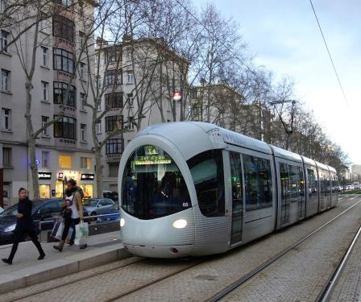
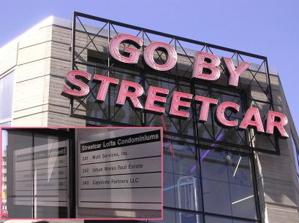
LRT is characterized by versatility of operation; it can operate separated from other traffic below grade, at grade, on an elevated structure, or together with road vehicles on the surface.
LRT operations differ in station spacing and design, fare structure and collection methods, train length and propulsion, degree of access control, and markets served. Unlike streetcars, travel times between light-rail stations are relatively unaffected by increased passenger volumes or service.

General Capacity Ranges
The capacity of a rail line is determined by station (or stop) capacity or way capacity, whichever is smaller; in most cases, it is station capacity.

Capacity depends on:
- car size and
- station length,
- allowable standees, and
- the minimum spacing (or headway) between trains.
This minimum headway is a function not only of dwell times at major stations, but also of train length, acceleration and deceleration rates, and train control systems.
Figure (1) illustrates the main factors affecting rail vehicle capacity.
Time-space diagrams can be used to estimate the safe separation or minimum headway between trains. Sometimes theoretical approaches are used. A more common practice is to obtain the minimum spacing between trains based on actual experience, station dwell times, and signal control systems.

The passenger capacity of LRT depends on:
- vehicle size,
- train length,
- and headway.

However, the achievable LRT capacities also depend on design and policy considerations that reflect specific local constraints of station design, at-grade operations, and type of right-of-way.
LRT trains usually are limited to a maximum of three cars for on-street operation. Longer trains usually cannot operate on city streets without simultaneously occupying more than the space between adjacent cross streets on short blocks, cannot clear at-grade intersections rapidly, and require long platform lengths at stations.
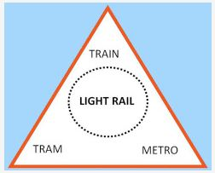

Minimum headways for light-rail systems depend on
- train length,
- platform and
- car design (high floor versus low floor),
- fare collection methods (prepayment versus pay on train),
- wheelchair accessibility, and headway controls (manual versus block signals).

Manual operations can accommodate 80 to 100 single-unit cars per track per hour. When trains run under block signal controls, as is common with rapid-transit systems, 120-s headways are possible.
Current operating experience in the United States and Canada suggests maximum realizable capacities of 12,000 to 15,000 persons/track/h. However, European experience shows up to 20,000 persons/h. Typical ranges in person capacities are listed in Table (3).
One of the variables determining capacity is light-rail and streetcar travel time when operating in two directions using a single track. See Table (4) list values for travel time when local data not avalable.

Figure (1): Influences on Rail Vehicle Capacity.

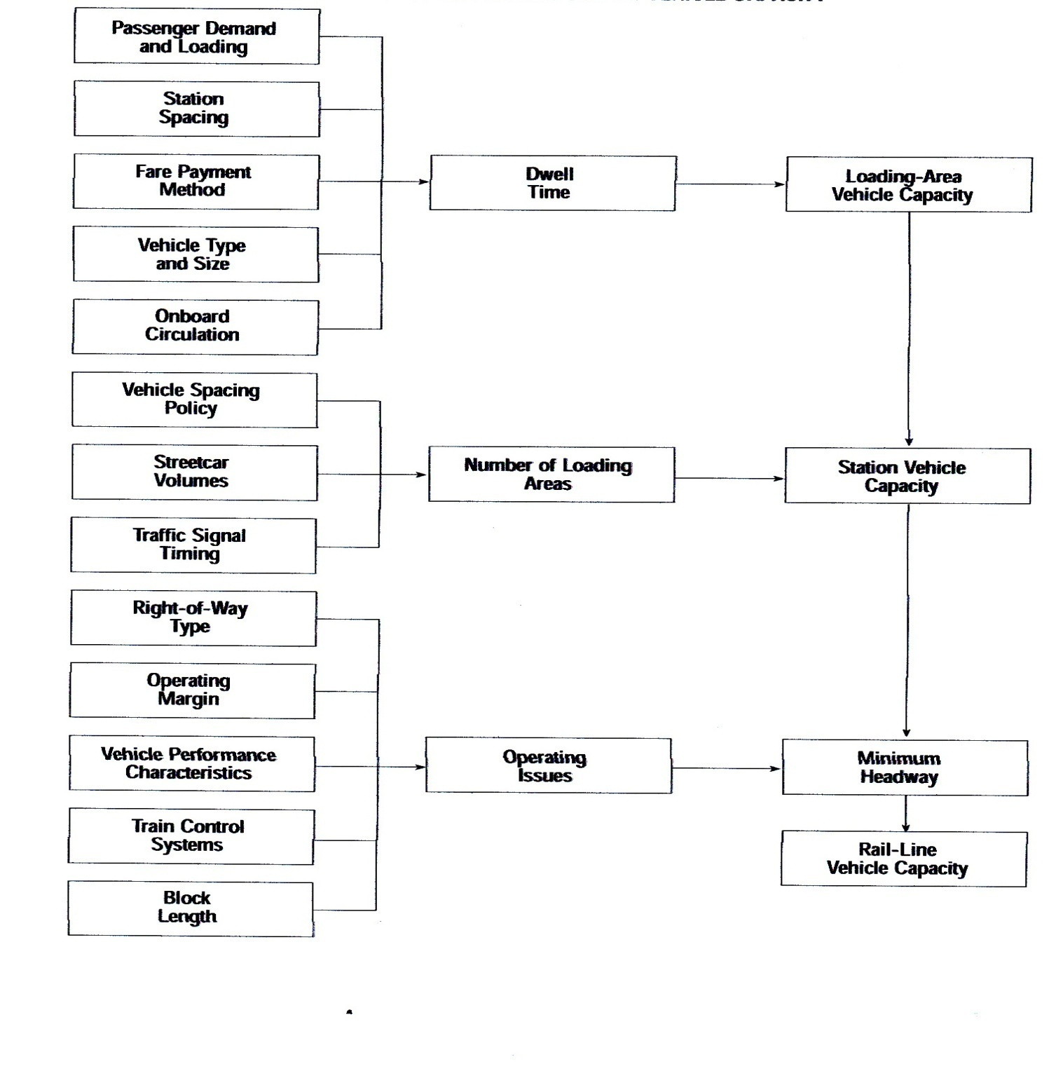
Table(3): Typical Light - Rail Transit Person Capacity : 30 Trains/Track/h 28-30m Articulated Cars.
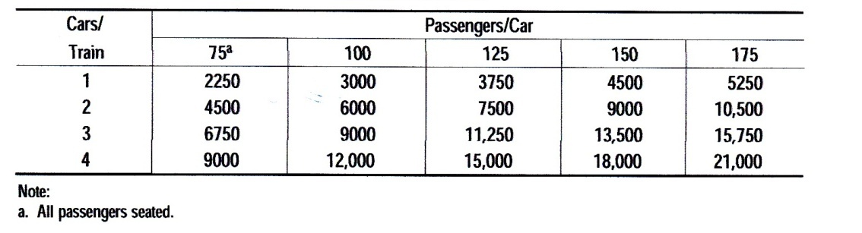

Table (4): Default Values for Single -Track Light Rail and Streetcar Travel Time.
The value of the maximum single-track section speed should be the most appropriate speed limit for that section. A 60-km/h speed limit is a suitable value for most protected, grade-separated lines. If the single track section is on-street, then a speed at or below the vehicle speed limit should be used. If there are signalized intersections, an allowance of half the signal cycle should be added to the travel time for each such intersection, adjusted for any improvements possible from preemption.

Rail- Priority Treatments
Operating variability caused by traffic congestion has been reduced for the recently built on-street light-rail lines that operate in reserved lanes. Some older systems still operate extensively in mixed traffic and are subject to the variability in train throughput caused by a reduced effective green time for trains. Traffic queuing, left turns, and parallel parking can reduce LRT capacity.
Traffic signals can be a major impediment to LRT operation if they are not designed for the needs of LRT. Poor traffic signaling can make train operation slow, unreliable, and unattractive to potential passengers. These problems can be addressed through the use of signal priority or preemption and signal progression.

- Signal priority allows the light-rail train to extend a green phase or to speed the arrival of the next one. Depending on the frequency of intersections and traffic congestion, this can have a substantial impact on the flow of general traffic. As a result, LRT signal priority in congested areas is often limited in scope to avoid negative effects on other traffic.

- Signal progression has supplanted priority or preemption for light-rail trains in many congested downtown areas. This technique gives trains a green window during which they can depart and travel to the next station on successive green signals. The benefits of progression increase with greater station spacing as less accumulated time is spent waiting for the progression to start at each station. The progression frequently is part of the normal traffic-signal phasing and is fully integrated with signaling for automobiles on cross streets.

Quality of Service Concept
Quality of service reflects the passenger’s perception of transit performance. It measures both the availability of transit service and its comfort and convenience. Quality of service depends on the operating decisions made by a transit system, especially concerning where, how often, and for how long service should be provided, and what kind it should be.

Definitions

- Transit performance measure; A quantitative or qualitative factor used to evaluate a particular aspect of transit service.

- Transit quality of service; The overall measured or perceived performance of transit service from the passenger’s point of view.

- Transit service measure; A quantitative performance measure that best describes a particular aspect of transit service and represents the passenger’s point of view. It is also known as a measure of effectiveness.

- LOS; Six designated ranges of values for a particular service measure, graded from A (best) to F (worst) based on a transit passenger’s perception of a particular aspect of transit service.

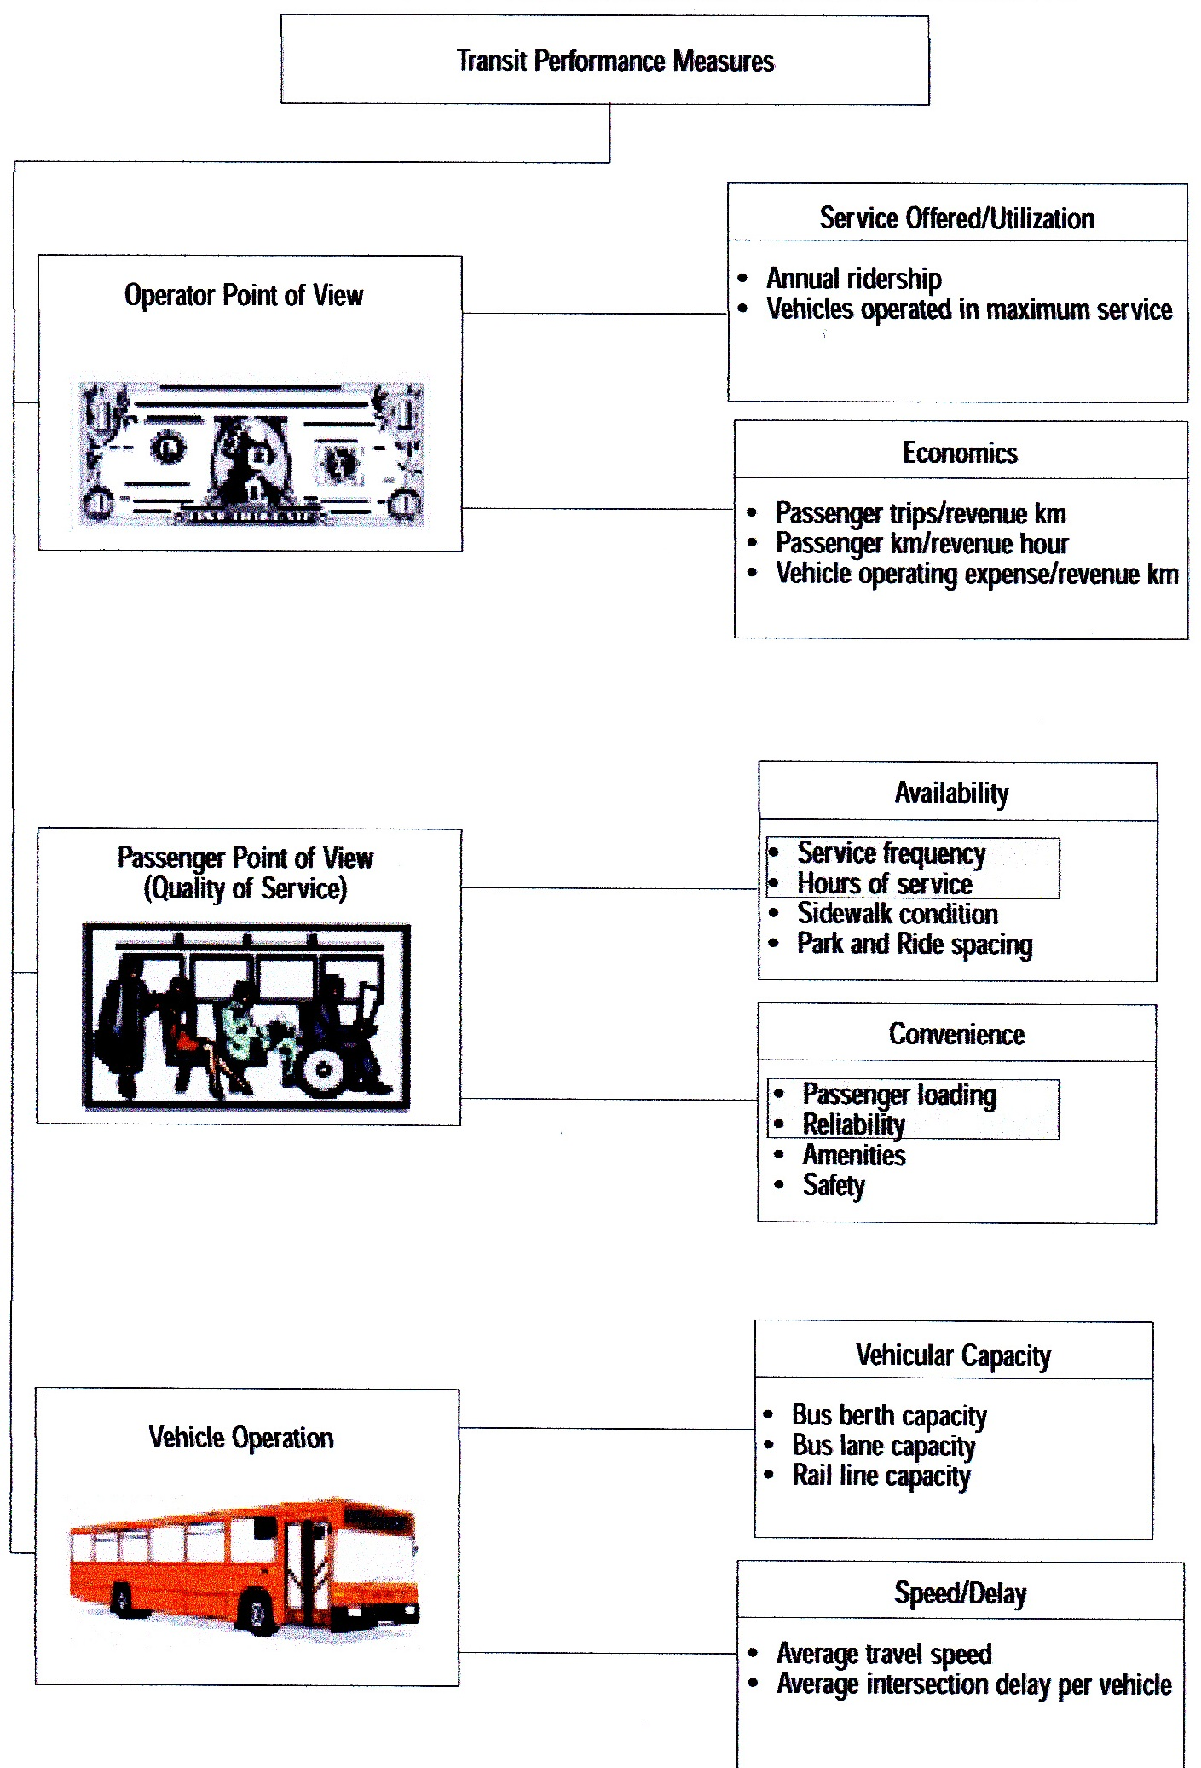
Quality -of - Service Factors

Service Coverage
Whether or not transit service is provided near a person's origin and destination is key in use of transit. Ideally, transit service is provided within a reasonable walking distance of the origin and destination, or demand-responsive service is available. The reasonableness of the walking distance varies from source to source and depends on the situation. For example, people will walk farther to rail stations than to bus routes and the elderly will not walk as far as younger adults. In general, 400 m or 5 min of walk time is the limit for a bus route’s typical service area; for a rail transit station.
If transit service is not provided near the origin, other options include driving to a park-and-ride lot or riding a bicycle to transit. Both of these options require that the transit operator provide additional facilities, such as parking lots, bicycle storage facilities.

Pedestrian Environment
Even if a transit stop is located within a reasonable walking distance of an origin and destination, the walking environment may not be amenable. Lack of sidewalks or poorly maintained sidewalks, lack of street lighting, and steep terrain all discourage pedestrian travel. Wide or busy streets without signalized crosswalks at regular intervals, or without pedestrian refuges in the median, also discourage pedestrian travel. A lack of pedestrian refuges poses difficulties, too, for transit operators providing service on urban streets.
Even if transit service is theoretically located within walking distance of both origin and destination, the areas around the transit stops must provide a comfortable walking environment for transit to be considered available.

Scheduling
How often and when transit service is provided are important factors in the decision to use transit. The more frequent the service, the shorter the wait when a bus or train is missed or when the exact schedule is not known, and the greater the flexibility customers will have in selecting travel times. The number of hours during the day when service is provided is also important. It does not matter whether a transit stop is located within walking distance if service is not provided at the desired time of travel; transit then cannot be an option.

Amenities
The facilities provided at transit stops and stations and on transit vehicles help make transit more comfortable and convenient. Typical amenities include the following :
- Benches, so that passengers can sit while waiting;
- Shelters to protect from wind, rain, snow, and sun;
- Informational signage, identifying the routes, their destinations, and scheduled arrivals;
- Trash receptacles for litter;
- Telephones, so that passengers can make personal calls while waiting or emergency calls when necessary;
- Vending facilities, from newspaper racks at commuter bus stops to manned newsstands, flower stands, food carts, transit ticket and pass sales, and similar facilities at rail stations and bus transfer centers; and
- Air conditioned vehicles, to provide a comfortable ride during hot and humid weather.

Transit Information
Potential riders need to know where and when transit service is available before they can begin using the service. Regular riders also should be informed about service changes that affect them. This information can be provided by a variety of means:
- Printed maps, schedules, and brochures. Passengers can pick these up on transit vehicles, at transit facilities, and at local businesses.
- Posted information on vehicles and at transit facilities. They can display schedule information onboard buses, at bus stops, and at bus terminals.
- Telephone. Information should be available by phone at the convenience of potential passengers (including weekends and evenings).
- Personal computers. Transit information can be posted on the Internet, and users can subscribe to e-mail lists that automatically send out service changes and other announcements.

Transfers
Requiring transfers between routes adds to a passenger’s total trip time; this can be minimized with timed transfers. A missed transfer also can increase the length of a transit trip. Required transfers increase the complexity of a transit trip for a first-time passenger. Transfer surcharges also inhibit ridership.

Total Trip Time
Total trip time includes the travel time from the origin to a transit stop, waiting time for a transit vehicle, travel time onboard a vehicle, travel time from transit to the destination, and any time required for transfers between routes during the trip. In general,
both the absolute travel time and the travel time in relation to competing modes will factor in a traveler’s decision about transit.
Total trip time is influenced by several factors, including the route spacing (affecting the walking distance to transit), the service frequency (affecting the waiting time), the frequency of stops, traffic congestion, signal timing, and the fare collection system.

Cost
Potential passengers weigh the cost and value of using transit against the out-of pocket costs and value of using other modes. Out-of-pocket transit costs consist of the fare for each trip or the cost of a monthly pass. Out-of-pocket automobile costs, in contrast, only include road and bridge tolls and parking charges, because other automobile costs—such as fuel, maintenance, insurance, taxes.

Safety and Security
Riders’ perceptions—as well as the actual conditions—of the safety and security of transit enter into the mode-choice decision. Riders consider not only personal safety in relation to potential transit crime and vehicular crashes, Security can be improved by placing stops in well-lit areas with public telephones available for emergency calls. Transit systems use a variety of methods to enhance security on transit vehicles, including uniformed and plainclothes police officers.

Passenger Loads
Transit is less attractive when passengers must stand for long periods of time, especially in crowds. Crowded vehicles also slow down transit operation, adding time for passengers to get on and off. Most transit agencies assess passenger crowding based on the occupancy relative to the number of seats, expressed as a load factor. A factor of 1.0 means that all seats are occupied. The importance of vehicle loading varies by the type of service. In general, transit provides load factors at or below 1.0 for long-distance commuting and high-speed, mixed-traffic operations. Inner-city service may approach a load factor of 2.0 or more, but other services will be between 1.0 and 2.0.

Appearance and Comfort
Some transit systems have established specific standards for transit facility appearance and cleanliness. Passengers are interested in ride comfort, which includes seat comfort, temperature control.

Reliability
Reliability affects the amount of time passengers must wait at a transit stop, as well as the consistency of a passenger’s arrival time at a destination from day to day. Reliability encompasses on-time performance as well as the regularity of headways between successive transit vehicles. Uneven headways result in uneven passenger loadings, so that a transit vehicle arriving late picks up not only its regular passengers but others who have arrived early for the following vehicle. Reliability is influenced by traffic conditions (in on-street, mixed-traffic operations), staff availability and vehicle maintenance.

Framework
Transit quality-of-service measures are divided into two main categories:
availability, and comfort and convenience. According to the measures addressing spatial and temporal availability, if transit is located too far away or if it does not run at the times it is needed, a potential user would not consider the transit service available, and therefore the quality of service would be poor. However, if transit service is available, the quality measures to evaluate user perceptions of comfort and convenience can be applied.
The different elements of a transit system require different performance measures:
- Transit stops. Measures should address transit availability and convenience at a single location. The performance measures in this category will vary from one location to another, since they depend on passenger volumes, scheduling, routing, and stop and
station design.
- Route segments. Measures should address availability and convenience along a portion of a route, which can range from two stops to the entire length. These measures will tend to stay the same for the length of a route segment, regardless of conditions at an individual stop.
- Systems. Measures should describe availability and convenience for more than one route in a specified area (e.g., a district, city, or metropolitan area) or for a specified type of service (e.g., fixed route vs. demand responsive). System measures also can address door-to-door travel.
Combining the two performance measure categories with the three transit system elements produces the matrix shown in Table (5).

Table(5): Transit Quality -of - Service Freamework.
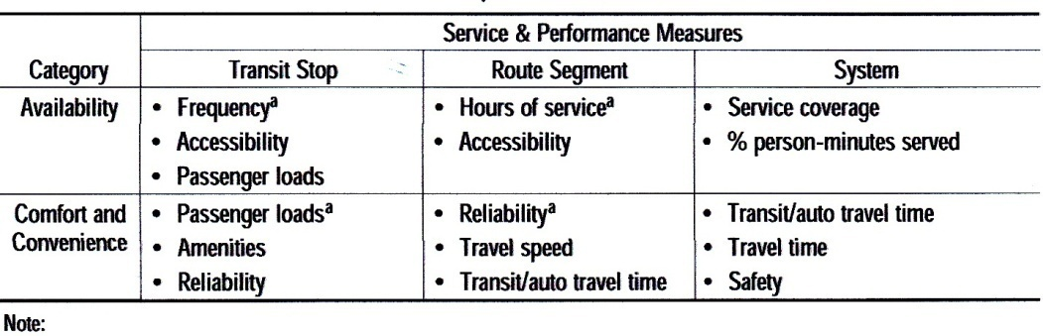
Availabitiy

Transit Stops
The spatial aspect of transit availability at a transit stop is a given. During a typical hour-long analysis period, the hours of service are also a given. Therefore, frequency is the service measure for this category.
Route Segments
Of the three primary measures of transit availability as shown in Table (5); frequency, hours of service, and service coverage; frequency is used for transit stops, and service coverage is a given, since the route exists. Therefore, hours of service become the service measure for route segments. This is appropriate, since more than one route, each operating with different frequencies and travel times, can serve the same origins and destinations. In these cases, the focus is on the total span of time during which a given pair of origins and destinations can be accessed.

System
System availability measures relate to how many people have access to transit and how often. Service coverage within a transit area that has a population or job density to support at least hourly bus service (equivalent to a service frequency LOS E) is chosen as the service measure.

Comfort and Convenince

Transit Stops
Whether or not one can find a seat on a transit vehicle is an important measure of measure transit comfort. Passenger loads, the selected service measure, also influence boarding and alighting times, which in turn affect total dwell time and the capacity of transit routes.

Route Segment
Reliability is used as the service measure for route segments because it not only an aspect of service quality important to users, whether or not they get to their destination on time, but also affects other service measures. If transit vehicles arrive in a bunch, or not at all, the effective service frequency is reduced. Vehicles arriving late also have higher passenger loadings, since they pick up not only their regular passengers but others who have arrived early for the next vehicle.

System
The travel time difference between transit and automobile (the absolute difference in travel time from origin to destination by automobile and by transit) is an important consideration in a passenger’s decision to use transit. System wide, this measure can be calculated by sampling locations and trip purposes within the analysis area, or by using a transportation planning model that can calculate trip times for all combinations of origins and destinations by transit and by automobile, for a variety of trip purposes.
An alternative performance measure is travel time, useful for indicating when higher speed service (such as limited-stop or express service) should be considered between two locations. Since travel time varies with the size of a community and the amount of traffic congestion (for transit modes operating in mixed traffic), travel time is not suitable as a service measure without defining different categories of city sizes. Safety, in terms of both accident and crime rates, affects the image of the entire transit system and is another system wide comfort and convenience measure.

