Lec.7 & 8 Ground Water Pollution 4th class

Contaminant Transport Mechanisms
The contaminant introduced into the soil-rock-groundwater system will spread within the system only if a transport mechanism is available, for example, a flowing liquid. As soon as the contaminant reaches the subsurface water in the unsaturated or saturated zone, various processes (physical, geochemical and biochemical) determine its fate. The physical processes include advection, dispersion, evaporation, filtration, and degassing while those of geochemical are acid-base reactions, adsorption-desorption, ion exchange, oxidation-reduction, precipitation-dissolution, retardation and complexation.
The biochemical processes include amongst others transpiration, bacterial respiration, decay and cell synthesis ( Figure 1).
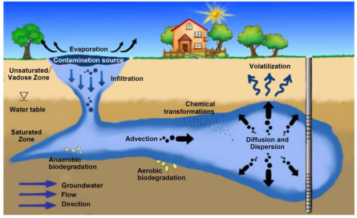
Fig.1 Main processes involved in contaminant transport in the aquifer

Concept of Macroscopic Groundwater Velocity

A geological medium is any type of rock or sediment in the subsurface. If groundwater flow occurs through the pore spaces between the grains of the rock or sediment, that geological medium is called a porous medium. Examples of porous media are sandstone, gravel and sand aquifers. In some geological media groundwater flow occurs through fractures (e.g. granite (Fig.2)) or conduits (e.g. karstic limestone (Fig.3)) or through a combination of pores, fractures, and conduits (e.g. basalt).

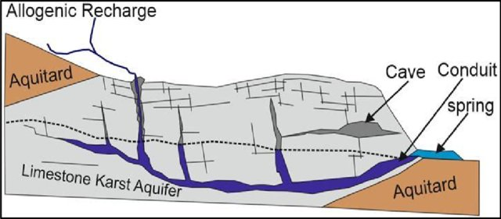

Fig.2 Groundwater flow occurs through fractures
(e.g. granite)

Fig.3 groundwater flow occurs through conduits (e.g. karstic limestone)

When groundwater flows through a porous medium, individual particle of water may choose different pathways around the grains of a geological medium (Fig. 4). A particle of water may need a longer or a shorter period of time to move from plane A to B depending on the chosen pathway. It is impossible to measure the time it takes for each water particle. Only the average time for water traveling from A to B can be measured experimentally. Thus, we have to accept a macroscopic viewpoint of the problem and define a macroscopic average travel time, a linear distance between plane A and B, and an average linear groundwater velocity for water moving from A to B.
The average linear groundwater velocity is defined by dividing the straight-line distance
from A to B by the average time it takes for water to travel from A to B.
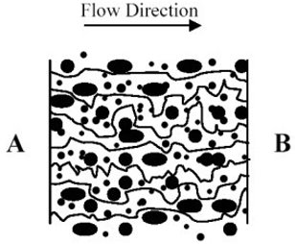

Fig. 4 Different pathways through a porous, geological medium. The average linear
groundwater velocity is the straight-line distance from A to B divided by the average
time needed to travel this distance by all water particles.

Advection Process
The process by which solutes are transported by the bulk movement of flowing groundwater . Dissolved and suspended solids are carried along with flowing groundwater. The path and rate of movement are governed by the geological setting and hydraulic gradient.
Why is advection important?
Advection is the main process by which solutes are transported in the subsurface especially in highly permeable material. As a result Darcy' Law can be used as a first estimate in predicting the movement of pollution plumes.

The one-dimensional flux of a solute through a porous medium can be expressed by the equation below:
$J=v_{x} . C n_{e}$ ………. (1)
where:
J = mass flux per unit area per unit time
v_{x} = average linear ground water velocity in the direction of flow
C = concentration in mass per unit volume of solution
n_{e} = effective porosity of the geological medium

Dispersion and Diffusion Processes

Dispersion (Mechanical Dispersion)
Spreading and mixing of chemical constituents in groundwater due to microscopic variations in velocities within and between interstices. Process by which water, solutes and suspended molecules travel at rates different from the average linear velocity in the direction of the groundwater flow (longitudinal dispersion) or perpendicular to groundwater flow (transverse or vertical dispersion).
Why is dispersion important?
Dispersion is one of the mechanisms that controls the spreading of chemicals and contaminants in the subsurface.
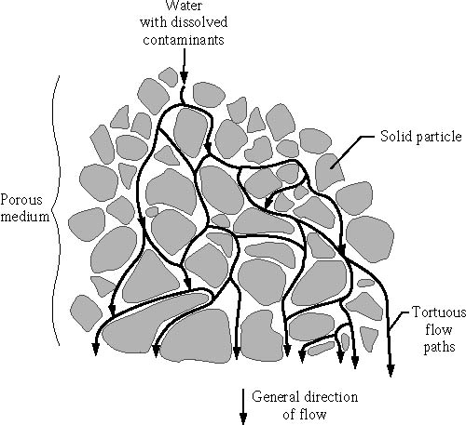

Fig.5 Schematic of mechanical dispersion
In other words
Mechanical dispersion is caused by the different flow paths water particles take in a geological medium (Fig.4 and Fig.5 ). Some of the flow paths are faster because they follow a more direct path or because they are going through larger pores or through the center of pores in which water flows faster because less friction is involved. Other flow paths may be slower because they are closer to the grain boundaries, thus being exposed to more friction in the pore throat, slowing down the water particles. The different flow paths of the water particles cause the mechanical dispersion, a mechanical mixing and dilution of the solute within the bulk movement of groundwater.
The numerical value of mechanical dispersion is the product of advective groundwater velocity and the dispersivity. The dispersivity is a characteristic property of the geological medium, and differs in value for each of the spatial components. For examples, if all the pores are nearly the same size, dispersivity of the rock or sediment would be low. Dispersivity in the direction of flow is referred to as longitudinal dispersivity (in x-direction), dispersivity perpendicular to flow is referred to as transverse dispersivity both in a horizontal plane to flow (in y-direction) and in a vertical plane to flow (in z-direction, flow up or down in a groundwater medium).
It is generally assumed that longitudinal dispersivity is about 10 times larger than transverse dispersivity because the local variation in the velocity field is much more dominant in the direction of flow rather than perpendicular to it. Transverse dispersivity is primarily caused by flow paths that branch out from the centerline of solute movement due to the tortuosity of the geological medium. Concentration distributions (plumes) of a point source form ellipsoids of revolution in three dimensions. If vertical transverse dispersivity is smaller than horizontal transverse dispersivity, as is often the case in layered sedimentary rocks, the plumes take on a surfboard shape.

Diffusion (Molecular Diffusion)

The process by which ions or molecules move from areas of high solute concentrations to areas of low solute concentration.
A solute in water will move from an area of greater concentration toward an area where it is less concentrated. Diffusion will occur as long as a concentration gradient exists, even if the fluid is not moving. The rate of diffusion is temperature dependent.
Why is diffusion important?
Diffusion can be important in the movement of chemicals and contaminants in the subsurface, particularly in low hydraulic conductivity environments.

In other words
Molecular diffusion is caused by random molecular motion due to the thermal kinetic energy of the solute. The molecular motion in liquids is smaller than in gases but larger than in solids. The coefficient of molecular diffusion is smaller for liquids in a porous medium than in a pure liquid because a collision with the solids of the groundwater medium hinders diffusion. The value of the coefficient of molecular diffusion depends on the type of solute in the ground water medium, but the major anions and cations it usually ranges between 10⁻¹⁰ and 10⁻¹¹ m² s⁻¹.

Molecular diffusion can be expressed by Fick’s law as

$F=-D_{f} \frac{dC}{dx}$ ……… (2)
where
F = mass flux per unit area per unit time
D_{f} = diffusion coefficient
C = contaminant concentration
dC/dx = concentration gradient

