Lec.2 & 3 Ground Water Pollution 4th class

Sources and Types of Groundwater Contamination
How we Contaminate Groundwater
Any addition of undesirable substances to groundwater caused by human activities is considered to be contamination. It has often been assumed that contaminants left on or under the ground will stay there. Groundwater often spreads the effects of dumps and spills far beyond the site of the original contamination. Groundwater contamination is extremely difficult, and sometimes impossible, to clean up.
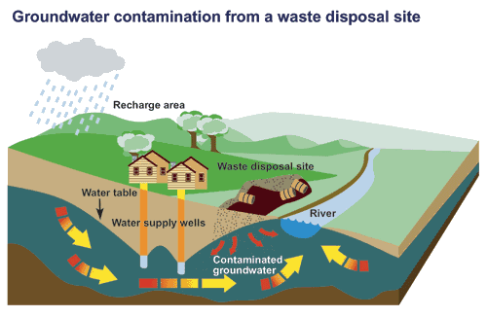

Groundwater contaminants come from two categories of sources: point sources and distributed, or non-point sources. Landfills, leaking gasoline storage tanks, leaking septic tanks, and accidental spills are examples of point sources. Infiltration from farmland treated with pesticides and fertilizers is an example of a non-point source.
Among the more significant point sources are municipal landfills and industrial waste disposal sites. When either of these occur in or near sand and gravel aquifers, the potential for widespread contamination is the greatest.
Scientists also predict that in the next few decades more contaminated aquifers will be discovered, new contaminants will be identified, and more contaminated groundwater will be discharged into wetlands, streams and lakes. Once an aquifer is contaminated, it may be unusable for decades.
Furthermore, the effects of groundwater contamination do not end with the loss of well-water supplies. Several studies have documented the migration of contaminants from disposal or spill sites to nearby lakes and rivers as this groundwater passes through the hydrologic cycle.

Sources of groundwater contamination
There are many different sources of groundwater contamination. Groundwater becomes
contaminated when anthropogenic, or people-created, substances are dissolved or mixed in waters recharging the aquifer. Examples of this are road salt, petroleum products leaking from underground storage tanks, nitrates from the overuse of chemical fertilizers or manure on farmland, excessive applications of chemical pesticides, leaching of fluids from landfills and dumpsites, and accidental spills.
Contamination also results from an overabundance of naturally occurring iron, sulphides,
manganese, and substances such as arsenic. Excess iron and manganese are the most common natural contaminants. Another form of contamination results from the radioactive decay of uranium in bedrock, which creates the radioactive gas radon. Methane and other gases sometimes cause problems. Seawater can also seep into groundwater and is a common problem in coastal areas. It is referred to as "saltwater intrusion".
These contaminants can originate from a “point source” or “non-point source” - meaning they can come from a single source (or point) or, that they don’t have one specific source and come instead from the cumulative effect of any number of factors or activities.
Below are some of the many point- and non-point sources of groundwater pollution, as well as more detailed explanations of these contaminants>

Point sources

- On-site septic systems
- Leaky tanks or pipelines containing petroleum products
- Leaks or spills of industrial chemicals at manufacturing facilities
- Underground injection wells (industrial waste)
- Municipal landfills
- Livestock wastes
- Leaky sewer lines
- Chemicals used at wood preservation facilities
- Mill tailings in mining areas
- Fly ash from coal-fired power plants
- Sludge disposal areas at petroleum refineries
- Land spreading of sewage or sewage sludge
- Road salt storage areas
- Wells for disposal of liquid wastes
- Runoff of salt and other chemicals from roads and highways
- Spills related to highway or railway accidents
- Coal tar at old coal gasification sites
- Asphalt production and equipment cleaning sites

Non-point (distributed) sources
- Fertilizers on agricultural land
- Pesticides on agricultural land and forests
- Contaminants in rain, snow, and dry atmospheric fallout

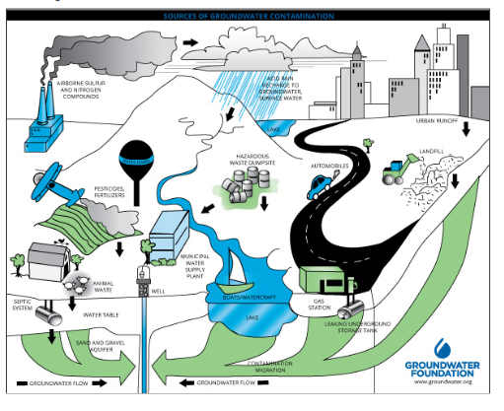

Leaking underground storage tanks and piping
Leaks of petroleum products have been increasing over the last two decades because underground steel tanks installed in large numbers in the 1950s and 1960s have become corroded. Before 1980, most underground tanks were made of steel. Without adequate corrosion protection, up to half of them leak by the time they are 15 years old.
Groundwater dissolves many different compounds, and most of these substances have the potential to contaminate large quantities of water. For example, one liter of gasoline can contaminate 1 000 000 liters of groundwater. This problem is particularly severe in the Atlantic provinces where there is a high usage of groundwater. In many cases, the problem is noticed long after the aquifer is contaminated, for example, when consumers start tasting or smelling gasoline.

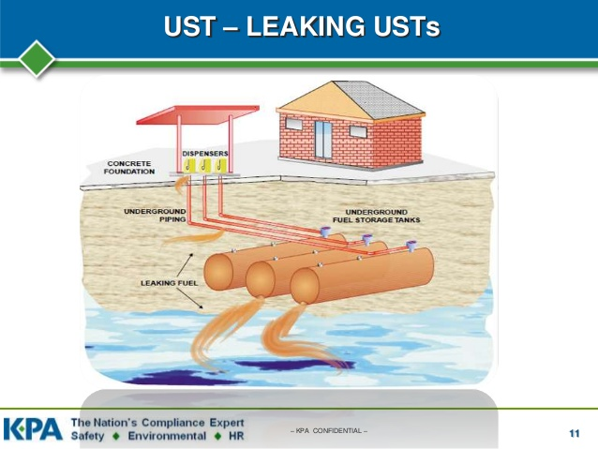

As with petroleum products, the problems are caused by groundwater dissolving some of the compounds in these volatile substances. These compounds can then move with the groundwater flow. Except in large cities, drinking water is rarely tested for these contaminants.

Sewers and Other Pipelines

Sewer pipes carrying wastes sometimes leak fluids into the surrounding soil and ground water. Sewage consists of organic matter, inorganic salts, heavy metals, bacteria, viruses, and nitrogen. Other pipelines carrying industrial chemicals and oil brine have also been known to leak, especially when the materials transported through the pipes are corrosive.

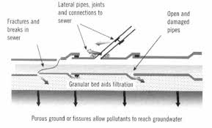

Landfills
Solid waste is disposed of in thousands of municipal and industrial landfills throughout the world. Chemicals that should be disposed of in hazardous waste landfills sometimes end up in municipal landfills. The waste includes garbage, trash, debris, sludge, foundry waste and hazardous substances. In addition, the disposal of many household wastes is not regulated. Once in the landfill, chemicals can leach into the ground water by means of precipitation and surface runoff. New landfills are required to have clay or synthetic liners and leachate (liquid from a landfill containing contaminants) collection systems to protect ground water. Most older landfills, however, do not have these safeguards. Older landfills were often sited over aquifers or close to surface waters and in permeable soils with shallow water tables, enhancing the potential for leachate to contaminate ground water.
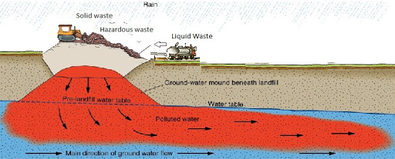
Closed landfills can continue to pose a ground water contamination threat if they are not capped with an impermeable material (such as clay) before closure to prevent the leaching of contaminants by precipitation
Surface Impoundments
Surface impoundments are relatively shallow ponds or lagoons used by industries and municipalities to store, treat, and dispose of liquid wastes. As many as 180,000 surface impoundments exist in the United States.
Surface impoundments are commonly used by municipal wastewater and sewage treatment operations for settling of solids, biological oxidation, and chemical treatment. They are also used by animal feedlots and farms, and by many industries including oil and gas, mining, paper and chemical operations. Water from surface impoundments may be discharged to streams and lakes.
Like landfills, new surface impoundment facilities are required to have liners, but even these liners sometimes leak.
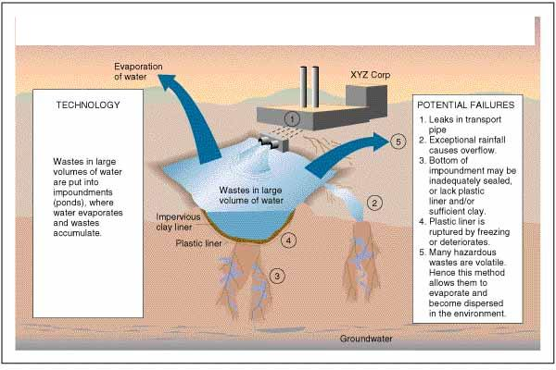

Waste Disposal Injection Wells
Injection wells are used to collect storm water runoff, collect spilled liquids, dispose of wastewater, and dispose of industrial, commercial, and utility wastes. These wells are regulated by the U.S. EPA’s Underground Injection Control Program. In New England, these wells may not be used to inject hazardous wastes from industrial, commercial, and utility operations. The injection wells used in this region are typically shallow and include sumps and dry wells used to handle storm water.
Disposal wells that pose threats to drinking water supplies are prohibited and must be closed, connected to a public sewage system, or connected to a storage tank.
Injection wells can cause ground water contamination if the fluid enters a drinking water aquifer due to poor well design, faulty construction, or inadequate understanding of the cracks, fault zones, or abandoned well casings.
Normally, such wells are designed to have pressure gages and monitoring wells to detect any leak or fracture problems with the injection.

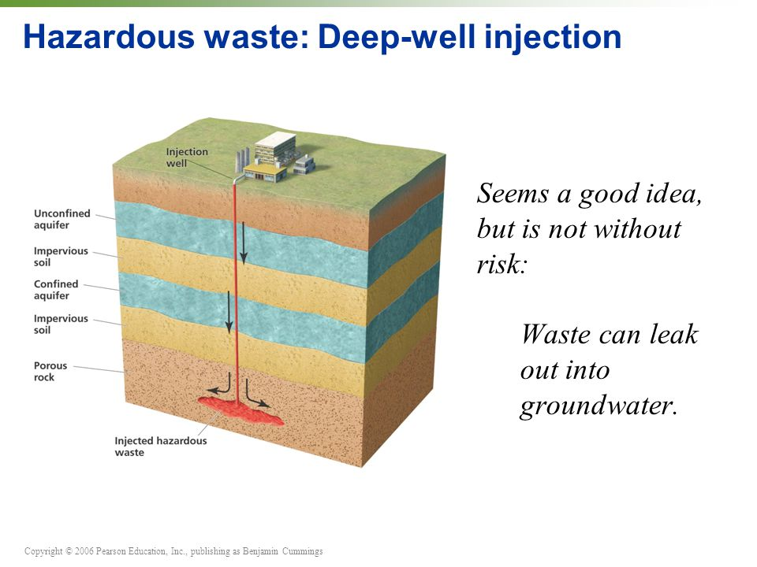

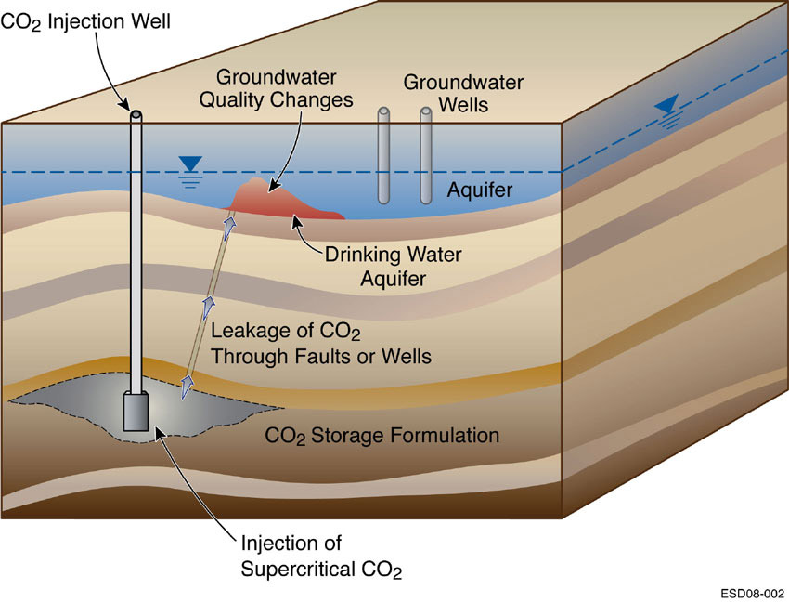

Drainage Wells
Drainage wells are used in wet areas to help drain water and transport it to deeper soils. These wells may contain agricultural chemicals and bacteria.
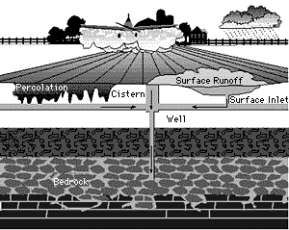

Improperly Constructed Wells
Problems associated with improperly constructed wells can result in ground water contamination when contaminated surface or ground water is introduced into the well.

Poorly Constructed Irrigation Wells
These wells can allow contaminants to enter ground water. Often pesticides and fertilizers are applied in the immediate vicinity of wells on agricultural land.

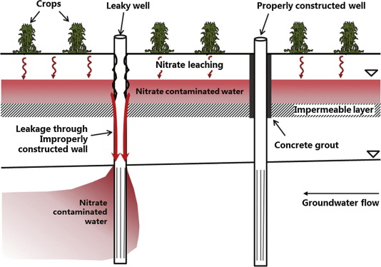

Improperly Abandoned Wells
These wells can act as a conduit through which contaminants can reach an aquifer if the well casing has been removed, as is often done, or if the casing is corroded. In addition, some people use abandoned wells to dispose of wastes such as used motor oil. These wells may reach into an aquifer that serves drinking supply wells. Abandoned exploratory wells (e.g., for gas, oil, or coal) or test hole wells are usually uncovered and are also a potential conduit for contaminants.

See Abandoned_Wells_Brochure (pdf), read it and write a paragraph about one of sources of groundwater contamination

Active Drinking Water Supply Wells
Poorly constructed wells can result in ground water contamination. Construction problems, such as faulty casings, inadequate covers, or lack of concrete pads, allow outside water and any accompanying contaminants to flow into the well.
Sources of such contaminants can be surface runoff or wastes from farm animals or septic systems.
Contaminated fill packed around a well can also degrade well water quality. Well construction problems are more likely to occur in older wells that were in place prior to the establishment of well construction standards and in domestic and livestock wells.

Septic disposal systems
One of the main causes of ground water contamination in the United States is the effluent (outflow) from septic tanks, cesspools, and privies.
Approximately one-fourth of all homes in the United States rely on septic systems to dispose of their human wastes. Although each individual system releases a relatively small amount of waste into the ground, the large number and widespread use of these systems makes them a serious contamination source. Septic systems that are improperly sited, designed, constructed, or maintained can contaminate ground water with bacteria, viruses, nitrates, detergents, oils, and chemicals. Along with these contaminants are the commercially available septic system cleaners containing synthetic organic chemicals (such as methylene chloride). These cleaners can contaminate water supply wells and interfere with natural decomposition processes in septic systems.
Most, if not all, state and local regulations require specific separation distances between septic systems and drinking water wells.
Serious system failures are usually quite evident because wastes will surface and flood the drainage field ( not only causing and odor, but also exposing people to pathogenic bacteria and viruses). Unfortunately, we cannot see or smell contaminants from underground systems that leach into aquifers. Years may pass before contamination emanating from poorly designed systems is detected. Septic systems discharge a variety of organic and inorganic compounds including BOD, COD, TSS, fecal coliform bacteria, nitrates and nitrites, ammonia and phosphorus. Synthetic organic chemicals such as benzene and methylene chloride may also be discharged to the subsurface.
Commercial and industrial septic systems present unique and potentially more severe problems to ground water contamination than do domestic systems due to the hazardous nature of the wastes disposed of in these systems. Chemicals including nitrates, heavy metals such ad lead, copper, and zinc, and certain synthetic organic chemicals such as benzene and chloroform are dumped into such systems.
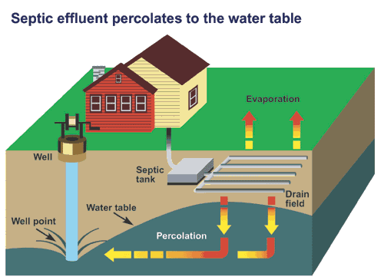

Saltwater intrusion
Saltwater intrusion can be a problem in coastal areas where rates of groundwater pumping are high enough to cause sea water to invade freshwater aquifers. The problem can be avoided by appropriate well field design and by drilling relief wells to keep the salt water away from the fresh groundwater source.

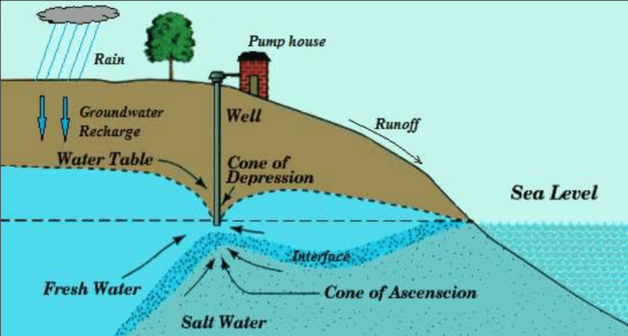

Agricultural Wastes
Numerous agricultural activities can result in non-point sources of groundwater contamination. Fertilizers, pesticides, and herbicides are applied as part of common agricultural practice throughout the world. These applications can act as sources of contamination to groundwater supplies serving large populations. Whether or not fertilizers, pesticides, and herbicides become sources of groundwater contamination depends on changing hydrogeologic conditions, application methods, and biochemical processes in the soil. In developing countries, animal and/or human waste is used for fertilizer. There are the same concerns with pathogens and nitrates. The manufactured inorganic fertilizers widely used in developed countries, and finding increasing usage in all countries, also pose the threat of nitrate contamination of groundwater systems.
Pesticide and herbicide application provides a source of numerous toxic organic chemicals to groundwater supplies. Even without the introduction of fertilizers, pesticides, and herbicides, irrigation activities can lead to groundwater contamination. Naturally occurring
minerals in the soil can be leached at higher rates leading to hazardous concentration levels in the groundwater. Evaporation of irrigation water can cause evaporative concentration of certain chemicals in the root zone. Flushing of these chemicals can then lead to hazardous concentration levels in groundwater.
Agricultural activities related to animals also can be groundwater contamination sources. These include the feeding of animals and the storage and disposal of their waste. Animal wastes and feedlot runoff are commonly collected in some sort of pit or tank creating the contamination threat described earlier for sewage disposal.

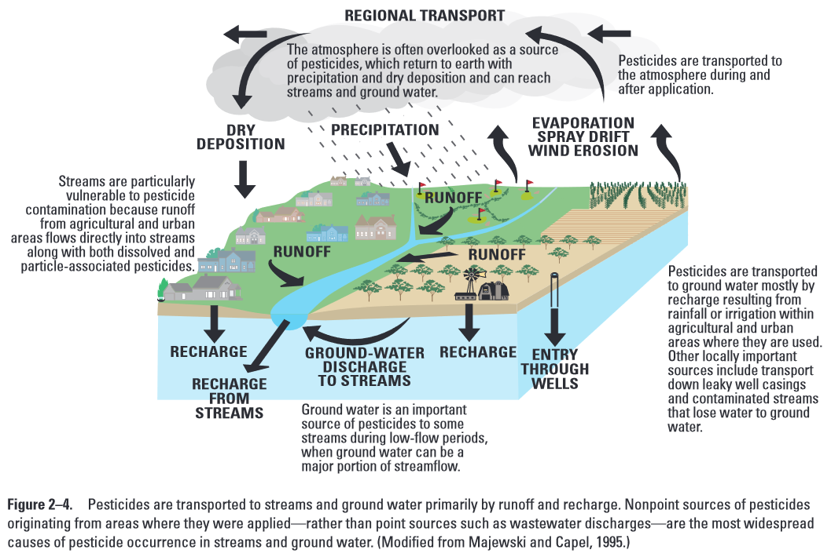
Land Application and Mining
Land application is a treatment and disposal method also called land treatment and land farming. The practice involves spreading waste sludge and wastewater generated by public treatment works, industrial operations such as paper, pulp and textile mills, tanneries and canneries, livestock farms, and oil and gas exploration and extraction operations. Wastewater is applied primarily by a spray irrigation system, while sludge from wastewater plants is generally applied to soil as fertilizer. Oily wastes from refining operations have been land farmed in soil to be broken down by soil microbes. If properly designed and operated, land application recycles nutrients and waters to the soil and aquifer.
Contamination occurs when heavy metals, toxic chemicals, nitrogen, and pathogens leach to underlying aquifers. This occurs if the sludge or wastewater has not received adequate pretreatment or if the depth to ground water has not been properly considered. In some cases, the hazardous materials do not degrade in the subsurface.
The construction techniques, products, and by-products of mining operations have been serious threats to the quality and quantity of nearby aquifers for decades. Surface and underground mining may disrupt natural ground water flow patterns and create the potential for acid mine drainage to seep from the mine. Million of acres of U.S. land have been mined for coal, copper, uranium and other minerals. Mine tailing and associated pits also create serious problems as water comes in contact with metals and other wastes. Inactive and abandoned mines as well as active mines can be steady and serious sources of contamination.

Radioactive Contaminants
Potentially very hazardous and lethal effects of exposure make radioactive wastes of special concern. The mining of radioactive minerals, the processing of radioactive materials, and, particularly, the disposing of radioactive wastes can create very long term sources of groundwater contamination. As for land disposal of other wastes either liquid or solid-the important factor for risk assessment is the degree of isolation from the groundwater system. Although much work has gone into the engineering design of nuclear waste depositories, much uncertainty remains.
Special uncertainties arise because radioactive chemicals with significant half-lives can remain health threats for thousands of years, during which changes in geologic as well as hydrologic conditions become important. Leaching of naturally occurring radioactive materials is also a source of groundwater contamination. Radon gas, for example, may be
found in groundwater in or near some areas of crystalline rock or shales.
The nuclear industry is currently the main generator of radioactive contaminants. Potential sources occur in uranium mining and milling, fuel fabrication. Power plant operation, fuel reprocessing and waste disposal. The disposal of civilian radioactive wastes and uranium mill tailings is licensed under the Nuclear Regulatory Commission. High level radioactive wastes from nuclear power plants are currently in temporary storage but will eventually go into an underground repository such as the one planned for Yucca Mountain, Nevada.

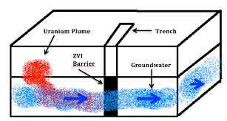
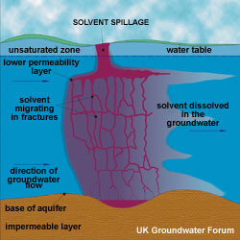

Military Sources of Contamination

Numerous spills, leaks, and landfills have been discovered on military bases throughout U.S.. the U.S. Air Force alone estimates more than 4300 waste sites and spills on more than 100 of their bases in 1999. Many of the sites have contaminant plumes including fuels, chlorinated solvents, trace metals, and other organics.

