Lecture 6
STRUCTURAL
CHARACTERIZATION TECHNIQUES

Assistant Professor
Dr. Raouf Mahmood

Lecture 6
STRUCTURAL CHARACTERIZATION TECHNIQUES

X-ray Diffraction Technique
X-ray Diffraction (XRD) is one of the classical methods for identification and characterization of crystalline solids. Each crystalline solid has its unique characteristic X-ray powder pattern which is used as a” fingerprint” for its identification. The method is based on the diffraction of X-rays by the sample in different directions. Waves of wavelength comparable to the crystal lattice spacing are strongly scattered (diffracted).
The X-ray source is Cu X-ray having a wavelength 1.54 °A. The diffracted rays are detected by a detector placed on the opposite side shown in figure 1.The X-ray source, sample and the detector are placed in a certain configuration given by the Bragg geometry that gives a θ -2θ scan. The source is stationary and the sample and the detector are mobile. When the sample moves by an angle θ, the detector moves by angle 2θ. The sample is loaded on a soda glass substrate.
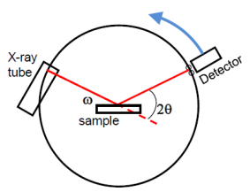
Figure 1. X-Ray diffraction Schematic
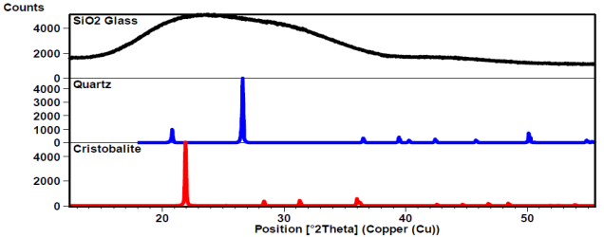
Figure 2. X-Ray diffraction schematic
The schematic of X-ray diffractometer is shown in figure1.The angle and intensities of the diffracted X-rays are used to perform crystallographic studies. The intensity of the diffracted X-rays is measured as a function of the diffraction angle 20 (Figure 2).The intensities of the spots provide information about the atomic basis. The sharpness and shape of the spots are related to the perfection of the crystal.
The structure of the material can be obtained from intensity vs. 2θ plot.
(i) The presence or absence of a certain set of planes gives us the crystal structures.
(ii) The shift of the peaks from its original positions in case of bulk crystals gives the strains in the material.
Although the method of X-ray diffraction is quantitative, in general, it is used for qualitative analysis. This form of analysis, extends to all crystalline solids including ceramics, metals, insulators, organic, polymers, thin film powders etc.
X-ray diffractometers can be used either for single crystals or for powders. While single crystal diffractometers are used for the study of molecular structure, powder diffractometers are used for analysis of phases, though the latter can also be used to derive molecular information, Two approaches are generally used for the analysis of X-ray diffraction data.
- Laue equations: In Laue equations, diffraction from one-dimensional crystal may be treated in the same way as the diffraction by an optical grating.
Upon projection, the grating is like an array of points similar to a crystal. The
diffraction condition is again
nλ=dSinθ ……………….(1)
In a crystal arrangement of atoms is periodic in all three directions and three independent Laue equations can be written.
- Bragg’s law: In Bragg’s law, a crystal is viewed as a plan containing several lattice points. When X-rays are incident on a crystal, different lattice planes causes simultaneous reflections of the X-ray beam. These simultaneous reflections may cause constructive or destructive interference depending on the angle of incidence of X-rays, interlayer separation, wavelength of X-rays. The reflection being equal to the angle of incidence as shown in figure 3.The reflected beams are in phase when the path length between the beams is an integral multiple of the wavelength. The planes of light travelling after reflection will be in phase only when this condition is satisfied. This means that distance A’B’C’=nλ or
2dSinθ=nλ ………………… (2)
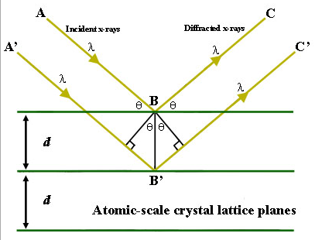
Figure 3. Bragg’s law
But for all other angles other than θ destructive interference occurs. Few specific directions along which the interference is constructive are given by the Braggs law
2dsinθ = nλ …………….(3)
Where d is the separation between the planes of the crystal, θ is the angle of incidence of X-ray and λ is the wavelength of the X-ray. For all angle other than θ, destructive interference will occur leading to cancellation of the intensity. For crystals containing thousands of such planes, Bragg’s law imposes severe restrictions on θ and the cancellation of intensities is usually complete. However, in cases where number of diffraction planes is limited, diffraction peak will broaden.

