Chapter Seven
Working with Programs
Using Menus:
To make a program do your bidding, you give it commands. You can give commands to your Windows program several different ways: by using menus, toolbars, right mouse button shortcut menus and keystroke shortcuts.
Note: To open any menu in program, you can either press on the menu to see the commands inside it or by pressing Alt + the first letter of the menu name.
The procedure for using menus and the general order/layout of the menu is usually similar in most Windows programs. In any Windows program you may find the following menus.
Menus File | Description
File | Commands to open, save, close, print, create new files and get help on the program you are using.
Edit (Home) | Commands to copy, cut, paste, change the font style and color, numbering and alignment of a paragraph, find, select and replace text in a document
View | Commands to change how the document is displayed on the screen
Insert | Lists items that you can insert into a document, such as graphics, page numbers, and the current date
Format (page layout) | Commands to format text, paragraphs, tab stops, etc. Strangely, the command to format the page (i.e. margins, etc.) is located in the File menu under Page Setup.
Review | Commands to do the spelling and grammar check, adding commands display word counting.

Using Toolbars:
Toolbars are another common way to boss around your programs. Toolbars contain buttons for the commands you use most frequently. Instead of having to wade through several menus to do something, you can click a single button.
Two toolbars appear in the program, the Standard toolbar and the Formatting toolbar. The Standard toolbar contains buttons for the most frequently used commands, such as saving and printing a document. The Formatting toolbar has buttons for quickly formatting fonts and paragraphs.
Filling Out a Dialog Box:
Dialog boxes usually contain several types of controls, including:
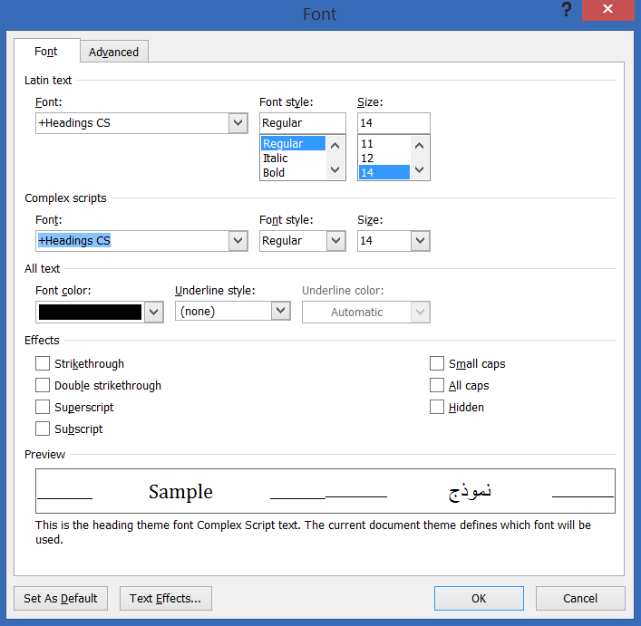
•Text boxes
• List boxes
• Check boxes
• List arrows
• Buttons
For example: in Microsoft word program, you can do the following actions by using the (Font) dialog box:
- Changing the font type.
- Changing the font style (bold ctrl+b, italic ctrl+i, underline ctrl+u).
- Changing the font size.
- Changing the font color.
- Adding some effects on a word such as using (superscript, subscript, hidden letters and so on).

Entering Text in the Word Program:
1. Open the Word program.
2. Click inside the Word window, and type …….
As you type, notice that the insertion point (the small, blinking vertical bar) moves to indicate where you are typing.
3. Press the <Enter> key twice.
Word inserts a new paragraph, or new line, each time you press the <Enter> key.

Editing Text:
After typing a document, you will often discover that you need to make some changes to your text
- Press the up arrow key…. The insertion point moves according it
- Press the <Backspace> key several times, until the word is deleted……The Backspace key deletes one space to the left of the insertion point. Simply use the mouse to move the pointer where you want to place the insertion point and then click for typing again.
The Backspace key deletes text before, or to the left of the insertion point, while the Delete key deletes text after, or to the right of the insertion point.

Selecting, Replacing, and Deleting Text:
You can use a lot of editing and formatting techniques such as formatting, cutting, copying, pasting, replacing and deleting text, also require that you select the text you want to modify. the following are shortcuts for selecting text

To Select This | Do This
A word | Double-click the word.
A line | Click next to the line in the left margin.
A sentence | Triple – click the sentence
The entire document | Press and hold <Ctrl> and click in the left margin

Cutting, Copying and Pasting Text
- To Cut an Object or Text: Select the text or object you want to cut. Click the Cut button on the Standard toolbar, or select Edit then Cut from the menu, or press <Ctrl> + <X>.
- To Copy an Object or Text: Select the text or object you want to copy. Click the Copy button on the Standard toolbar, or select Edit then Copy from the menu, or press <Ctrl> + <C>.
- To Paste a Cut or Copied Object: Place the insertion point where you want to paste the text or object. Click the Paste button on the Standard toolbar, or select Edit then Paste from the menu, or press <Ctrl> + <V>.

Saving a File:
Once you have created something in a program, you must save the file if you ever want to use it again in the future. When you save a file, you’re transferring it from your computer’s memory (which is erased when you close the program) to the computer’s local disk (which is permanent and not erased when you close the program). To save any file you must do the following:
1- Click the Save button on the Standard toolbar.
2- Give your file a name. File names can be up to 255 characters long and contain letters, numbers, and some symbols. You can’t use the symbols " \ / : * | < > in a file name.
3- Specify where you want to save it.
4- Choose the file type.
5- Press Enter or Save button.

Printing a File:
When you want to print your work, you must open a print dialog box by pressing the print command or press Ctrl+p. In this dialog box, there are several options as:
1- Name: Used to select what printer to send your file to when it prints (if you are connected to more than one printer). The currently selected printer is displayed.
2- Properties: Displays some options such as printing on both sides of the page, selecting the paper size you want to use, printing in color or black and white, etc.
3- Page range: Allows you to specify what pages you want to print. There are several options:
- All: Prints the entire document.
- Selection: Prints only the text you have selected.
- Pages: Prints only the pages of the file you specify. Select a range of pages with a hyphen (for example: 5-8) and separate single pages with a comma (for example: 3,7).
4- Number of copies: Specifies the number of copies you want to print.

