Chapter Five
Introduction to Windows XP
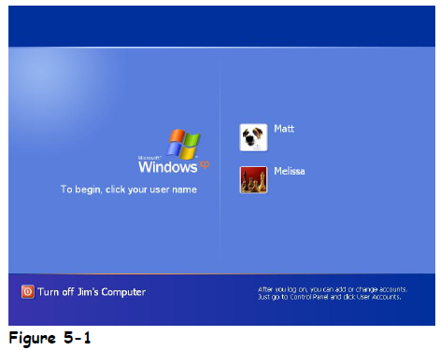
Windows XP should automatically start after you turn on your computer. The default log in screen is the Welcome screen, as shown in Figure 5-1.
If you have a user name and password, you must inter it in this dialog:
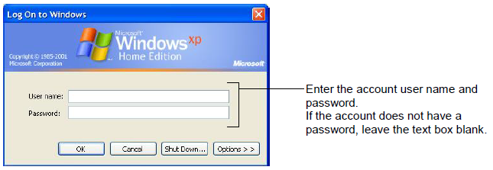
Major Parts of the Windows XP Screen:
- Desktop: This is the large background area of the Windows screen. You can customize the desktop by adding shortcuts to your favorite programs, documents, and printers. You can also change the appearance of the desktop to fit your personality.
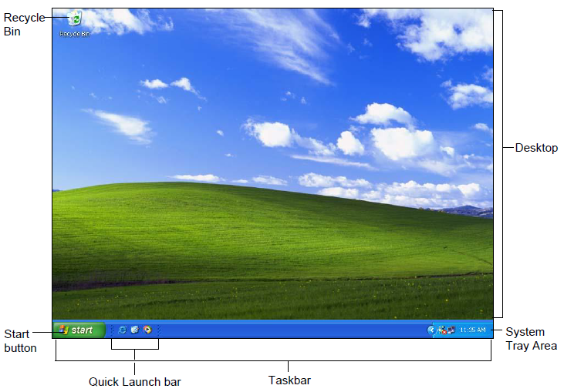
- Recycle Bin: The Recycle Bin stores all the files you delete from your computer. You can use the Recycle Bin to retrieve files you‘ve accidentally deleted. Create more disk space by emptying the Recycle Bin.
- Taskbar: The Taskbar appears at the bottom of your screen and contains the Start button and the opened program, document, or window, which appears as an icon on the taskbar. This lets you see which programs are currently running and allows you to easily switch between them.
- Start button: The Start button lets you quickly open your programs and documents.
- Quick Launch bar: The Quick Launch bar gives you quick access to your most frequently used applications. Internet Explorer, Outlook Express and the Windows desktop are included in the Quick Launch bar by default.
Windows XP Start Menu:
In windows XP’s Start menu all the icons that were formerly stored on the desktop, such as My Computer and My Documents, are now on the Start menu, as well as other applications, documents, and computer settings.
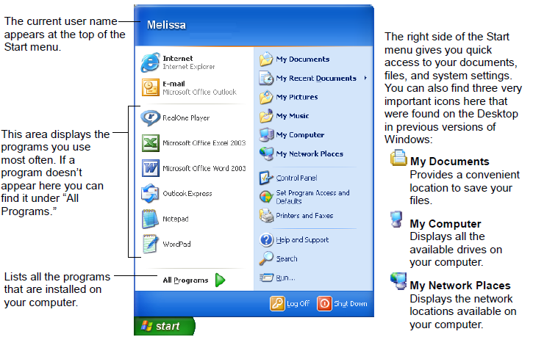

Using the Mouse: you can use the mouse to do the following:
- Pointing: is the most basic action you can do with the mouse. To point to something, simply place the mouse pointer over it by moving the mouse.
- Clicking: means pressing and releasing the left mouse button one time.
- Double-clicking: means pressing and releasing the mouse button twice in rapid succession. You will usually open an object, such as a file, folder, or program by double-clicking it.
- Clicking and dragging: To click and drag something: (a) Move the mouse pointer over the object you want to move, then click and hold down the left mouse button. (b) While you are still holding down the left mouse button, move the mouse until the pointer is over the place you want to put the object. Then, (c) release the mouse button. this method is used in these situations:
- Move a window to a new location on the screen.
- Move a file to a new folder.
- Change the size of a window.
- Move just about anything on your computer’s screen.
5. Right-clicking: Whenever you right-click something, it brings up a shortcut menu that lists everything you can do to the object.
Exiting Windows and Turning Off Your Computer: When you’ve finished using your computer, you need to shut down Windows before you turn your computer off. Shutting down gives Windows a chance to save information in the computer’s memory to the local disk, cleaning up temporary files, and verifying that you’ve saved any changes you made to any files you worked on. When you turn your computer off, you should always follow the next few steps:
1.Save all your work and exit all your programs.
2. Click the Start button and Click the Shut Down button in the Start menu: the options of shut down windows are:
- Stand by: Use Stand by if you have a laptop and are going to leave your computer briefly but want to conserve as much energy as possible while you are away. After you return your computer to its original running state, you will be able to pick up exactly where you left off. (Make sure you save everything you were working on first).
- Shut down: Use this option if you want to turn your computer off. It saves your Windows settings and saves any information stored in memory to the local disk.
- Restart: Use this option if Windows or your Windows-based programs start acting flaky. You often have to restart your computer after installing new software.
- Log Off As…:This option appears only if your computer is connected to a network. This option closes all your programs and disconnects your computer from the network, preparing your computer to be used by someone else.

