**Traffic Flow Theory and Modeling**

**1. Overview**

 Traffic flow theory is mainly presented from the macroscopic perspective where aggregate traffic variables, such as:

- traffic flow,

- traffic density,

- average traffic speed.

In Traffic flow modeling two extreme situations as shown below:

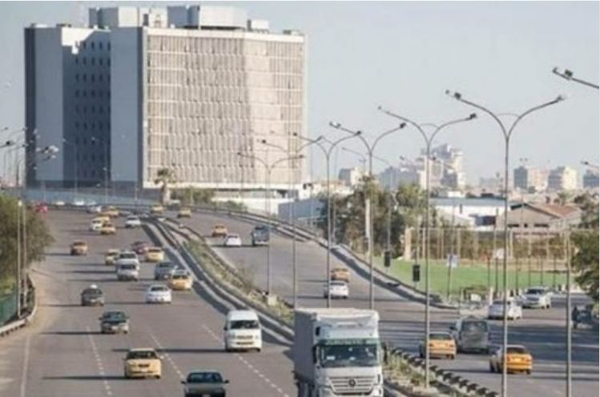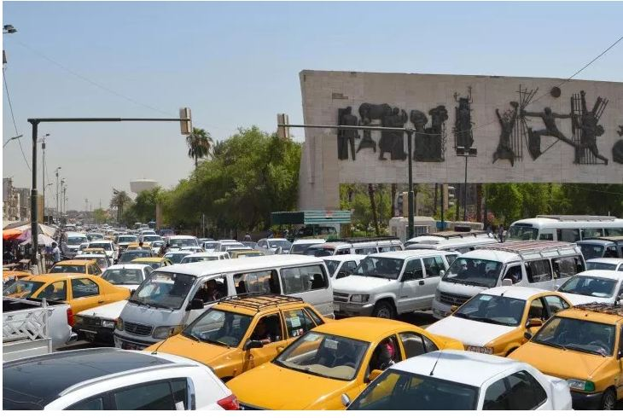

low to intermediate density (Almost) complete stoppage

Low interaction between vehicles; Flow dynamics irrelevant;

everyone travels almost their desired speed simply queueing theory

**Uniform Flow**

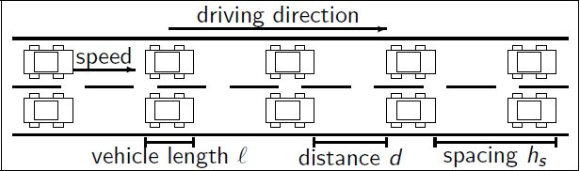

Some fundamental quantities:

* density k : number of vehicles per unit length (at fixed time).
* flow rate (throughput) f : number of vehicles passing fixed position per unit time.
* speed (velocity) u: distance traveled per unit time.
* time headway ht : time between two vehicles passing fixed position.
* space headway (spacing) hs : road length per vehicle.
* occupancy b: percent of time a fixed position is occupied by a vehicle.

**Non-Uniform Flow**

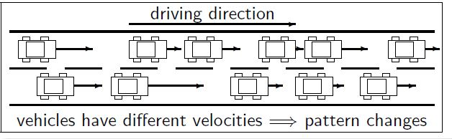

Fundamental quantities

* density k: number of vehicles per unit length (at fixed time). .......... as before
* flow rate f : number of vehicles passing fixed position per unit time. ........ as before
* time mean speed: fixed position, average vehicle speeds over time.
* space mean speed: fixed time, average speeds over a space interval.
* bulk velocity: u = f / k usually meant in macroscopic perspective.

**2. Fundamental Relationship**

In microscopic view, it is obvious that the headway (h), the spacing (s) and the speed (v) are related. The headway times the speed will give the distance covered in this time, which is the spacing. It thus suffices to know two of the three basic variables to calculate the third one.

Capture.JPG

Since headways and spacings have macroscopic counterparts, there is a macroscopic equivalent for this relationship.

Capture.JPG

The macroscopic equivalent of this relationship is the average of this equation. Remembering

**Capture.JPG**

This equation shows that the flow q is proportional with both the speed u and the density k. Intuitively, this makes sense because when the whole traffic stream moves twice as fast if the flow doubles. Similarly, if – at original speed –the density doubles, the flow doubles as well.

Table 1 summarizes the variables and their relationships.

**Table 1**: The basic traffic variables and their relationship

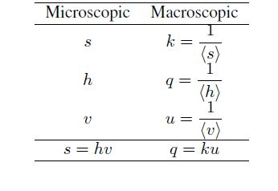

**3. Macroscopic Variables**

**3.1 Trajectories and microscopic variables**

In a microscopic approach to traffic, each vehicle is examined separately.

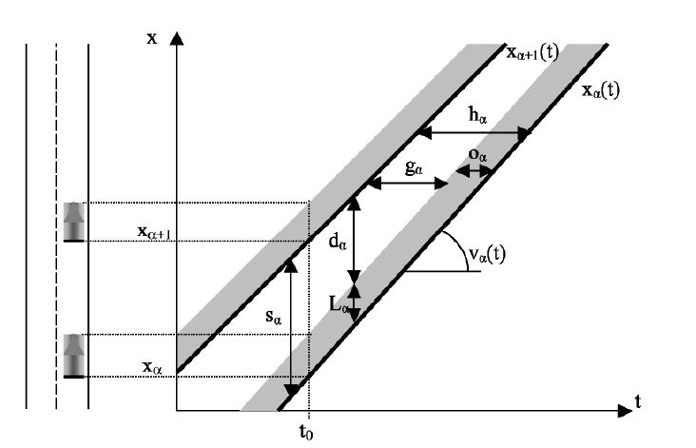

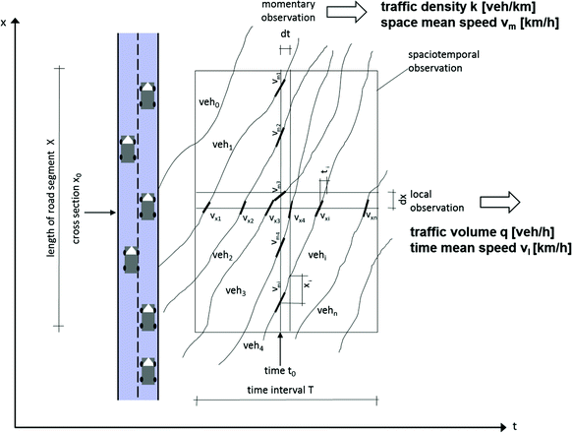

**Figure 1 A road with two vehicles along an x-axis and the same vehicles in a t-x co-ordinate system.**

On the left side in Figure 1, along a vertical X-axis, *xa* indicates the position of vehicle a at time *t0*. The vehicle in front of this vehicle is indicated by a+1. Since both vehicles travel across the road, their positions are time dependent. The right side of Figure 1 presents the vehicles in a *t-x* co-ordinate system.

The position of a vehicle through time is called a trajectory. In this course we use the rear point, the rear bumper of a vehicle, as the point of reference for the trajectory of that vehicle. Figure 1 uses bold black lines to indicate the trajectories of vehicles a en a+1. The grey area represents the entire vehicle.

It is impossible for two trajectories to intersect when the vehicles travel on the same traffic lane. The speed $v_{α}$ of a vehicle if given by the derivative with respect to the trajectory. The second derivative is the acceleration $a_{α}$. Accelerating cars have positive values for $a_{x}$ and braking cars have negative values for $a_{α}$.

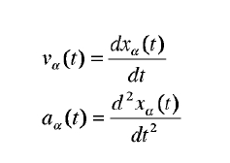

A vehicle occupies a specific part of the road. This space occupancy or simply *space $s_{α}$* consists of the physical length of the vehicle $L_{α}$ and the *distance $d_{α}$* kept by the driver to the vehicle in front, or:

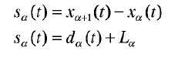

Analogously to space, vehicles also use a certain segment of time which is called *headway h*. This headway time consists of the interval time or *gap g* and the *occupancy o*.

Capture.PNG

At constant speeds, or in general when acceleration is neglected, occupancy becomes:

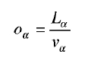

The speed difference D*v* is given by:

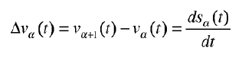

These variables can all be measured. Two aerial photographs taken in quick succession give us the positions, the speeds, the occupancies, the headways and the gaps. Using detection loops (that work on the magnetic-induction-principle) and detection cameras the speed, space, length and distance of vehicles can be measured fairly inexpensively.

Roads usually show a variety of vehicle types and drivers. We call the idealised traffic state with only one type of road user *homogeneous*. A traffic state is *stationary* when it does not change over time. When this is the case, vehicles on homogeneous roads share the same speeds and trajectories are straight lines.

**3.2 Macroscopic variables**

At the macroscopic level we do not look at the vehicles as separate entities. The traditional traffic demand model discussed elsewhere in this course is a macroscopic model. This macroscopic level is also relevant to the dynamic description of traffic. This section defines the macroscopic variables that translate the discrete nature of traffic into continuous variables.

***A measurement interval***

A measurement interval *S* is defined as an area in the *t-x* space. When macroscopic variables are defined later on, it is always done for a certain measurement interval. Figure 2 and Figure 3 below show some measurement intervals:

*S1*: This rectangular measurement interval covers a road section of length DX during an infinitely small time interval *dt*. This coincides approximately with a location interval DX at a specific moment *t1*. We assume that *n* vehicles move through this interval and in the text we shall indicate them by index *i*. Such a location interval could be recorded from an aeroplane on an aerial photograph.

*S2*: This rectangular measurement interval represents an infinitely small road length *dx* during a time interval of DT. This coincides approximately with a time interval DT at a location *x2*. In further derivations we assume that *m* trajectories cross this measurement interval and for these *m* vehicles we use the index *j*. Induction loops and detection cameras have been placed on several locations of our road network and these measure the traffic during time intervals.

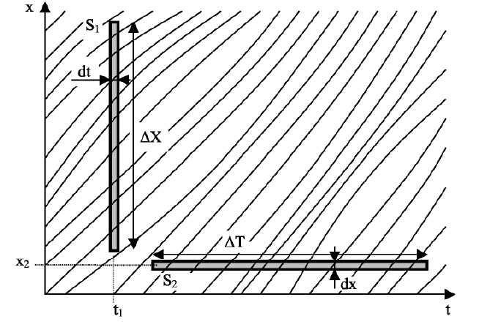

**Figure 2 Trajectories and the measurement intervals *S1* and *S2.***

*S3* is an arbitrary measurement interval in time and space. This measurement interval has an area Opp(*S3*) with dimensions time * space . Several trajectories traverse this measurement interval. The distance travelled by a vehicle in the measurement interval is the projection of its trajectory on the *x*-axis. The time spent by this vehicle in the measurement interval is the projection of the matching trajectory on the time-axis.

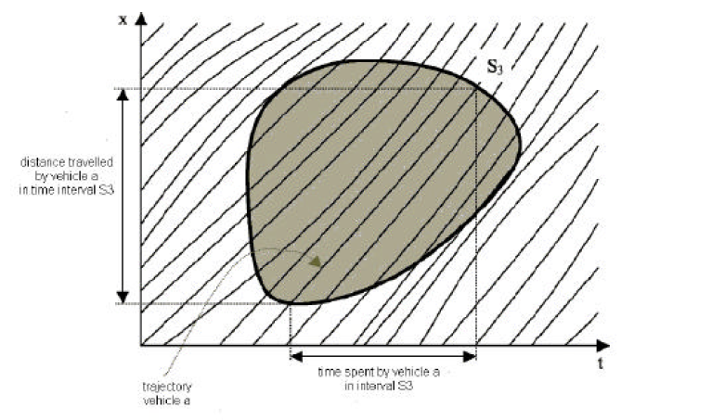

**Figure 3 The measurement interval *S3.***

**Density**

Density is a typical variable from physics that was adopted by traffic science. Density *k* reflects the number of vehicles per kilometre of road. For a measurement interval at a certain point in time, such as *S1*, *k* can be calculated over a road section with DX length as:

Capture.PNG

The index *n* indicates the number of vehicles at *t1* on the location interval DX. Total space

of the *n* vehicles can be set equal to DX, thus:

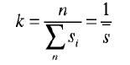

where the mean space occupancy in the interval *S1* is defined as:

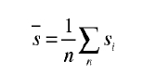

Density *k* depends on the location, time and the measurement interval. We will, therefore, rewrite formula of density, in order to include these dependent factors in our notation. For the location *x1* we take the centre of the measurement interval DX.

Capture.PNG

Density is traditionally expressed in vehicles per kilometre. Maximal density on a road fluctuates around 100 vehicles per kilometre per traffic lane.

The density definition in above equation is confined to a certain point in time. The next step is to generalise this definition If we multiply numerator and denominator of above equation by the infinitely small time interval *dt* around *t1,* density becomes:

Capture.PNG

The denominator of above equation now becomes equal to the area of the measurement interval *S1*. The numerator reflects the total time spent by all vehicles in the measurement interval *S1*.

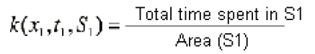

In the same way we define the density at location *x*, at time *t* and for a measurement interval *S* as:

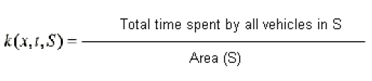

*By way of illustration:*

Density according to definition above for *x2*, *t2* in the measurement interval *S2*, as illustrated once more in Figure 4:

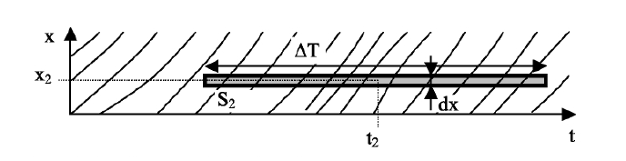

**Figure 4 Time interval *S2.***

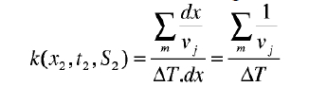

***Flow rate***

The flow rate *q* can be compared to the discharge or the flux of a stream. The flow rate represents the number of vehicles that passes a certain cross-section per time unit. For a time interval DT at any location *x2*, such as the measurement interval S2 in Figure 4, the flow rate is calculated as follows:

Capture.PNG

The index *m* represents the number of vehicles that passes location *x2* during DT. This time interval is the sum of the *m* headways. Through the introduction of a mean headway *h* we find the following expression for the traffic flow rate:

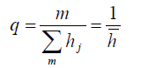

The flow rate is expressed in vehicles per hour. We call the maximum possible flow rate of any road its capacity. Depending on vehicle composition, the capacity of a motorway lies between 1800 and 2400 vehicles per hour per traffic lane.

This definition of flow rate is limited to a time interval. We get a more general definition by multiplying the numerator and the denominator with an infinitely small location interval *dx* around *x2*. The denominator again becomes the area of the measurement interval and the numerator equals the total distance travelled by all vehicles in the measurement interval.

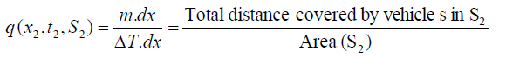

This leads to a general definition for flow rate:

Capture.PNG

*By way of illustration:*

Applying equation above we calculate the flow rate for the measurement interval S1, at location *x1* and time *t1*:

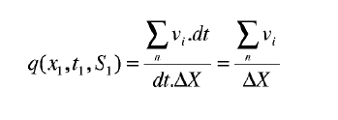

***Mean speed***

We define the mean speed *u* as the quotient of the flow rate and the density. The mean speed is also a function of location, time and measurement interval. Note that the area of the measurement interval no longer appears in definition below:

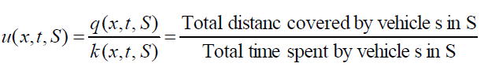

In another form this definition of the mean speed is also called the fundamental relation of traffic flow theory:

Capture.PNG

This relation irrevocably links flow rate, density and mean speed. Knowing two of these variables immediately leads to the remaining third variable.

We calculate the mean speed for the measurement intervals S1 and S2 as follows:

mean speed for these *n* vehicles in the interval S1 at location *x1* and point in time *t1* then becomes:

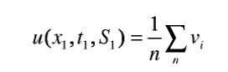

We get the mean speed for a location interval by averaging the speeds of all of the vehicles in this interval. The mean speed for *m* vehicles then becomes:

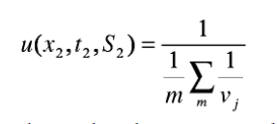

This shows that the mean speed over a time interval is the *harmonic* mean of the individual speeds.

If we take the normal arithmetical average of the individual vehicle speeds in a time interval we get the *time-mean speed ut*, as defined below:

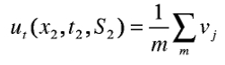

This time- mean speed $u_{t}$ differs from the mean speed *u* and does therefore, NOT comply with the fundamental relation.

The difference between the mean speed and the time-mean speed is illustrated by the example below:



**Figure 5 Motorway with two traffic lanes.**

Consider a long road with two traffic lanes, where all vehicles on the right traffic lane travel at 60 km/h and the vehicles on the left lane at 120 km/h. All the vehicles on the first traffic lane that passed a detector during a 1 minute time interval can be found on a 1 kilometre long road section. For the left traffic lane, the length of this road section equals 2 kilometres. Thus, when the time- mean speed is assessed, faster cars are considered over a much longer road section than slower cars. When we calculate mean speed, and also when we calculate density, the length of the road section used is the same for fast and slow cars. Therefore, the proportion of fast vehicles is overestimated when calculating time- mean speed thus making it always larger than or equal to the mean speed.

***Relative occupancy***

Most traffic measurements are carried out at a fixed location *x2*. The occupancy *o* of a vehicle is easy to measure in such cases. The relative occupancy *b* in time interval S2 is given by:

Capture.PNG

If we assume that all vehicles have the same length, we get a relation between the relative occupancy *b* and the density *k*.

Capture.PNG

**Fundamental diagram**

The previous chapter defined three macroscopic variables: flow rate *q*, density *k* and mean speed *u*. Because of the fundamental relation *q = k.u* (2.15) there are only two independent variables. This chapter introduces an empirical relation between the two remaining independent variables. We do this by assuming stationary (flow rates do not change along the road and over time) and homogeneously composed traffic flow (all vehicles are equal). This means that we can simplify the notation somewhat because the dependence on location, time and measurement interval no longer applies in a stationary flow.

**Observations**

On a three-lane motorway we measured the flow rate *q* and the mean speed *u* during time intervals of one minute. Each observation, therefore, gives a value for the mean speed *u* and a value for the flow rate *q*. Figure 6 shows the different observation points in a *q-u* diagram.

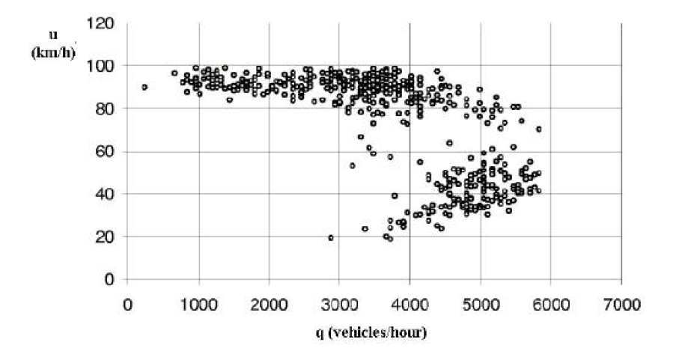

**Figure 6 Observation points in a *q-u* diagram.**

We calculate the density *k* (= *q / u*) for each observation. This means that the points of observation can also be plotted in a *k-q* diagram (Figure 7) and a *k-u* diagram (Figure 8).

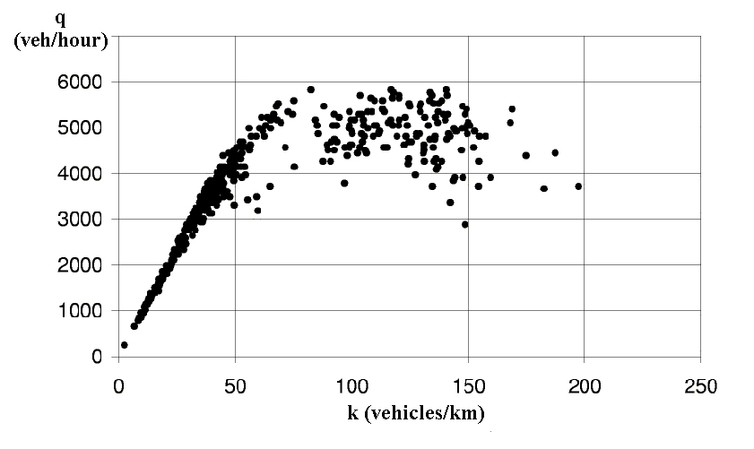

**Figure 7 Observation points in a *k-q* diagram.**

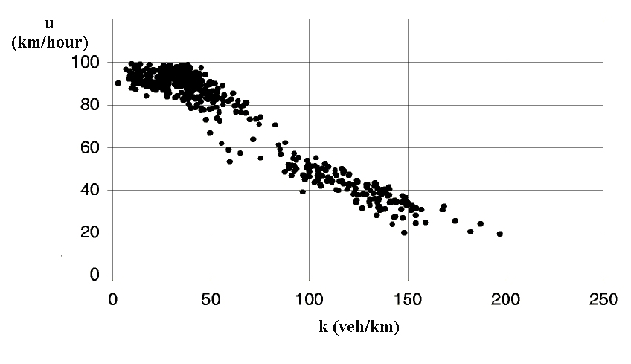

**Figure 8 Observation points in a *k-u* diagram.**

The observations were carried out on an actual motorway where traffic is not homogeneous: there is a variety of vehicle types and drivers behave in a variety of ways. Nor is real traffic stationary: vehicles accelerate and decelerate continuously. Abstracting from the inhomogeneous and non-stationary characteristics, we can describe the empirical characteristics of traffic using an equilibrium relation that we can present in the form of the three diagrams shown above.

***The fundamental diagrams***

Road traffic is always in a specific state that is characterised by the flow rate, the density and the mean speed. We combine all the possible homogeneous and stationary traffic states in an equilibrium function that can be described graphically by three diagrams. The equilibrium relations presented in this way are better known under the name of fundamental diagrams. Figure 9 sketches them and it shows the relationship between each of the diagrams.

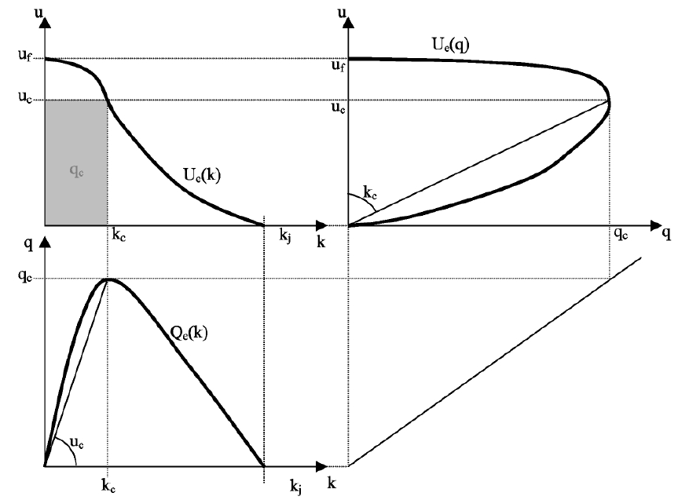

**Figure 9 The three related fundamental diagrams.**

A diagram shows the relation between two of the three variables. The third variable can always be recovered by means of the relationship *q = k.u*. The third variable in the *q-u* and the *k-q* diagram is an angle. The flow rate in the *k-u* diagram is represented by an area. A fundamental diagram applies to a specific road and is drawn up on the basis of observations. Thus stationary and homogeneous traffic is always in a state that is located on the bold black line. Some special state points require extra attention:

***Completely free flowing traffic***

When vehicles are not impeded by other traffic they travel at a maximum speed of *uf* (*free speed*). This speed is dependent, amongst other things, on the design speed of a road, the speed restrictions in operation at any particular time and the weather. At free speed, flow rate and density will be close to zero.

***Saturated traffic***

On saturated roads flow rate and speed are down to zero. The vehicles are queuing and there is a maximum density of *kj* (*jam density*).

***Capacity traffic***

The capacity of a road is equal to the maximum flow rate *qc*. The maximum flow rate of *qc* has an associated capacity speed of *uc* and a capacity density of *kc*. The diagram shows that the capacity speed *uc* lies below the maximum speed *uf* .

**Mathematical models for the fundamental diagrams**

In this section we present mathematical expressions for the equilibrium relations given by the fundamental diagrams. We examine the original diagram of Greenshield and the triangular diagram.

Greenshield (1934)

Greenshield drew up a first formulation that was based on a small number of slightly questionable measurements. In this formulation the relation in the *k-u* diagram is assumed to be linear, leading to parabolic relations for the remaining diagrams.

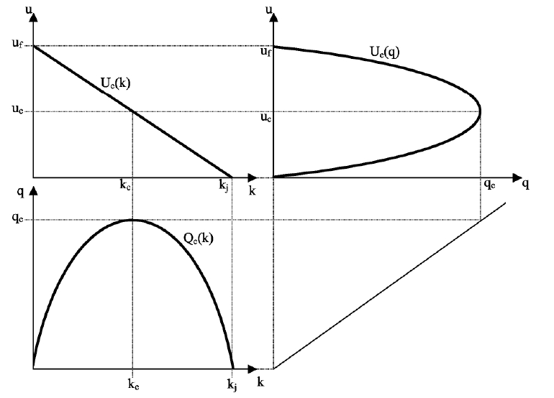

**Figure 10 The fundamental diagrams according to Greenshield.**

In Greenshield's diagrams, the capacity speed *uc* is half the maximum speed *uf*. The capacity density *kc* in this model is half the maximum density *kj*. This formulation is a rough simplification of observed traffic behaviour, but is still frequently used because of its simplicity and for historical reasons. The equilibrium function in the *k-u* diagram can be written as:

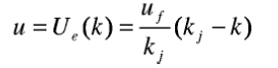

Applying the fundamental relation gives the other relations ( *Qe(k)* and *Ue(q)* ). Note that the relation *Ue(q)* is not a function

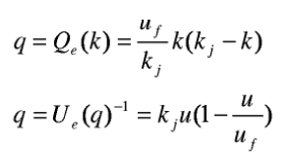

**Triangular diagram**

A second much-used formulation assumes that the fundamental *k-q* diagram is triangular in shape. In this equilibrium relation the mean speed equals the maximum speed for all traffic states that have densities smaller than the capacity density. The branch of the triangle that links the capacity state with the saturated state, has a negative constant slope *w*. Figure 11 represents this triangular diagram.



**Figure 11 The fundamental diagrams when a triangular *k-q* diagram applies.**

**Macroscopic traffic flow model**

In the two previous chapters we learned that the fundamental relation (*q=k.u)* and the fundamental diagrams (Figure 9) enable us to describe the traffic state of stationary and homogeneous traffic. Thus we can calculate the two remaining variables for a given value of a macroscopic variable. When traffic is stationary and homogeneous, we know that the values for these variables will remain constant along the entire road and for some extended period.

However, real traffic is neither homogeneous nor stationary. In this chapter our aim is to describe the evolution of traffic over time. In doing so, we will ignore the dependency on the measurement interval *S* in the notation in order to discover the dynamic relation between *q(x,t)*, *u(x,t)* and *k(x,t)*. We assume, therefore, that we are dealing with point variables: variables that are singularly defined at any moment and at every location. By doing this we can show these three variables as functions in the *t-x* plane.

***Derivation and formulation***

We use a traffic conservation law to describe the changes in time and location of the macroscopic variables along a road. The fundamental relation *q(x,t)=k(x,t).u(x,t)* continues to apply.

We divide the road to be modelled in cells with a length of Dx. The density of cell *i* at time *tj* is indicated by *k(i,j)*. The number of vehicles in the cell is *k(i,j)*.Dx . One time interval Dt later, at *tj+*1, density has changed as follows (see Figure 13):

• A number of vehicles travelled from cell *i*- l into cell *i.* The expected inflow is given by *q(i-*1*,j*). t

• From cell *i* a number of vehicles travelled to cell *i*+l. This outflow is given by *q(i,j)*. t

• Feeder- and exit roads enable in- and outflows that are indicated by *z(i,j)*.x.t where *z* is expressed per time- and length- unit and is taken positive for an increase in the number of vehicles.



**Figure 12 Derivation of the conservation law.**

For cell *i* at time *tj* we can now write the following formulation of the state:

Capture.PNG

or:

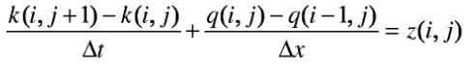

Taking the limit with respect to the time step and letting cell length approach zero results in the following partial differential equation representing the *conservation law of traffic*:

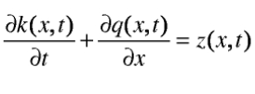

We add another assumption to this conservation law: All possible dynamic traffic states comply with the stationary fundamental diagrams. This means that although traffic states on roads can change over time, they still comply with the fundamental diagrams at each moment and at every location. Therefore the successive traffic states 'move' as it were across the bold black lines in the fundamental diagrams.

This assumption allows us to write the flow rate in function of density as follows:

Capture.PNG

Applying the chain rule gives a partial differential equation that only contains partial derivatives with respect to density.

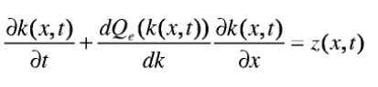

In the expression above *z(x,t)* represents the volume of traffic that enters the road at time *t* and location *x* (a negative value for exiting traffic) and *dQe(k)/dk* , or in short *Qe’(k)* represents the derivative of the fundamental *k-q* function. In the subsequent derivation we assume a concave fundamental diagram which means that *Qe’(k)* will always decrease for increasing densities.

Using the fundamental diagram in the traffic conservation law led to the first dynamic traffic model in the 1950s. This model was named after the people who first proposed it: the LWR- model (Lighthill, Whitham, Richards). Several schemes were developed to numerically solve this equation with the help of a computer in order to obtain a traffic model that could be applied to practical situations. In the following section we will study this equation in an analytical way in order to gain some insight into some of the dynamic characteristics of a traffic stream.

***Characteristics***

The partial differential equation above is known in mathematical analysis as the "Burgers equation". It can be solved analytically with the help of given boundary conditions. If we apply the equation to a road without feeder- and exit lanes and if, for the sake of convenience, we assume that *Qe’(k)* equals *c*, the conservation equation above can be simplified to:

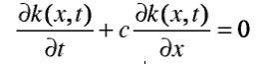

Solving this equation means finding the traffic density on this road in function of time and location. The solution to this equation is given by:

Capture.PNG

where F is an arbitrary function.

If we know the value of the density at a point, we can draw a straight line through that point with slope *c*. The density then remains constant along this line. Such a straight line is known as a *solution line* or *characteristic*.

We sketch the *t-x* diagram in Figure 13a. Assume that the initial value in *x*0 equals *k*0. A straight line with slope *c* can then be drawn through *x*0 along which density also equals *k*0.



**Figure 13 (a) the *t-x* diagram and (b) the *k-q* fundamental diagram.**

In actual fact the value of *c* equals *Qe’(k*0*)*. This is the derivative of the fundamental diagram function for *k*0. In other words, *c* equals the slope of the tangent to the fundamental *k-q* diagram in *k*0. We can now draw the *k-q* diagram to scale with the *t-x* diagram so that equal slopes in both diagrams correspond to the same speed. It is now possible to draw a line parallel to the tangent to the fundamental diagram through a point in the *t-x* diagram where we know the initial condition.

From the initial- and boundary conditions we can draw solution lines where the traffic state is known. A specific value for the density *k*0 always corresponds to an associated flow rate *q*0 and a mean speed *u*0. Along a characteristic both density, flow rate and mean speed remain constant. Note, from the fundamental diagram in Figure 13b, that vehicle speed always exceeds the speed *c* of the characteristics.

We divide the various traffic states into traffic regimes according to the slope of the characteristics:

•*Free flow*

When density lies below the capacity dens ity *kc*, we speak of free flow. During this regime the mean speed of the traffic stream exceeds the capacity speed *uc* . During free flow the speed of the characteristics *c = Qe’(k)* is positive. As a result, the characteristics run in the same direction as the traffic flow. This means that the properties of the traffic flow propagate in the same direction as the traffic flow itself (see Figure 13). The slope of the characteristics *c*, however, is always below the mean vehicle-speed *u*0. Thus the properties of the traffic regime move at a lower speed than the individual vehicles.

• *Congested flow*

When traffic speed lies below the capacity speed *uc* or when traffic density lies between the capacity density *kc* and the maximum density *kj* we speak of congested flow. It is the regime in which tailbacks develop. During congestion *Qe’(k)* is negative. The characteristics run opposite to the direction of travel (see Figure 15) and the properties of the traffic flow propagate against the direction of the vehicle

stream.

• *Capacity flow*

Capacity flow is considered to be a separate regime. In this regime the flow rate is maximal. At capacity flow *Qe’(k)* equals zero and the characteristics run parallel to the time-axis. This regime cannot propagate in either direction relative to the traffic stream. Capacity flow remains at the same location and functions as an upstream boundary for congested flow and a downstream boundary for free flow. We call the locations where this traffic regime occurs the bottlenecks in a traffic network.

The table below gives an summary:

