Lecture Eight

Properties of hazardous wastes
9.1 Solubility
It is the extent of concentration (mg/L) to which a hazardous compound dissolves in a solvent. It determines whether the chemical can be found as a separate phase or dissolved, thus controlling fate and transport. Hydrophobic compounds (Non Aqueous Liquid Phase NALP) tend to partition onto solids from emulsions and float at air-water interface (L NALP), or sink to the bottom of aquifer (DNALP). In general, solubility is inversely proportional to sorption, bioaccumulation and volatilization. It is affected by temperature (usually expressed at 25ºC).
Solubility depends on molecular structure, size and forces of attraction. We can generalize by saying that size is inversely proportional to molar volume. E.g. – solubility of naphthalene C₁₀H_{8,} (128.17 g·mol⁻¹) is 32 mg/L, while solubility of benzopyrene C₂₀H₁₂ (252.32 g.mol⁻¹ ) is 0.00038 mg/L.
9.2 Effective Solubility
It is the true solubility of a compound in mixture, denoted by S^{i}_{e}.

Effective Solubility C_{w} = X_{o} S
C_{w} = Effective solubility of the specific compound (mgL⁻¹)
x_{o} = mole fraction (of chemical in fuel)
S = pure solubility of the specific compound (mgL⁻¹)
Mole Fraction X_{o} = MF_{x} MW_{o} / MW_{x}
MF_{x} = mass fraction of selected chemical in fuel
MW_{o} = average molecular weight of fuel (gram.mol⁻¹)
MW_{X} = molecular weight of selected chemical (gram.mol⁻¹)
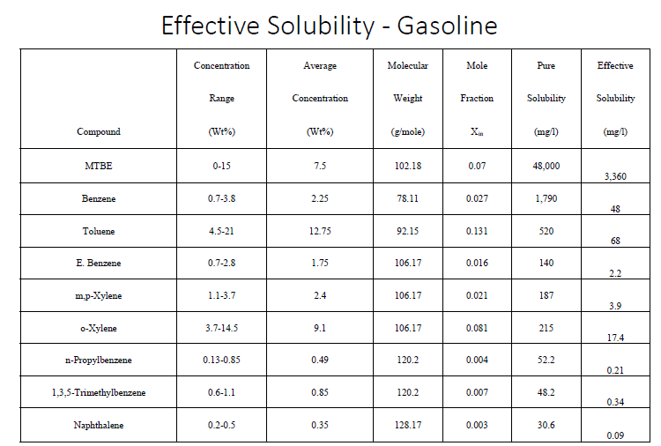
9.3 Water solubility of weak acids/ bases
Weak acids dissociate into their ionized form.

𝑅𝐶𝑂𝑂𝐻 𝑅𝐶𝑂𝑂⁻+𝐻⁺
𝐴𝑐𝑡𝑖𝑣𝑖𝑡𝑦 𝑐𝑜𝑒𝑓𝑓𝑖𝑐𝑖𝑒𝑛𝑡, 𝑘_{𝑎}=({𝑅𝐶𝑂𝑂⁻}{𝐻⁺}/{𝑅𝐶𝑂𝑂𝐻})
For weak bases:
𝐶𝑎²⁺+2𝑂𝐻⁻→𝐶𝑎(𝑂𝐻)²
𝑆𝑜𝑙𝑢𝑏𝑖𝑙𝑖𝑡𝑦 𝑝𝑟𝑜𝑑𝑢𝑐𝑡, 𝑘_{𝑠𝑝}=[𝐶𝑎²⁺][𝑂𝐻⁻]²

9.4 Vapour Pressure
The vapor pressure of a liquid is the equilibrium pressure of a vapor above its liquid (or solid); that is, the pressure of the vapor resulting from evaporation of a liquid (or solid) above a sample of the liquid (or solid) in a closed container. Examples:

substance | vapor pressure at 25ºC
diethyl ether | 0.7 atm
bromine | 0.3 atm
ethyl alcohol | 0.08 atm
water | 0.03 atm
The vapor pressure of a liquid varies with its temperature, as the following graph shows for water. The line on the graph shows the boiling temperature for water.
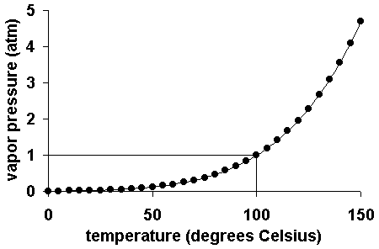

As the temperature of a liquid or solid increases its vapor pressure also increases. Conversely, vapor pressure decreases as the temperature decreases.
The vapor pressure of a liquid can be measured in a variety of ways. A simple measurement involves injecting a little of the liquid into a closed flask connected to a manometer.
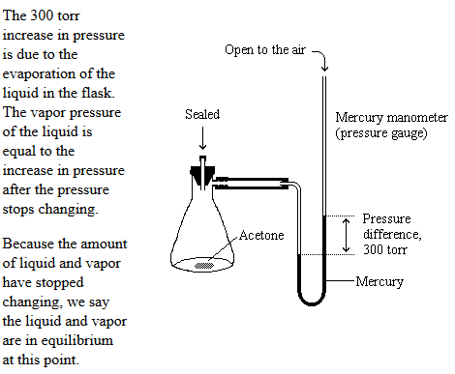
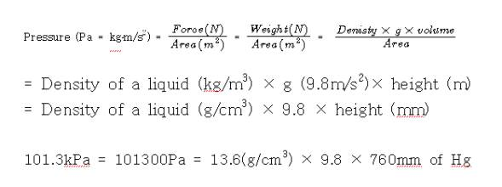Raoult’s Law
𝑝_{𝑎}=𝑝_{𝑣}𝑋_{𝑎} (for pure phase)

Fig. 1: Vapour pressure of a liquid contaminant

Where 𝑝_{𝑎}=𝑝𝑎𝑟𝑡𝑖𝑎𝑙 𝑝𝑟𝑒𝑠𝑠𝑢𝑟𝑒 𝑜𝑓 𝑐𝑜𝑛𝑡𝑎𝑚𝑖𝑛𝑎𝑛𝑡 𝑎 (𝑎𝑡𝑚)
𝑝_{𝑣}=𝑣𝑎𝑝𝑜𝑢𝑟 𝑝𝑟𝑒𝑠𝑠𝑢𝑟𝑒 𝑜𝑓 𝑝𝑢𝑟𝑒 𝑐𝑜𝑚𝑝𝑜𝑢𝑛𝑑 (𝑎𝑡𝑚)
𝑋_{𝑎}=𝑚𝑜𝑙𝑒 𝑓𝑟𝑎𝑐𝑡𝑖𝑜𝑛 𝑜𝑓 𝑎 = 𝑚𝑜𝑙𝑒𝑠 𝑜𝑓 𝑎/𝑡𝑜𝑡𝑎𝑙 𝑛𝑢𝑚𝑏𝑒𝑟 𝑜𝑓 𝑚𝑜𝑙𝑒𝑠
Henry’s Law
Henry’s Law states that under equilibrium, partial pressure of a volatile gas above a liquid is proportional to the concentration of the compound in the liquid.

Fig. 2: Partitioning of a contaminant from water to air
Henry’s Constant 𝐻 (𝑎𝑡𝑚.𝑚³/𝑚𝑜𝑙)=𝑃_{𝑔}/𝐶_{𝑙} = 𝑉𝑃/𝑆
Where P_{g} is the partial pressure of the volatile gas above the liquid (atm) and C_{l} is the concentration of the compound in liquid (mol/m³)
Dimensionless form of Henry’s constant 𝐻′=𝐶_{𝑎}/𝐶_{𝑤}=𝐻/𝑅𝑇
Where C_{a} and C_{w} are the concentrations of the contaminant in air and water respectively.
Regression equation: 𝐻=𝑒^{𝐴−(𝐵𝑇)}
Where A and B are constants and T is the temperature
Example 1: Determine the Henry’s constant of toluene at 20ºC. Vapour pressure is given to be 22 mm Hg and solubility is 515 mg/L.
Solution:
Toluene C₆H₅-CH₃ 𝑀𝑜𝑙𝑒𝑐𝑢𝑙𝑎𝑟 𝑤𝑒𝑖𝑔ℎ𝑡=92𝑔/𝑚𝑜𝑙
𝑉𝑎𝑝𝑜𝑢𝑟 𝑝𝑟𝑒𝑠𝑠𝑢𝑟𝑒=22 𝑚𝑚 𝐻𝑔=22 𝑚𝑚/760𝑚𝑚 𝑎𝑡𝑚=0.0289 𝑎𝑡𝑚 𝑆𝑜𝑙𝑢𝑏𝑖𝑙𝑖𝑡𝑦=515𝑚𝑔/𝐿=515∗0.001 𝑔/0.001 𝑚³∗92𝑔/𝑚𝑜𝑙=5.59𝑚𝑜𝑙/𝑚³ 𝐻𝑒𝑛𝑟𝑦′𝑠 𝑐𝑜𝑛𝑠𝑡𝑎𝑛𝑡 𝐻=𝑉𝑃/𝑆=0.0289/5.59=5.2∗10⁻³ 𝑎𝑡𝑚.𝑚³/𝑚𝑜𝑙

9.5 Partitioning

Partitioning is the distribution of chemicals between two different media/ phases. There are various partitioning coefficients, which empirically describe these phenomena.
Fig. 3: Figure showing partitioning of hazardous waste to various media

9.5.1 Octanol-water partitioning coefficient
Octanol–water partition coefficient (K_{ow}) is a very valuable parameter with numerous environmental applications, where it is used as a primary characterizing parameter since it represents a measure of the tendency of a compound to move from the aqueous phase into lipids. Octanol-water partitioning coefficient 𝐾_{𝑜𝑤}=𝐶_{𝑜𝑐𝑡𝑎𝑛𝑜𝑙}/𝐶_{𝑤𝑎𝑡𝑒𝑟}
where C_{octanol} and C_{w} are the concentrations, in g L⁻¹, of the species in the octanol-rich phase and in the water-rich phase respectively.
9.5.2 Soil-water partitioning coefficient
Water is the preferred medium for contaminants. If the contaminant is in aqueous phase, it gets adsorbed by soil easily.
Soil-water partitioning coefficient 𝐾_{𝑑}=𝐶_{𝑠𝑜𝑖𝑙}/𝐶_{𝑤𝑎𝑡𝑒𝑟} (for linear adsorption)
K_{d} is similar to adsorption coefficient and soil is the (heterogeneous) adsorbent.
9.5.3 Organic Carbon (OC) content
OC content, also known as humic content plays an important role in organic chemical partitioning. It is the fraction of organic carbon present in soil.
𝐾_{𝑂𝐶}=𝐶_{𝑂𝐶}/𝐶_{𝑤𝑎𝑡𝑒𝑟} and 𝐾_{𝑑}=𝐾_{𝑂𝐶}∗𝑓_{𝑂𝐶} (if 𝑓_{𝑂𝐶}>𝑓_{𝑂𝐶}∗)
Where f_{OC} is the fraction of organic carbon present in soil (this is an important factor for partitioning) and f_{OC}* is the critical organic carbon concentration
Organic content of soil is the main contributor towards sorption only if 𝑓_{𝑂𝐶}>𝑓_{𝑂𝐶}∗.
f_{OC}* is calculated from the surface area (Sa) of soil (empirical relation): 𝑓_{𝑂𝐶}∗(%)=𝑆𝑎/200(𝐾_{𝑜𝑤})^{0.84}
The relationship between KOC and KOW is shown in Fig. below:
Tables of Log K_{ow} and Log K_{OC} are present in the references.

9.5.4 Contaminants in Biota
The partitioning coefficient between biota and water is also known as Bioconcentration Factor (BCF).
𝐵𝐶𝐹 (𝑘𝑔/𝐿)=𝐶_{𝑏𝑖𝑜𝑡𝑎} (𝑔/𝑘𝑔)/𝐶_{𝑤𝑎𝑡𝑒𝑟} (𝑔/𝐿)
It is an estimate of the amount of chemical that is likely to accumulate in aquatic organisms. The higher the lipid content in an organism, the more the accumulation.
9.5.5 Biomagnification
Is the incremental increase in a contaminant’s concentration at each level of the food chain. This can be explained with the help of the following graphic:

Fig. 4: Biomagnification of DDT (DichloroDiphenylTrichloroethane)

Example 2: An insecticide chlordane is found in lake water at a concentration of 560 μg/L. Find the concentration of the insecticide in fish. Given BCF for chlordane is 14000 L/kg.
Solution: 𝐶_{𝑏𝑖𝑜𝑡𝑎}=𝐵𝐶𝐹∗𝐶_{𝑤𝑎𝑡𝑒𝑟}=14000𝐿/𝑘𝑔∗(560∗10⁻⁶𝑔/𝐿)=7.84𝑔/𝑘𝑔

9.5.6 Sorption
Properties of the phase as well as properties of the contaminant affects sorption into soil. Sorption controls the rate at which the contaminants move across media.
9.5.6.1 Cation Exchange Capacity (CEC)
It is the quantity of cations sorbed per amount of soil. It is a property of the soil, not the contaminant. Generally, it can be said that bigger the charge of the cation, the better the attraction.
Trend in CEC: 𝑀𝑜𝑛𝑜𝑣𝑎𝑙𝑒𝑛𝑡 𝑐𝑎𝑡𝑖𝑜𝑛𝑠<𝐷𝑖𝑣𝑎𝑙𝑒𝑛𝑡<𝑇𝑟𝑖𝑣𝑎𝑙𝑒𝑛𝑡 𝑎𝑛𝑑 ℎ𝑖𝑔ℎ𝑒𝑟
Also, higher CEC is observed in soils with higher clay/ organic matter.

9.5.6.2 Forces controlling sorption
▪ Vander Waal’s attraction force
Van der Waals Forces are the weak forces which contribute to intermolecular bonding between molecules. Van der Waals forces are the sum of the attractive and repulsive electrical forces between atoms and molecules.
▪ Hydrogen bonding, A hydrogen bond (often informally abbreviated H-bond) is a primarily electrostatic force of attraction between a hydrogen (H) atom which is covalently bound to a more electronegative atom or group, particularly the second-row elements nitrogen (N), oxygen (O), or fluorine (F)—the hydrogen bond donor (Dn) and another electronegative atom bearing a lone pair of electrons—the hydrogen bond acceptor (Ac)
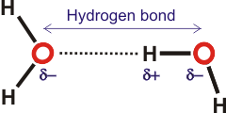

▪ Dipole-dipole interaction (Dipole-dipole forces are attractive forces between the positive end of one polar molecule and the negative end of another polar molecule. Dipole-dipole forces have strengths that range from 5 kJ to 20 kJ per mole. ... The partially positive end of a polar molecule is attracted to the partially negative end of another.)
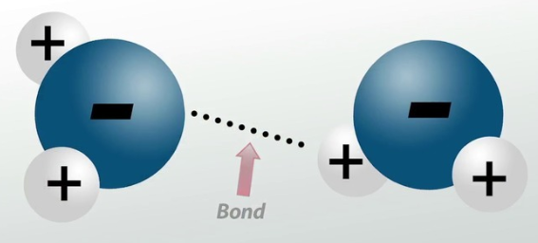

Example 3: Determine the K_{OC}, K_{d}, C_{s} (sorbed phase concentration) for perchloroethylene (C₂C_{l4}) in a soil-water system. Given 𝑓_{𝑂𝐶}=0.2% (found using TOC analyzer), log𝐾_{𝑜𝑤}=2.79, 𝐾_{𝑜𝑐}=316, 𝑆𝑎=12 𝑚²/𝑔, 𝐶_{𝑤}=10 𝑚𝑔/𝐿
Assuming linear sorption, find the concentration of PCE in soil.
Solution:
Check if 𝑓_{𝑂𝐶}>𝑓_{𝑂𝐶}∗
𝑓_{𝑂𝐶}∗(%)=𝑆𝑎/200(𝐾_{𝑜𝑤})^{0.84}=12/200∗(616.59)^{0.8}=3.517∗10⁻⁴%
Therefore 𝐾_{𝑑}=𝐾_{𝑂𝐶}∗𝑓_{𝑂𝐶}=316∗0.002=0.632𝑚𝐿𝑔 𝐾_{𝑑}=𝐶_{𝑠𝑜𝑖𝑙}/𝐶_{𝑤𝑎𝑡𝑒𝑟}
This implies 𝐶_{𝑠𝑜𝑖𝑙}=0.632𝑚𝐿/𝑔∗10𝑚𝑔/𝐿=6.32𝑚𝑔/𝑘𝑔

9.6 Reasons for actual solubility in field being much lesser than the theoretical maximum solubility
1. Effective solubility
Solubility is proportional to mole fraction of contaminant.
2. Dilution
Dilution is the process of decreasing the concentration of a solute in solution, usually simply by mixing with more solvent. To dilute a solution means to add more solvent without the addition of more solute.
Fig. 5: Dilution of contaminant in ground water

3. Mass Transfer
There are two types of contaminant mass transfer which take place: equilibrium mass transfer (which reaches saturation) and rate limited mass transfer (when saturation is not reached). Rate limited mass transfer happens due to limited contact area/ time. Lesser contact area results in lesser solubility. Lesser contact time occurs when there is rapid movement of groundwater and there molecules of contaminant are small in size.
4. Remediation
Sometimes, it is observed that a concentration of a contaminant is greater than the concentration at saturated level.
𝐶>𝐶_{𝑠𝑎𝑡𝑢𝑟𝑎𝑡𝑒𝑑}
This is brought about by the presence of co-solvents and surfactants. Co-solvents refer to a group of intermediate solvents (such as methanol) that have the ability to dissolve pollutants, as well as dissolve in water.

5. Volatilization
Volatilization refers to the mass transfer of a contaminant from liquid to gaseous phase. It is important to monitor the migration of hazardous chemicals from waste sites and storage facilities (both above and below ground).
Factors contributing to concentration of contaminant in air:
▪ Vapour pressure and Henry’s Law (decides volatilization rate)
▪ Temperature
▪ Mixing (for e.g., fans/ blowers)
▪ Contact area (within the storage container)
▪ Ventilation rate (mixing from outside the room/ system)
▪ Rate limited mass transfer and dilution will play an important role
Rate of volatilization
Hanna-Davis equation for rate limited mass transfer in a closed container (close to source):
𝑄_{𝑣𝑜𝑙}=𝑀𝐾𝐴(𝑉𝑃-P)/𝑅𝑇
Where 𝑄_{𝑣𝑜𝑙}=𝑅𝑎𝑡𝑒 𝑜𝑓 𝑣𝑜𝑙𝑎𝑡𝑖𝑙𝑖𝑧𝑎𝑡𝑖𝑜𝑛 (𝑔/𝑠)
𝐾=𝑀𝑎𝑠𝑠 𝑡𝑟𝑎𝑛𝑠𝑓𝑒𝑟 𝑐𝑜𝑒𝑓𝑓𝑖𝑐𝑖𝑒𝑛𝑡 (𝑚³/𝑚²/s)
𝐴=𝐴𝑟𝑒𝑎
𝑉𝑃=𝑉𝑎𝑝𝑜𝑢𝑟 𝑝𝑟𝑒𝑠𝑠𝑢𝑟𝑒
𝑃=𝑃𝑎𝑟𝑡𝑖𝑎𝑙 𝑝𝑟𝑒𝑠𝑠𝑢𝑟𝑒 𝑎𝑏𝑜𝑣𝑒 𝑙𝑖𝑞𝑢𝑖𝑑
𝑀=𝑀𝑜𝑙𝑒𝑐𝑢𝑙𝑎𝑟 𝑤𝑒𝑖𝑔ℎ𝑡 𝑜𝑓 𝑐𝑜𝑛𝑡𝑎𝑚𝑖𝑛𝑎𝑛𝑡
For an open container, 𝑃=𝑎𝑡𝑚𝑜𝑠𝑝ℎ𝑒𝑟𝑖𝑐 𝑝𝑟𝑒𝑠𝑠𝑢𝑟𝑒
The equation becomes: 𝑄_{𝑣𝑜𝑙}=𝑀𝐾𝐴(𝑉𝑃)/𝑅𝑇

Determination of Mass Transfer Coefficient:
Taking water as the reference: 𝐾𝑤=0.83𝑐𝑚/𝑠
If D is the diffusion coefficient and M the molecular weight of the contaminant: 𝐾₁/𝐾₂=(𝐷₁/𝐷₂)^{2/3}
𝐷₁/𝐷₂=√𝑀₂/𝑀₁
Therefore 𝐾₁/𝐾₂=(𝑀₂/𝑀₁)^{1/3}
Performing mass balance for volatilization and ventilation rates within a closed room (control volume):
Fig. 6: Ventilation and volatilization flows in a closed room containing hazardous waste

𝐴𝑐𝑐𝑢𝑚𝑢𝑙𝑎𝑡𝑖𝑜𝑛=𝐹𝑙𝑜𝑤 𝑖𝑛−𝑓𝑙𝑜𝑤 𝑜𝑢𝑡±𝑐ℎ𝑎𝑛𝑔𝑒 𝑖𝑛 𝑠𝑦𝑠𝑡𝑒𝑚
C represents concentration of contaminant (g/m³), M_{vol} the volatilization rate (g/s), Q_{ven} the ventilation flow rate (m³/s), V the control volume, k_{m} the mixing constant

Example 4: A cylindrical storage tank 1.5 m in diameter is left open in a volume of 220 m³. It is known that the ventilation rate is 12 air-changes every hour. Determine the steady state concentration of toluene (C₆H₅-CH₃), when k_{m} is 0.2. The temperature is 20ºC, atmospheric pressure 1 atm, vapour pressure of toluene 0.0289 atm.

9.7 Some relationships to describe movement of contaminant from soil
Dow’s Equation
This first order equation describes volatilization of contaminant in surface soils.
Assuming first order: −𝑑𝑐/𝑑𝑡 𝑖𝑠 𝑝𝑟𝑜𝑝𝑜𝑟𝑡𝑖𝑜𝑛𝑎𝑙 𝑡𝑜 𝐶 (𝑐𝑜𝑛𝑐𝑒𝑛𝑡𝑟𝑎𝑡𝑖𝑜𝑛)
−𝑑𝑐/𝑑𝑡=𝑘_{𝑣}𝐶
k_{v} is the volatilization rate constant.
On integrating:
𝐶_{𝑡}=𝐶_{𝑜}𝑒^{−𝑘}_{𝑣}^{𝑡} (C_{t} being concentration at time t, and C_{o} the initial concentration) 𝑘_{𝑣}=4.4∗10⁷∗𝑉𝑃/𝐾_{𝑂𝐶}.𝑆
Where 𝑉𝑃=𝑣𝑎𝑝𝑜𝑢𝑟 𝑝𝑟𝑒𝑠𝑠𝑢𝑟𝑒 (𝑚𝑚 𝐻𝑔), 𝑆=𝑠𝑜𝑙𝑢𝑏𝑖𝑙𝑖𝑡𝑦 (𝑚𝑔/𝐿), 𝐾_{𝑂𝐶}=𝑠𝑜𝑖𝑙 𝑎𝑑𝑠𝑜𝑟𝑝𝑡𝑖𝑜𝑛 𝑐𝑜𝑒𝑓𝑓𝑖𝑐𝑖𝑒𝑛𝑡 (𝑚𝐿/𝑔)
9.7.1 Hamaker Equation
This equation describes volatilization of contaminant from deep aquifers. It is a semi-empirical equation.
Example 5: A surface spill of endrine has occurred. Find the half-life of endrine and the time required for 99.9% volatilization. Given: log𝐾_{𝑂𝐶}=4.11,𝑉𝑃=7∗10⁻⁷ 𝑚𝑚 𝐻𝑔, 𝑆=0.24 𝑚𝑔/𝐿

9.7.2 Fate and transport of contaminants in groundwater
Advection
The contaminant is physically carried by the medium (with the same velocity as the medium). Advection will transport contaminants at different rates in each stratum. Advective flux describing the bulk movement of the fluid carrying contaminant.

Fig. 7: Velocity profile of contaminant (once it is released) – similar to a Plug Flow Reactor

Diffusion
Diffusion is the process by which a contaminant will move from an area of greater concentration towards an area of lesser concentration. Diffusion will occur as long as a gradient exists.
Dispersion
Mechanical dispersion consists of two methods: longitudinal and transverse. Longitudinal dispersion occurs along the direction of flow path, while transverse dispersion occurs normal to the flow path and causes lateral spreading of the contaminant. Mechanical dispersion and diffusion combine in groundwater flow to create hydrodynamic dispersion. The process begins when a contaminant enters the aquifer. Once introduced, the advecting groundwater carries the mass of the contaminant with it, and in the process, the contaminant spreads, thereby decreasing the maximum concentration with time. However, the contaminant is now spread over a much wider area. Ground water behaves in a manner similar to packed bed + PFR type.
The adsorption of a solute onto the aquifer material (example – clay) results in reduction of concentration in the aqueous phase and a retardation of the velocity of contaminant migration. The degree of retardation experienced by a particular organic contaminant will depend on the f_{OC} of aquifer materials. The higher the f_{OC}, the more sites will be available for adsorption.

Fig. 8: Process of dispersion in groundwater flow (tortuous flow – flow through pores)

Fig. 9: Comparison between advective and dispersive transport of contaminants through groundwater

Fig. 10: Graphs showing different modes of contaminant transport

Retardation
Retardation, R is the slowing down of transport of contaminant. It can be denoted by:

Pulse model:
Transformation occurs, but there is no sorption:

Darcy’s Law
Darcy’s Law gives an expression for groundwater flow through porous media.
The rate at which groundwater flows is equal to the product of the hydraulic conductivity multiplied by the hydraulic gradient.
𝑉=𝐾𝐴(𝐺), where V is the groundwater velocity, K the hydraulic conductivity (related to porosity and permeability of aquifer), A the cross-sectional area, and G the hydraulic gradient (difference in pressure head divided by distance travelled).
Puff model:
This model is used to describe an instantaneous spill in the atmosphere.
Contaminant concentration at ground level with velocity u in the X-direction is given by:
(Assuming concentrations in Y and Z directions are 0)

Example 6: A hazardous waste spill site has released 10 kg Trichloroethylene TCE (C₂HCl₃) into the air. If the spill occurred with the sky being mostly overcast and a wind velocity of 7 m/s in the X-direction; determine the concentration of TCE 0.5 Km downwards.
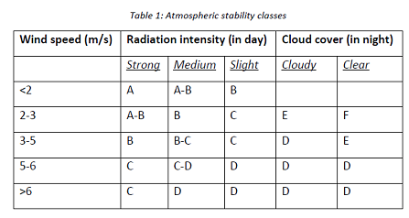

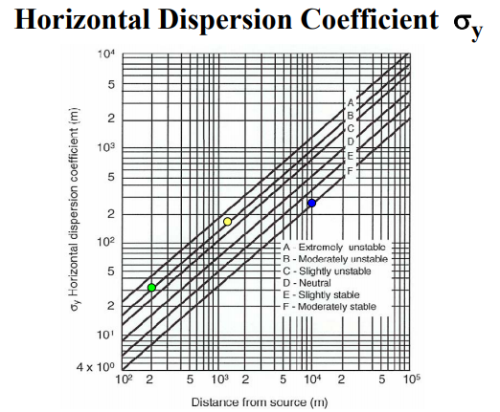
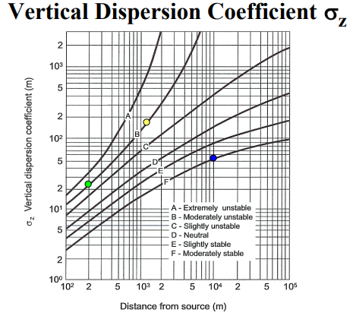
Health Effects of Hazardous Waste
A hazardous waste can have adverse health effects in any of the following scenarios:
• A large amount is released at once
• A small amount if released intermittently in the same location
• The substance does not get diluted
• The substance is very toxic
Humans, plants and animals can come into contact with hazardous waste by either inhalation, ingestion, or dermal exposure.

Fig. 12: Exposure pathways

Flammability:
Lower flammability limit (LFL): usually expressed in volume per cent, is the lower end of the concentration range over which a flammable mixture of gas or vapour in air can be ignited at a given temperature and pressure. The flammability range is delineated by the upper and lower flammability limits (LFL and UFL). Outside this range of air/vapor mixtures, the mixture can not be ignited (unless the temperature and pressure are increased). The LFL decreases with increasing temperature; thus, a mixture that is below its LFL at a given temperature may be ignitable if heated sufficiently.
The LFL _{mix} of a mixture can be evaluated using the Le Chatelier mixing rule,
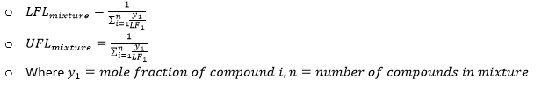
Example: Determine LFL and UFL of a gaseous mixture (v/v) of 0.65% acetone, 0.2% decane and 0.3% hexane.
