**Fundamentals of Linear Vibrations**

1. Single Degree-of-Freedom Systems
2. Two Degree-of-Freedom Systems
3. Multi-DOF Systems

4. Continuous

**Single Degree-of-Freedom Systems**

A spring-mass system

1- Newton law

* + General solution for any simple oscillator

1. Equivalent springs
   * Spring in series and in parallel
2. Energy Methods
   * Strain energy & kinetic energy (Work-energy statement)

**Undamped Free Vibrations of Single Degree of Freedom Systems :**

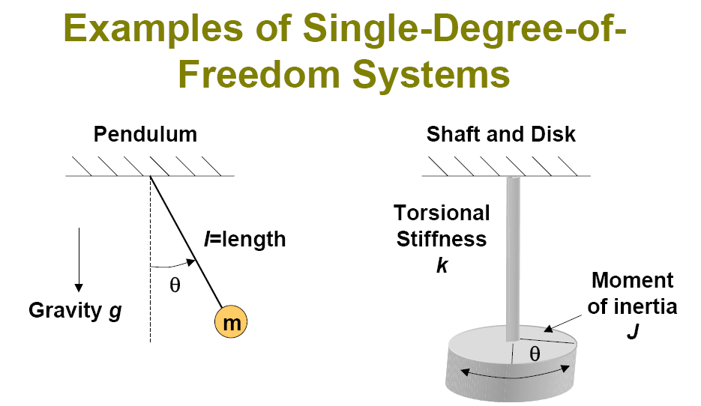

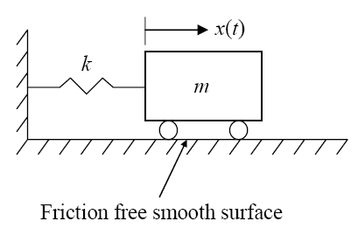

Or, in another form:

Equation of Motion:



General approach:

1. Select coordinate system
2. Apply small displacement
3. Draw FBD
4. Apply Newton’s Laws:

**Any simple oscillator**

**Simple oscillator – Example 1**

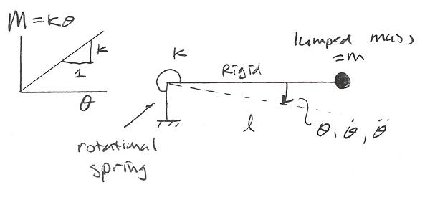









Simple oscillator – Example 2

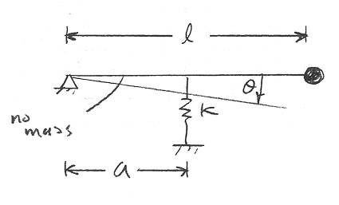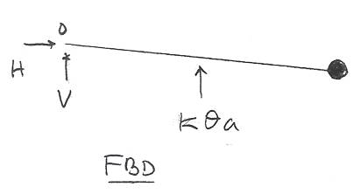



+





**Simple oscillator – Example 3**

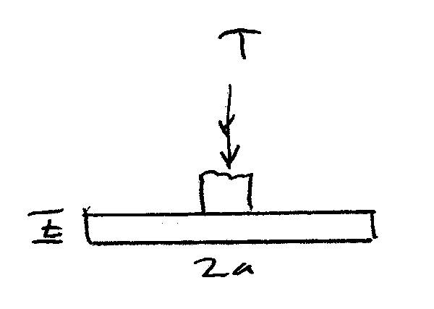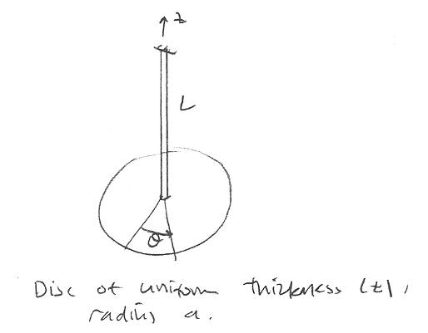



+



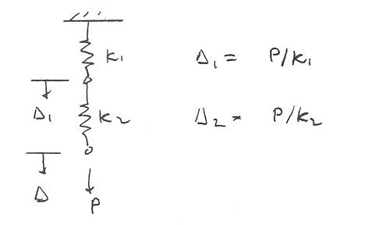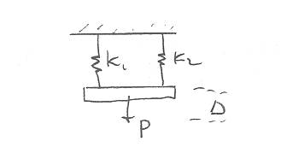

Springs in series:

same force - flexibilities add

Springs in parallel:

same displacement - stiffnesses add







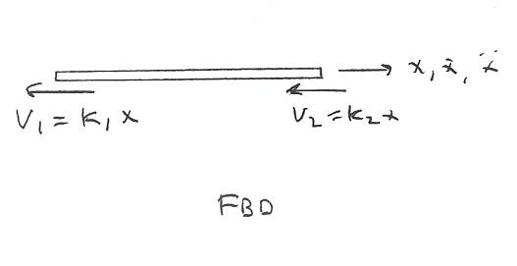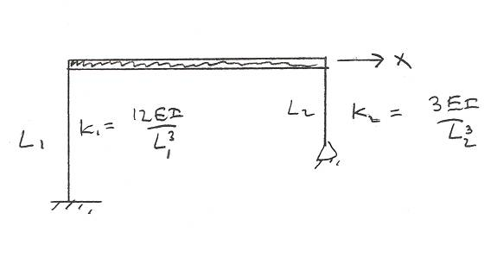

Equivalent springs – Example 4

Example 5 :

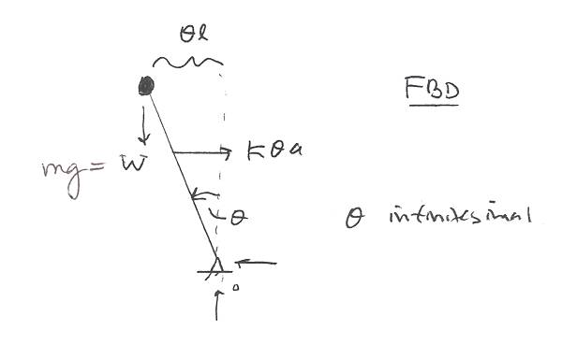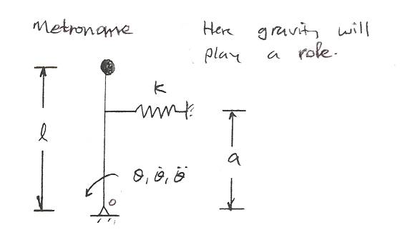

+

Example 6 :

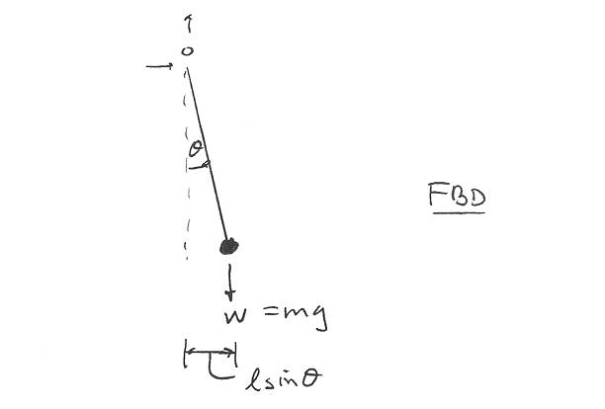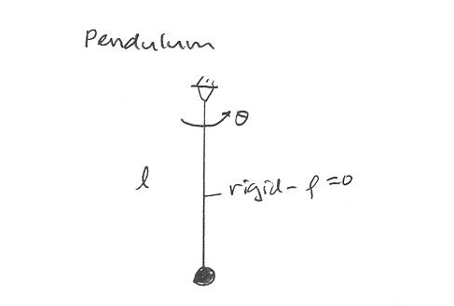

+



We cannot define *ωn*

since we have *sinθ* term

If *θ < < 1, sinθ ≈ θ* :



Work-Energy principles

Energy methods

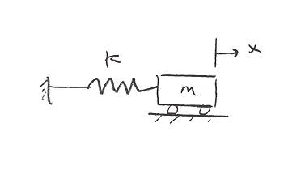



Work-energy principles have many uses, but one of the most useful is

to derive the equations of motion.

Conservation of energy: E = const.



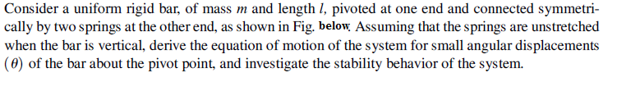

Sol:

