Uninterrupted Flow
Capacity and Level of Service for Highway Segments
When predicting the performance of a traffic facility, an important question is how much traffic the facility can carry. The field of capacity analysis has been extended to include level-of-service. That is, current analysis represents the trade-off between the quantity of traffic a facility can carry and the resulting level-of-service offered to the user of the facility.

Capacities and level-of-service
Capacity is usually defined as follows:
The maximum hourly rate at which persons or vehicles can reasonably be expected to traverse a point or uniform section of a lane or roadway during a given time period (usually 15 minutes) under prevailing roadway, traffic, and control conditions.
It is stressed that several aspects make a practical single definition of capacity complicated. These complications are among other things due to the capacity drop phenomenon, the differences between the capacity of a motorway link (or multilane facility, basic motorway segment), a motorway bottleneck (on-ramps, off-ramps, weaving sections), and the stochastic nature of the capacity.
In the US, typical values of the capacity of a freeway with a design speed of 60 or 70 miles/h is 2000 veh/h/lane under ideal conditions; in Europe and especially in the Netherlands, capacities under ideal circumstances are much higher, around 2400 veh/h. Ideal conditions in this case imply 12-foot lanes and adequate lateral clearances; no trucks, buses, or recreational vehicles in the traffic stream; and weekday or commuter traffic. When ideal conditions do not exist, the capacity is reduced.
The Highway Capacity Manual proposes using the following example relation to express the influence of non-ideal conditions:
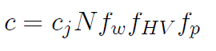

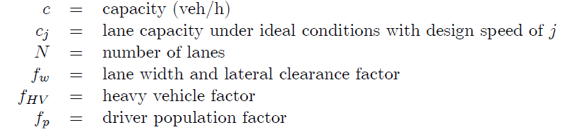

Capacity is a measure of maximum route productivity that does not address the traffic flow quality or the level-of-service to the users. The level-of-service (LOS) reflects the flow quality as perceived by the road users. These flow quality aspects for drivers on the motorway is closely related to the experienced travel times (or travel speeds), the predictability of future traffic conditions (e.g. travel speed, waiting times), and experienced comfort of the trip (number of stops, required accelerations and decelerations, ability to drive at the desired speed).

To include the user-related traffic flow quality aspects, the concept of service volume has been introduced. The service volume SF has a definition which is exactly like capacity except that a phrase is added at the end: “while maintaining a designated level-of-service”. In the HCM , six service levels ranging from service level A to F are distinguished. Table 1 (and Fig. 1) shows the definitions of these levels of services. In illustration, if one wishes to operate this particular section of freeway at LOS C, the volume-capacity ratio should be limited to 0.77, and speeds over 54 mph and lane densities of less than 30 veh/mile per lane should results. Speed characteristics, density characteristics, and the relation between these characteristics have been and will be discussed elsewhere in this syllabus. Note that the values in the Netherlands are very different from the values shown in table 6.1. Moreover, the concepts are not only applicable to freeway traffic flow operations, but for instance also in the analysis of pedestrian walking facilities, such as railway stations, sport stadiums, etc.

Table 1: Level of service for basic freeway sections for 70 km/h design speed.
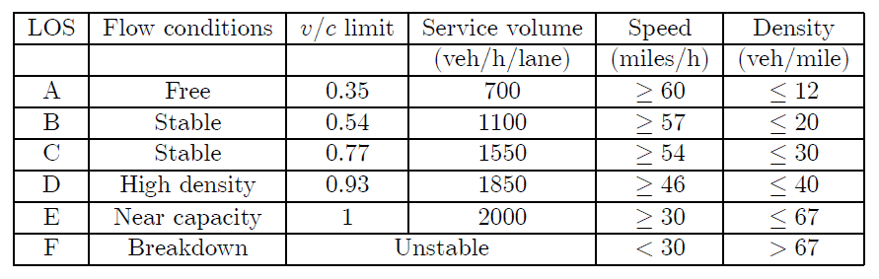

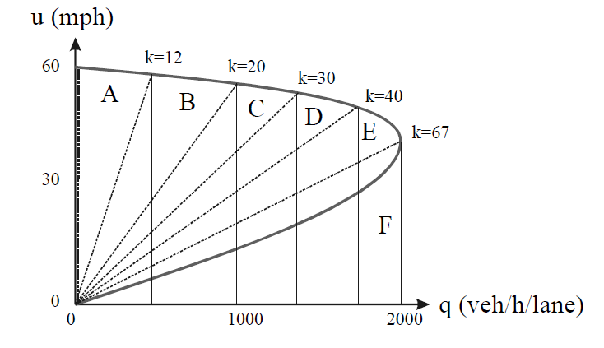
Figure 1: Speed-Flow Relation for a Multilane Facility for 70mph Design Speed.

Capacity and Driver Behaviour

Before discussing how the notion of capacity can be applied to basic motorway segments and bottle-necks, let us first describe how the capacity relates to the characteristics of the traffic flow or rather of the driver vehicle combinations in the flow. Recall that for a single lane of the roadway, the flow q can be determined from the headways $h_{i}$ as follows:

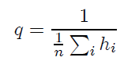
When a roadway lane operates at capacity, this thus implies that most drivers follow each other at the minimum time headway (empty zone), say $h_{i}^{*}$ . Thus, we have for the capacity of a lane:
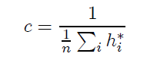
Note that this relation indicates clearly that the capacity is related to driver behaviour, which explains how aspects like the vehicle fleet composition, lane width and lateral clearance factor, weather conditions, etc., will affect capacity, namely by (changing) the behaviour of drivers.
For instance, trucks drivers generally need a larger headway with respect to their leader, due to the length of the truck, as well as larger safety margins for safe and comportable driving.

For multilane facilities, besides the car-following behaviour, the distribution of traffic over the roadway lanes will determine the capacity. Ideally, during capacity operations, all lanes of the roadway are utilised fully, that is, all driver-vehicle combinations are following their leader at the respective minimal headway $h_{i}^{*}$ . In practise however, this is not necessarily the case, since the lane distribution will depend on the lane demands and overtaking opportunities upstream of the bottleneck.

Multilane Facilities

By definition, multilane facilities have two or more lanes available for use (for each direction of travel). The key is that multilane facilities provide uninterrupted flow conditions away from the influence of ramps or intersections. They are often referred to as basic motorway segments. In the approach proposed by the HCM, first capacity analysis under ideal conditions is performed, followed by capacity analysis under non-ideal circumstances. Ideal conditions satisfy the following criteria:

• Essentially level and straight roadway.
• Divided motorway with opposing flows not influencing each other.
• Full access control.
• Design speed of 50 mph or higher.
• Twelve-foot minimum lane widths.
• Six-foot minimum lateral clearance between the edge of the travel lanes and the nearest
obstacle or object.
• Only passenger cars in the traffic stream.
• Drivers are regular users of such facilities.

Capacity Analysis under Ideal Conditions

The speed-flow relationships for multilane facilities have been discussed before. These diagrams relate our three scales (flow, density, speed) that are important in LOS analysis. The average speed is an indication of the LOS provided to the users. Traffic flow is an indication of the quantity of traffic that can use the facility. The density is an indication for the freedom of movement of the users. It is noted that the upper density boundary of LOS E (of 67 veh/mile/lane) occurs at the capacity value. Only one congested state in considered in the 1985 HCM LOS classification.

For multilane facilities, the basic equation needed for capacity (and LOS) analysis under ideal conditions is (equ. 1):

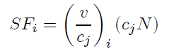
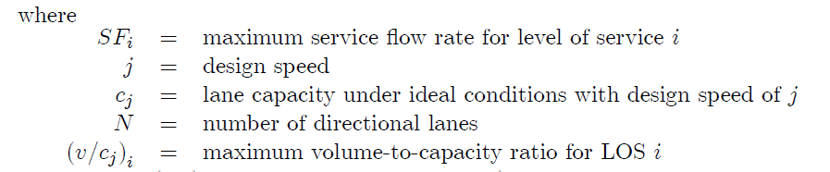

The (equ. 1) above can be used in three ways:
1) by solving for ${SF}_{i}$, the maximum service flow can be determined for a given designed multilane facility under specified LOS requirement;
2) by solving for ${(v/cj)}_{i}$, the LOS can be determined for a given designed multilane facility carrying a specific service flow rate. Finally,
3) by solving for ($c_{j}N$), the design of a multilane facility can be determined when the LOS and the service flow are specified.

Capacity Analysis under Non-Ideal Conditions

The starting point for capacity and LOS analysis for multilane facilities under less than ideal conditions is to go back to eqn. (1). Clearly, the factor ($c_{j}N$) should be reduced by some factor or a series of factors . Each factor would represent one non-ideal.
It should be noted that in multiplying these factors, we implicitly assume that these factors and independent and that their combined independent effects are multipliable. In any case, eqn. (1) becomes:

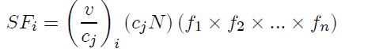

where $f_{1}$, ..., $f_{n}$ are reduction factors for non-ideal conditions. In the HCM, four reduction factors are proposed for multilane facilities, namely:

1. the width reduction factor $f_{W}$ , describing the reduction in capacity due to less than ideal lane widths and side clearances,
2. the heavy-vehicle reduction factor $f_{HV}$ , describing the reduction in the capacity (in veh/h/lane!) due to the presence of heavy vehicles under different vertical alignment conditons,
3. the driver population factor $f_{P}$ reflects the reduction in capacity due to the presence of non-regular users, and
4. the environment factor $f_{E}$ to consider the reduction in capacity due to the lack of a median and/or the lack of access control.

Ramps
Ramps are sections of roadway that provide connections from one motorway facility to another motorway facility or to another non-motorway facility. Entering and exiting traffic causes disturbances to the traffic on the multilane facilities and can thus affect the capacity and the LOS of the basis motorway segments. Fig. 2 shows a typical (schematised) motorway configuration where an on-ramp is followed by an off-ramp. On each ramp, three locations must be carefully studied.

Figure 2: Typical Motorway Configuration.

Location A is the entrance to the on-ramp and is affected by the ramp itself and/or by the at-grade intersection. Since the dimensions and the geometrics at location A are (normally) better or at least as good as that of location B, the effect of the physical on-ramp will be studied further at location B. Normally, the at-grade intersection controls the entrance to the on-ramp, and the potential restrictions this causes will not be studied in this course.
Location B is on the on-ramp itself and its capacity is affected by the number and the width of the lanes, as well as the length and the grade of the on-ramp. As long as the on-ramp demand is smaller than the on-ramp capacity, LOS is not really a concern. The reason for this is the relative short length of the ramps.

Locations E and F are “mirror images” of locations A and B in an analytical sense. Location E is the off-ramp itself; similar to the on-ramp, the LOS is not really a concern for the off-ramp. Location F is at the exit of the off-ramp where it connect to a crossing arterial at an at-grade intersection.
An important difference between locations A and F is the location of the queues if they exit. At location A, any queues will extend into the at-grade intersection, whereas at location F, any queues will extend up the off-ramp and - if serious enough - into the multilane facility.
Locations C and D are the merge and the diverge areas and require special analytical procedures.
The substance of the analytical procedure is to compare the actual demands in the merge and the diverge areas with the allowable service flow rates. This comparison is then used to determine the resulting LOS.
Table 3 shows an example of allowable service flow rates for merging and diverging areas for ideal conditions for various levels of service. Note that the upper limit of LOS E corresponds to the capacity of the rightmost lane under ideal conditions, which in this case equals 2000 passenger-cars per hour. As noted in table 3, the LOS of merge and diverge areas diminish as traffic demands in the rightmost lane increase. These allowable service flow rates should be reduced when non-ideal conditions are considered, using the reduction factors employed for basic multilane facilities. If the capacities and levels-of-service of the basic multilane motorway segment between the merge and the diverge area have been computed, the multilane service flow rates divided by the number of lanes in the basic segment can be used as the allowable lane service flow rates in the merge and diverge analysis.

Table 3: Allowable Service Flow Rates for Merging and Diverging Areas (passenger cars per hour) from HCM.
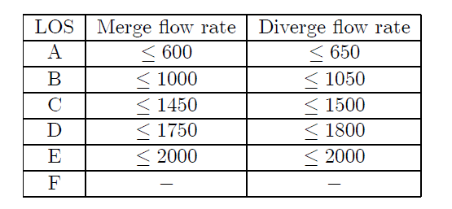
The major difficulty is in estimating the traffic demands in the rightmost lane. The key to the solution is to consider that traffic in the rightmost lane is made up of subgroups of traffic each having an unique origin and destination along the multilane facility. Fig. 3 can be used to illustrate this approach. Table 4 shows all possible OD movements. Note that not all OD movements will pass through the merge and diverge areas and can thus be ignored in our analysis. The remaining nine OD movements can be combined into four groups: through, entering, exiting and local. Each will now be addressed in order to determine its share of the traffic demand in the rightmost lane in the vicinity of the merge and diverge areas is question.
For demonstration purposes, the distance between the on-ramp nose and the off-ramp gore is assumed to be 4000 feet and its share of traffic in the rightmost lane will be calculated at 1000-foot intervals.

Table 4: Possible Motorway OD Movements.
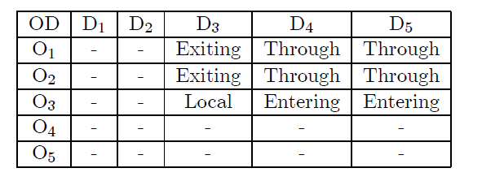

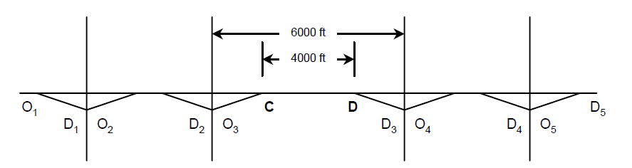

Figure 3: Extended Typical Motorway Ramp Configuration.

Through traffic is traffic that enters the motorway at least 4000 feet upstream of the merge area and exits the freeway at least 4000 feet downstream of the diverge area. Table. 4 shows which OD movements are combined and classified as through traffic, assuming interchange spacing on the order of 1 mile. The question is now to determine how much of this traffic will be in the rightmost lane. Table 5 that describe the percentage of traffic in the rightmost lane for n-lane motorway facilities. The percentages shown in this table are assumed to be constant between the on-ramp and the off-ramp.

Table 5: Possible Motorway OD Movements.
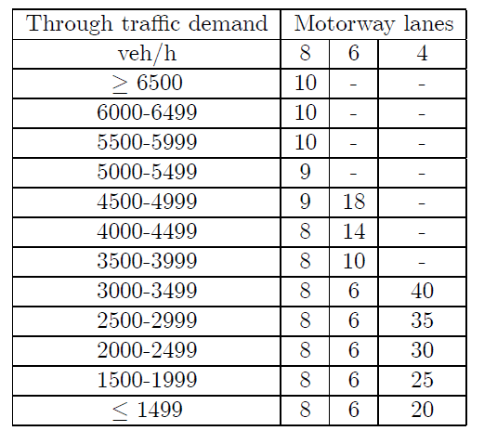

Entering traffic is that traffic that enters the motorway in the merge area (location C) and has a destination that is beyond the diverge area (location D); see Table. 4. All entering traffic is in the rightmost lane in the merge area and as the traffic moves farther and farther downstream, a smaller and small proportion remains in the rightmost lane. Fig. 6.4a shows some figures describing the percentage of entering traffic on the rightmost lane. Fig. 4b shows the percentage of exiting traffic on the rightmost lane. Finally, local traffic is traffic that enters in the merge area (location C) and exits in the diverge area (location D). Generally, it is assumed that local traffic remains in the rightmost lane.

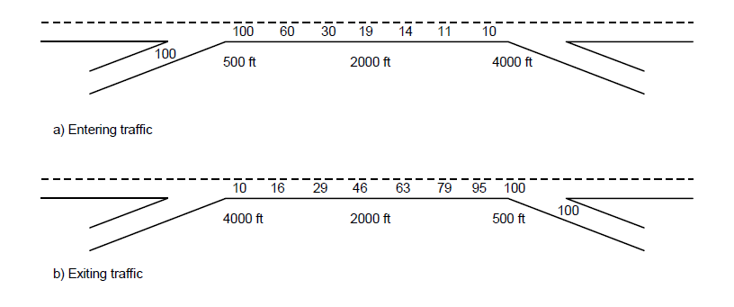
Figure 4: Percentage of Entering and Exiting Traffic in Rightmost Lane.

In sum, the total traffic in the rightmost lane at various locations can be determined by the sum of through, entering, exiting and through traffic. The demand on the rightmost lane is subsequently compared with the allowable service flow rates (such as those given in Table. 1). The highest demand in the vicinity of the merge area is compared with the allowable merge service flow rates, and the highest demand in the vicinity of the diverge area is compared with the allowable diverge service flow rates. The resulting level of service can then be determined.
Although the principles set forth earlier for capacity and LOS analysis of merging and diverging areas are straightforward, their applications can be complicated and tedious. The complications can be caused by unusual ramp geometrics and are particularly difficult at near capacity or oversaturated situations.
The HCM contains many monographs that can be used to estimate the LOS provided in the merge and diverge areas under a wide variety of geometric configurations.

Weaving Sections

Traffic entering and leaving multilane facilities can also interrupt the normal flow of basic motorway segments by creating weaving sections.
Weaving is defined as the crossing of two (or more) traffic streams traveling in the same direction along a significant length of motorway without the aid of traffic control devices.
Weaving vehicles that are required to change lanes cause “turbulance” in the traffic flow and by so doing reduce the capacity and the LOS of weaving sections. Thus, analytical techniques are needed to evaluate this reduction.

A variety of weaving analysis techniques are available and are being used. Still, it has been recognised that further research on the capacity and LOS of weaving sections is very important. In this section, we show one specific approach to analyse a weaving area in order to show the important factors and arising complications. We will only consider one specific type of weaving section, namely the one shown in Fig.5. Here vo1 denotes the heavy flow from A to C (outer flow 1), and $v_{o2}$ denotes the light flow from B to D (outer flow 2). Neither of these flows is a weaving movement;
their sum:
$v_{nw}$ = $v_{o1}$ +$v_{o2}$ is referred to as the total non-weaving flow.
The flow from B to C and A to D cross each other’s path over a certain distance and are referred to as weaving flows. The higher weaving flow is indicated by vw1; the lower weaving flow is referred to as $v_{w2}$; their sum:
$v_{w}$ = $v_{w1}$ +$v_{w2}$ is referred to as the total weaving flow.
The length of the weaving section is denoted by L.

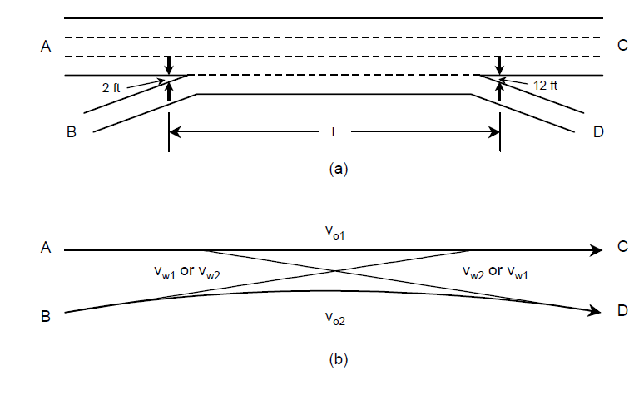
Figure 5: Typical Simple Weaving Section.
In the approach of the HCM, one first needs to determine if the weaving causes more than the normal amount of lane changing. For instance, when the weaving length L is large and the total weaving flow is small, then only the normal amount of lane changing is expected and the roadway section is “out of the realm of weaving”. In the HCM, the following equation expresses the service flow rate for a specific weaving section:

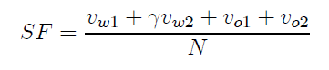

Where:
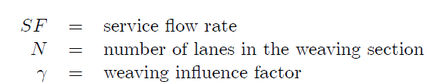

The weaving influence factor γ is a function of the total weaving traffic demand $v_{w}$ and the
length of the weaving section L (see example Fig. 6).

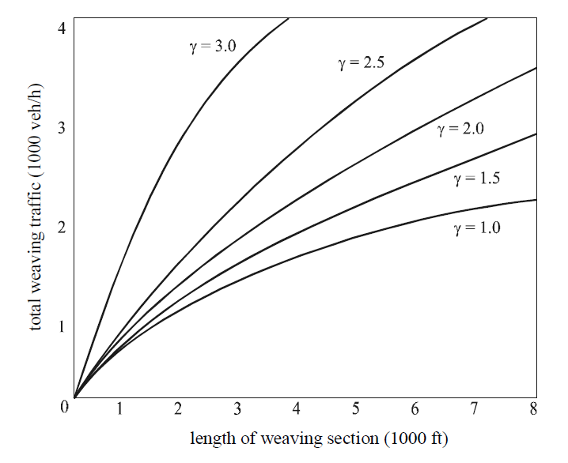

Figure 6: Weaving Influence Factor γ as a Function of the Length of the Weaving Area and the
amount of Weaving Traffic.

Three types of weaving sections are distinguished (A, B, and C), as well as the distinction between unconstrained and constrained operations. based on field study results, 12 multiple regression equations where proposed predicting the speed of weaving and non-weaving vehicles. Using these speed predictions, the LOS can be determined.

Weaving Sections Types

The weaving sections are distinguished based on the required lane changing manoeuvres of the weaving vehicles. Type A weaving sections (see Fig. 7) require that each weaving vehicle is required to make one lane changing movement, although more than one lane change may be required is weaving vehicles on are not in the correct lane at the start of the weaving section.
The minimum number of lane changes equals:

the minimum rate of lane changes is equal to:

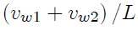

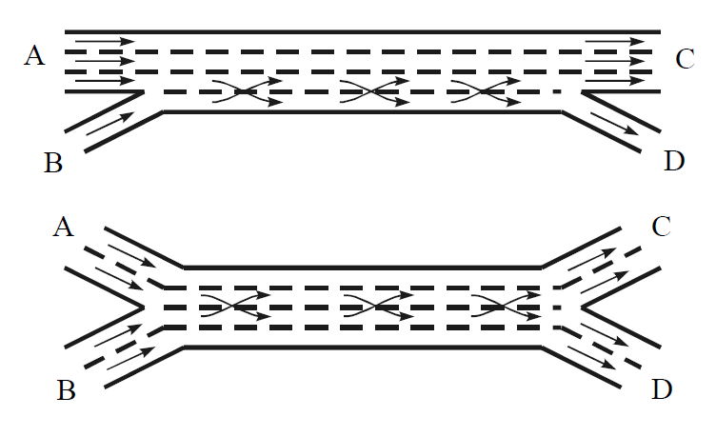
Figure 7: Examples of weaving Area Configuration A.

Type B weaving sections (see Fig. 8) require that one waving movement may be accomplished without making any lane changes, while the other movement requires one lane change. This design can be very effective if the minor weaving flow $v_{w2}$ is relatively small. The minimum number of lane changes equals $v_{w2}$; the minimum lane changing rate equals $v_{w2}/L$.

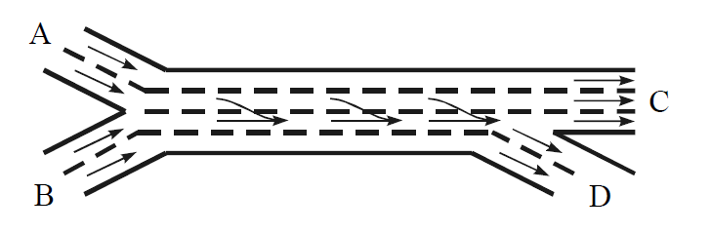
Figure 8: Example of Weaving Area Configuration B.

Type C weaving sections (see Fig.9) require that one waving movement may be accomplished without making a lane change, and the other waving movement requires at least two or more lane changes. This can be an effective design if the second weaving flow is small, but it can heavy very adverse effects if the second weaving flow is too large, the number of lane changes is large, and the weaving length is too short. The minimum number of lane changes equals ${2v}_{w2}$ (or more if more than two lane changes are required); the minimum lane changing rate is equal to ${2v}_{w2}$/L.

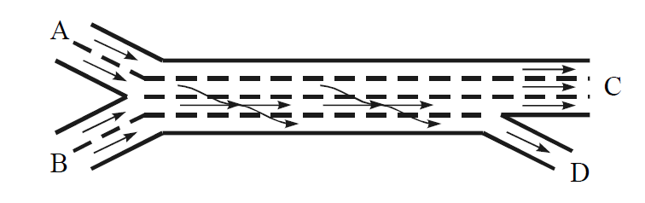
Figure 9: Example of Weaving Area Configuration C.

Table 6 : Criteria for Unconstrained and Constrained Operations of Weaving Sections. $S_{nw}$ and $S_{w}$ respectively Denote the Speed of the Non-weaving and Weaving Vehicles.
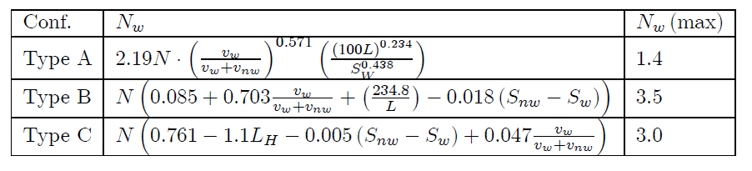

Constrained and Unconstrained Operations

HCM approach also distinguishes constrained and unconstrained operations. If the weaving configuration in combination with the traffic demand patterns permits the weaving and non-weaving vehicles to spread out evenly across the lanes in the weaving section, the flows will be somewhat balanced between lanes and the operation is more effective and is classified as unconstrained. On the contrary, if the configuration and demand limit the ability of weaving vehicles to occupy their proportion of available lanes to maintain balances operations, the operations is less effective and is classified as constrained.
Consider for instance the weaving section shown in Fig.5: if the flow from A to C is relatively light and the other flows are relatively heavy, the lanes on the left side of the weaving section will be underutilised and the lanes on the right side will be over utilised. Such imbalanced or constrained operations will result in weaving vehicles travelling at lower speed (hence lower LOS) and non-weaving vehicles travelling at a higher speed.

Determination of the type of operation is done by comparing two variables, namely $N_{w}$ (number of lanes that must be used by weaving vehicles in order to achieve balanced or unconstrained operations) and $N_{w}$ (max) (maximum number of lanes that may be used by weaving vehicles for a given configuration). If $N_{w}$ < $N_{w}$ (max), the operation is defined as unconstrained, while if $N_{w}$ > $N_{w}$ (max) the operation is defined as constrained. Based on empirical observations, procedures to compute these variables are shown in Table 6.

The next step in the analysis is to select appropriate multiregression type equations for prediction weaving and non-weaving speeds based on types of weaving configurations and types of operations. Again, empirically derived equations have been determined and can be found in the 1985 HCM. These are listed in Table 7. These parameters can subsequently be substituted in the following equation:

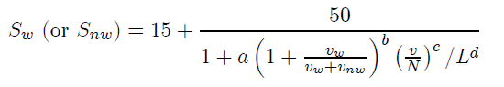

Table 7: HCM Parameter Values for Determination of Speeds of Weaving and non-Weaving Traffic.
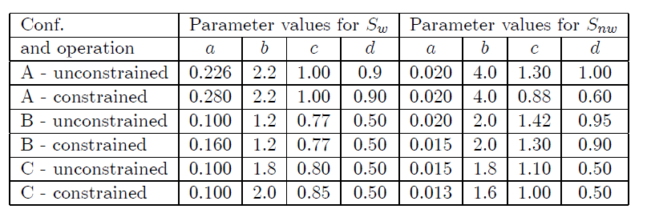
Note that the speeds of weaving and non-weaving vehicles are also required to decide between constrained and non-constrained operations, yet these speeds have not yet been determined. The suggested approach is to first assume unconstrained operations, calculate weaving and nonweaving speeds and then use the equations in Table 7 see if the assumption of unconstrained operations is correct. If not, the process is repeated assuming constrained operations. The final step in determining the LOS of the weaving section is to enter Table 8 with the predicted weaving and non-weaving speeds.

Table 8: Level of Service Criteria for weaving Sections.
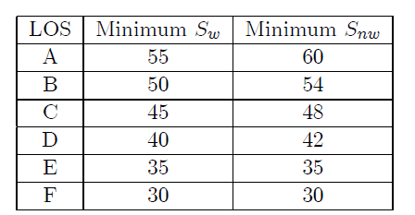

Stochastic Nature of Motorway Capacity

Maximum flows (maximum free flows of queue discharge rates) are not constant values, and vary under the influence of several factors. Factors influencing that capacity are among other things the composition of the vehicle fleet, the composition of traffic with respect to trip purpose, weather-, road-, and ambient conditions, etc. These factors affect the behaviour of driver vehicle combinations and thus the maximum number of vehicles that can pass a cross-section during a given time period. Some of these factors can be observed and their effect can be quantified. Some factors can however not be observed directly.

Furthermore, differences exist between drivers implying that some drivers will need a larger minimum time headway than other drivers, even if drivers belong to the same class of users. As a result, the minimum headways $h_{i}^{*}$ will not be constant values but follow a distribution function (in fact, the empty zone distribution $p_{pol}$ (h)), As a result, capacity will also be a random variable following a specific distribution. The shape of this distribution depends on among other things the capacity definition and measurement method / period. In most cases, a Normal distribution will can be used to describe the capacity.

Capacity drop
The existence of two different maximum flow rates, namely pre-queue capacity and queue discharge rate respectively. Each of these have their own maximum flow distribution.

The pre-queue maximum flow can be defined as the maximum flow rate observed at the downstream location just before the on-set of congestion (a queue) upstream. These maximum flows are characterised by the absence of queues or congestion upstream the bottleneck, high speeds, instability leading to congestion on-set within a short period, maximum flows showing a large variance.

The queue discharge flow is the maximum flow rate observed at the downstream location as long as congestion exists. These maximum flow rates are characterised by the presence of a queue upstream the bottle-neck, lower speeds and densities, a constant outflow with a small variance which can sustain for a long period, however with lower flow rates than in the pre-queue flow state.

Both capacities can only be measured downstream of the bottle-neck location. Differences between the two capacities (so-called capacity drop) are in the range of -1% to -15%. Different explanations for the capacity drop can be and have been given. Some researchers argue that the main reason is the preference for larger headways if drivers experience congested conditions. Differences between acceleration and deceleration behaviour may also contribute to this phenomenon.

Capacity Estimation Approaches

To determine the capacity of a bottle-neck or a basic motorway segment, appropriate capacity estimation techniques are required. These techniques can be classified in techniques that do not require capacity observations and those who do. The former methods, which are based on free flow traffic and constrained traffic measurements are generally less reliable than methods using capacity measurements. If the capacity state has not been reached and a capacity estimation must be performed, the following approaches are applicable:

1. Headway distribution method. The observed headway distribution is used to determine the distribution of the minimum headway $h_{i}^{*}$ , which in turn is used to estimate a single capacity value (no distinction between pre-queue capacity and queue-discharge rate).

2. Fundamental diagram method. This approach uses the relationship between speed and density or flow rate to estimate the capacity value. A functional form needs to be selected and assumptions about the critical density must be made.

Methods using explicitly capacity flows sometimes use additional flow measurements in order to get an improved capacity estimate. Some methods do not distinguish between queue and pre-queue maximum flows.

1. Selected maxima method. Measured flow rate maxima are used to estimate a capacity value or distribution. The capacity state must be reached during each maxima selection period. Approach should be applied over a long period.

2. Bimodal distribution method. This method may be applied if the observed frequency distributions of the flow rates exhibit a clear bimodal form. The higher flow distribution is assumed to represent capacity flows.

3. Queue discharge distribution method. This is a very straightforward method using queue discharge flow observations to construct a capacity distribution or a capacity value. The method requires additional observations (for instance, speeds upstream of the bottle-neck) to determine the congested state.

4. Product-limit method. This method uses below-capacity flows together with capacity flows to determine a capacity value distribution. Speed and / or density data is needed to distinguish the type of flow measurement at the road section upstream of the bottleneck.

