Lec.3 Noise pollution 4th year
3.1 Sound weighting

3.1.1 ‘A’ Frequency Weighting
‘A’ Weighting is standard weighting of the audible frequencies designed to reflect the response of the human ear to noise. At low and high frequencies, the human ear is not very sensitive, but between 500 Hz and 6 kHz the ear is much more sensitive. The ‘A’ weighting filter covers the full frequency range of 20 Hz to 20 kHz, but the shape approximates to the frequency sensitivity of the human ear. So the A-weighted value of a noise source is an approximation to how the human ear perceives the noise. Measurements made using A-weighting are usually shown with dB(A) to show that the information is ‘A’ weighted decibels or, for example, as LAeq, LAFmax, LAE etc where the A shows the use of A-Weighting.
3.1.2 ‘C’ Frequency Weighting
‘C’ Weighting is a standard weighting of the audible frequencies commonly used for the measurement of Peak Sound Pressure level. Measurements made using ‘C’ weighting are usually shown with dB(C) to show that the information is ‘C’ weighted decibels or, for example, as LCeq, LCPeak, etc where the C shows the use of ‘C’ Weighting.
3.1.3 ‘Z’ Frequency Weighting
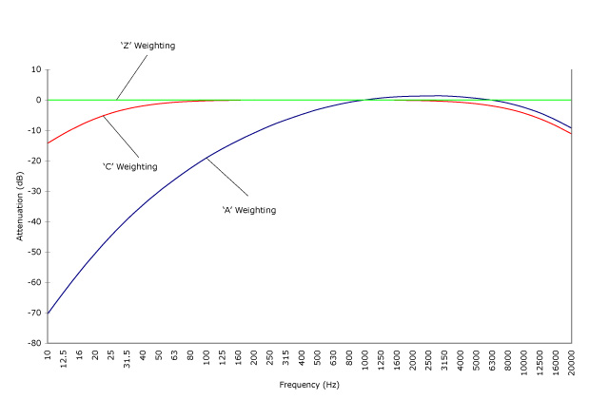
Z weighting is a flat frequency response between 10Hz and 20kHz ±1.5dB excluding microphone response. Measurements made using ‘Z’ weighting are usually shown with dB(Z) to show that the information is ‘Z’ weighted decibels or, for example, as LZeq, etc where the Z shows the use of ‘Z’ Weighting.

Frequency Weighting Curves – ‘A’, ‘C’ & ‘Z’

3.2 Where these Frequency Weightings are defined
All of these frequency weightings are defined in the standards to which a noise measurement instrument is designed. For example, the frequency weightings used on a sound level meter will be defined in IEC 61672:2003 (BS EN 61672-1:2003 ). This standard specifies the performance and tolerances for the frequency weighting curves to be used.
Frequency Weightings defined in IEC 61672:2013
Frequency (Hz) | 63 | 125 | 250 | 500 | 1k | 2k | 4k | 8k | 16k
A-weighting (dB) | – 26.2 | – 16.1 | – 8.6 | – 3.2 | 0 | + 1.2 | + 1.0 | -1.1 | – 6.6
C-weighting (dB) | – 0.8 | – 0.2 | 0 | 0 | 0 | – 0.2 | – 0.8 | – 3.0 | – 8.5
Z-weighting (dB) | 0 | 0 | 0 | 0 | 0 | 0 | 0 | 0 | 0

3.3 Equivalent Continuous Noise Level
The equivalent continuous level Leq, is the sound pressure level of a steady sound has over a given period, is measured in dB(A).
$$L_{eq}=10\log{\frac{{t_{1}×10}^{\frac{SPL1}{10}}+{t_{2}×10}^{\frac{SPL2}{10}}+…}{T}}$$
Leq is the equivalent continuous A-weighted sound pressure level , dB
t₁, t₂, … T is the time interval , hr
$${Leq}_{T_{1}}-{Leq}_{T_{2}}=10\log{\frac{T_{2}}{T_{1}}}$$

3.4 Noise Exposure from Single Discrete Events
The sound exposure level LAE, of a single discrete noise event is the level which if mentioned constant for a period 1sec would contain as much A-weighted sound energy as is contained in the actual noise event.
$$L_{AE}=L_{Aeq,T}+10logT$$
Where T must be in seconds
L_{AE} value can be used to calculate the value of L_{Aeq,T} when N identical evets all having the same L_{AE} value occur within time T:
$$L_{Aeq,T}=L_{AE}+10logN-10logT$$

3.5 Day-Night Level
It is a single descriptor to cover the 24-hr period with a weighting factor of (10 dBA) for noise over the nine-hour period between 22:00 and 07:00 hr.
$L_{dn}=10\log\left[\frac{15×{10}^{\left(\frac{L_{d}}{10}\right)}+9×{10}^{\left(\frac{\left(L_{n}+10\right)}{10}\right)}}{24}\right]$
L_{d}= The L_{eq} over the period 07:00 – 22:00 local time.
L_{n}= The L_{eq} over the period 22:00 – 07:00 local time.

3.6 Day-Evening-Night Level
It is a single descriptor to cover the 24-hr period but allows for the varying annoyance for the day, evening and night with a weighting factor of (5 dBA) for evening and (10 dBA) for night.
$$L_{den}=10\log\left[\frac{12×{10}^{\left(\frac{L_{day}}{10}\right)}+4×{10}^{\left(\frac{\left(L_{even}+5\right)}{10}\right)}+8×{10}^{\left(\frac{\left(L_{night}+10\right)}{10}\right)}}{24}\right]$$
L_{day}= The L_{eq} over the period 07:00 – 19:00 local time.
L_{evening}= The L_{eq} over the period 19:00 – 23:00 local time
L_{night}= The L_{eq} over the period 23:00 – 07:00 local time

3.7 Day and Night Levels
L_{d}= L_{eq,16hr}=The L_{eq} over the period 07:00 – 23:00 local time
L_{n}= L_{eq,8hr}=The L_{eq} over the period 23:00 – 07:00 local time

