Lec.2 Noise pollution 4th year
Types of Noise and Environmental Noise Propagation
2.1 Types of Noise
1- Continuous Noise
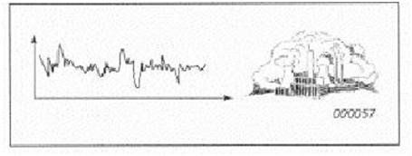
Continuous noise is produced by machinery that operates without interruption in the same mode, for example, blowers, pumps and processing equipment. Measuring for just a few minutes with hand-held equipment is sufficient to determine the noise level. If tones or low frequencies are heard, the frequency spectrum can be measured for documentation and further analysis.

2- Intermittent Noise
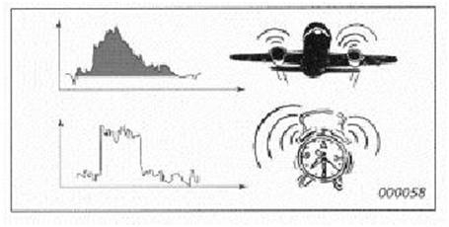
When machinery operates in cycles, or when single vehicles or aeroplanes pass by, the noise level increases and decreases rapidly. For each cycle of a machinery noise source, the noise level can be measured just as for continuous noise. However, the cycle duration must be noted. A single passing vehicle or aircraft is called an event. To measure the noise of an event, the Sound Exposure Level is measured, combining level and duration into a single descriptor. The maximum sound pressure level may also be used. A number of similar events can be measured to establish a reliable average.

3- Impulsive Noise
The noise from impacts or explosions, e.g., from a pile driver, punch press or gunshot, is called impulsive noise. It is brief and abrupt, and its startling effect causes greater annoyance than would be expected from a simple measurement of sound pressure level. To quantify the impulsiveness of noise, the difference between a quickly responding and a slowly responding parameter can be used (as seen at the base of the graph). The repetition rate (number of impulses per second, minute, hour or day) should also be documented.

2.2 Environmental Noise Propagation
The most important factors affecting noise propagation are:
• Type of source (point or line)
• Distance from source
• Atmospheric absorption
• Wind
• Temperature and temperature gradient
• Obstacles such as barriers and buildings
• Ground absorption
• Reflections
• Humidity
• Precipitation
To arrive at a representative result for measurement or calculation, these factors must be taken into account. Regulations will often specify conditions for each factor.

1- Point source
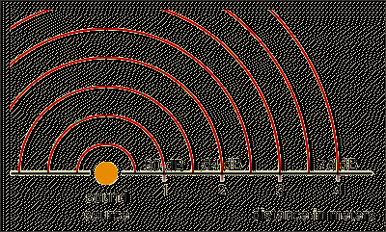
If the dimensions of a noise source are small compared with the distance to the listener, it is called a point source, for example, fans and chimney stacks. The sound energy spreads out spherically, so that the sound pressure level is the same for all points at the same distance from the source, and decreases by 6 dB per doubling of distance. This holds true until ground and air attenuation noticeably affect the level. For a point source with sound power level (LW) , located near the ground, the sound pressure level (Lp) at any distance (r, in m) from that source can be calculated from the equation:
Lp = LW – 20log₁₀ (r) – 8 dB
${SPL}_{1}-{SPL}_{2}=20log\left(\frac{r_{2}}{r_{1}}\right)$
r₁ r₂ r

2-Line Source
If a noise source is narrow in one direction and long in the other compared to the distance to the listener, it is called a line source. It can be a single source such as a long pipe carrying a turbulent fluid, or it can be composed of many point sources operating simultaneously, such as a stream of vehicles on a busy road. The sound level spreads out cylindrically, so the sound pressure level is the same at all points at the same distance from the line, and decreases by 3 dB per doubling of distance. This holds true until ground and air attenuation noticeably affect the level. For a line source with sound power level per meter (LW/m) located near the ground, the sound pressure level (Lp) at any distance (r, in m) from that source can be calculated from the equation:
Lp = LW – 10log10 (r) – 5 dB
${SPL}_{1}-{SPL}_{2}=10log\left(\frac{r_{2}}{r_{1}}\right)$ r₂
r₁
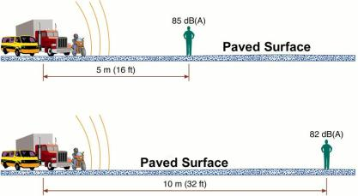

Wind and Temperature
Wind speed increases with altitude, which will bend the path of sound to “focus ”
it on the downwind side and make a “shadow” on the upwind side of the source.
Why Measure Downwind?
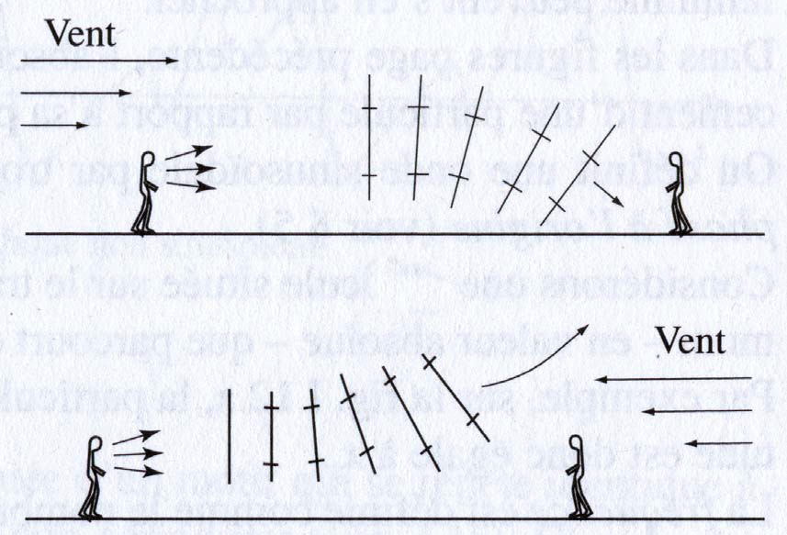
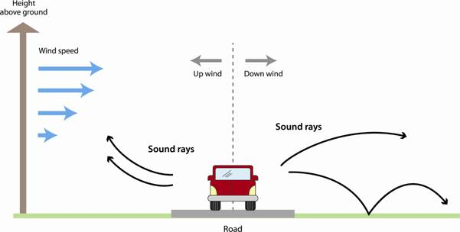
At short distances, up to 50 m, the wind has minor influence on the measured sound level. For longer distances, the wind effect becomes appreciably greater. Downwind, the level may increase by a few dB, depending on wind speed. But measuring upwind or side-wind, the level can drop by over 20 dB, depending on wind speed and distance. This is why downwind measurement is preferred – the deviation is smaller and the result is also conservative.

Temperature
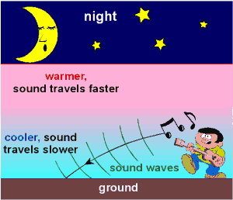
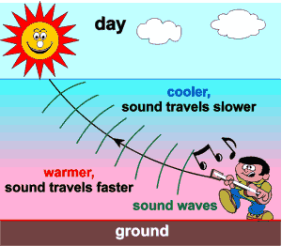
Temperature gradients create effects similar to those of wind gradients, except that they are uniform in all directions from the source. On a sunny day with no wind, temperature decreases with altitude, giving a “shadow” effect for sound. On a clear night, temperature may increase with altitude (temperature inversion), “focusing” sound on the ground surface.

During day, the layers of air near the ground is warmer than the layers of air higher up.
Air layer near the ground is less dense. Therefore, sound wave is bent toward the normal.
At night, the layers of air near the ground is cool faster than the layers of air higher up.
Air layer near the ground is denser. Sound travels faster in warm air than in cool air resulting increasing of wavelength. When the angle of incidence is larger than the critical angle, total internal reflection occurs.
Therefore, the path of the sound curves reflects downwards and you can hear the sound easily at night
Ground Effects
Sound reflected by the ground interferes with the directly propagated sound. The effect of the ground is different for acoustically hard (e.g., concrete or water), soft (e.g., grass, trees or vegetation) and mixed surfaces. Ground attenuation is often calculated in frequency bands to take into account the frequency content of the noise source and the type of ground between the source and the receiver. Precipitation can affect ground attenuation. Snow, for example, can give considerable attenuation, and can also cause high, positive temperature gradients. Regulations often advise against measuring under such conditions.

