**Chapter Six**

**Electrical Insulation**

**Introduction**

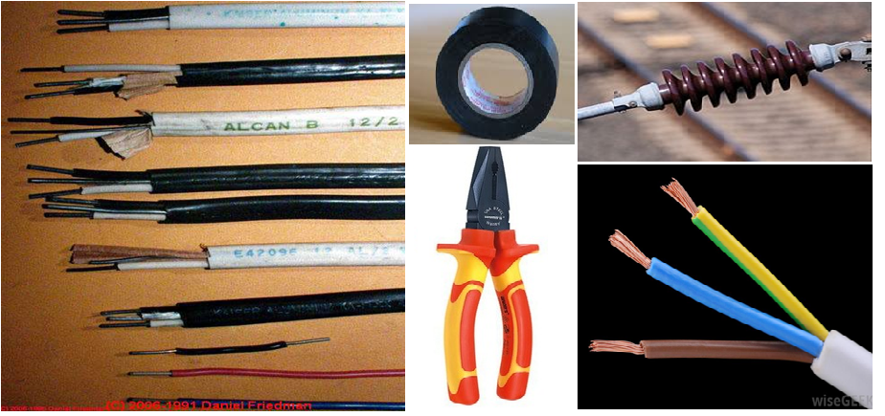Insulators are used in many applications; to wrap electrical cables or in electrical equipment to separate electrical conductors. The term insulator is also used more specifically to refer to supports that used to attach electric power transmission lines to towers and poles. They support the weight of the suspended wires without allowing the current to flow through the tower to ground. An electrical insulator is a material whose internal electric charges do not flow freely, and therefore make it nearly impossible to conduct an electric current under the influence of an electric field. This contrasts with other materials which conduct electric current more easily. A perfect insulator does not exist, because even insulators contain small numbers of mobile charges (charge carriers) which can carry current.

**Fig. (6.1) Applications of electrical insulators**

**Classification of Materials**

It is known that any substance contains a number of molecules and atoms. These atoms have some electrons in the outer orbit called "free electrons". Due to the ease expelled of the free electrons from the external orbit and make it move easily to another atom, and so on creating a flow of electrons called "electrical current".

**Materials could be classified according to its ability to electrical conduction as:**

**1. Conductors**

A conductor is an object or type of material that allows the flow of electrical current in one or more directions. The mobile charged particles are usually the [electrons](https://en.wikipedia.org/wiki/Electrons). Conduction materials include [metals](https://en.wikipedia.org/wiki/Metal) (copper, aluminum, iron, etc), electrolytes, superconductors, semiconductors, plasmas and some nonmetallic conductors such as [graphite](https://en.wikipedia.org/wiki/Graphite) and conductive polymers.

Copper has a high conductivity and it used for electrical applications, such as building wire, motor windings, cables and [busbars](https://en.wikipedia.org/wiki/Busbar" \o "Busbar). Because of its ease of connection by [soldering](https://en.wikipedia.org/wiki/Soldering) or clamping, copper is still the most common choice for most light-gauge wires. Aluminum has higher conductivity than copper, but it has properties that cause problems when used for building wiring. It can form a resistive oxide that makes wires unable to terminate heat. Aluminum can creep, slowly deforming under load, eventually causing device connections to loosen, and also has a different coefficient of thermal expansion. This accelerates the loosening of connections. However, aluminum wires could be used for low voltage distribution, such as buried cables and service drops, require use of compatible connectors and installation methods to prevent heating at joints. Aluminum is also the most common metal used in high-voltage transmission lines, in combination with steel as structural reinforcement. Silver is more conductive than copper, but due to cost it is not practical. However, it is used in specialized equipment, such as [satellites](https://en.wikipedia.org/wiki/Satellite), and as a thin plating to mitigate [skin effect](https://en.wikipedia.org/wiki/Skin_effect) losses at high frequencies.

**2. Semiconductors**

Semiconductors are crystalline materials or amorphous solids with higher resistance than typical conductors but still much lower than insulators. Their resistance decreases as their temperature increases, which is behavior opposite to that of a metal. So, their conducting properties may be adopted in useful ways (for some purposes like in diodes and transistors) by doping of impurities into the crystal structure to reduce its resistance. Doping is important to increase the number of charge carriers within the crystal. When a doped semiconductor contains mostly free holes, then it is called "p-type", and when it contains mostly free electrons, then it is known as "n-type". Many pure elements and some compounds display semiconductor properties like silicon, germanium, compounds of gallium, and mixtures of (arsenic, selenium and tellurium).

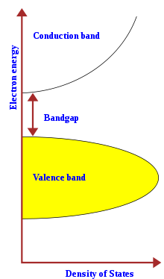It is important here referring to the term "energy gap" which is the energy required by an electron to move from valence band to conduction band. This is equivalent to the energy required to free an outer shell electron from its orbit to become a mobile charge carrier, able to move freely within the solid material. The energy gap is a major factor determining the electrical conductivity of a solid. Substances with large band gaps are generally insulators, those with smaller band gaps are semiconductors, while conductors either have very small band gaps or none, because the valence and conduction bands overlap.

**Fig. (6.2) Semiconductor energy structure**

**Table (6.1) Energy gap for common semiconductors and insulators**

| **Material** | **Symbol** | **Energy gap (eV) at 25 °C** |
| --- | --- | --- |
| plastics | - | 6-10 |
| Silicon dioxide | SiO2 | 9 |
| Ceramics:  Aluminum oxide (Al2O3)  Mullite (3Al2O3 · 2SiO2)  Forsterite (2MgO · SiO2)  Beryllium oxide (BeO)  Aluminum nitride (AlN) | - | 4 - 8 |
| Diamond | [C](https://en.wikipedia.org/wiki/Carbon) | 5.5 |
| Silicon nitride | Si3N4 | 5 |
| Gallium nitride | GaN | 3.4 |
| Gallium phosphide | GaP | 2.26 |
| Copper oxide | Cu2O | 2.1 |
| Gallium arsenide | GaAs | 1.43 |
| Silicon | Si | 1.11 |
| Germanium | Ge | 0.67 |
| Lead sulfide | PbS | 0.37 |

**3. Insulators**

Those materials that do not allow the flow of electric current, such as: wood, plastic, quartz and ceramic. The main reason of the ability of these materials to restrict the electrical flow is that the atomic structure contains a very small number of free electrons midwife to move.



**Conductor Insulator**

**Fig. (6.3) Comparison between electrical conductor and insulator**

**It may understand the following from the figure:**

• Material that contains a plenty of free electrons becomes a "conductor".

• Material that contains few of free electrons becomes an "insulator".

The electric field still active even in an insulating material, where an imbalance occurs and the positive charges attract to the electric field while the negative charges displace away. This separation between electrical charges generates the so-called "dipole" and the corresponding process called "polarization". The insulator that can be polarized by an applied electric field is called "dielectric material".

**Properties of Dielectric Materials**

**1. Resistance**: is the ability of the material to repel the electrical current. The resistance of a given conductor depends on the material it is made of and on its dimensions. For a given material, the resistance is given by:

$R= ρ \frac{L}{A}$

ρ = the resistivity of the material (ohm.m)

L = length of the wire (m)

A = cross-sectional area of the wire (m2)

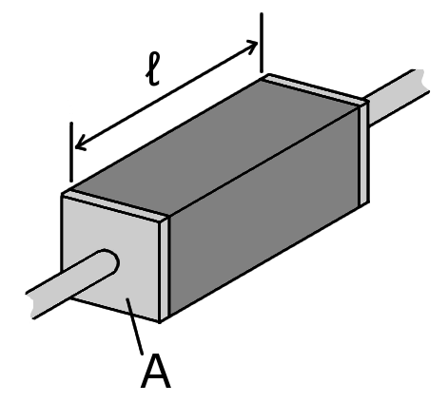

**Fig. (6.4) A piece of resistive material**

Resistivity is the property that distinguishes the insulators, where insulators have higher resistivity than semiconductors or conductors. Some materials such as glass, paper and Teflon, which have high resistivity, are very good electrical insulators. A much larger class of materials, even though they may have lower bulk resistivity, are still good enough to prevent significant current from flowing at normally used voltages, and thus are employed as insulation for electrical wiring and cables. Examples include rubber, polymers and most plastics.

**Table (6.2) Resistivity for common materials**

| **Material** | **ρ (Ω·m) at 25 °C** | **Material** | **ρ (Ω·m) at 25 °C** |
| --- | --- | --- | --- |
| Carbon (graphene) | 1.00×10−8 | GaAs | 1.00×10−3 to 1.00×103 |
| Silver | 1.59×10−8 | Germanium | 4.60×10−1 |
| Copper | 1.68×10−8 | Water | 2.00×10−1 to 2.00×103 |
| Aluminum | 2.82×10−8 | Silicon | 6.40×102 |
| Tungsten | 5.60×10−8 | Wood (damp) | 1.00×103 to 1.00×104 |
| Zinc | 5.90×10−8 | Glass | 1.00×1011 to 1.00×1015 |
| Nickel | 6.99×10−8 | Rubber | 1.00×1013 |
| Iron | 1.00×10−7 | Sulfur | 1.00×1015 |
| Tin | 1.09×10−7 | Air | 1.30×1016 to 3.30×1016 |
| Lead | 2.20×10−7 | Quartz | 7.50×1017 |
| Titanium | 4.20×10−7 | Polyethylene terephthalate (PET) | 1.00×1021 |
| Mercury | 9.80×10−7 | Teflon | 1.00×1023 to 1.00×1025 |
| Carbon (amorphous) | 5.00×10−4 to 8.00×10−4 | Ceramics | 1.00×1012 to 1.00×1014 |

**2. Permittivity:** is a measure of how an electric field affects a dielectric medium. In other words, the permittivity of a medium describes how much electric field is generated per unit charge in that medium. More electric flux exists in a medium with a low permittivity because of polarization effects. The best insulator is that which has a large permittivity. Since the increasing of the permittivity leads to increase the capacitance of the material, hence it could say that the permittivity increases the ability of the insulation to absorb more amounts of electrical charges and avoid the transfer of energy. Permittivity relates to the ability of material to resist an electric field. In [SI](https://en.wikipedia.org/wiki/SI) units, permittivity (ε) is measured in farads per meter (F/m).

Permittivity is directly related to electric susceptibility, which is a measure of how easily a dielectric polarizes in response to an electric field, as following:

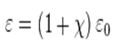

χ = electric susceptibility

ε0 = vacuum permittivity (8.85×10−12 F/m)

**H.W.** Using the equation above; prove that for a vacuum χ = 0

In engineering applications, permittivity is often expressed in relative, rather than in absolute terms. The relative permittivity of the material is also called the "dielectric constant", thus:

r =  / o

εr = relative permittivity of the material

**Table (6.3) Relative permittivity (dielectric constant) for common materials**

|  |  |
| --- | --- |
| **Material** | **http://maxwells-equations.com/epsR.gif** |
| Vacuum | 1.0 |
| Air | 1.0006 |
| Conductive polymers | 2-12 |
| Wood | 2-6 |
| PTFE/Teflon | 2.1 |
| Polypropylene | 2.2-2.36 |
| Polyethylene | 2.25 |
| Polystyrene | 2.4-2.7 |
| Carbon disulfide | 2.6 |
| Polyimide | 3.4 |
| Paper | 3.85 |
| Silicon dioxide | 3.9 |
| FR-4 | 4.0 |
| Concrete | 4.5 |
| Pyrex | 4.7 |
| Glass | 3.7-10 |
| Rubber | 7 |
| Diamond | 5.5-10 |
| Salt | 3-15 |
| Graphite | 10-15 |
| Silicon | 11.7 |
| Water (200 oC) | 34.5 |
| Water (20 oC) | 80.1 |
| Water (0 oC) | 88 |
| Calcium Copper Titanate (CCT) | 1000 - 100000 |

**3. Polarization:** is the ability of insulating material to undergo the separation between electrical charges and its strength. All insulators become electrically conductive when a sufficiently large voltage is applied that the electric field extracts the electrons away from the atoms. This is known as "breakdown voltage" of an insulator. Hence, "dielectric strength" is the maximum electric field that an insulating material can withstand under ideal conditions without breaking down. Breakdown voltage gradient is usually expressed, as voltage drop per unit length (V/m), to measure the dielectric strength of the insulator.

**Table (6.4) Dielectric strength for common materials**

|  |  |
| --- | --- |
| **Material** | **Dielectric Strength (MV/m)** |
| Air | 3.0 |
| Alumina | 13.4 |
| Glass | 9.8 - 13.8 |
| Silicone oil, mineral oil | 10 - 15 |
| Polystyrene | 19.7 |
| Polyethylene | 19 - 160 |
| Neoprene rubber | 15.7 - 26.7 |
| Distilled water | 65 - 70 |
| Fused silica | 25–40 |
| Waxed paper | 40 - 60 |
| PTFE ,Teflon | 20 - 173 |
| Mica | 118 |
| Diamond | 2000 |
| Vacuum | 10 |

**Purposes of Dielectric Materials**

There are many types of dielectric materials used in different electrical systems for various purposes. Some materials used for electrical insulation like: plastics, rubber, wood, ceramics, glass, cellulose paper, and oils. Some others used for electrical charging like: crystals, ceramics and polymers.

**Applications for Electrical Insulation**

**1. Wiring**

Conductor wires should be insulated electrically and physically, within the cable. Insulators could be found in many forms: solid, semi-solid and foam. Plastics, rubbers and epoxy are commonly used to cover the electrical wires.

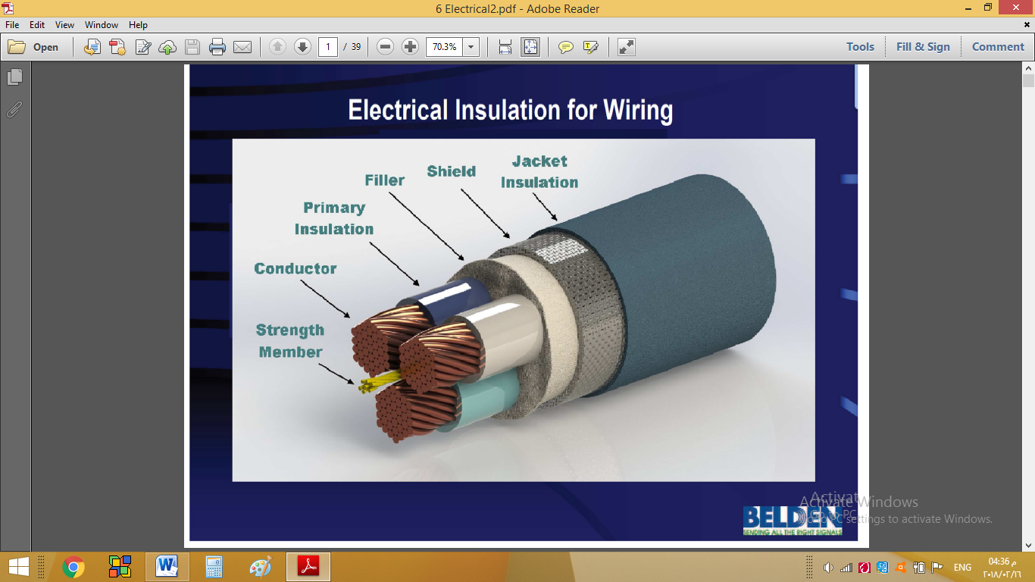

**Fig. (6.5) Insulation of wiring**

**Requirements of wire insulation:**

The insulation material should consider the following specifications in design:

* Electrical: working voltage, dielectric strength, dielectric constant and velocity propagation.
* Physical: density, tensile strength, flexibility, temperature rating and flammability.

The electrical insulation usually includes the following layers: primary insulation, filler and jacket.

**Primary insulator:** is a flexible material used to insulate the conductors and prevent any contact. Alternative polymers could be used like thermoplastic and thermoset materials. Thermoplastic materials used for electrical insulation are: PVC, HDPE, PP, PEEK, PTFE, PET, PES, PEI, ECTFE, PBT and FE. While thermoset materials are: Neoprene, rubber, SBR and EPDM.

**Filler:** is a material used to fill the gap between insulated wires and the jacket. Usually they filled with: foam like (PU), textile or just air. For heavy cables, the filler could be covered by a metallic sheathing.

**Jacket**: is the external shell of the cable usually manufactured from solid materials like: Neoprene, rubber, PVC and HDPE. Jacket used to:

* protect the internal components of the cable physically
* improve the cable appearance
* provide flame retardancy
* 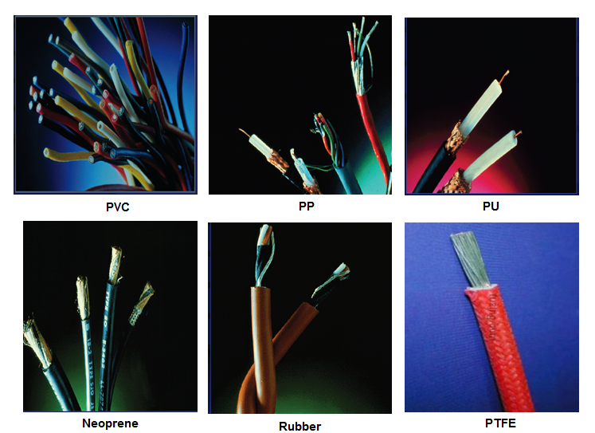protect from the environment

**Fig. (6.6) Some materials used for wire insulation**

**Example:** A copper wire assigned to withstand (220 V & 10 A). Determine suitable radius for the conductor as well as thickness of the insulation using electrical code ANSI/NFPA 70-1999.



Where

E = Dielectric strength (14 MV/m for PVC)

F = Safety factor (10)

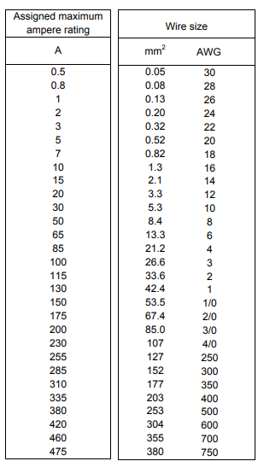**Solution:**

From table:

Awire = 1.3 mm2 = π r2

→ r = 0.643 mm radius of conductor

t = r [exp(V F / r E) - 1]

t = 0.643 [exp(220x10/0.643x10-3x14 x106)-1]

t = 0.18 mm thickness of insulation

**2. Overhead Transmission Lines**

The transmission towers must be equipped with appropriate electrical insulators; at the points of installing the transmission lines, to prevent the leakage of electric power from the high voltage lines to the ground. The requirements for electrical insulation:

- Mechanical strength to withstand the expected stresses.

- Insulation quality under the worst environmental conditions.

- Completely free of impurities and pores.

- Resistant to internal puncture and flashover.

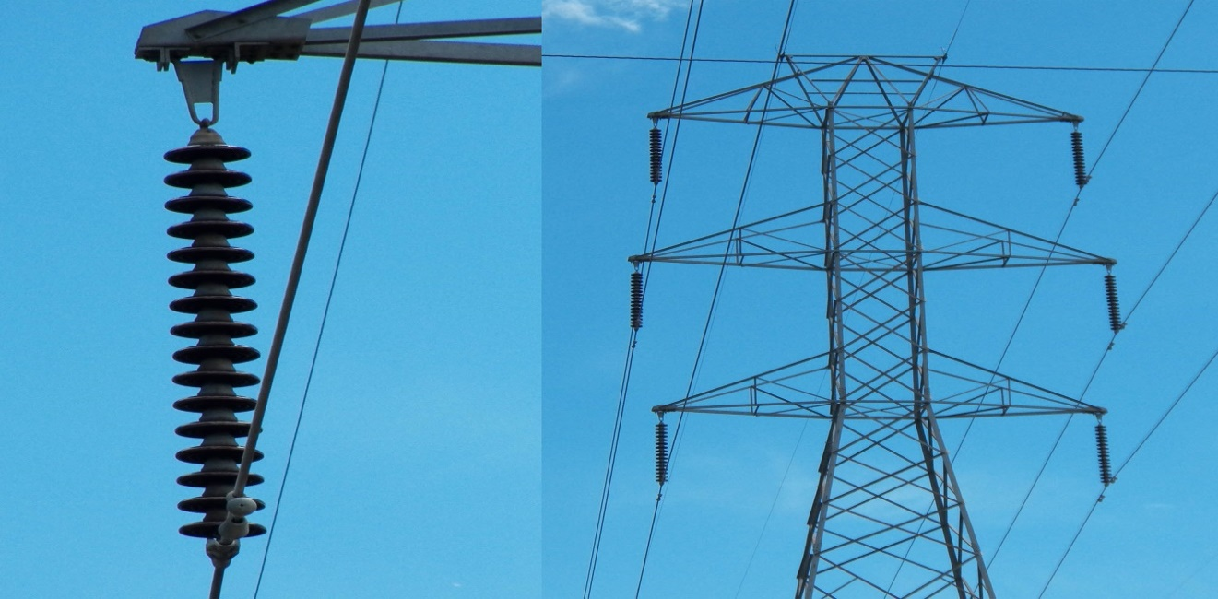

**Fig. (6.7) Overhead transmission lines**

The insulation has two basic functions:

1- Electrical function: It provides full electrical insulation between electrical conductors and towers.

2 - Mechanical function: hanging the electrical lines, bearing mechanical forces and in all expected weather conditions.

**Types of insulators used for overhead lines:**

**1. Porcelain insulators:** These insulators have high electrical insulation; they are made of aluminum silicate mixed with polymer and quartz. The mixture is heated to the right temperature to achieve the required mechanical strength. The dielectric strength of this material reaches 60 kV/cm and the tensile force is 500 kg/cm2. The porcelain insulator could be found in two forms: pin and long rod.

**2. Glass Insulators:** Glass insulators are made of silicon and have high dielectric strength up to 140 kV/cm. Glass is characterized as transparent, which has many advantages like the possibility to notice any impurities or cracks and do not heat too much when exposes to sunlight. While, the disadvantage is that glass suffers of condensation thus limitation of using in wet areas. Glass insulation is found in the form of pin type only.

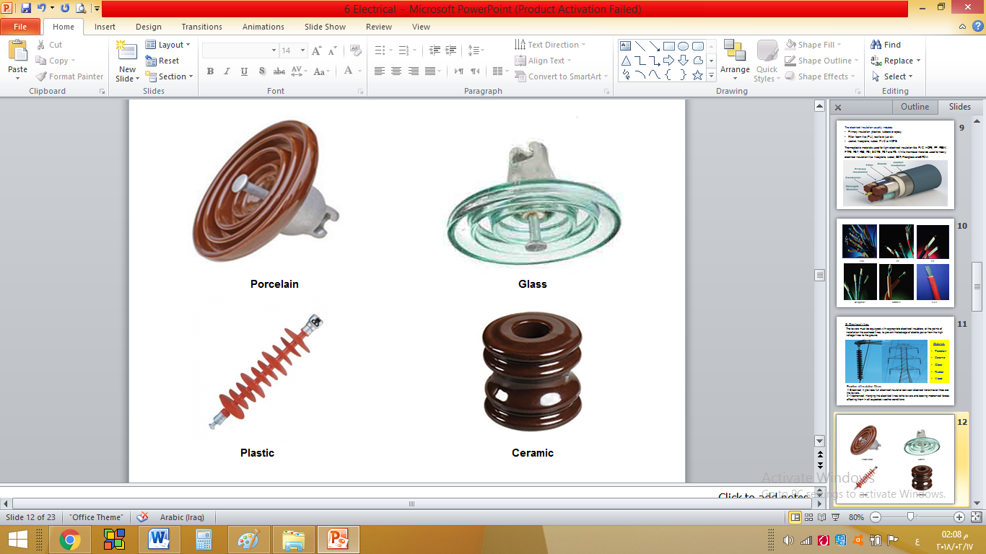**3. Plastic Insulators**: These insulators are made of reinforced plastic and rubber. They are characterized by light weight as (1/30) compared to the porcelain type. The other advantages are: the reduction of pollution, and easily installation on the towers. On the other hand, their prices are still high. These insulators are in the form of long rod type only.

**Fig. (6.8) Types of insulators used for overhead lines**

**Types of discs:**

There are several types of insulation discs could be used for overhead lines.

1. Pin type: this type is supported on a forged steel pin which is secured to the cross arm of the supporting structure. Pin type could be used with maximum voltage of 33 kV.
2. Suspension type: A suspension insulator consists of a number of separate insulator disc units connected with each other by metal lines to form a flexible string or chain. This type could be used with voltage higher than 33 kV, and can withstand 1800 kg tension force.
3. Strain (tension) type: Strain or tension insulators are design for handling mechanical stresses at angle positions where there is a change in the direction of the line or at termination of the lines.
4. 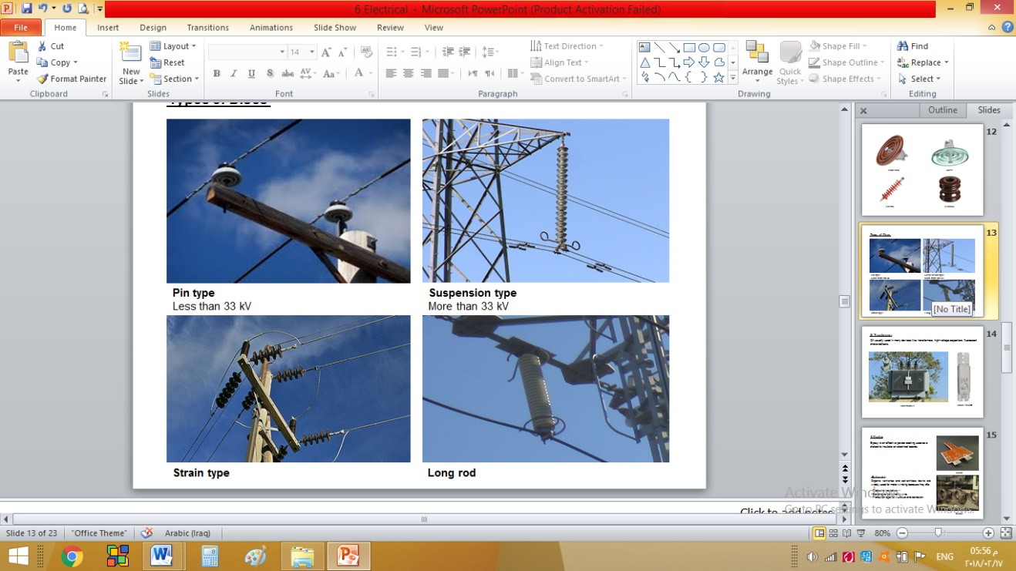Long rod type: It is made of porcelain or rubber and used when the voltage is very high. The length of the chain may be more than one meter.

**Fig. (6.9) Types of discs**

**Shapes of discs according to the usage:**

1. Standard insulation: It is used in low-pollution areas. The lower surface of the insulator is designed with a few turnings.

2. Anti-Pollution: It is suitable for high pollution areas, which contributes to reduce pollution by increasing creepage distance without increasing the length of the chain.

3. Anti-fog: Used in areas where there is active fog where there are many turnings to increase the condensation.

4. Desert: It is used in desert areas where the surface of the insulator is open and flat to prevent accumulation of dust on it.

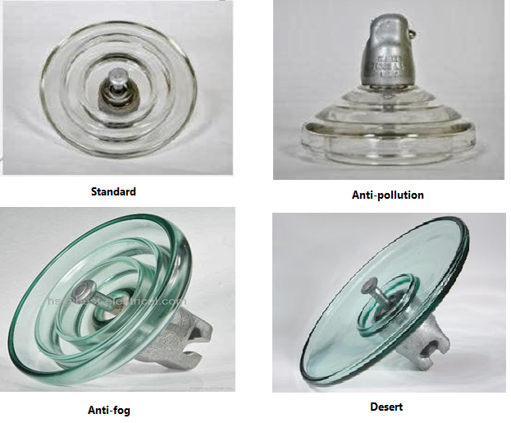

**Fig. (6.10) Shapes of discs**

**Selection of insulation discs:**

Electricity is transferred through power lines from the generating station to the distribution station. For the purpose of reducing power loss, the voltage is raised to the highest value using the transformer. The standard voltages for long-distance transmission lines are from 11 kV to 400 kV. Therefore the number of insulating discs (insulation series) must meet the balance between electrical insulation and mechanical failure opportunities as well as the cost of insulation. Each material has a table showing the optimal number for certain conditions.

**Table (6.5) Working voltage for overhead transmission lines**

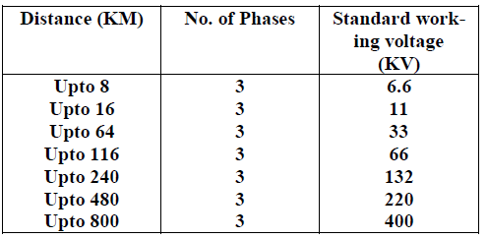

**Example:**

Calculate the number of insulated discs required to overcome working voltage of overhead lines between Baghdad and Kirkuk (280 km) in a wet region, where (SF = 1.75).

**Solution:**

Working voltage = 220 KV

Safety voltage = 220 x 1.75 = 385 KV

So, from the table, No. of discs = 11

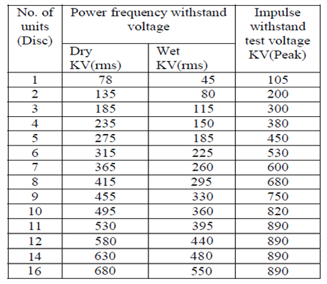

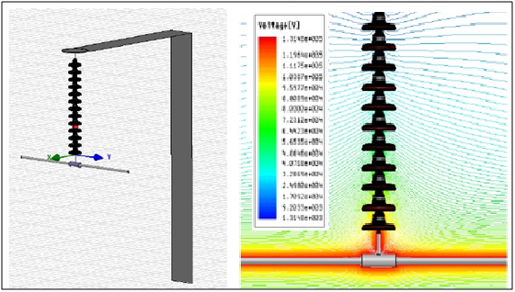

**Distribution of electrical voltage on the insulation discs:**

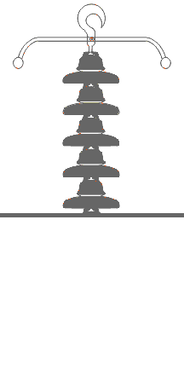Let us assume that there is a series of five-disc insulators where each insulator is considered as a capacitor of capacity (C) and a further capacitor is considered between the hanging metal and the tower of capacity (C1), as shown below:

From Kirchhoff's circuit law;

V2 = V1 (1 + m) ------------- ( 1 )

V3 = V1 (1 +3m + m2) ------------- ( 2 )

V4 = V1 (1 +6m + 5m2 + m3) ------------- ( 3 )

V5 = V1(1 +10m +15m2 +7m3 +m4) ------------- ( 4 )

It is clear that the disk connected to the electrical line has a higher voltage than the voltage on the next dish. This behavior is similar for upper discs until reducing the voltage on the tower arm disc to zero.

V = V1 + V2 +V3 + V4 + V5 ------------- ( 5 )

V = V1 (5 +20m + 21m2 +8m3 +m4) ------------- ( 6 )

Note that (V) is the potential difference of the phase, while the potential difference of the line is (Vline = 1.732 V).

**Example:** A 3-phase power transmission line installed on a tower using a series of five discs. Find the voltage on each disc if (m = 0.1).

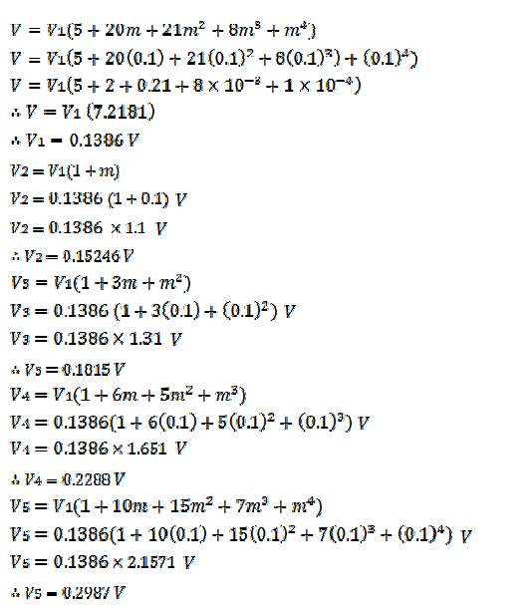**Solution:**

**3. Transformers**

Insulating oils are used in transformers and some electrical equipment. These oils have two primary functions: electrical insulation and cooling. In order to be effective, Oil must have low viscosity and high resistance against oxidation and impurities. Transformer oil is usually a bright yellow liquid with a density of about 0.88 mm / cm3 at 15° C and its cooling value is 11 times greater than that of air, and its volume expansion coefficient is 0.00075 cm3 / cm3.

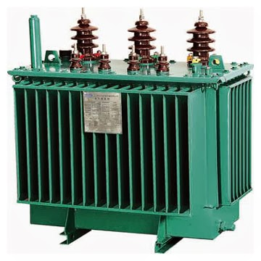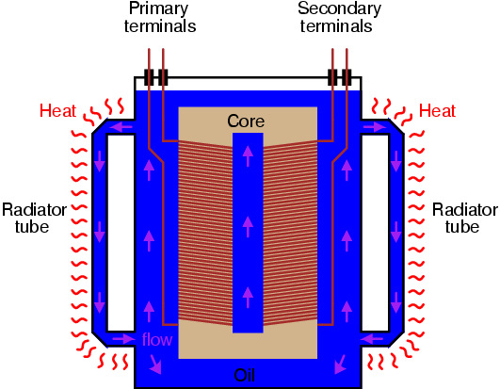

**Fig. (6.11) Electrical transformer**

**Characteristics of insulating oil:**

1. Dielectric Strength: The oil used for 11 kV should have dielectric strength of 30 kV / 2.5 mm at least and for 66 kV should be at least 50 kV / 2.5 mm.

2. Viscosity: The lower the oil viscosity the better heat transfer from the heart of the transformer to the outside, but should not be too much liquidity because the oil vapor is flammable if exposed to any flame. The maximum evaporation rate is 1.6% for eight hours of work.

3. Flash point: The temperature at which the oil vapor ignites when exposed to flame. The British specifications set the minimum temperature of 145 °C.

4. Density: The density should not exceed 0.895 g/cm3 at 20 °C.

5. Oxidization: The oxidation of oil causes a deposition that inhibits the cooling process. The oil is tested at 120 °C and for 75 hours with copper as a catalyst. The acceptable percentage of deposition is (0.4mg.KOH/g) which is approximately 1% deposition. The neutral volume can be measured by dissolving the oil with a mixture of methanol and toluene. The acceptable neutral volume is 0.03 mg/kOH/g. The oil should be free of sulfur.

6. Water content: water affects oil solubility and leads to pollutants and oxidation. Water content shall not exceed 40 ppm.

**4. Powder Coating**

Powder coating technology is recognized as a superior method of applying a protective finish on numerous shapes and sizes, as opposed to wet applications. One approach that is effectively used as a high dielectric insulator on copper or aluminum conductors is epoxy powder coating. It is used to ensure consistent insulation barrier due to its durability. The surface should be clean and dry prior to the powder application.

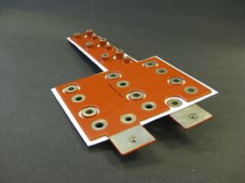

**Fig. (6.12) Electrical board coated by epoxy**

**5. Insulating varnishes**

Organic varnishes and solvent-less resins are widely used for motor winding because they offer:

- Dielectric insulation.

- Bonding to the winding wire.

- Protection against moisture and corrosion.

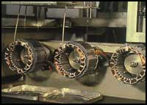

**Fig. (6.13) Electrical motors insulated by varnish**

**Applications for Energy Storage**

1. **Capacitors**

A capacitor is a passive two-terminal electrical component used to store electrical energy in the form of an electrostatic field. It consisting from two electrical conductors (plates) separated by a dielectric material that can store energy by polarization. The conductors are metal foils or conductive electrolyte. A dielectric could be glass, ceramic, plastic film, air, vacuum, paper, mica or oxide layer.

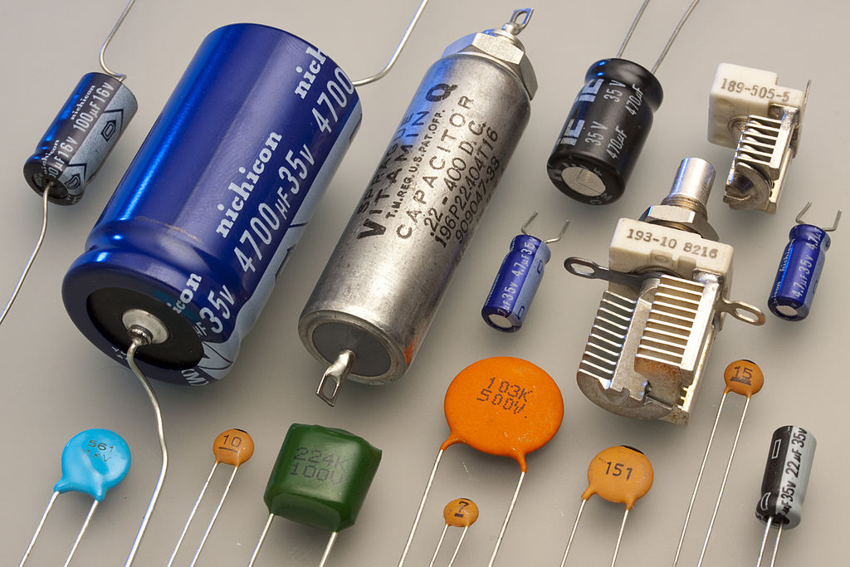

**Fig. (6.14) Electrical capacitors**

***A. Parallel Plates***

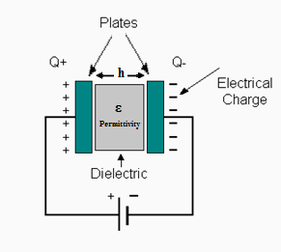The formula of capacitance (C) for parallel plates capacitor of a gap distance (h) can be derived as following;

C = Q / V

Where:

Q = Electric charge (coulomb)

V = D h / ε (voltage for parallel plates)

So,

C = Q ε / D h

But,

D = Q / A (density of field in coulomb/m2)

Thus,

C = A ε / h

**Example:** It is required to manufacture a capacitor of 17x10-9 coulomb/m2 field density under 2.4 V between plates of 1 cm x 2 cm area and spaced 3 mm apart. Select a proper dielectric material for this capacitor.

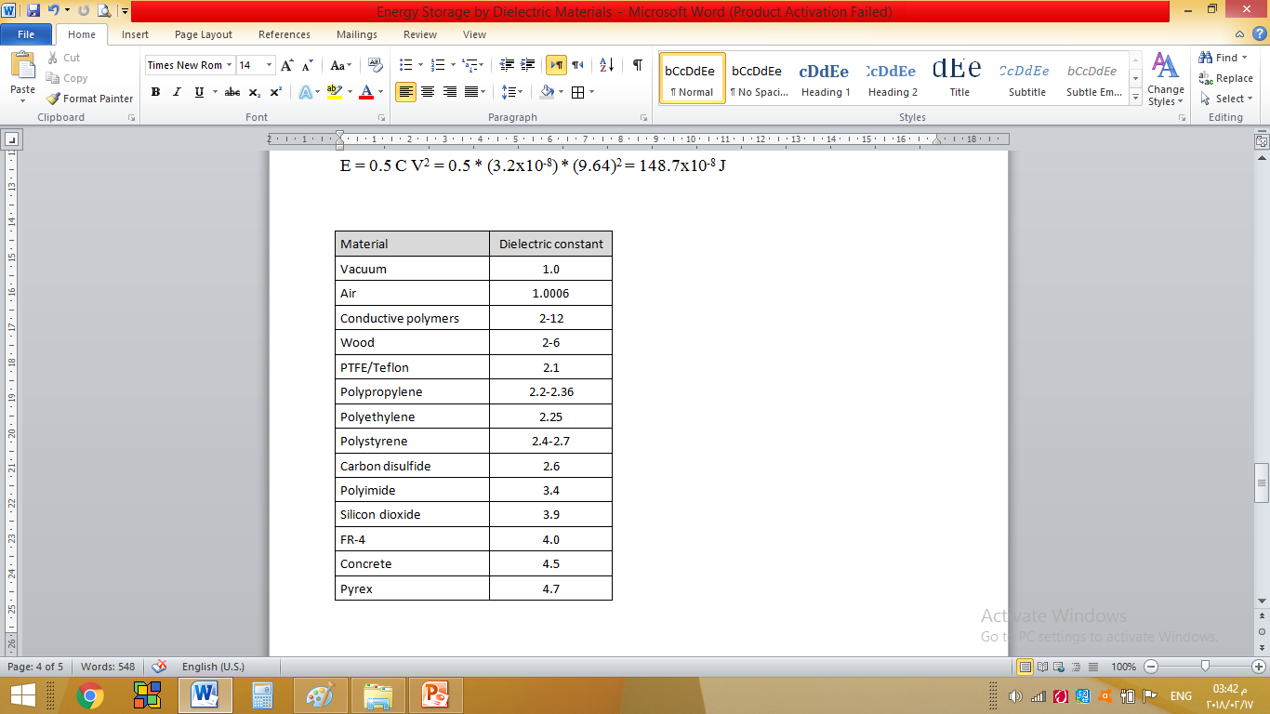**Solution:**

V = D h / ε

or

ε = D h / V

= 17x10-9 x 3 x10-3 / 2.4

= 21.25 x10-12 F/m

εr = ε / εo

= 21.25 x10-12 / 8.85×10-12 = 2.4

From permittivity table, the dielectric material is polystyrene.

***B. Cylindrical***

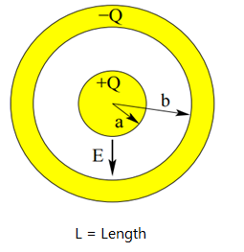The formula of capacitance (C) for cylindrical capacitor of a length (L) can be derived as following;

C = Q / V

Where:

$V \left(r\right)= \int_{a}^{b}{\frac{Q}{2πϵL} \frac{dr}{r}}$ (voltage for cylindrical)

$$V= \frac{Q}{2πϵL}\ln{(b/a)}$$

Thus,



1. **Piezoelectric Materials**

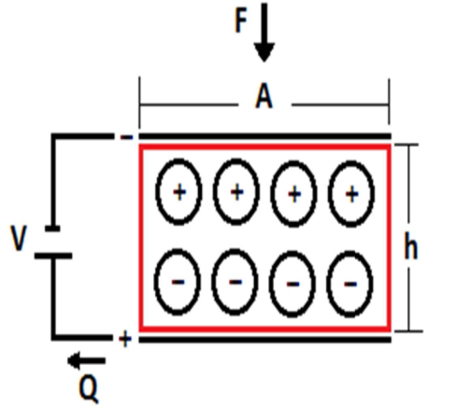Piezoelectricity is the appearance of electrical voltage across the sides of a material (such as crystal, ceramic and polymer) when it subjected to a mechanical stress, due to the change of polarization. The potential difference (V) generated in a piezoelectric material by the applied force (F) could be expressed by:

V = (F/A) h G

Where,

A = Subject area (m2)

h = Thickness (m)

G = Axial piezoelectric voltage coefficient (Vm/N)

Some piezoelectric materials show a spontaneous polarization without mechanical stress due to a non-vanishing electric dipole moment associated with their unit cell. If the dipole moment can be reversed by the application of an electric field, the material is said to be ferroelectric, such as PZT, BaTiO3 and PbTiO3.

**Example**: A piezoelectric ceramic of (PZT) used to produce electricity in a sport shoe has 35 mm diameter and 0.6 mm thickness. The weight of the human body is assumed as 70 kg. Neglecting the planar polarization, calculate the generated voltage and energy. Note: εr = 2250, G = 22.5x10-3 V.m/N

**Solution:**

A = π / 4 * (0.035)2 = 9.62x10-4 m2

F = 70 * 9.81 = 686.7 N

V = (F / A) h G = (686.7 / 9.62x10-4) * (0.6x10-3) * (22.5x10-3) = 9.64 v

ε = εr x εo = 2250 * 8.85x10-12 = 2x10-8 F/m

C = ε A / h = (2x10-8) * (9.62x10-4) /0.6x10-3 = 3.2x10-8 F

E = 0.5 C V2 = 0.5 * (3.2x10-8) * (9.64)2 = 148.7x10-8 J