Chapter Two
Thermal Insulation

Thermal Insulators
Those materials that prevent or reduce various modes of heat transfer (conduction, convection and radiation) from the outside to the inside or vice versa, whether the environment temperature is high or low.

The Advantages of Thermal Insulation
1. Reduce the amount of heat transmitted through the parts of the house
2. Reduce the energy required for heating or cooling the house
3. Make the internal temperature of the building stable, non-volatile
4. Reduce energy bills
5. Reduce the burning of fuel in power plants
6. Reduce the emission of greenhouse gases

Classification of Thermal Insulators
- According to the structure
1. Organic materials, such as cotton, wool, cork, rubber and cellulose.
2. Inorganic materials: such as glass, asbestos, rockwool, perlite, vermiculite and calcium silicate.
3. Metallics: such as aluminum foils and tin reflectors.

- According to the Shape
- Rolls: vary in the degree of flexibility and the ability to bend or pressure. They could be fastened by nails like glass wool, rock wool, polyethylene and foil-ceramic rolls.
- Sheets: There are specific dimensions and thicknesses such as polyethylene layers, polystyrene, cork and cellulose.
- Liquid or gaseous fluids: poured or sprayed on to form the desired dielectric layer, such as polyurethane foam and epoxy.
- Grains: a powder or granules are usually placed in the spaces between the walls and it can also be mixed with some other materials. Examples of such materials granulated cork and polymers.

Commercial Insulators
The thermal insulation refers to all isolators systems and processes that reduce the heat exchange between inside and outside. Thermal insulation in buildings in hot climates is designed to prevent the entry of heat to the building. Thus, the using of thermal insulation materials reduces the heat transfer. The most important thermal insulators are glass wool, cork, polyurethane and other polymeric materials as well as evacuated panels. It should refer here that air is one of the best thermal insulators due to its low coefficient of thermal conductivity (0.025 W/m.K) and availability everywhere.

The most common insulators:
1. Cellulose: which is made from wood or recycled paper and is characterized by its susceptibility to water and dust absorption.
2. Cork: This is taken from cork tree. It could be made industrial from petroleum product which is called the Expanded Polystyrene (EPS). It is found in the form of panels and used as thermal and acoustic insulators.
3. Glass wool: are widely used to insulate buildings, as well as boilers and reservoirs.
4. Rock wool: This material is used to isolate the buildings and storages.
5. Polyurethane: usually uses as insulated panel or foam to fill the cracks.
6. Polystyrene cork: both types, EPS and XPS
7. Astrofoil (XPE) layers: consist of two aluminum foils and including air bubbles which are made of polyethylene materials. The aluminum layers reflect the solar radiations in the summer while the air bubbles reduce the heat transfer through the walls because of high air isolation. This material is a good insulator against the water and air leaks.
8. Polycarbonate panels: These sheets are lightweight panels, and are composed of several layers to be able to withstand the shocks with the presence of air cavities for the purposes of thermal insulation.
9. Reflective materials: such as aluminum panels, alu-cobond and reflective paints. These materials are used to reflect solar radiation on the exterior walls.
10. Fire retardant sheets: are wooden panels characterized by their ability to delay the fire growth in addition to the thermal insulation ability.

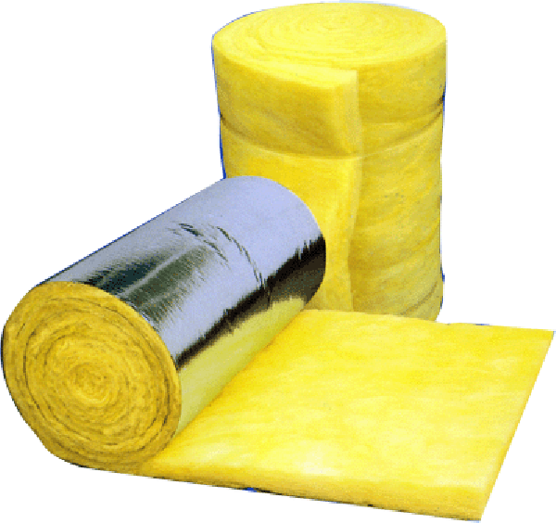
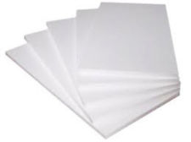
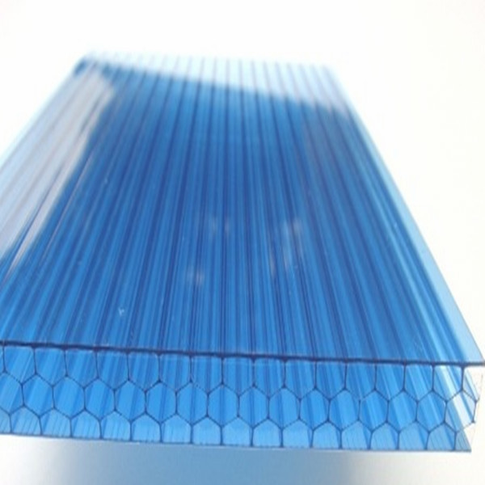
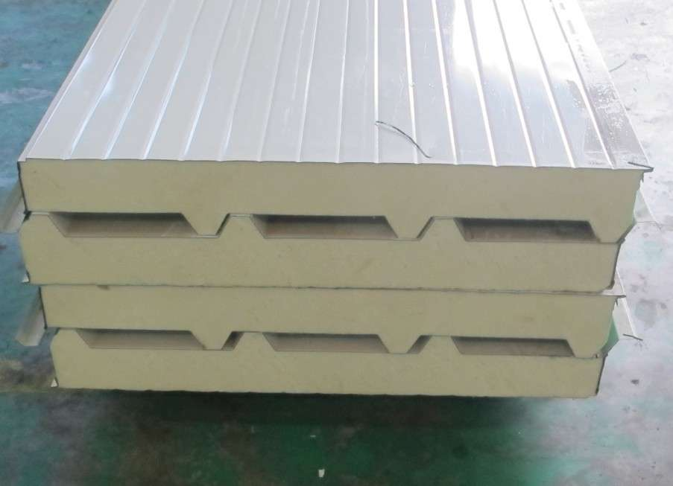
EPS Glass Wool
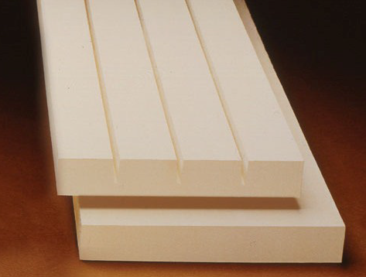
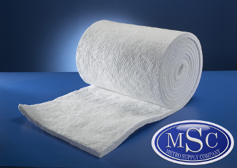
polycarbonate sheet Polyurethane panel

Ceramic roll Calcium silicate
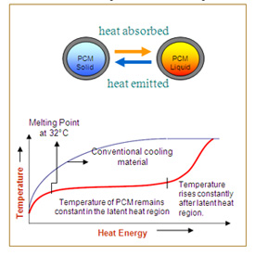
Phase Change Materials (PCM)
Those materials that consequently oscillating between liquid and solid phases, hence absorb or release heat depending on the surrounding temperature. Many substances that can act as phase change materials such as paraffin and salt hydrates.
These materials could be used in moderate warm climate where the ambient air is hot at the daytime and cool nightly. In the warm daytime, this material absorbs the heat from indoor air and turns to be in the liquid state. In the cold night, the material releases the heat and turns to be in the solid state again. By repeating this process, the indoor air temperature remains stable without electricity.

National Gypsum has produced a phase change drywall with the following specifications:
- The phase change material is Micronal Paraffin
- Tiny spheres of paraffin (5-10 micrometers in diameter) are encapsulated in acrylic shells, and these are mixed with the gypsum in drywall.
- Melting temperature is 24 ºC and could be operated till 32 ºC.
- Heat capacity is 125 W/m².
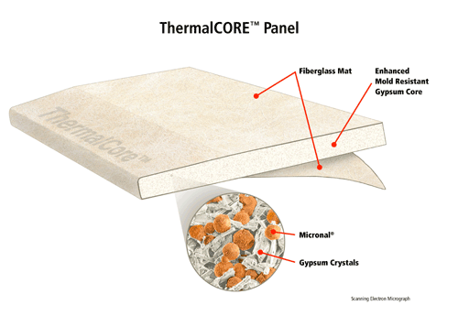

Thermal Properties of Insulator
Like the thermal conductivity coefficient, the less conductivity coefficient indicates the better resistance to heat transfer. The other thermal properties are: reflectivity, absorptivity, heat capacity, density, coefficient of thermal expansion and the coefficient of thermal bridging.
Thermal Conductivity
Thermal conductivity is the property of a material to conduct heat. Heat transfer occurs at a higher rate across materials of high thermal conductivity than across materials of low thermal conductivity. Correspondingly, materials of high thermal conductivity are widely used in heat sink applications and materials of low thermal conductivity are used as thermal insulation. The thermal conductivity of a material varies with the temperature. The reciprocal of thermal conductivity called thermal resistivity. There are a number of ways to measure thermal conductivity of a material using the conductivity meter aperture. The unit of thermal conductivity is (W/m.K).
Thermal conductivity for common insulators
Item | Material | Thermal Conductivity (W/m.K)
1 | Astro-foil (XPE) | 0.08
2 | Asbestos | 0.12
3 | Asphalt | 0.69
4 | Alucobond | 0.15
5 | Acrylic | 0.2
6 | Aerogel | 0.02
7 | Bitumen | 0.17
8 | Calcium silicate | 0.05
9 | Cellulose | 0.08
10 | Coal | 0.24
11 | Cotton | 0.04
12 | Cork (EPS) | 0.05
13 | Ceramic fiber | 0.08
14 | Engine Oil | 0.15
15 | Epoxy | 0.35
16 | Glass Fiber | 0.03
17 | Glass Wool | 0.04
18 | PVC | 0.2
19 | Paraffin Wax | 0.25
20 | Plywood | 0.13
21 | Polycarbonate | 0.19
22 | Perlite | 0.05
23 | Polystyrene (XPS) | 0.08
24 | Polyurethane | 0.02
25 | Rubber | 0.35
26 | Vacuumed panel | 0.007
27 | Vermiculite | 0.06
28 | Wool | 0.05

Thermal conductivity for common construction materials
Item | Material | Thermal Conductivity (W/m.K)
1 | Basalt | 2.3
2 | Block (Hollow) - 20 cm | 0.5
3 | Block (Hollow) – 15 cm | 0.6
4 | Block (Hollow) – 10 cm | 0.7
5 | Block (Solid) | 0.9
6 | Brick (Cavity) | 0.4
7 | Brick (Solid) | 0.5
8 | Concrete (Reinforced) | 2
9 | Concrete (Not Reinforced) | 0.8
10 | Cement plaster | 1
11 | Clay | 1.2
12 | Dry Wall – 10 cm | 0.3
13 | Granite | 3
14 | Gypsum | 0.8
15 | GRC | 0.9
16 | Glass | 1
17 | Limestone | 1.5
18 | Mica | 0.7
19 | Marble | 2.2
20 | Porcelain | 1.5
21 | Sandstone | 1.5
22 | Sandwich Panel – 10 cm | 0.04
23 | Sandwich Panel – 5 cm | 0.05
24 | Thermostone – 20 cm | 0.3
25 | Thermostone – 10 cm | 0.4
26 | Wood | 0.15

Thermal conductivity for common metals
Item | Material | Thermal Conductivity (W/m.K)
1 | Aluminum (AL) | 200
2 | Bronze | 110
3 | Copper (Cu) | 400
4 | Iron (Fe) | 80
5 | Lead (Pb) | 35
6 | Silver (Ag) | 450

Thermal conductivity for common gases
Item | Material | Thermal Conductivity (W/m.K)
1 | Air | 0.025
2 | Argon | 0.015
3 | Bromine | 0.04
4 | Carbon dioxide (CO₂) | 0.014
5 | Helium | 0.15
6 | Methane | 0.03

Reflectivity It is the ratio of reflected radiation from a surface to the total incident radiation. The factors affecting the amount of reflectivity are the color and the level of fine-tuning the surface. The following table shows values of reflectivity for some materials.
Item | Material | Reflectivity (%)
1 | Aluminum | 80
2 | Gypsum | 70
3 | Cork | 45
4 | Concrete | 35
5 | Plastic | 20
6 | Wood | 17
7 | Glass | 10
8 | Asphalt | 3

Absorptivity It is the ratio of absorbed radiation by the surface. The color of the surface affects the amount of absorption. The following table shows absorptivity values for some materials.
Color | Solar Absorptance
Green | 0.47
Ochre | 0.6
Dark Beige | 0.7
Blue | 0.7
Red | 0.75
Brown | 0.75
Dark Brown | 0.83
Dark Colors | 0.9
Black | 0.95

Heat capacity: the ability of material to store the heat. The material with high heat capacity is called thermal mass
Density: it is the mass of matter in a certain volume. The unit is (kg/m³).
Thermal expansion coefficient: is the amount of change in the volume of material as a result of temperature change.
Coefficient of thermal bridge: which describes the amount of heat transfer in certain areas called thermal bridges. Thermal bridge is an area in the building envelope in which the highest heat transfer compared with neighboring areas, this causing the failure of building materials, the spread of moisture and mold growth. Examples of these areas:
- The joints between the ceiling and walls
- Link areas between windows and walls
- Piles and foundations

Thermal Properties of some materials
Item | Material | Specific Heat (J/kg.K) | Density (kg/m³)
1 | Brick | 850 | 1900
2 | Concrete | 900 | 2500
3 | Granite | 900 | 2750
4 | Thermostone | 750 | 890
5 | Aluminum | 900 | 2700
6 | Iron | 450 | 8000
7 | Wood | 1700 | 750
8 | Rubber | 1600 | 950
9 | Marble | 850 | 2800
10 | Glass | 600 | 2500
11 | Water | 4200 | 1000
12 | Gypsum | 1000 | 1500
13 | EPS | 1500 | 24
14 | XPS | 1900 | 32
15 | Glass wool | 700 | 24
16 | Cellulose | 1750 | 1200
17 | Polyurethane | 500 | 12

Other features of Thermal Insulators
Mechanical: Such as durability, compression, tensile and shear stresses. Some insulators are characterized by strength and endurance than others. That makes sense to be used for supporting of the building beside to the goal of thermal insulation.
Moisture absorption: The presence of water or humid air in the insulator reduces the thermal insulation value of the material and it may destruct the material rapidly. The moisture is measured by the effect of moisture absorption and permeability.
Acoustic: Some insulating materials may be used as acoustic insulators as well as thermal insulators.
Safety: Some insulating materials could get hurt to human during storage, installation and usage. These may cause deformities in the human body, poisoning, infections or allergies in the skin and eyes, which requires importance of knowing the chemical composition of the material and ability to interact with the environment and constitute a mold, germs and insects. There are some physical properties should be considered like the ability of combustion and sublimation.

Modes of Heat Transfer
1. Conduction is heat transfer through the wall thickness from the hot face to the cold one. The thermal conductivity varies from a substance to another. For example, concrete and steel have high conductivity compared to an insulating material such as cork. The amount of heat transfer by conduction depends on the temperature difference between the surfaces of the wall, wall thickness, area of ​​surfaces exposed to heat and coefficient of thermal conductivity of the material, as well as the lag time (period of accumulated heat).
2. Convection is the transfer of heat due to the ambient air nearby the wall. where, the air molecules move from hot zone to cold zone carrying the thermal energy away and replaced by air molecules have cold temperature and less density. This process is known as convection current. Air movement helps to increase the heat transfer rate.
3. Radiation is the transfer of radiant heat that does not require necessarily a medium, like the heat of the sun to the earth. The radiant heat is transferred from the source to the colder places. The reflective surfaces such as metal foils reflect thermal radiation and reduce heat absorption by the walls.
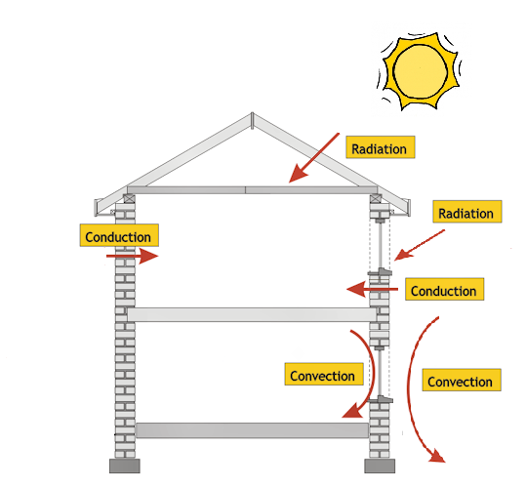

Thermal Insulation in Buildings
Buildings could be divided in terms of the acquisition method of heat into two types, which are buildings in hot climates and buildings in cold climates. In hot climates, most of the heat is gained from the outside through walls, ceilings and windows. The increase in thermal insulation in the outer shell of the building will lead necessarily to reduce the amount of heat gained and this consequently leads to reduce the energy needed for cooling. But in cold climates, heat is transferred from inside to out. Therefore, the insulating layers are placed inside.
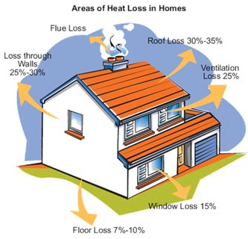
It is found that the heat transfer through the house parts are as follows:
- About 60% of the heat is transmitted through the ceilings and walls of the building.
- About 15% of the heat is transmitted by the windows.
- About 25% of the heat is transferred through the vents and doors of the building.

There are some concepts must be defined before entering to the design, such as:

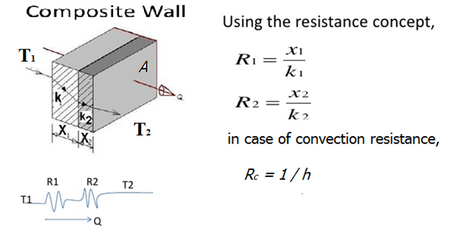
Thermal resistance is the susceptibility of the material to resist the heat. Thermal resistance has inverse relation with the coefficient of thermal conductivity. To find out the total resistance of the wall or ceiling, the collection of resistors for all materials should be included as well as the convection resistance adjacent to the external and internal surfaces. Dealing with these resistors exactly like that used with electrical resistors, they are either parallel or series. Resistance also called R-Value. It is worth noting that the US R-Value is about six times the SI R-Value due to the different standards.
Overall Heat Transfer Coefficient is the factor that is used to determine the optimum thickness of the insulation material in buildings. It is also called U-Value. And it can be calculated from the following relationship:

Then calculate the amount of heat transfer through the wall by the following relationship:

Where T is the temperature of the surface and A is the surface area

The unit of U-Value is (W/m².K). The U-Value of uninsulated wall is high up (1-5), while the U-Value of insulated wall is less than (1), while for super-insulation wall is less than (0.2). The world is moving to standardize the U-Value for residential buildings as minimum as possible toward satisfying the zero energy building.
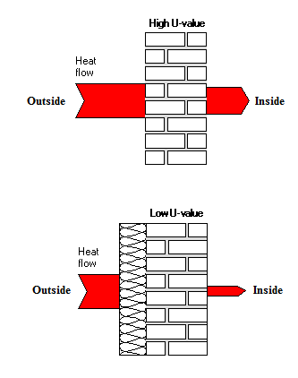

Engineering Calculations Show the Effect of Insulation in Energy Conservation

Example (1): Heat losses through the wall in the winter
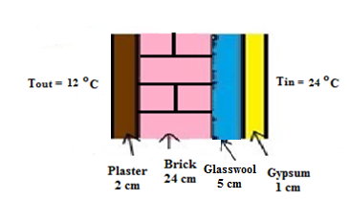
Calculate the reduction in the amount of heat transmitted through the wall shown in the figure due to the insulation. The area of the wall is 1 m² and the coefficients of convection heat transfer are:
- 10 W/m².K for external surface
- 5 W/m².K for internal surface
Note: Values of thermal conductivity of the materials are taken from the tables.

Solution:
- Before insulation
Plaster R1 = x1/k1 = 0.02/1 = 0.02
Brick R2 = x2/k2 = 0.24/0.5 = 0.48
Gypsum R3 = x3/k3 = 0.01/0.8 = 0.0125
External air Ro = 1/ho = 1/10 = 0.1
Internal air Ri = 1/hi = 1/5 = 0.2
Total resistance R = R1 + R2 + R3 + Ro + Ri = 0.8125
U = 1 / R = 1.23 W/m².K
Q = U A (Ti-To) = 1.23 * 1 * (24-12) = 14.8 W

- After insulation
Glasswool Rg = xg/kg = 0.05/0.04 = 1.25
Total resistance R = R1 + R2 + R3 + Ro + Ri + Rg = 2.0625
U = 1 / R = 0.485 W/m².K
Q = U A (Ti-To) =0.485 * 1 * (24-12) = 5.8 W

So the reduction in the heat loss is:
= (14.8 – 5.8)/14.8 = 0.608 = 61 %
Example (2): Calculation of the heat load in summer
Calculate the size of air-conditioning device (ton of refrigeration) required to cool a room of 6 m x 4m x 3m before and after the insulation. Note that the wall and the roof materials are shown in the figures below. Neglect the effect of radiation and convection heat transfer. Add 3000 W to the total load due to the heat gained through windows, ventilation, occupants and equipment.
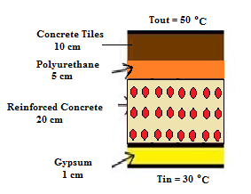
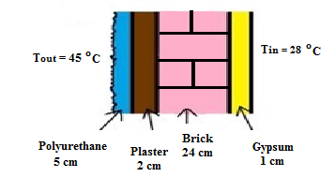
Wall section Roof section

K_{plaster}=1, K_{brick}=0.5, K_{gypsum}=0.8, K_{polyurethane}=0.02, K_{RC}=2, K_{concrete tiles}=0.8

Solution:

- Before insulation
- Walls
Plaster R1 = x1/k1 = 0.02/1 = 0.02
Brick R2 = x2/k2 = 0.24/0.5 = 0.48
Gypsum R3 = x3/k3 = 0.01/0.8 = 0.0125
Total resistance R = R1 + R2 + R3 = 0.5125
U = 1 / R = 1.95 W/m².K
A = (6*3*2) + (4*3*2) = 60 m²
Q = U A (Ti-To) = 1.95 * 60 * (45-28) = 1990 W

- Roof
Concrete tiles R1 = x1/k1 = 0.1/0.8 = 0.125
Reinforced con. R2 = x2/k2 = 0.2/2 = 0.1
Gypsum R3 = x3/k3 = 0.01/0.8 = 0.0125
Total resistance R = R1 + R2 + R3 = 0.2375
U = 1 / R = 4.21 W/m².K
A = 6*4 = 24 m²
Q = U A (Ti-To) = 4.21 * 24 * (50-30) = 2021 W

Q_{total} = Q_{walls} + Q_{roof} + Q_{others} = 1990 + 2021 + 3000 = 7011 W
Load = Q_{total} / 3500 = 7011/ 3500 = 2 TR

- After insulation
- Walls
Polyurethane Rp = xp/kp = 0.05/0.02 = 2.5
Total resistance R = 0.5125 + 2.5 = 3.0125
U = 1 / R = 0.332 W/m².K
Q = U A (Ti-To) = 0.332 * 60 * (45-28) = 338 W

- Roof
Polyurethane Rp = xp/kp = 0.05/0.02 = 2.5
Total resistance R = 0.2375 + 2.5 = 2.7375
U = 1 / R = 0.365 W/m².K
Q = U A (Ti-To) = 0.365 * 24 * (50-30) = 175 W

Q_{total} = Q_{walls} + Q_{roof} + Q_{others} = 338 + 175 + 3000 = 3513 W
Load = Q_{total} / 3500 = 3513/ 3500 = 1 TR

Electricity Demand Reduction
The use of insulation keeps the indoor temperature stable as well as reduces the thermal loads and thus the amount of electricity demand. It is usually account the electricity consumption in (kWh). In order to calculate the Annual Energy Demand (AED) use the following equation:

AED = Q_{total} * N / 100
Where N is the number of days under use

The amount of the annual consumption of electric power determines the building performance. The building performance factor could be calculated from the following relationship depending on the floor area:
BPF = AED / Floor Area

This factor is used to determine the type of building in terms of energy consumption, where high-energy building consumes more than (250 kWh/m²) per year while medium-energy building consumes an average between (100-200 kWh/m²) per year and low-energy building consumes less than (50 kWh/m²) per year.
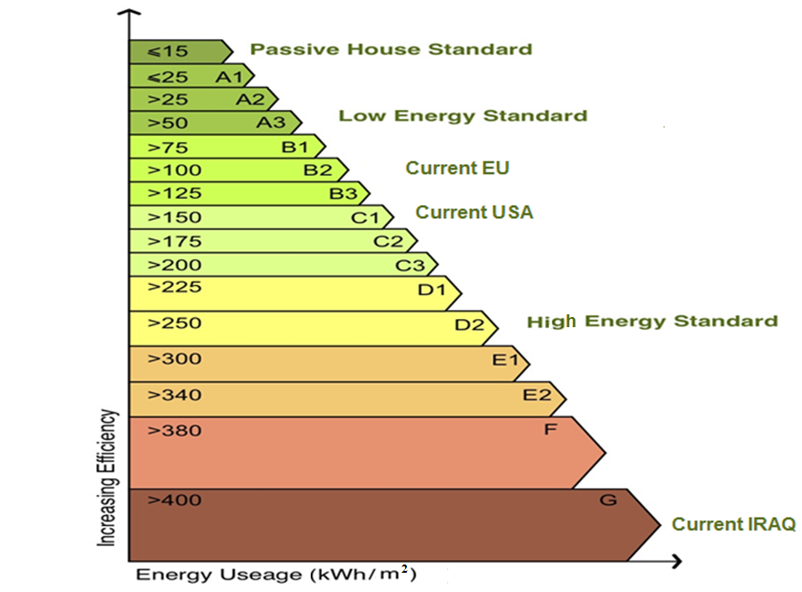
Reduce Oil Consumption
It is found that roughly about 3,000 liters of oil equivalent each year are burned to produce electricity for heating or cooling for uninsulated house. This could be saved up to 60% through the using of thermal insulation techniques. The approximate equation to determine the relationship between energy demand and the annual fuel consumption in (liters/m²) of floor area is:

Oil Consumption = 1.5 * Exp (BPF/120)

Greenhouse Effect
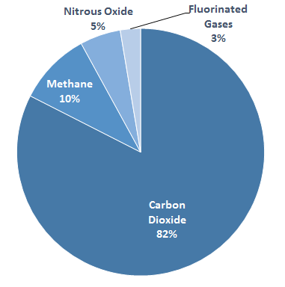
Greenhouse gas is any compound gas in the atmosphere that is capable to absorb infrared and keeping the heat from escaping out of the atmosphere. Greenhouse gases are responsible of the phenomenon of global warming.

The sector of residential building has the major impact on the increase of greenhouse gases and it is considered as the most damage to the climate. The traditional house (non-insulated) causes the emission of more than 7,000 kilograms of carbon dioxide CO₂ into the atmosphere each year. The approximate equation to determine the relationship between energy demand and the annual CO₂ emission in (kg/m²) of floor area is:

CO₂ Emission = 3.5 * Exp (BPF/120)

Example (3): Calculation of energy demand, fuel consumption and CO₂ emission
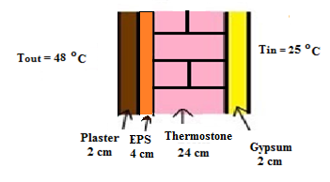
A house of 10 m length, 5 m width and 3 m height has insulated walls and ceiling, as shown in the figure. Neglect the effect of radiation and convection heat transfer. Add 4000 W due to the heat gained through other sources. Calculate:
1. Total heat transmitted through the building.
2. Annual electricity consumption in the building as a result of cooling (Suppose the use of air-conditioning for 120 days).
3. Efficiency of the building and its type.
4. Fuel consumption in power plant as a result of the annual consumption.
5. CO₂ emissions in power plant.
K_{plaster}=1, K_{EPS}=0.05, K_{thermostone}=0.3, K_{gypsum}=0.8
Solution:
1) Heat transfer
Plaster R1 = x1/k1 = 0.02/1 = 0.02
EPS R2 = x2/k2 = 0.04/0.05 = 0.8
Thermostone R3 = x3/k3 = 0.24/0.3 = 0.8
Gypsum R4 = x4/k4 = 0.02/0.8 = 0.025
Total resistance R = R1 + R2 + R3 + R4 = 1.645
U = 1 / R = 0.608 W/m².K
A = (10*3*2) + (5*3*2) + (10*5) = 140 m² total area of walls and roof
Q = U A (Ti-To) = 0.608 * 140 * (48-25) = 1957 W
2) Annual Electricity Demand
Q_{total} = 1957 + 4000 = 5957 W
AED = Q_{total} * N / 100 = 5957 * 120 / 100 = 7148 kWh
3) BPF = AED / Floor Area = 7148 / 50 = 143 kWh/m²
So the house is medium energy standard
4) Oil Consumption = 1.5 * Exp (BPF/120) = 1.5 * Exp (143/120) = 5 liters/m²
5) CO₂ Emission = 3.5 * Exp (BPF/120) = 12 kg/m²
Economical Effect
The quality of the insulation materials are chosen to satisfy balance between the economic cost and achieving the requirements of good insulation and reduce energy consumption. To make the process more economical, thermal insulation of the building must be chosen carefully according to the following factors:
- The amount of insulation material and thickness.
- The cost of insulation material and labor costs, which will install it.
- The amount of energy that is saved to the building. Hence, the money saved.
The total cost of insulation equals to the cost of the insulators plus the cost of air-conditioning units that used for a certain period. It has found that super insulation of the building increases the cost of construction up to 20%, but this amount would be recovered as a result of lower electricity bills in a few years. Some developed countries have reduced the electricity bills for low-energy homes as a plan of encouragement. The following table shows average prices of some insulators.

Item | Insulation Material | Cost ($/m²) for each cm thickness
1 | Alucobond | 20
2 | Asbestos | 8
3 | Asphalt | 2
4 | Cellulose | 1.5
5 | Cement | 6
6 | Clay | 0.7
7 | Coal | 2
8 | Cotton | 3
9 | Cork (EPS) | 1.5
10 | Glass Fiber | 2.5
11 | Glass Wool | 2.5
12 | Gypsum Plaster | 3
13 | Perlite | 4
14 | Polystyrene | 3
15 | Polyurethane | 6
16 | Rubber | 2
17 | Wood | 15
18 | Wool | 8
19 | Granite | 18
20 | GRC | 10
21 | Limestone | 12
22 | Sandstone | 12
23 | Marble | 18
24 | Basalt | 12

