Transportation Planning

1. Urban Transportation Planning
Urban transportation planning involves the evaluation and selection of highway or transit facilities to serve present and future land uses. For example, the construction of a new shopping center, airport, or convention center will require additional transportation services. Also, new residential development, office space, and industrial parks will generate additional traffic, requiring the creation or expansion of roads and transit services.
Urban transportation planning is concerned with two separate time horizons. The first is a short-term emphasis intended to select projects that can be implemented within a one- to three-year period. These projects are designed to provide better management of existing facilities by making them as efficient as possible. The second time horizon deals with the long-range transportation needs of an area and identifies the projects to be constructed over a 20-year period.
Short-term projects involve programs such as traffic signal timing to improve flow, car and van pooling to reduce congestion, park-and-ride fringe parking lots to increase transit ridership, and transit improvements.
Long-term projects involve programs such as adding new highway elements, additional bus lines or freeway lanes, rapid transit systems and extensions, or access roads to airports or shopping malls.
The urban transportation planning process can be carried out in terms of the procedures outlined previously and is usually described as follows. Figure 1 illustrates the comprehensive urban area transportation planning process.
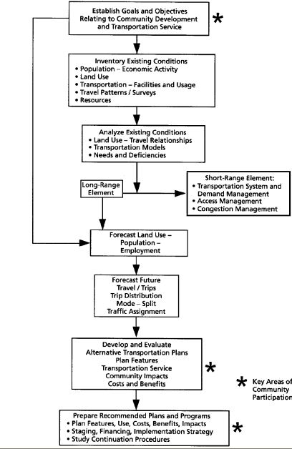

Figure 1. Comprehensive Urban Area Transportation Planning Process.

1.2 Inventory of Existing Travel and Facilities
This is the data-gathering activity in which urban travel characteristics are described for each defined geographic unit or traffic zone within the study area. Inventories and surveys are made to determine traffic volumes, land uses, origins and destinations of travelers, population, employment, and economic activity. Inventories are made of existing transportation facilities, both highway and transit. Capacity, speed, travel time, and traffic volume are determined. The information gathered is summarized by geographic areas called traffic analysis zones (TAZ).
The size of the TAZ will depend on the nature of the transportation study, and it is important that the number of zones be adequate for the type of problem being investigated. Often, census tracts or census enumeration districts are used as traffic zones because population data are easily available by this geographic designation.
1.3 Establishment of Goals and Objectives
The urban transportation study is carried out to develop a program of highway and transit projects that should be completed in the future. Thus, a statement of goals, objectives, and standards is prepared that identifies deficiencies in the existing system, desired improvements, and what is to be achieved by the transportation improvements.
For example, if a transit authority is considering the possibility of extending an existing rail line into a newly developed area of the city, its objectives for the new service might be to maximize its revenue from operations, maximize ridership, promote development, and attract the largest number of auto users so as to relieve traffic congestion.

1.4 Generation of Alternatives
In this phase of the urban transportation planning process, the alternatives to be analyzed will be identified. It also may be necessary to analyze the travel effects of different land-use plans and to consider various lifestyle scenarios. The options available to the urban transportation planner include various technologies, network configurations, vehicles, operating policies, and organizational arrangements.
In the case of a transit line extension, the technologies could be rail rapid transit or bus. The network configuration could be defined by a single line, two branches, or a geometric configuration such as a radial or grid pattern. The guideway, which represents a homogeneous section of the transportation system, could be varied in length, speed, waiting time, capacity, and direction. The intersections, which represent the end points of the guideway, could be a transit station or the line terminus. The vehicles could be singly driven buses or multicar trains. The operating policy could involve 10-minute headways during peak hours and 30-minute headways during off peak hours, or other combinations. The organizational arrangements could be private or public. These and other alternatives would be considered in this phase of the planning process.

1.5 Estimation of Project Cost and Travel Demand
This activity in the urban transportation planning process involves two separate tasks. The first is to determine the project cost, and the second is to estimate the amount of traffic expected in the future. The estimation of facility cost is relatively straightforward, whereas the estimation of future traffic flows is a complex undertaking requiring the use of mathematical models and computers.

1.6 Evaluation of Alternatives
This phase of the process is similar in concept to what was described earlier but can be complex in practice because of the conflicting objectives and diverse groups that will be affected by an urban transportation project.
Among the groups that could be affected are the traveling public (user), the highway or transit agencies (operator), and the non-traveling public (community).
Each of these groups will have different objectives and viewpoints concerning how well the system performs. The traveling public wants to improve speed, safety, and comfort; the transportation agency wishes to minimize cost; and the community wants to preserve its lifestyle and improve or minimize environmental impacts.

2. Planning-Level Demand Estimation
Future travel is determined by forecasting future land use in terms of the economic activity and population that the land use in each TAZ will produce. With the land-use forecasts established in terms of number of jobs, residents, auto ownership, income, and so forth, the traffic that this land use will add to the highway and transit facility can be determined. This is carried out in a four-step process that includes the determination of the number of trips generated, the origin and destination of trips, the mode of transportation used by each trip (for example, auto, bus, rail), and the route taken by each trip. The urban traffic forecasting process thus involves four distinct activities: trip generation, trip distribution, modal split, and network assignment, as illustrated in Figure 2. When the travel forecasting process is completed, the highway and transit volumes on each link of the system will have been estimated. The actual amount of traffic, however, is not known until it occurs. The results of the travel demand forecast can be compared with the present capacity of the system to determine the operating level of service.

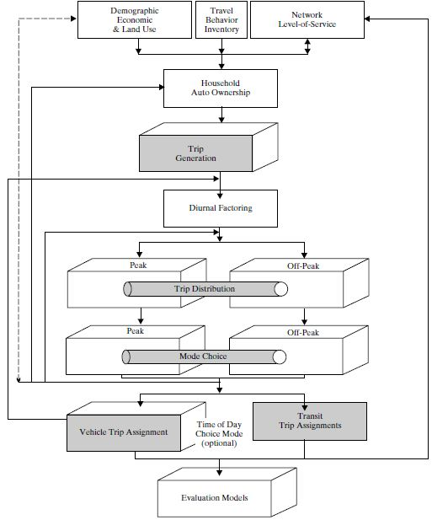
Figure 2 Travel Demand Model Flowchart.

3. Environmental Impact Statements
Federal and/or state regulations may require that the environmental impacts of proposed projects be assessed. These impacts may include effects on air quality, noise levels, water quality, wetlands, and the preservation of historic sites of interest.
The analytical process through which these effects are identified can take one of three forms, depending on the scope of the proposed project: a full environmental impact statement (EIS), a simpler environmental assessment (EA), or a cursory checklist of requirements known as a categorical exclusion (CE). Examples of projects that might receive the CE designation are utility installations along an existing transportation facility, bicycle lanes, noise barriers, and improvements to rest areas: Generally, projects that receive the CE designation do not require further detailed
analysis. Projects for which an EIS is required might include the construction of a new limited-access freeway or a fixed guideway transit line. For some projects, it might not initially be clear whether the project merits a full environmental study. For those projects, an environmental assessment may be conducted, and the EA will either result in a finding of no significant impact (FONSI) or in a finding that a full EIS is warranted.
For some large-scale projects that require an EIS, projects may be “tiered.” The first tier addresses macroscopic issues, such as whether a proposed facility should be a highway bypass or a light rail line and whether it should follow an eastern or western alignment. The second tier addresses microscopic issues, such as the number of
parcels that might be taken once a decision has been made that the facility will be a rail line following a western alignment.
The purpose of this environmental review process is “to assure that all potential effects (positive as well as adverse) are addressed in a complete manner so that decision-makers can understand the consequences” of the proposed project. Once an agency, such as a state department of transportation, completes a draft EIS, the public is given an opportunity to comment.

3.1 Elements of an EIS
Although the entire environmental review process is beyond the scope of this text, examination of some of the common elements of an EIS illustrate its role in transportation planning.
The project’s purpose and need section articulates why the project is being undertaken: Is it to improve safety, to increase capacity in response to expected future traffic growth, or is it a deficient link in a region’s comprehensive transportation network?
The purpose and need section should include relevant AADT projections, crash rates, and a description of existing geometric conditions.
The alternatives to the proposed project, such as the do-nothing case, should be described, as well as any criteria that have been used to eliminate alternatives from further consideration. For example, if a second bridge crossing over a body of water is being considered, then alternatives could be to change the location, to widen an existing bridge, to improve ferry service, or to do nothing. Criteria that prevent further consideration, such as the presence of an endangered species at what would have been another potential location or the permanent loss of several acres of wetlands, are given in this section.
The environmental effects of the proposed project, such as water quality (during construction and once construction is complete), soil, wetlands, and impacts on plant and animal life, especially endangered species, should be analyzed. Note that environmental effects also include the impact on communities, such as air quality, land use, cultural resources, and noise.

3.2 Computing Environmental Impacts for Emissions and Noise
The level of detail in a full EIS can be staggering given the amount of analysis required to answer some seemingly simple questions: What is the noise level? How much will automobile emissions increase?
A number of tools are provided by regulatory agencies that can answer some of these questions. For example, the Environmental Protection Agency (EPA) has developed an emissions-based model (known as MOBILE) that may be used to evaluate emissions impacts of alternatives. The results of this model, compared with observed carbon monoxide concentrations, can be used to determine the relative impact of different project alternatives on the level of carbon monoxide.

For example, the FHWA will permit one to use the $L_{10}$ descriptor, which is “the percentile noise level that is exceeded for ten percent of the time.” A more common noise descriptor is $L_{eq}$, which is the average noise intensity over time. A variant of this descriptor may be used by the U.S. Department of Housing and Urban Development (HUD), where the $L_{eq}$ for each hour is determined but then a 10 dB “penalty” is added to the values from 10 p.m. to 7 a.m. Since noise is proportional to traffic speed, the impact of this last type of descriptor is to favor projects that would not necessarily result in high speeds in close proximity to populated areas during the evening hours.
An EIS utilizes current and forecasted volume counts (i.e., automobiles, medium trucks, and heavy trucks), speeds, and directional split in order to compare environmental effects for the current conditions, future conditions with the proposed project, and future conditions assuming any other alternatives, which at a minimum should include the no-build option.

4. Forecasting Travel
To accomplish the objectives and tasks of the urban transportation planning process, a technical effort referred to as the urban transportation forecasting process is carried out to analyze the performance of various alternatives. There are four basic elements and related tasks in the process: (1) data collection (or inventories), (2) analysis of existing conditions and calibration of forecasting techniques, (3) forecast of future travel demand, and (4) analysis of the results. These elements and related tasks are described in the following sections.

4.1 Defining the Study Area
Prior to collecting and summarizing the data, it is usually necessary to delineate the study area boundaries and to further subdivide the area into traffic analysis zones (TAZ) for data tabulation. An illustration of traffic analysis zones for a transportation study is shown in Figure 3.

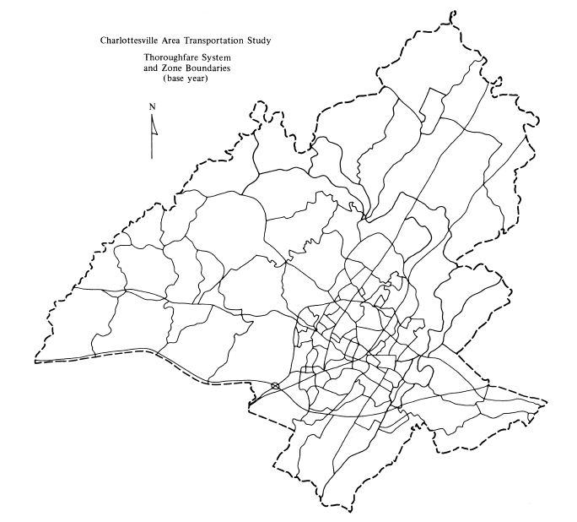
Figure 3 Traffic Analysis Zones for Transportation Study.

The selection of these zones is based on the following criteria:
1. Socioeconomic characteristics should be homogeneous.
2. Intrazonal trips should be minimized.
3. Physical, political, and historical boundaries should be utilized where possible.
4. Zones should not be created within other zones.
5. The zone system should generate and attract approximately equal trips, households,
population, or area. For example, labor force and employment should be
similar.
6. Zones should use census tract boundaries where possible.
7. The total number of zones should not be so large as to overwhelm computer
resources.

It may be necessary to exercise some judgment in determining the total number of zones. For example, one guideline for establishing the total number within a study area is that there should be, on average, one zone per 1,000 people (such that an area with 500,000 people would have 500 total zones). The internal trip table for such a study
area will thus have 500 * 500 = 250,000 cells (e.g., trips from zone 1 to zone 1, trips from zone 1 to zone 2, trips from zone 1 to zone 3, and so forth). By comparison, suppose the study area has a population of 2 million. Application of the 1,000 people/ zone guideline would yield 2,000 total zones and thus 2,000 * 2,000 = 4 million cells
for the internal trip table, which requires substantially more computing power and time to process.

Agencies may provide some guidance for achieving these seven criteria. Examples of such guidance are an average of 1,000 people/zone for smaller areas, a ratio of between 0.9 and 1.1 for productions to attractions, no more than 10,000 trips should be generated for a given zone, and a ratio of labour force to employment must be at least 0.80. Such guidelines do not constitute absolute standards but rather represent a compromise between an ideal data set and available resources for data collection and processing.

4.2 Data Collection
The data collection phase provides information about the city and its people that will serve as the basis for developing travel demand estimates. The data include information about economic activity (employment, sales volume, income, etc.), land use (type, intensity), travel characteristics (trip and traveler profile), and transportation facilities (capacity, travel speed, etc.). This phase may involve surveys and can be based on previously collected data.

4.3 Population and Economic Data
Once a zone system for the study area is established, population and socioeconomic forecasts prepared at a regional or statewide level are used. These are allocated to the study area, and then the totals are distributed to each zone. This process can be accomplished by using either a ratio technique or small-area land-use allocation models.
The population and economic data usually will be furnished by the agencies responsible for planning and economic development, whereas providing travel and transportation data is the responsibility of the traffic engineer. For this reason, the data required to describe travel characteristics and the transportation system are described as follows.

4.4 Transportation Inventories
Transportation system inventories involve a description of the existing transportation services; the available facilities and their condition; location of routes and schedules; maintenance and operating costs; system capacity and existing traffic; volumes, speed, and delay; and property and equipment. The types of data collected about the current
system will depend on the specifics of the problem.

For a highway planning study, the system would be classified functionally into categories that reflect their principal use. These are the major arterial system, minor arterials, collector roads, and local service. Physical features of the road system would include number of lanes, pavement and approach width, traffic signals, and traffic-control devices. Street and highway capacity would be determined, including capacity of intersections. Traffic volume data would be determined for intersections and highway links. Travel times along the arterial highway system would also be determined.

A computerized network of the existing street and highway system is produced. The network consists of a series of links, nodes, and centroids (as illustrated in Figure 4). A link is a portion of the highway system that can be described by its capacity, lane width, and speed. A node is the end point of a link and represents an intersection or location where a link changes direction, capacity, width, or speed.
A centroid is the location within a zone where trips are considered to begin and end.
Coding of the network requires information from the highway inventory in terms of link speeds, length, and capacities. The network is then coded to locate zone centroids, nodes, and the street system.

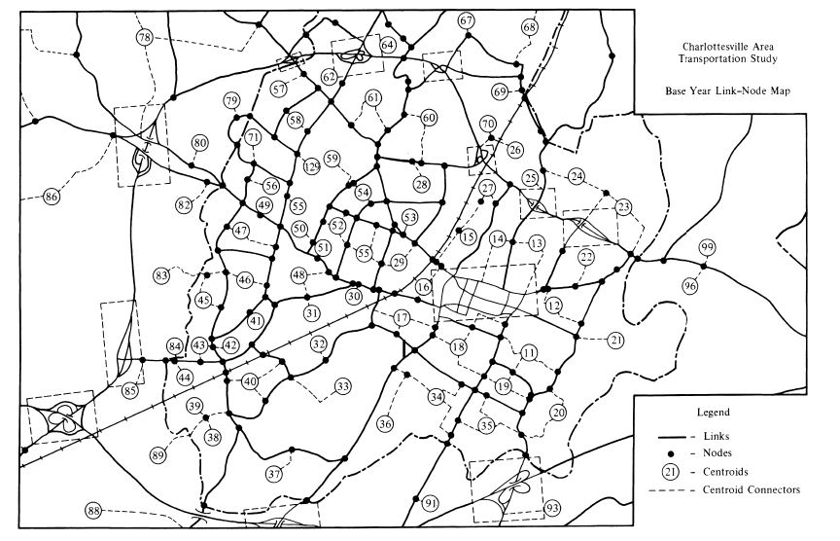
Figure 4 Link-Node Map for Highway System.

Figure 5 shows external stations which are established at the study area boundary. External stations are those roadways where traffic is likely to enter or exit the study area, such as primary and interstate facilities, and are used to account for the impact of changes outside the study area on the travel network within the study area.
For a transit planning study, the inventory includes present routes and schedules, including headways, transfer points, location of bus stops, terminals, and parking facilities. Information about the bus fleet, such as its number, size, and age, would be identified. Maintenance facilities and maintenance schedules would be determined, as would the organization and financial condition of the transit companies furnishing service in the area. Other data would include revenue and operating expenses.

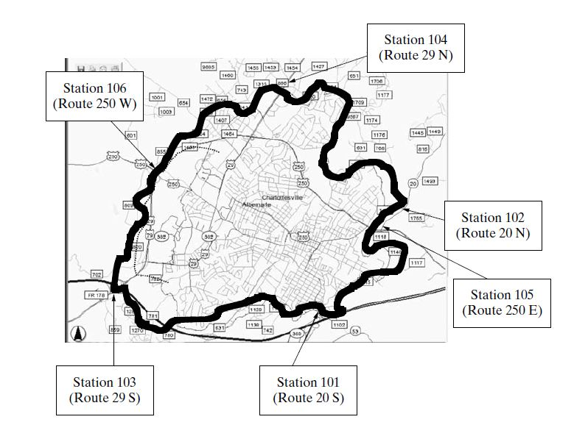

Figure 5 External Stations for a Study Area Boundary.

The transportation facility inventories provide the basis for establishing the networks that will be studied to determine present and future traffic flows. Data needs can include the following items:
• Public streets and highways
—Rights of way
—Roadway and shoulder widths
—Locations of curbed sections
—Locations of structures such as bridges, overpasses, underpasses, and major
culverts
—Overhead structure clearances
—Railroad crossings
—Location of critical curves or grades
—Identification of routes by governmental unit having maintenance jurisdiction
—Functional classification
—Street lighting
• Land use and zoning controls
• Traffic generators
—Schools
—Parks
—Stadiums
—Shopping centers
—Office complexes
• Laws, ordinances, and regulations
• Traffic control devices
—Traffic signs
—Signals
—Pavement markings
• Transit system
—Routes by street
—Locations and lengths of stops and bus layover spaces
—Location of off-street terminals
—Change of mode facilities
• Parking facilities
• Traffic volumes
• Travel times
• Intersection and roadway capacities
In many instances, the data will already have been collected and are available in the files of city, county, or state offices. In other instances, some data may be more essential than others. A careful evaluation of the data needs should be undertaken prior to the study.

5. Travel Surveys
Travel surveys are conducted to establish a complete understanding of the travel patterns within the study area. For single projects (such as a highway project), it may be sufficient to use traffic counts on existing roads or (for transit) counts of passengers riding the present system. However, to understand why people travel and where they wish to go, origin-destination (O-D) survey data can be useful. The O-D survey asks questions about each trip that is made on a specific day—such as where the trip begins and ends, the purpose of the trip, the time of day, and the vehicle involved (auto or transit)—and about the person making the trip—age, sex, income, vehicle owner, and so on.

The O-D survey may be completed as a home interview, or people may be asked questions while riding the bus or when stopped at a roadside interview station. Sometimes, the information is requested by telephone or by return postcard. O-D surveys are rarely completed in communities where these data have been previously collected.
O-D data are compared with other sources to ensure the accuracy and consistency of the results. Among the comparisons used are crosschecks between the number of dwelling units or the trips per dwelling unit observed in the survey with published data. Screen line checks can be made to compare the number of reported trips that cross a defined boundary, such as a bridge or two parts of a city, with the number actually observed. For example, the number of cars observed crossing one or more bridges might be compared with the number estimated
from the surveys. It is also possible to assign trips to the existing network to compare how well the data replicate actual travel. If the screen line crossings are significantly different from those produced by the data, it is possible to make adjustments in the O-D results so that conformance with the actual conditions is assured.
Following the O-D checking procedure, a set of trip tables is prepared that shows the number of trips between each zone in the study area. These tables can be subdivided, for example, by trip purpose, truck trips, and taxi trips. Tables are also prepared that list the socioeconomic characteristics for each zone and the travel time between zones.

5.1 Steps in the Travel Forecasting Process
Forecasting can be summarized in a simplified way by indicating the task that each step in the process is intended to perform. These tasks are as follows.

Step 1. Population and economic analysis determines the magnitude and extent of activity in the urban area.

Step 2. Land use analysis determines where the activities will be located.

Step 3. Trip generation determines how many trips each activity will produce or attract.

Step 4. Trip distribution determines the origin or destination of trips that are generated at a given activity.

Step 5. Modal split determines which mode of transportation will be used to make the trip.

Step 6. Traffic assignment determines which route on the transportation network will be used when making the trip where each user seeks to minimize their travel time on the network.

