Performance of Multiprocessor Architecture
Standard Performance Measures
Most of the standard measures adopted by the industry to compare the performance of various parallel computers are based on the concepts of:
Peak Performance
[Theoretical maximum based on best possible utilization of all resources]
Sustained Performance
[based on running application-oriented benchmarks]
Generally measured in units of:
MIPS [to reflect instruction execution rate]
MFLOPS [to reflect the floating-point capability]

The parallel run time T(n) of a program or application is the time required to run the program on an n-processor parallel computer. When n = 1, T(1) denotes sequential runtime of the program on single processor.
1- Computational Models
1.1- Equal Duration Model
In this model, it is assumed that a given task can be divided into n equal subtasks, each of which can be executed by one processor. If ts is the execution time of the whole task using a single processor, then the time taken by each processor to execute its subtask is tm = ts/n. Since, according to this model, all processors are executing their subtasks simultaneously, then the time taken to execute the whole task is tm = ts/n. The speedup factor of a parallel system can be defined as the ratio between the time taken by a single processor to solve a given problem instance to the time taken by a parallel system consisting of n processors to solve the same problem instance.
$$S(n)=\text{speedup factor }=\frac{\text{ts}}{\text{tm}}=\frac{\text{ts}}{\text{ts}/n}=n$$
The above equation indicates that, according to the equal duration model, the speedup factor resulting from using n processors is equal to the number of processors used, n. One important factor has been overlooked in the above derivation. This factor is the communication overhead, which results from the time needed for processors to communicate and possibly exchange data while executing their subtasks. Assume that the time incurred due to the communication overhead is called tc then the actual time taken by each processor to execute its subtask is given by tm = ًts/n+tc.

$$S(n)=\text{speedup factor with communication overhead }=\frac{\text{ts}}{\text{tm}}=\frac{\text{ts}}{\frac{\text{ts}}{n}+\text{tc}}=\frac{n}{1+\text{n*}\frac{\text{tc}}{\text{ts}}}$$
The above equation indicates that the relative values of ts and tc affect the achieved speedup factor. A number of cases can then be contemplated: (1) if tc « ts then the potential speedup factor is approximately n; (2) if tc » ts then the potential speedup factor is ts/tc « 1; (3) if tc = ts then the potential speedup factor is n/n +‏ 1 ≈ 1, for n » 1.
In order to scale the speedup factor to a value between 0 and 1, we divide it by the number of processors, n. The resulting measure is called the efficiency, $ξ$. The efficiency is a measure of the speedup achieved per processor. According to the simple equal duration model, the efficiency $ξ$ is equal to 1 if the communication overhead is ignored. However if the communication overhead is taken into consideration, the efficiency can be expressed as
$$ξ=\frac{1}{1+n∗\frac{\text{tc}}{\text{ts}}}$$
Although simple, the equal duration model is however unrealistic. This is because it is based on the assumption that a given task can be divided into a number of equal subtasks that can be executed by a number of processors in parallel. However, it is sufficient here to indicate that real algorithms contain some (serial) parts that cannot be divided among processors. These (serial) parts must be executed on a single processor.
1.2- Parallel Computation with Serial Sections Model
In this computational model, it is assumed that a fraction f of the given task (computation) is not dividable into concurrent subtasks. The remaining part (1-f) is assumed to be dividable into concurrent subtasks. Performing similar derivations to those done in the case of the equal duration model will result in the following.
The time required to execute the task on n processors is $\text{tm}=\text{fts}+(1−f)({\text{ts}}/n)$. The speedup factor is therefore given by
$$S(n)=\frac{\text{ts}}{\text{fts}+(1−f)\frac{\text{ts}}{n}}=\frac{n}{1+(n−1)f}$$
According to this equation, the potential speedup due to the use of n processors is determined primarily by the fraction of code that cannot be divided. If the task (program) is completely serial, that is, f = 1, then no speedup can be achieved regardless of the number of processors used. This principle is known as Amdahl’s law. It is interesting to note that according to this law, the maximum speedup factor is given by${\text{lim}}_{n→∞}S(n)=1/f$. Therefore, according to Amdahl’s law the improvement in performance (speed) of a parallel algorithm over a sequential one is limited not by the number of processors employed but rather by the fraction of the algorithm that cannot be parallelized. A first glance at Amdahl’s law indicates that regardless of the number of processors used, there exists an intrinsic limit on the potential usefulness of using parallel architectures. For some time and according to Amdahl’s law, researchers were led to believe that a substantial increase in speedup factor would not be possible by using parallel architectures.
We will discuss the validity of that and similar postulates in the next section. However, let us show the effect of the communication overhead on the speedup factor, given that a fraction, f, of the computation is not parallelizable. As stated earlier, the communication overhead should be included in the processing time. Considering the time incurred due to this communication overhead, the speedup factor is given by
$$S(n)=\frac{\text{ts}}{\text{fts}+(1−f)\left(\text{ts}/n\right)+\text{tc}}=\frac{n}{1+(n−1)f+n(\text{tc}/\text{ts})}$$
The maximum speedup factor under such conditions is given by
$$\underset{n→∞}{\text{lim}}S(n)=\underset{n→∞}{\text{lim}}\frac{\text{ts}}{\text{fts}+(1−f)\left(\text{ts}/n\right)+\text{tc}}=\frac{1}{f+(\text{tc}/\text{ts})}$$
The above formula indicates that the maximum speedup factor is determined not by the number of parallel processors employed but by the fraction of the computation that is not parallelized and the communication overhead. Having considered the speedup factor, we now touch on the efficiency measure. Recall that the efficiency is defined as the ratio between the speedup factor and the number of processors, n. The efficiency can be computed as:
$$ξ(\text{no communication overhead})=\frac{1}{1+(\text{n-}1)f}$$
$$ξ(\text{with communication overhead})=\frac{1}{1+(\text{n-}1)f+n\left(\text{tc}/\text{ts}\right)}$$
As a last observation, one has to notice that in a parallel architecture, processors must maintain a certain level of efficiency. However, as the number of processors increases, it may become difficult to use those processors efficiently. In order to maintain a certain level of processor efficiency, there should exist a relationship between the fraction of serial computation, f, and the number of processor employed.
After introducing the above two computational models, we now turn our attention to a discussion on some performance laws that were hypothesized regarding the potential gain of parallel architectures. Among these are Grosch’s, Amdahl’s and Gustafson–Brasis’s laws.

2- Speedup Performance Laws
2.1- Grosch’s Law
It was as early as the late 1940s that H. Grosch studied the relationship between the power of a computer system, P, and its cost, C. He postulated that
P =K x C^{s}
where s and K are positive constants. Grosch postulated further that the value of s would be close to 2. Simply stated, Grosch’s law implies that the power of a computer system increases in proportion to the square of its cost. Alternatively, one can express the cost of a system as assuming that s = 2. The relation between computing power and cost according to Grosch’s law is shown in Figure 3.2.

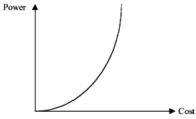
Figure 3.2 Power–cost relationship according to Grosch’s law.
According to Grosch’s law, in order to sell a computer for twice as much, it must be four times as fast. Alternatively, to do a computation twice as cheaply, one has to do it four times slower. With the advances in computing, it is easy to see that Grosch’s law is repealed, and it is possible to build faster and less expensive computers over time.

2.2- Amdahl’s Law
Recall that in Section 1.2 we defined the speedup factor of a parallel system as the ratio between the time taken by a single processor to solve a given problem instance to the time taken by a parallel system consisting of n processors to solve the same problem instance.
$$S(n)=\frac{\text{ts}}{\text{fts}+(1−f)\left(\text{ts}/n\right)}=\frac{n}{1+(n−1)f}$$
$$\underset{n→∞}{\text{lim}}S(n)=\frac{1}{f}$$
Similar to Grosch’s law, Amdahl’s law made it so pessimistic to build parallel computer systems due to the essential limit set on the performance improvement (speed) regardless of the number of processors used. An interesting observation to make here is that according to Amdahl’s law, f is fixed and does not scale with the problem size, n. However, it has been practically observed that some real parallel algorithms have a fraction that is a function of n. Let us assume that f is a function of n such that$\underset{n→∞}{\text{lim}}f(n)=0$. Hence,
$$\underset{n→∞}{\text{lim}}S(n)=\underset{n→∞}{\text{lim}}\frac{n}{1+(n−1)f(n)}=n$$
This is clearly in contradiction to Amdahl’s law. It is therefore possible to achieve a linear speedup factor for large-sized problems, given that$\underset{n→∞}{\text{lim}}f(n)=0$, a condition that has been practically observed. For example, researchers at the Sandia National Laboratories have shown that using a 1024-processor hypercube multiprocessor system for a number of engineering problems, a linear speedup factor can be achieved.
Consider, for example, the well-known engineering problem of multiplying a large square matrix A(mxm) by a vector X(m) to obtain a vector, that is, C(m) ← A(mxm) * X(m). Assume further that the solution of such a problem is performed on a binary tree architecture consisting of n nodes (processors). Initially, the root node stores the vector X(m) and the matrix A(mxm) is distributed row-wise among the n processors such that the maximum number of rows in any processor is$\left\lfloor \frac{m}{n}\right\rfloor +1$.
A simple algorithm to perform such computation consists of the following three steps:
1. The root node sends the vector X(m) to all processors in O(m log n)
2. All processors perform the product
in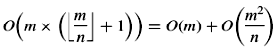
3. All processors send their ci values to the root node in O(m log n).
According to the above algorithm, the amount of computation needed is
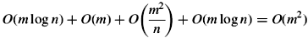
The indivisible part of the computation (steps 1 and 3) is equal to O(m)+ ‏ O(m log n). Therefore, the fraction of computation that is indivisible f (m) = (O(m) +‏ O(mlog n))/O(m²) = O((1+‏ log n)/m). Notice that $\underset{n→∞}{\text{lim}}f(n)=0$. Hence, contrary to Amdahl’s law, a linear speedup can be achieved for such a large-sized problem.
It should be noted that in presenting the above scenario for solving the matrix vector multiplication problem, we have assumed that the memory size of each processor is large enough to store the maximum number of rows expected. This assumption amounts to us saying that with n processors, the memory is n times larger. Naturally, this argument is more applicable to message passing parallel architectures than it is to shared memory ones. The Gustafson–Barsis law makes use of this argument and is presented below.

2.3- Gustafson–Barsis’s Law
In 1988, Gustafson and Barsis at Sandia Laboratories studied the paradox created by Amdahl’s law and the fact that parallel architectures comprised of hundreds of processors were built with substantial improvement in performance. In introducing their law, Gustafson recognized that the fraction of indivisible tasks in a given algorithm might not be known a priori. They argued that in practice, the problem size scales with the number of processors, n. This contradicts the basis of Amdahl’s law. Recall that Amdahl’s law assumes that the amount of time spent on the parts of the program that can be done in parallel, (1-f ), is independent of the number of processors, n.
Gustafson and Brasis suppose that when using a more powerful processor, the problem tends to make use of the increased resources. They found that to a first approximation the parallel part of the program, not the serial part, scales up with the problem size. They postulated that if s and p represent respectively the serial and the parallel time spent on a parallel system, then s +‏ p x n represents the time needed by a serial processor to perform the computation. They therefore, introduced a new factor, called the scaled speedup factor, SS(n), which can be computed as:
This equation shows that the resulting function is a straight line with a slope = (1-n). This shows clearly that it is possible, even easier, to achieve efficient parallel performance than is implied by Amdahl’s speedup formula. Speedup should be measured by scaling the problem to the number of processors, not by fixing the problem size.
Having considered computational models and rebutted some of the criticism set forth by a number of computer architects in the face of using parallel architectures, we now move to consider some performance issues in dynamic and static interconnection networks. The emphasis will be on the performance of the interconnection networks rather than the computational aspects of the processors.
Benchmarks
Benchmarks are a set of programs of program fragments used to compare the performance of various machines. Machines are exposed to these benchmark tests and tested for performance.
When it is not possible to test the applications of different machines, then the results of benchmark programs that most resemble the applications run on those machines are used to evaluate the performance of machine.
Kernel Benchmarks
[Program fragments which are extracted from real programs]
[Heavily used core and responsible for most execution time]
Synthetic Benchmarks
[Small programs created especially for benchmarking purposes]
[These benchmarks do not perform any useful computation]
Sources of Parallel Overhead
Parallel computers in practice do not achieve linear speedup or an efficiency of 1 because of parallel overhead. The major sources of which could be:
- Inter-processor Communication
- Load Imbalance
- Inter-Task Dependency
- Extra Computation
- Parallel Balance Point
Isoefficiency Function
The isoefficiency function can be used to measure scalability of the parallel computing systems.
It shows how the size of problem must grow as a function of the number of processors used in order to maintain some constant efficiency.
The general form of the function is derived using an equivalent definition of efficiency as follows:
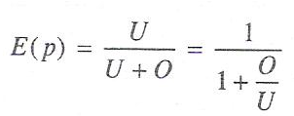
Where, U is the time taken to do the useful computation (essential work), and
O is the parallel overhead. (Note: O is zero for sequential execution).
If the efficiency is fixed at some constant value K then
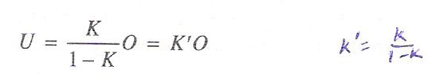
Where, K’ is a constant for fixed efficiency K.
This function is known as the isoefficiency function of parallel computing system.
A small isoefficiency function means that small increments in the problem size (U), are sufficient for efficient utilization of an increasing no. of processors, indicating high scalability.
A large isoeffcicnecy function indicates a poorly scalable system.

3- Interconnection Networks Performance Issues
In particular, it should review the definitions given about the diameter D, the degree d, and the symmetry of a network. In addition to those definitions, we provide the following definition.
(B)Channel bisection width of a network, B, is defined as the minimum number of wires that, when cut, divide the network into equal halves with respect to the number of nodes. The wire bisection is defined as the number of wires crossing this cut of the network. For example, the bisection width of a 4-cube is B = 8.
Table 3.1 provides some numerical values of the above topological characteristics for sample static networks. General expressions for the topological characteristics of a number of static interconnection networks are summarized in Table 3.2. It should be noted that in this table, N is the number of nodes and n is the number of dimensions.

TABLE 3.1 Topological Characteristics of Static Networks
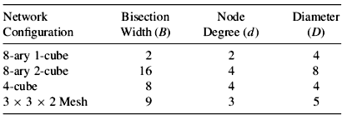

. Bandwidth The bandwidth of a network can be defined as the data transfer rate of the network. In a more formal way, the bandwidth is defined as the asymptotic traffic load supported by the network as its utilization approaches unity.
TABLE 3.2 Topological Characteristics of a Number of Static Networks
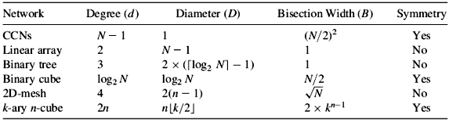

3.1- Bandwidth of a Crossbar
We will define the bandwidth for the crossbar as the average number of requests that can be accepted by a crossbar in a given cycle. As processors make requests for memory modules in a crossbar, contention can take place when two or more processors request access to the same memory module.
In general, for M memory modules and n processors, if a processor generates a request with probability ρ in a cycle directed to each memory with equal probability, then the expression for the bandwidth can be computed as follows. The probability that a processor requests a particular memory module is ρ/M. The probability that a processor does not request that memory module during a given cycle is (1 - ρ/M).
The probability that none of the n processors request that memory module during a cycle is
(1 - (ρ/M)) ^{n}
The probability that at least one request is made to that memory module is
(1-(1-(ρ/M)) ^{n})
Therefore, the expected number of distinct memory modules with at least one request (the bandwidth) is
BW = M(1-(1-(ρ/M))^{n}).
Notice that in case there is equal probability that any module be requested by a processor, then the term ρ/M in the above equation will become 1/M. Now, considering the case M = 3 and n = 3, the BW = 19/9 = 2.11, the same as before.
In deriving the above expression, we have assumed that all processors generate requests for memory modules during a given cycle. A similar expression can be derived for the case whereby only a fraction of processors generate requests during a given cycle.

3.2- Bandwidth of a Multiple Bus
We will develop an expression for the bandwidth of the general multiple bus arrangement shown in Figure 3.3. It consists of M memory modules, n processors, and B buses. A given bus is dedicated to a particular processor for the duration of a bus transaction. A processor–memory transfer can use any of the available buses.

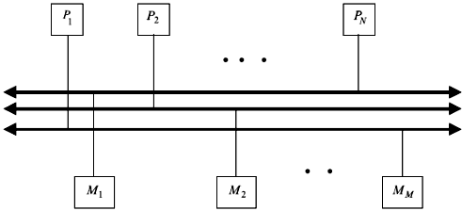
Figure 3.3 A multiple bus system.
The set of M arbiters accepts only one request for each memory module at any given time. Let us assume that a processor generates a request with probability ρ in a cycle directed to each memory with equal probability. Therefore, out of all possible memory requests, only up to M memory requests can be accepted. The probability that a memory module has at least one request is given by
$$β=1−{\left(1−\left(ρ/M\right)\right)}^{n}$$
Owing to the availability of only B buses, then of all memory requests, only B request can be satisfied. The probability that exactly k different memory modules are requested during a given cycle can be expressed as
$α=\left(\begin{matrix}N \\ k\end{matrix}\right)∗β^{k}∗{\left(1−β\right)}^{N−k}$.
Two cases have to be considered .These are the case where fewer than B different requests being made while fewer than B buses are being used and the case where B or more different requests are made while all B buses are in use. Given these two cases, the bandwidth of the B buses system can be expressed as:
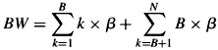

3.3- Bandwidth of a Multistage Interconnection Network (MIN)
In this subsection, we compute the bandwidth of a MIN. A simplifying assumption that we make is that the MIN consists of stages of a x b crossbar switches. One such MIN is the Delta network. This assumption is made such that the results we obtained for the bandwidth of the crossbar network can be utilized .Let us assume that the request rate at the input of the first stage is given by r₀. The number of requests accepted by the first stage and passed on to the next stage is
$R_{1}=(1−(1−(r_{0}/b))^{a})$.
The number of requests at any of the b output lines of the first stage is
$r_{1}=1−(1−(r_{0}/b))^{a}$.
Since these requests become the input to the next stage, then by analogy the number of requests at the output of the second stage is given by
$r_{2}=1−(1−(r_{1}/b))^{a}$.
This recursive relation can be extended to compute the number of requests at the output of stage j in terms of the rate of input requests passed on from stage j-1 as follows:
$r_{j}=1−(1−(r_{j−1}/b))^{a}$ for 1 ≤ j ≤ n
where n is the number of stages. Based on this, the bandwidth of the MIN is given by
.
Latency is defined as the total time required transmitting a message from a source node to a destination node in a parallel architecture machine.
It should be noted that parallel machines attempt to minimize the communication latency by increasing the interconnectivity. In our discussion, we will show the latency caused by the time spent in switching elements. Latency caused by software overhead, routing delay, and connection delay are overlooked in this discussion.
The latency of a k-ary n-cube is k x log₂ N, that of binary hypercube is given by (log₂ N), while that of a 2D mesh is given by $\sqrt{N}$.
Average distance, d_{a}, traveled by a message in a static network, is a measure of the typical number of links a message has to traverse as it makes its way from any source to any destination in the network. In a network consisting of N nodes, the average distance can be computed using the following relation:
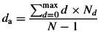
In the above relation N_{d} is the number of nodes separated by d links and max is the maximum distance necessary to interconnect two nodes in the network. Consider, for example, a 4-cube network. The average distance between two nodes in such a network can be computed as follows. We compute the distance between node (0000) and all other 15 nodes in the cube. These are shown in Table 3.3. From these, therefore, the average distance for a 4-cube is (32/15) ≈ 2.13.

TABLE 3.3 Distance from Node 0000 to all Other Nodes
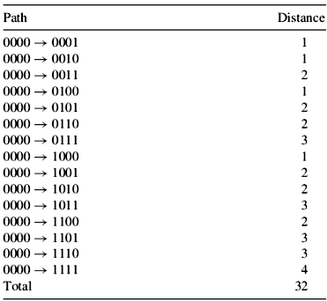

Complexity (Cost) of a static network can be measured in terms of the number of links needed to realize the topology of the network.
The cost of a k-ary n-cube measure in terms of the number of links is given by n x N, that of a hypercube is given by (n x N)/2, that of a 2D mesh (having N nodes) is given by 2(N-2), and that of a binary tree is given by (N- 1).
Interconnectivity of a network is a measure of the existence of alternate paths between each source–destination pair. The importance of network connectivity is that it shows the resistance of the network to node and link failures. Network connectivity can be represented by the two components: node connectivity and link connectivity.
Consider, for example, the binary tree architecture. The failure of a node, for example, the root node, can lead to the partitioning of the network into two disjoint halves. Similarly, the failure of a link can lead to the partitioning of the network. We therefore say that the binary tree network has a node connectivity of 1 and a link connectivity of 1.
Tables 3.4 and 3.5, provide overall performance comparison among different dynamic interconnection networks and different static networks, respectively. Having presented a number of performance measures for static and dynamic networks, we now turn our attention to the important issue of parallel architecture scalability.

TABLE 3.4 Performance Measure for a Number of Dynamic Networks
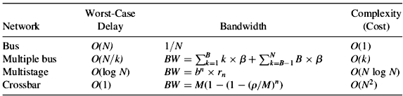
TABLE 3.5 Performance Measure for a Number of Static Networks
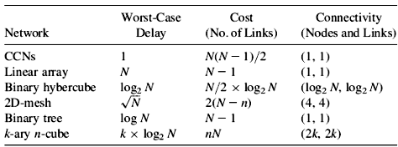

4- Scalability of Parallel Architectures
A parallel architecture is said to be scalable if it can be expanded (reduced) to a larger (smaller) system with a linear increase (decrease) in its performance (cost). This general definition indicates the desirability for providing equal chance for scaling up a system for improved performance and for scaling down a system for greater cost effectiveness and/or affordability.
Scalability is used as a measure of the system’s ability to provide increased performance, for example, speed as its size is increased. In other words, scalability is a reflection of the system’s ability to efficiently utilize the increased processing resources.
In terms of speed, a scalable system is capable of increasing its speed in proportion to the increase in the number of processors. Consider, for example, the case of adding m numbers on a 4-cube (n = 16 processors) parallel system. Assume for simplicity that m is a multiple of n. Assume also that originally each processor has (m/n) numbers stored in its local memory. The addition can then proceed as follows. First, each processor can add its own numbers sequentially in (m/n) steps. The addition operation is performed simultaneously in all processors.
Secondly, each pair of neighboring processors can communicate their results to one of them whereby the communicated result is added to the local result. The second step can be repeated (log₂ n) times, until the final result of the addition process is stored in one of the processors. Assuming that each computation and the communication takes one unit time then the time needed to perform the addition of these m numbers is
$T_{p}=\left(m/n\right)+2{\text{*log}}_{2}n$.
Recall that the time required to perform the same operation on a single processor is T_{s} = m. Therefore, the speedup is given by
$$S=\frac{m}{\left(m/n\right)+2{\text{*log}}_{2}n}$$
Table 3.6 provides the speedup S for different values of m and n. It is interesting to notice from the table that for the same number of processors, n, a larger instance of the same problem, m, results in an increase in the speedup, S. This is a property of a scalable parallel system.

TABLE 3.6 The Possible Speedup for Different m and n
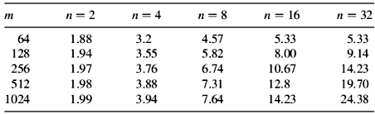

In terms of efficiency, a parallel system is said to be scalable if its efficiency can be kept fixed as the number of processors is increased, provided that the problem size is also increased. Consider, for example, the above problem of adding m numbers on an n-cube. The efficiency of such a system is defined as the ratio between the actual speedup, S, and the ideal speedup, n. Therefore, $ξ=(S/n)=m/(m+{\text{log}}_{2}n)$. Table 3.7 shows the values of the efficiency, $ξ$, for different values of m and n. The values in the table indicate that for the same number of processors, n, higher efficiency is achieved as the size of the problem, m, is increased. However, as the number of processors, n, increases, the efficiency continues to decrease.

TABLE 3.7 Efficiency for Different Values of m and n
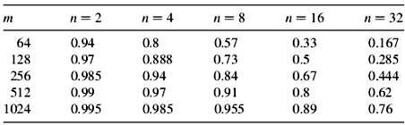

Given these two observations, it should be possible to keep the efficiency fixed by increasing simultaneously both the size of the problem, m, and the number of processors, n. This is a property of a scalable parallel system.
It should be noted that the degree of scalability of a parallel system is determined by the rate at which the problem size must increase with respect to n in order to maintain a fixed efficiency as the number of processors increases.
Recall that the time spent by each processor in performing parallel execution in solving the problem of adding m numbers on an n-cube is given by
$\left(m/n\right)+2{\text{*log}}_{2}n$.
Of this time, approximately (m=n) is spent performing the actual execution, while the remaining portion of the time, T_{oh}, is an overhead incurred in performing tasks such as interprocessor communication. The following relationship applies: T_{oh} = n x T_{p} - T_{s}. For example, the overall overhead for the addition problem considered above is given by T_{oh}= 2n- log₂ n. It is interesting to note that a sequential algorithm running on a single processor does not suffer from such overhead. Now, we can rewrite the expression for the efficiency as$ξ=m/(m+T_{\text{oh}})$, which leads to the equation$m=ξ/(1−ξ)T_{\text{oh}}$. Consider again the problem of adding m numbers using an n-cube. For this problem the problem size
$m={2∗ξ}/(1−ξ)∗n{\text{*log}}_{2}n=\text{Kn}{\text{*log}}_{2}n=Θ\left(n{\text{*log}}_{2}n\right)$.
The rate at which the problem size, m, is required to grow with respect to the number of processors, n, to keep the efficiency, $ξ$, fixed is called the isoefficiency of a parallel system and can be used as a measure of the scalability of the system. A highly scalable parallel system has a small isoefficiency, while a poor parallel system has a large isoefficiency. Theoretically speaking, a parallel system is considered scalable if its isoefficiency function exists; otherwise the system is considered not scalable. Recall that Gustafson has shown that by scaling up the problem size, m, it is possible to obtain near-linear speedup on as many as 1024 processors.
Having discussed the issues of speedup and efficiency of scalable parallel systems, we now conduct a discussion on their relationship. It is useful to indicate at the outset that typically an increase in the speedup of a parallel system (benefit), due to an increase in the number of processors, comes at the expense of a decrease in the efficiency (cost). In order to study the actual behavior of speedup and efficiency, we need first to introduce a new parameter, called the average parallelism (Q). It is defined as the average number of processors that are busy during the execution of given parallel software (program), provided that an unbounded number of processors are available. The average parallelism can equivalently be defined as the speedup achieved assuming the availability of an unbounded number of processors. A number of other equivalent definitions exist for the average parallelism. It has been shown that once Q is determined, then the following bounds are attainable for the speedup and the efficiency on an n-processor system:
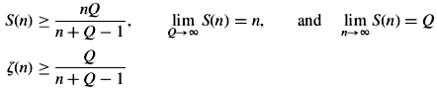

The above two bounds show that the sum of the attained fraction of the maximum possible speedup, S(n)=Q, and attained efficiency, must always exceed 1. Notice also that, given a certain average parallelism, Q, the efficiency (cost) incurred to achieve a given speedup is given by . It is therefore fair to say that the average parallelism of a parallel system, Q, determines the associated speedup versus efficiency tradeoff.
In addition to the above scalability metrics, there has been a number of other unconventional metrics used by some researchers. A number of these are explained below.
Size scalability measures the maximum number of processors a system can accommodate. For example, the size scalability of the IBM SP2 is 512, while that of the symmetric multiprocessor (SMP) is 64.
Application scalability refers to the ability of running application software with improved performance on a scaled-up version of the system. Consider, for example, an n-processor system used as a database server, which can handle 10,000 transactions per second. This system is said to possess application scalability if the number of transactions can be increased to 20,000 using double the number of processors.
Generation scalability refers to the ability of a system to scale up by using next generation (fast) components. The most obvious example for generation scalability is the IBM PCs. A user can upgrade his/her system (hardware or software) while being able to run their code generated on their existing system without change on the upgraded one.
Heterogeneous scalability refers to the ability of a system to scale up by using hardware and software components supplied by different vendors.

