Message Passing Architecture

Message passing systems provide alternative methods for communication and movement of data among multiprocessors (compared to shared memory multiprocessor systems). A message passing system typically combines local memory and the processor at each node of the interconnection network. There is no global memory so it is necessary to move data from one local memory to another by means of message passing. This is typically done by send/receive pairs of commands, which must be written into the application software by a programmer.
Figure 5.1 shows a high-level description of a message passing system. Each processor has access to its own local memory and can communicate with other processors using the interconnection network. These systems eventually gave way to Internet-connected systems where the processor/memory nodes are cluster nodes, servers, clients, or nodes in a greater grid.

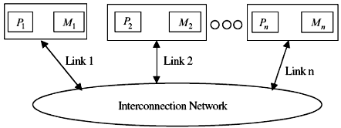
Figure 5.1 Message passing systems.

1- Introduction to Message Passing
A message passing architecture is used to communicate data among a set of processors without the need for a global memory. The basis for the scheme is that each processor has its own local memory and communicates with other processors using messages. The elimination of the need for a large global memory together with its synchronization requirement, gives message passing schemes an edge over shared memory schemes.
Figure 5.1 shows the main components of a message passing multiprocessor architecture. There are n nodes in the figure numbered N1 to Nn. A node Ni consists of a processor Pi and a local memory Mi. Each processor has its own address space. Nodes communicate with each other by links (called external channels) and via an interconnection network, normally a static-type network. In particular, hypercubes and the nearest-neighbor two-dimensional and three-dimensional mesh interconnection networks have received considerable attention over the years. Two important factors must be considered in designing message passing interconnection networks: link bandwidth and the network latency. The link bandwidth is defined as the number of bits that can be transmitted per unit of time (bits/s). Network latency is defined as the time to complete a message transfer through the network.
In executing a given application program, the program is divided into concurrent processes; each is executed on a separate processor. If the number of processes is larger than the number of processors, then more than one process will have to be executed on a processor in a time-shared fashion. Processes running on a given processor use what is called internal channels to exchange messages among themselves.
Processes running on different processors use the external channels to exchange messages. Data exchanged among processors cannot be shared; it is rather copied (using send/receive messages). An important advantage of this form of data exchange is the elimination of the need for synchronization constructs, such as semaphores, which results in performance improvement. In addition, a message passing scheme offers flexibility in accommodating a large number of processors in addition to being readily scalable. It should be noted that a given node can execute more than one process, each at a given time.
Figure 5.2 shows an example message passing system consisting of four processes. In this figure, a horizontal line represents the execution of each process and lines extended among processes represent messages exchanged among these processes. A message is defined as a logical unit for internode communication; it is considered as a collection of related information that travels together as an entity. A message can be an instruction, data, synchronization, or interrupt signals. A message passing system interacts with the outside world by receiving input message(s) and/or outputting message(s). It is essential that the outside world perceives a consistent behavior of a given message passing system.
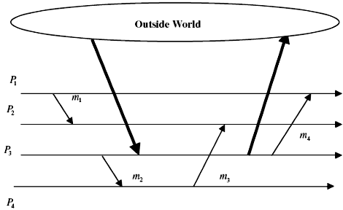
Figure 5.2 An example of a message passing system.
Process Granularity The size of a process in a message passing system can be described by a parameter called process granularity. This is defined as follows.
$$\text{Pr}\text{ocess Granularity }=\frac{\text{compution time}}{\text{communication time}}$$
Three types of granularity can be distinguished. These are:
1. Coarse granularity: Each process holds a large number of sequential instructions and takes a substantial amount of time to execute.
2. Medium granularity: Since the process communication overhead increases as the granularity decreases, medium granularity describes a middle ground where communication overhead is reduced.
3. Fine granularity: Each process contains a few sequential instructions (as few as just one instruction).
Message passing multiprocessors uses mostly medium or coarse granularity.

2- Routing in Message Passing Networks
Routing is defined as the techniques used for a message to select a path over the network channels. Formally speaking, routing involves the identification of a set of permissible paths that may be used by a message to reach its destination, and a function, h, that selects one path from the set of permissible paths.
A routing technique is said to be adaptive if, for a given source and destination pair, the path taken by the message depends on network conditions, such as network congestion. Contrary to adaptive routing, a deterministic routing technique, also called oblivious, determines the path using only the source and destination, regardless of the network conditions. Although simple, oblivious routing techniques make inefficient use of the bandwidth available between the source and destination.
Routing techniques can also be classified based on the method used to make the routing decision as centralized (self) or distributed routing. In centralized routing, the routing decisions regarding the entire path are made before sending the message. In distributed routing, each node decides by itself which channel should be used to forward the incoming message. Centralized routing requires complete knowledge of the status of the rest of the nodes in the network. Distributed routing requires knowledge of only the status of the neighboring nodes.
Examples of the deterministic routing algorithms include the e-cube or dimension order routing used in the mesh and tours multicomputer networks and the XOR routing in the hypercube. The following example illustrates the use of a deterministic routing technique in a hypercube network.

Example 1 Assume that S = S5S4 . . . S1S0 to be the source node address, and that D = D5D4 . . . D1D0 is the destination node address in a six-dimensional hypercube message passing system. Let $R=S⊕D$be the exclusive OR function executed bitwise for each node in the path. The results of the XOR-ing operation indicate the dimension in which the message should be sent in order to reach the destination.
Consider the case whereby S = 10(001010) and D = 39(100111). Then R = (101101); that is, the message has to be sent along dimensions 0, 2, 3, and 5 in order to reach the destination. The order in which these dimensions are traversed is not important. Let us assume that the message will follow the route by traversing the following dimensions 5, 3, 2, and 0. Then the route is totally determined as:
10(001010) →42(101010) →34(100010) →38(100110) →39(100111).

2.1- Routing for Broadcasting and Multicasting
There are two types of communication operations in message passing systems, that is, one-to-one (point-to-point or unicast) and collective communications. In unicast a node is allowed to communicate a message to only a single destination, which may be its immediate neighbors. A number of routing operations are defined under collective communication. Among these, broadcast and multicast are the most widely used. In broadcast, also known as the one-to-all operation, one node sends the same message to all other nodes. In multicast, also known as the one-to-many operation, one node sends its messages to k distinct destinations.
Broadcast is mainly used to distribute data from one node to others during computation of a distributed memory program. Multicast has several uses in large-scale multiprocessors, including parallel search algorithms and single program multiple data (SPMD) computation. Practical broadcast and multicast routing algorithms must be deadlock-free (see below) and should transmit the message to each destination node in as little time and using as short a path as possible. One technique to achieve this is to deliver the message along a common path to as many destinations as possible and then replicate the message and forward each copy on a different channel band for a unique set of destination nodes. The path followed by each copy may further branch in this manner until the message is delivered to every destination node. In such a tree-based communication model, the destination set is partitioned at the source and separate copies are sent on one or more outgoing links. A message may be replicated at intermediate nodes and forwarded along multiple outgoing links towards disjoint subsets of destinations. Another method to implement a multicast operation uses separate addressing. In this case, a separate copy of the message is sent directly from the source to every destination. Clearly, this is an inefficient technique. A hypercube broadcast tree-based nearest-neighbor communication is shown in Figure 5.3.

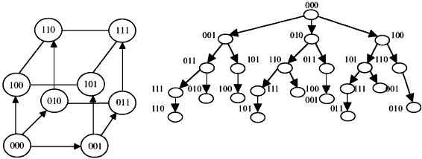
Figure 5.3 Hypercube broadcast tree-based communication.

2.2- Routing Potential Problems
A number of possible problems can result from the use of certain routing mechanisms in message passing systems. These include deadlock, livelock, and starvation, which are explained below.

Deadlock When two messages each hold the resources required by the other in order to move, both messages will be blocked. This is called a deadlock. It is a phenomenon that occurs whenever there exists cyclic dependency for resources. Management of resources in a network is the responsibility of the flow control mechanism used. Resources must be allocated in a manner that avoids deadlock.
A straightforward, but inefficient, way to solve the deadlock problem is to allow rerouting (maybe discarding) of the messages participating in a deadlock situation. Rerouting of messages gives rise to nonminimal routing, while discarding messages requires that messages be recovered at the source and retransmitted. This preemptive technique leads to long latency and, therefore, is not used by most message passing networks.
A more common technique is to avoid the occurrence of deadlock. This can be achieved by ordering network resources and requiring that messages request use of these resources in a strict monotonic order. This restricted way for using network resources prevents the occurrence of circular wait, and hence prevents the occurrence of deadlock. The channel dependency graph (CDG) is a technique used to develop a deadlock-free routing algorithm. A CDG is a directed graph D=G(C, E), where the vertex set C consists of all the unidirectional channels in the network and the set of edges E includes all the pairs of connected channels, as defined by the routing algorithm. In other words, if $(\text{ci, cj})∈\text{ E}$, then ci and cj are, respectively, an input channel and an output channel of a node and the routing algorithm may only route messages from ci to cj. A routing algorithm is deadlock-free if there are no cycles in its CDG. Consider, for example, the 4-node network shown in Figure 5.4a.
The CDG of the network is shown in Figure 5.4b. There are two cycles in the CDG and therefore this network is subject to deadlock. Figure 5.4c shows one possible way to avoid the occurrence of deadlock, that is, disallowing messages to be forwarded from channel c1 to c2 and from c7 to c8.

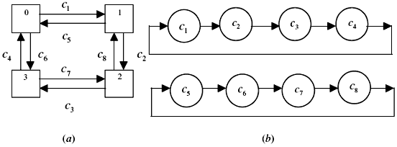

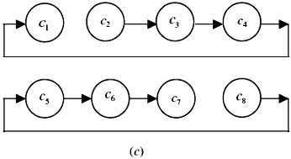
Figure 5.4 A 4-node network and its CDGs (a) a 4-node network; (b) channel dependency graph; and (c) CDG for a deadlock-free version of the network.

Livelock Livelock describes a situation in which a message keeps going around the network and never reaches its destination. It is a phenomenon that results from using adaptive routing algorithms where messages are rerouted in the hope to find another path to their destinations. When nodes need to communicate, they inject their messages into the network. A static injection model results when all nodes inject their messages at the same moment, with the network clear of messages.
This is to be compared to dynamic injection, according to which nodes can inject their messages at arbitrary times. Livelock can take place if dynamic injection is used. It cannot occur if static injection is used. A number of routing policies can be used to avoid livelock. They are based on the following. Let S be a set of priorities that is totally ordered. Whenever a message is injected into the network, some priority is assigned to it. In order to avoid livelock, the following must hold.
1. Messages are routed according to their priorities;
2. Once a message has been injected, only a finite number of messages will be injected with higher or equal priority.

Starvation A node is said to suffer from starvation if it has a message to inject into the network but is never allowed to do so. Starvation cannot arise if static injection is used. A number of routing policies can be used in order to avoid starvation taking place. The simplest among them is to allow each node to have its injection queue, where it stores the messages it wants to inject into the network. This queue is considered in the same way as the queues of the incoming links to that node and it competes with them. As long as a fair queue management policy is used, this method prevents starvation from happening. The main disadvantage is that a node with a high message injection rate can slow down all the other nodes in the network.

3- Switching Mechanisms in Message Passing
Switching mechanisms refer to the mechanisms used to remove data from an input channel and place it on an output channel. Network latency is highly dependent on the switching mechanism used. A number of switching mechanisms have been in use. These are the store-and-forward, circuit-switching, virtual cut-through, wormhole, and pipelined circuit-switching. In this section, we study some of these techniques.
In circuit-switching networks, the path between the source and destination is first determined, all links along that path are reserved, and no buffers are needed in each node. After data transfer, reserved links are released for use by other messages. An important characteristic of the circuit-switching technique is that the source and destination are guaranteed a certain bandwidth and maximum latency when communication is established between them. This static bandwidth allocation regardless of the actual use is the main drawback of the circuit-switching approach. However, static bandwidth allocation leads to a simple buffering strategy. In addition, circuit switching networks are characterized by having the smallest amount of delay. This is because message routing overhead is only needed when the circuit is set up; subsequent messages suffer no, or minimal, additional delay. Therefore, circuit switching networks can be advantageously used in the case of a large number of message transfers.
The store-and-forward switching mechanism provides an alternate data transfer scheme. The main idea is to offer dynamic bandwidth allocation to messages as they flow through the network, thus avoiding the main drawback of the circuit switching mechanism. Two main types of store-and-forward networks are common. These are packet-switched and virtual cut-through networks. In packet-switched networks, each message is divided into smaller fixed size parts, called packets, before being transmitted. Each node must contain enough buffers to hold received packets before transmitting them. A complete path from source to destination may not be available at the start of transmission. As links become available, packets are moved from node to node until they reach the destination node. Since packets are routed separately through the network, they may follow different paths to the destination node. This may lead to packets arriving out of order at the destination. Therefore, an end-to-end message assembly scheme is needed, incurring additional overhead. Packet-switched networks suffer also from the need for routing overhead for each packet, rather than message, sent into the network. In addition to dynamically allocating bandwidth, packet-switched networks have the advantage of reduced buffer requirements in each node.
In virtual cut-through, a packet is stored at an intermediate node only if the next required channel is busy. Virtual cut-through is similar to the packet-switching technique, with the following difference. In contrast to packet switching, when a packet arrives at an intermediate node and its selected outgoing channel is free, the packet is sent out to the adjacent node towards its destination before it is completely received. Therefore, the delay due to unnecessary buffering in front of an idle channel is avoided.
In order to reduce the size of the required buffers and decrease the incurred network latency, a technique called wormhole routing has been introduced. Here, a packet is divided into smaller units called flits (flow control bits). These flits move in a pipeline fashion with a header flit leading the way to the destination node. When the header flit is blocked due to network congestion, the remaining flits are also blocked. Only a buffer that can store a flit is required for a successful operation of the wormhole routing technique. The technique is known to produce a latency that is independent of the path length and it requires less storage at all nodes compared to the store-and-forward packet-switching technique.
Figures 5.5 and 5.6 illustrate the difference in performance between the storeand-forward (SF) and wormhole (WH) routing in terms of communication latency.
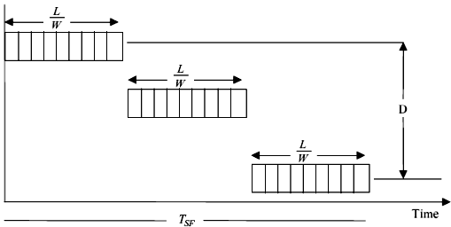
Figure 5.5 Communication latency in the store-and-forward (SF) technique.
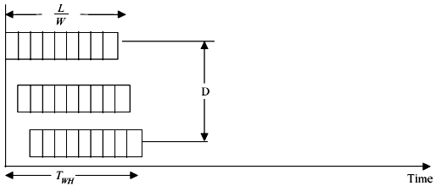
Figure 5.6 Communication latency in the wormhole (WH) technique.

In these figures, L represents the packet length in bits, W represents the channel bandwidth in bits/cycle, D is the number of channels, and Tc is the cycle time. As can be seen from the figures, the latency of the SF and that of the WH are given respectively by
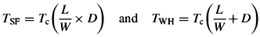
Table 5.1 shows an overall comparison of a number of switching mechanisms.
Switching Mechanism | Advantages | Disadvantages
Circuit switching | 1. Suitable for long messages  2. Deadlock-free | Wasting of bandwidth
Store-and-forward | 1. Simple  2. Suitable for interactive traffic  3. Bandwidth on demand | 1. Buffer for every packet  2. Potential long latency  3. Potential deadlock
Virtual cut-through | 1. Good for long messages  2. Possible deadlock avoidance  3. Elimination of data-link protocol | 1. Need for multiple message buffers  2. Wasting of bandwidth  3. Mainly used with profitable routing
Wormhole | 1. Good for long messages  2. Reduced need for buffering  3. Reduced effect of path length | 1. Possibility for deadlock  2. Inability to support backtracking

