Abstract Models

In a shared memory system, processing elements communicate with each other via shared variables in the global memory, while in message passing systems, each processing element has its own local memory and communication is performed via message passing. In this lecture, we study abstract models for both shared memory and message passing systems. We will study several parallel and distributed algorithms and evaluate their complexities using these models.
At first glance, abstract models may appear to be inappropriate in real-world situations due to their idealistic nature. However, abstract machines have been very useful in studying parallel and distributed algorithms and evaluating their anticipated performance independent of real machines. Clearly, if the performance of an algorithm is not satisfactory on an abstract system, it is meaningless to implement it on a real system. Although abstract models do not consider some practical considerations in real parallel and distributed systems, they focus on the computational aspects of the algorithmic complexity, which makes it less difficult to find performance bounds and complexity estimates.
We begin by discussing a model of shared memory systems called PRAM (Parallel Random Access Machine). We will study the PRAM model and the relationships between its different variations. We will also present a computational model for synchronous message passing systems. We will discuss complexity analysis of algorithms described in terms of both PRAM and message passing models. A number of algorithms for both models will be presented and evaluated.

1- The PRAM Model and Its Variations
The purpose of the theoretical models for parallel computation is to give frameworks by which we can describe and analyze algorithms. These ideal models are used to obtain performance bounds and complexity estimates. One of the models that has been used extensively is the parallel random access machine (PRAM) model. The PRAM model was introduced by Fortune and Wyllie in 1978 for modeling idealized parallel computers in which communication cost and synchronization overhead are negligible.
A PRAM consists of a control unit, a global memory shared by p processors, each of which has a unique index as follows: P₁, P₂, . . . , P_{p} . In addition to the global memory via which the processors can communicate, each processor has its own private memory. Figure 6.1 shows a diagram illustrating the components in the PRAM model.
The p processors operate on a synchronized read, compute, and write cycle. During a computational step, an active processor may read a data value from a memory location, perform a single operation, and finally write back the result into a memory location. Active processors must execute the same instruction, generally, on different data. Hence, this model is sometimes called the shared memory, single instruction, multiple data (SM SIMD) machine.
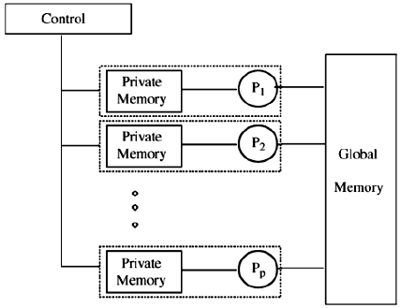
Figure 6.1 PRAM model for parallel computations.

Algorithms are assumed to run without interference as long as only one memory access is permitted at a time. We say that PRAM guarantees atomic access to data located in shared memory. An operation is considered to be atomic if it is completed in its entirety or it is not performed at all (all or nothing).
There are different modes for read and write operations in a PRAM. These different modes are summarized as follows:
. Exclusive read (ER): Only one processor can read from any memory location at a time.
. Exclusive write (EW): Only one processor can write to any memory location at a time.
. Concurrent read (CR): Multiple processors can read from the same memory location simultaneously.
. Concurrent write (CW): Multiple processors can write to the same memory location simultaneously. Write conflicts must be resolved using a well-defined policy such as:
Common: All concurrent writes store the same value.
Arbitrary: Only one value selected arbitrarily is stored. The other values are ignored.
Minimum: The value written by the processor with the smallest index is stored. The other values are ignored.
Reduction: All the values are reduced to only one value using some reduction function such as sum, minimum, maximum, and so on.
Based on the different modes described above, the PRAM can be further divided into the following subclasses:
. EREW PRAM: Access to any memory cell is exclusive. This is the most restrictive PRAM model.
. ERCW PRAM: This allows concurrent writes to the same memory location by multiple processors, but read accesses remain exclusive.
. CREW PRAM: Concurrent read accesses are allowed, but write accesses are exclusive.
. CRCW PRAM: Both concurrent read and write accesses are allowed.

2- Simulating Multiple Accesses on an EREW PRAM
The EREWPRAM model is considered the most restrictive among the four subclasses discussed in the previous section. Only one processor can read from or write to a given memory location at any time. An algorithm designed for such a model must not rely on having multiple processors access the same memory location simultaneously in order to improve its performance. Obviously, an algorithm designed for an EREW PRAM can run on a CRCWPRAM. The algorithm simply will not use the concurrent access features in the CRCW PRAM. However, the contrary is not true, an algorithm designed for CRCW cannot run on an EREW PRAM.
Is it possible to simulate concurrent access in the EREW model? The answer is yes. In general, any algorithm designed to run on a given model can be simulated on a more restrictive model at the price of more time and/or memory requirements. Clearly, the EREW PRAM model is the most restrictive among the four PRAM subclasses. Hence, it is possible to simulate the concurrent read and write operations on an EREW PRAM. In what follows, we show that this simulation can be done at the price of O(log p) time and O(p) memory, where p is the number of processors, using a broadcasting procedure.
Suppose that a memory location x is needed by all processors at a given time in a PRAM. Concurrent read by all processors can be performed in the CREW and CRCW cases in constant time. In the EREW case, the following broadcasting mechanism can be followed:
1. P1 reads x and makes it known to P2.
2. P1 and P2 make x known to P3 and P4, respectively, in parallel.
3. P1, P2, P3, and P4 make x known to P5, P6, P7, and P8, respectively, in parallel.
4. These eight processors will make x known to another eight processors, and so on.
In order to represent this algorithm in PRAM, an array L of size p is used as a working space in the shared memory to distribute the contents of x to all processors. Initially P1 will read x in its private memory and writes it into L[1]. Processor P2, will read x from L[1] into its private memory and write it into L[2]. Simultaneously, P3 and P4 read x from L[1] and L[2], respectively, then write them into L[3] and L[4], respectively. Processors P5 , P6 , P7 , and P8 will then simultaneously read L[1], L[2], L[3], and L[4], respectively, in parallel and write them into L[5], L[6], L[7], and L[8], respectively. This process will continue until eventually all the processors have read x. Figure 6.2 illustrates the idea of Algorithm Broadcast_EREW, when p = 8.
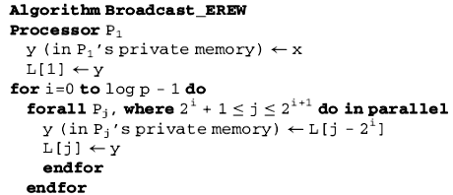
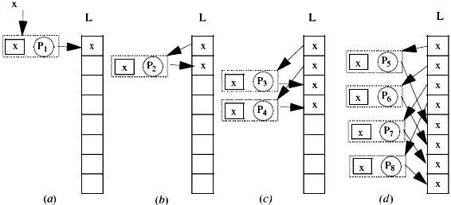Figure 6.2 Simulating concurrent read on EREW PRAM with eight processors using algorithm broadcast_EREW.

Since the number of processors having read x doubles in each iteration, the procedure terminates in O(log p) time. The array L is the price paid in terms of memory, which is O(p).

3- Analysis of Parallel Algorithms
The complexity of a sequential algorithm is generally determined by its time and space complexity. The time complexity of an algorithm refers to its execution time as a function of the problem’s size. Similarly, the space complexity refers to the amount of memory required by the algorithm as a function of the size of the problem. The time complexity has been known to be the most important measure of the performance of algorithms. An algorithm whose time complexity is bounded by a polynomial is called a polynomial–time algorithm. An algorithm is considered to be efficient if it runs in polynomial time. Inefficient algorithms are those that require a search of the whole enumerated space and have an exponential time complexity.
For parallel algorithms, the time complexity remains an important measure of performance. Additionally, the number of processors plays a major role in determining the complexity of a parallel algorithm. In general, we say that the performance of a parallel algorithm is expressed in terms of how fast it is, and how many resources it uses when it runs. These criteria can be measured quantitatively as follows:
1. Run time, which is defined as the time spent during the execution of the algorithm.
2. Number of processors the algorithm uses to solve a problem.
3. The cost of the parallel algorithm, which is the product of the run time and the number of processors.
The run time of a parallel algorithm is the length of the time period between the time the first processor to begin execution starts and the time the last processor to finish execution terminates. However, since the analysis of algorithms is normally conducted before the algorithm is even implemented on an actual computer, the run time is usually obtained by counting the number of steps in the algorithm. The cost of a parallel algorithm is basically the total number of steps executed collectively by all processors. If the cost of an algorithm is C, the algorithm can be converted into a sequential one that runs in O(C) time on one processor. A parallel algorithm is said to be cost optimal if its cost matches the lower bound on the number of sequential operations to solve a given problem within a constant factor. It follows that a parallel algorithm is not cost optimal if there exists a sequential algorithm whose run time is smaller than the cost of the parallel algorithm.
It may be possible to speed up the execution of a cost-optimal PRAM algorithm by increasing the number of processors. However, we should be careful because using more processors may increase the cost of the parallel algorithm. Similarly, a PRAM algorithm may use fewer processors in order to reduce the cost. In this case the execution may be slowed down and offset the decrease in the number of processors. Therefore, using fewer processors requires that we make them work more efficiently. Further details on the relationship between the run time, number of processors, and optimal cost can be found in Brent (1974).
In order to design efficient parallel algorithms, one must consider the following general rules. The number of processors must be bounded by the size of the problem. The parallel run time must be significantly smaller than the execution time of the best sequential algorithm. The cost of the algorithm is optimal.

3.1- The NC-Class and P-Completeness
In the theory of sequential algorithms, we distinguish between tractable and intractable problems by categorizing them into different classes. For those who are not familiar with these classes, we define them in simple terms. A problem belongs to class P if a solution of the problem can be obtained by a polynomial-time algorithm.
A problem belongs to class NP if the correctness of a solution for the problem can be verified by a polynomial-time algorithm. Clearly, every problem in P will also be in NP, or$P⊆\text{NP}$. It remain an open problem whether $P⊂\text{NP}$or$P=\text{NP}$. However, it is not likely that $P=\text{NP}$since this would imply that solving a problem is as easy as verifying whether a given solution to the problem is correct. A problem is in the class NP-hard if it is as hard as any problem in NP. In other words, every NP problem is polynomial-time reducible to any NP-hard problem. The existence of a polynomial-time algorithm for an NP-hard problem implies the existence of polynomial solutions for every problem in NP. Finally, NP-complete problems are the NP-hard problems that are also in NP.
The NP-complete problems are the problems that are strongly suspected to be computationally intractable. There is a host of important problems that are roughly equivalent in complexity and form the class of NP-complete problems. This class includes many classical problems in combinatorics, graph theory, and computer science such as the traveling salesman problem, the Hamilton circuit problem, and integer programming. The best known algorithms for these problems could take exponential time on some inputs. The exact complexity of these NP-complete problems has yet to be determined and it remains the foremost open problem in theoretical computer science. Either all these problems have polynomial-time solutions, or none of them does.
Similarly, in the world of parallel computation, we should be able to classify problems according to their use of the resources: time and processors. Let us define the class of the well-parallelizable problems, called NC, as the class of problem that have efficient parallel solutions. It is the class of problems that are solvable in time bounded by a polynomial in the log of the input size using a number of processors bounded by a polynomial in the input size. The time bound is sometimes referred to as polylogarithmic because it is polynomial in the log of the input size. In other words, the problems that can be solved by parallel algorithms that take polylogarithmic time using a polynomial number of processors, are said to belong to the class NC. The problems in the class NC are regarded as having efficient parallel solutions. The question now is: what is the relation between NC and P? It remain an open question whether$\text{NC}⊂P$ or$\text{NC}=P$. It appears that some problems in P cannot be solved in polylogarithmic time using a polynomial number of processors. Thus, it is not likely that $\text{NC}=P$.
We finally discuss the P-complete problems. A problem is in the class P-complete if it is as hard to parallelize as any problem in P. In other words, every P problem is polylogarithmic-time reducible to any P-complete problem using a polynomial number of processors. Also, the existence of a polylogarithmic-time algorithm for a P-complete problem implies the existence of polylogarithmic solutions for every problem in P using a polynomial number of processors. In other words, a P-complete problem is the problem that is solvable sequentially in polynomial time, but does not lie in the class NC unless every problem solvable in sequential polynomial time lies in NC. Among examples of P-complete problems are a depth-first search of an arbitrary graph, the maximum-flow problem, and the circuit value problem. The relationships between all these classes are illustrated in Figure 6.3, if we assume that $P⊂\text{NP}$and$\text{NC}⊂P$.

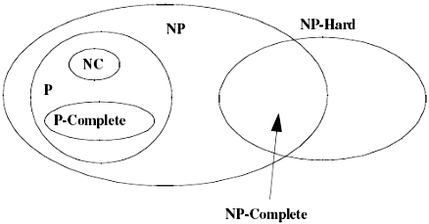
Figure 6.3 The relationships among P, NP, NP-complete, NP-hard, NC, and P-complete($P⊂\text{NP}$and$\text{NC}⊂P$).

4- Computing Sum and All Sums
In this section, we design a PRAM algorithm to compute all partial sums of an array of numbers. Given n numbers, stored in array A [1 . . n], we want to compute the partial sums A[1], A[1]+A[2], A[1]+A[2]‏+A[3],…………., A[1]+A[2]+…..+‏A[n]. At first glance, one might think that accumulating sums is an inherently serial process, because one must add up the first k elements before adding in element k+1. We will show that parallelism can be exploited in solving this problem.
To make it easy for the reader to understand the algorithm, we start by developing a similar algorithm for the simpler problem of computing the simple sum of an array of n values. Then we extend the algorithm to compute all partial sums using what is learned from the simple summation problem. In all cases we provide description of the algorithm, complexity analysis, and an example that illustrates how the algorithm works.

4.1- Sum of an Array of Numbers on the EREW Model
In this section, we discuss an algorithm to compute the sum of n numbers. Summation can be done in time O(log n) by organizing the numbers at the leaves of a binary tree and performing the sums at each level of the tree in parallel.
We present this algorithm on an EREW PRAM with n/2 processors because we will not need to perform any multiple read or write operations on the same memory location. Recall that in an EREW PRAM, read and write conflicts are not allowed. We assume that the array A[1 . . n] is stored in the global memory. The summation will end up in the last location A[n]. For simplicity, we assume that n is an integral power of 2. The algorithm will complete the work in log n iterations as follows. In the first iteration, all the processors are active. In the second iteration, only half of the processors will be active, and so on. The details are described in Algorithm Sum_EREW given below.
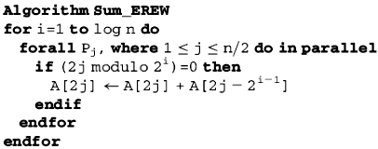

Complexity Analysis The for loop is executed log n times, and each iteration has constant time complexity. Hence the run time of the algorithm is O(log n). Since the number of processors used is n/2, the cost is obviously O(n log n). The complexity measures of Algorithm Sum_EREW are summarized as follows:
1. Run time, T(n) = O(log n).
2. Number of processors, P(n) = n/2.
3. Cost, C(n) = O(n log n).
Since a good sequential algorithm can sum the list of n elements in O(n), this algorithm is not cost optimal.

Example 1 Figure 6.4 illustrates the algorithm on an array of eight elements: 5, 2, 10, 1, 8, 12, 7, 3. In order to sum eight elements, three iterations are needed as follows. In the first iteration, processors P1, P2, P3, and P4 add the values stored at locations 1, 3, 5, and 7 to the numbers stored at locations 2, 4, 6, and 8, respectively.
In the second iteration, processors P2 and P4 add the values stored at locations 2 and 6 to the numbers stored at locations 4 and 8, respectively. Finally, in the third iteration processor P4 adds the value stored at location 4 to the value stored at location 8. Thus, location 8 will eventually contain the sum of all numbers in the array.

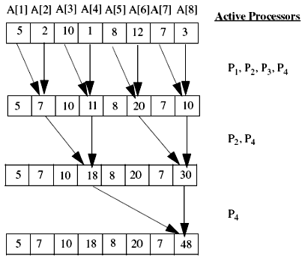
Figure 6.4 Example of Algorithm Sum-EREW when n = 8.

4.2- All Partial Sums of an Array
Take a closer look at Algorithm Sum_EREW and notice that most of the processors are idle most of the time. However, by exploiting the idle processors, we should be able to compute all partial sums of the array in the same amount of time it takes to compute the single sum. We present Algorithm AllSums_EREW to calculate all partial sums of an array on an EREW PRAM with n-1 processors (P2, P3, . . . , Pn). Again the elements of the array A[1 . . n] are assumed to be in the global shared memory. The partial sum algorithm replaces each A[k] by the sum of all elements preceding and including A[k].
In Algorithm Sum_EREW presented earlier, during iteration i, only n/2^{i} processors are active, while in the algorithm we present here, nearly all processors are in use. The details of the algorithm are shown in Algorithm AllSums_EREW:

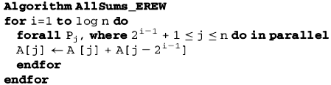
The picture given in Figure 6.5 illustrates the three iterations of the algorithm on an array of eight elements named A[1] through A[8].

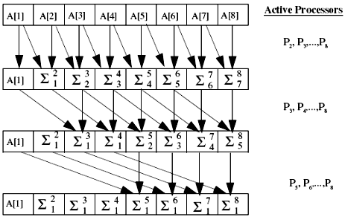
Figure 6.5 Computing partial sums of an array of eight elements.

Complexity Analysis The complexity measures of Algorithm AllSums_EREW are summarized as follows:
1. Run time, T(n) = O(log n).
2. Number of processors, P(n) = n - 1.
3. Cost, C(n) = O(n log n).
Is Algorithm AllSums-EREW cost optimal?

