General-Purpose Microprocessors

1- Overview of the CPU Design
A general-purpose microprocessor is often referred to as the central processing unit (CPU). The CPU is simply a dedicated microprocessor that only executes software instructions. In designing a CPU, we must first define its instruction set and how the instructions are encoded and executed. We need to answer questions such as how many instructions do we want? What are the instructions? What operation code (opcode) do we assign to each of the instructions? How many bits do we use to encode an instruction?
Once we have decided on the instruction set, we can proceed to designing a datapath that can execute all the instructions in the instruction set. In this step we are creating a custom datapath, so we need to answer questions such as what functional units do we need? How many registers do we need? Do we use a single register file or separate registers? How the different units are connected together?
Finally, we can design the control unit. Just like the dedicated microprocessor, the control unit asserts the control signals to the datapath. This finite-state machine cycles through three main steps or states: 1) fetch an instruction; 2) decode the instruction; and 3) execute the instruction. The control unit performs these steps by sending the appropriate control signals to the datapath or to external devices.
Instructions in your program are usually stored in external memory, so in addition to the CPU, there is external memory that is connected to the CPU via an address bus and a data bus. Hence, step 1 (fetch an instruction) usually involves the control unit setting up a memory address on the address bus and telling the external memory to output the instruction from that memory location onto the data bus. The control unit then reads the instruction from the data bus. To keep our design simple, instead of having external memory, we will put the memory directly inside the CPU and implemented simply as a 64-byte array. In fact, there are real CPUs with internal program memory.
For step 2 (decode the instruction) the control unit extracts the opcode bits from the instruction and determines what the current instruction is by jumping to the state that has been assigned for executing that instruction. Once in that particular state, the finite-state machine performs step 3 by simply asserting the appropriate control signals for controlling the datapath to execute that instruction.

2- Instruction Set
The instructions that our general-purpose microprocessor can execute and the corresponding encoding are defined in Figure 1. The Instruction column shows the syntax and mnemonic to use for the instruction when writing a program in assembly language. The Encoding column shows the binary encoding for the instructions and the Operation column shows the actual operation of the instruction. The instructions are separated into four categories:
1) Data movement instructions for transferring data between the accumulator, the general registers and the memory; 2) Jump instructions for changing the instruction execution sequence; 3) Arithmetic and logical instructions for performing arithmetic and logics; and 4) Input / output and miscellaneous instructions. There are five data movement instructions, eight jump instructions, ten arithmetic and logic instructions, two input/output instructions, and two miscellaneous instructions.
The number of instructions implemented determines the number of bits required to encode all the instructions. All instructions are encoded using one byte except for instructions that have a memory address as one of its operand, in which case a second byte for the address is needed. The encoding scheme uses the first four bits as the opcode. Depending on the opcode, the last four bits are interpreted differently as follows.

2.1- Two Operand Instructions
If the instruction requires two operands, it always uses the accumulator (A) for one operand. If the second operand is a register then the last three bits in the encoding specifies the register file number. An example of this is the LDA (load accumulator from register) instruction where it loads the accumulator with the content of the register file number specified in the last three bits of the encoding. Another example is the ADD (add) instruction where it adds the content of the accumulator with the content of the specified register file and put the result in the accumulator. The result of all arithmetic and logical operations is stored in the accumulator.
The LDI (load accumulator with immediate value) is also a two-operand instruction. However, the second operand is an immediate value that is obtained from the second byte of the instruction itself (iiiiiiii). These eight bits are interpreted as a signed number and is loaded into the accumulator.

2.2- One Operand Instructions
One-operand instructions always use the accumulator and the result is stored back in the accumulator. In this case, the last four bits in the encoding are used to further decode the instruction. An example of this is the INC (increment accumulator) instruction. The opcode (1110) is used by all the one-operand arithmetic and logical instructions. The last four bits (0001) specify the INC instruction.

2.3- Instructions Using a Memory Address
For instructions that have a memory address as one of its operand, an additional six bits are needed in order to access the 64 bytes of memory space. These six bits (aaaaaa) are specified in the six least significant bits of the second byte of the instruction. An example is the LDM (load accumulator from memory) instruction. The address of the memory location where the data is to be loaded from is specified in the second byte. In this case, the last four bits of the first byte and the first two bits in the second byte are not used and are always set to 0. All the absolute jump instructions follow this format.

2.4- Jump Instructions
For jump instructions, the last four bits of the encoding also serves to differentiate between absolute and relative jumps. If the last four bits are zeros, then it is an absolute jump, otherwise, they represent a sign and magnitude format relative displacement from the current location as specified in the program counter (PC). For example, the two-byte encoding 0110 0000 0000 0100 specifies an absolute unconditional jump to memory location 4. The first four bits (0110) specify the unconditional jump. The second four bits (0000) specify an absolute jump. The last six bits (000100) specify the memory address 4.
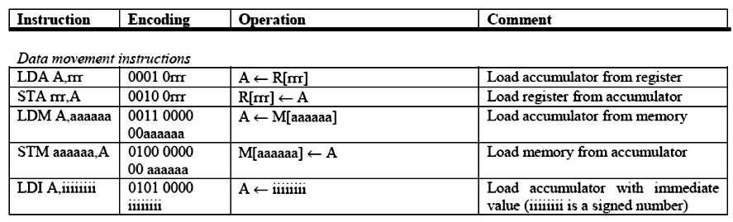
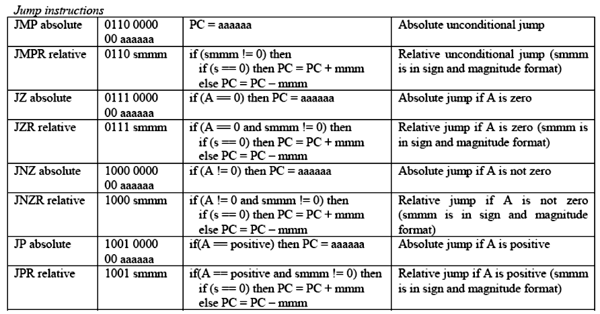
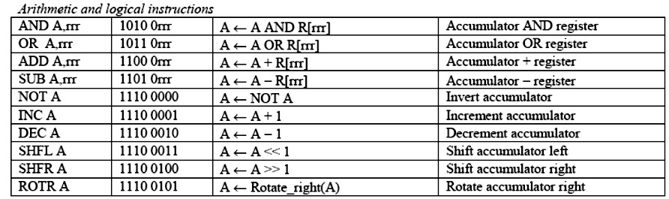
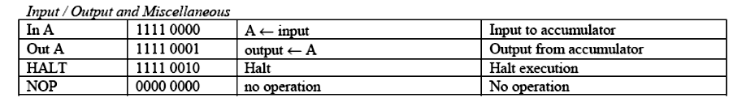
Notations:
A = accumulator.
R = general register.
M = memory.
PC = program counter.
rrr = three bits for specifying the general register number (0 – 7).
aaaaaa = six bits for specifying the memory address.
iiiiiiii = an eight bit signed number.
smmm = four bits for specifying the relative jump displacement in sign and magnitude format. The most significant bit (s) determines whether to jump forward or backward (0 = forward, 1 = backward). The last three bits (mmm) specify the number of locations to increment or decrement from the current PC location.

Figure 1. Instruction set for the general-purpose microprocessor.

On the other hand, the one-byte encoding 0110 0100 specifies a relative unconditional jump to PC+4. Again, the first four bits (0110) specify the unconditional jump. The next four bits (0100) specify that it is a relative jump because it is not zero. The relative position to jump to is +4 because the first bit is a 0, which is for forward and the last three bits evaluate to 4. To jump backward by four locations, we would use 1100 instead.
Two conditional flags (zero and positive) are used for conditional jumps. These flags are set or reset depending on the value of the accumulator when the accumulator is written to. Instructions that modify the accumulator include LDA, LDM, LDI, all the arithmetic and logic instructions, and IN. For example, if the result of the ADD instruction is a positive number, then the zero flag will be reset and the positive flag will be set. A conditional jump then reads the value of these flags to see whether to jump or not. The JZ instruction will not jump after the previous ADD instruction, where as the JP instruction will perform the jump.
3- Datapath
Having defined the instruction set for our general microprocessor, we are now ready to design the custom datapath that can execute all the operations as defined by all the instructions. We will follow the method described custom datapath at the register-transfer level. The resulting datapath is shown in Figure 2.
The width of the datapath is eight bits, i.e. all the connections for data movement are eight bits wide. In the figure, they are the thicker lines. The remaining thinner control lines are all one bit wide unless the name for that control line has a number subscript such as rfaddr_dp2,1,0, in which case there are as many lines as the subscript numbers. For example, the control line label rfaddr_dp2,1,0 is actually composed of three separate lines.

3.1- Input multiplexer
The 4-to-1 input MUX at the top of the datapath drawing selects one of four different inputs to be written into the accumulator. These four inputs, starting from the left, are: (1) imm_dp for getting the immediate value from the LDI instruction and storing it into the accumulator; (2) input_dp for getting a user input value for the IN instruction; (3) the next input selection allows the content of the register file to be written to the accumulator as used by the LDA instruction; (4) allows the result of the ALU and the shifter to be written to the accumulator as used by all the arithmetic and logical instructions.

3.2- Conditional Flags
The two conditional flags, zero and positive, are set by two comparators that check the value at the output of the MUX which is the value that is to be written into the accumulator for these two conditions. To check for a value being zero, recall that just a NOR gate will do. In our case, we need an eight-input NOR gate because of the 8-bit wide databus. To check for a positive number, we simply need to look at the most significant sign bit. A 2’s complement positive number will have a zero sign bit, so a single inverter connected to the most significant bit of the databus is all that is needed to generate this positive flag signal.

3.3- Accumulator
The accumulator is a standard 8-bit wide register with a write wr and clear clear control input signals. The write signal, connected to accwr_dp, is asserted whenever we want to write a value into the accumulator. The clear signal is connected to the main computer reset signal rst_dp, so that the accumulator is always cleared on reset. The content of the accumulator is always available at the accumulator output. The value from the accumulator is sent to three different places: (1) it is sent to the output buffer for the OUT instruction; (2) it is used as the first (A) operand for the ALU; and (3) it is sent to the input of the register file for the STA instruction.

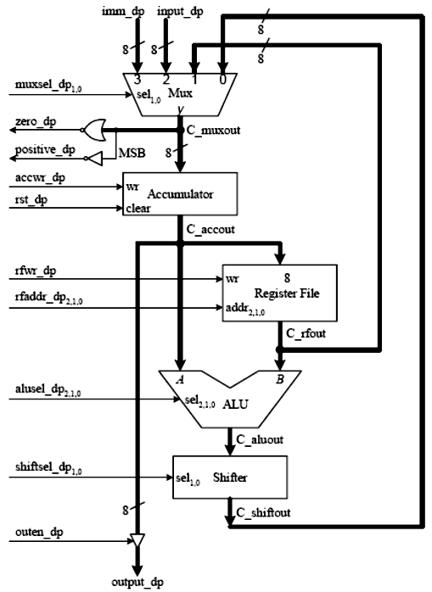

Figure 2. Datapath.

