The Microarchitecture of the Pentium 4 Processor

Abstract
The Intel® NetBurst™ microarchitecture of Intel’s new flagship Pentium® 4 processor. This microarchitecture is the basis of a new family of processors from Intel starting with the Pentium 4 processor. The Pentium 4 processor provides a substantial performance gain for many key application areas where the end user can truly appreciate the difference.
The description of the main features and functions of the NetBurst microarchitecture are 1-the front-end of the machine, including its new form of instruction cache called the Execution Trace Cache, 2- the out-of-order execution engine, including the extremely low latency double-pumped Arithmetic Logic Unit (ALU) that runs at 3GHz, 3- discuss the memory subsystem, including the very low latency Level 1 data cache that is accessed in just two clock cycles. We then touch on some of the key features that allow the Pentium 4 processor to have outstanding floating-point and multi-media performance. We provide some key performance numbers for this processor, comparing it to the Pentium® III processor.

1- Introduction
The Pentium 4 processor is Intel’s new flagship microprocessor that was introduced at 1.5GHz in November of 2000. It implements the new Intel NetBurst microarchitecture that features significantly higher clock rates and world-class performance. It includes several important new features and innovations that will allow the Intel Pentium 4 processor to deliver industry-leading performance for the next several years. This lecture provides an in-depth examination of the features and functions of the Intel NetBurst microarchitecture.
The Pentium 4 processor is designed to deliver performance across applications where end users can truly appreciate and experience its performance. For example, it allows a much better user experience in areas such as Internet audio and streaming video, image processing, video content creation, speech recognition, 3D applications and games, multi-media, and multi-tasking user environments. The Pentium 4 processor enables real time MPEG2 video encoding and near real-time MPEG4 encoding, allowing efficient video editing and video conferencing. It delivers world-class performance on 3D applications and games, such as Quake 3, enabling a new level of realism and visual quality to 3D applications.
The Pentium 4 processor has 42 million transistors implemented on Intel’s 0.18u CMOS process; with six levels of aluminum interconnect. It has a die size of 217 mm² and it consumes 55 watts of power at 1.5GHz. Its 3.2 GB/second system bus helps provide the high data bandwidths needed to supply data to today’s and tomorrow’s demanding applications. It adds 144 new 128-bit Single Instruction Multiple Data (SIMD) instructions called SSE2 (Streaming SIMD Extension 2) that improves performance for multi-media, content creation, scientific, and engineering applications.

2- Overview of the Netburst™ Microarchitecture
A fast processor requires balancing and tuning of many microarchitectural features that compete for processor die cost and for design and validation efforts. Figure 1 shows the basic Intel NetBurst microarchitecture of the Pentium 4 processor. There are four main sections: the in-order front end, the out-of-order execution engine, the integer and floating-point execution units, and the memory subsystem.
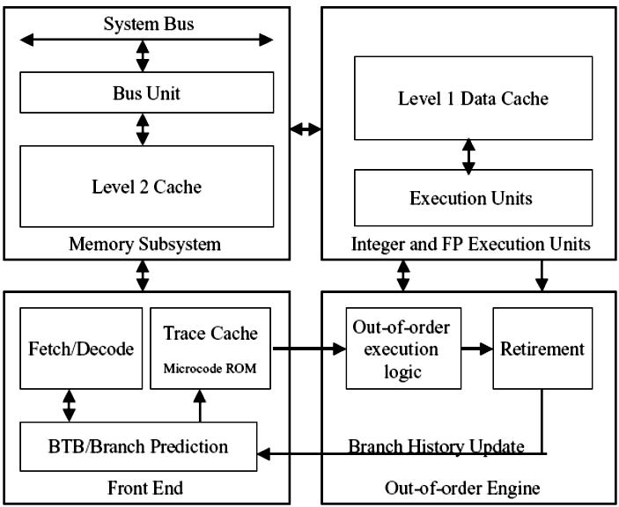Figure 1: Basic block diagram

In-Order Front End
The in-order front end is the part of the machine that fetches the instructions to be executed next in the program and prepares them to be used later in the machine pipeline. Its job is to supply a high-bandwidth stream of decoded instructions to the out-of-order execution core, which will do the actual completion of the instructions.
The front end has highly accurate branch prediction logic that uses the past history of program execution to speculate where the program is going to execute next. The predicted instruction address, from this front-end branch prediction logic, is used to fetch instruction bytes from the Level 2 (L2) cache. These IA-32 instruction bytes are then decoded into basic operations called uops (micro-operations) that the execution core is able to execute.
The NetBurst microarchitecture has an advanced form of a Level 1 (L1) instruction cache called the Execution Trace Cache. Unlike conventional instruction caches, the Trace Cache sits between the instruction decode logic and the execution core as shown in Figure 1.
In this location the Trace Cache is able to store the already decoded IA-32 instructions or uops. Storing already decoded instructions removes the IA-32 decoding from the main execution loop. Typically the instructions are decoded once and placed in the Trace Cache and then used repeatedly from there like a normal instruction cache on previous machines. The IA-32 instruction decoder is only used when the machine misses the Trace Cache and needs to go to the L2 cache to get and decode new IA-32 instruction bytes.

Out-of-Order Execution Logic
The out-of-order execution engine is where the instructions are prepared for execution. The out-of-order execution logic has several buffers that it uses to smooth and re-order the flow of instructions to optimize performance as they go down the pipeline and get scheduled for execution. Instructions are aggressively reordered to allow them to execute as quickly as their input operands are ready. This out-of-order execution allows instructions in the program following delayed instructions to proceed around them as long as they do not depend on those delayed instructions. Out-of-order execution allows the execution resources such as the ALUs and the cache to be kept as busy as possible executing independent instructions that are ready to execute.
The retirement logic is what reorders the instructions, executed in an out-of-order manner, back to the original program order. This retirement logic receives the completion status of the executed instructions from the execution units and processes the results so that the proper architectural state is committed (or retired) according to the program order.
The Pentium 4 processor can retire up to three uops per clock cycle. This retirement logic ensures that exceptions occur only if the operation causing the exception is the oldest, non-retired operation in the machine. This logic also reports branch history information to the branch predictors at the front end of the machine so they can train with the latest known-good branch-history information.

Integer and Floating-Point Execution Units
The execution units are where the instructions are actually executed. This section includes the register files that store the integer and floating-point data operand values that the instructions need to execute. The execution units include several types of integer and floating-point execution units that compute the results and also the L1 data cache that is used for most load and store operations.

Memory Subsystem
Figure 1 also shows the memory subsystem. This includes the L2 cache and the system bus. The L2 cache stores both instructions and data that cannot fit in the Execution Trace Cache and the L1 data cache. The external system bus is connected to the backside of the second-level cache and is used to access main memory when the L2 cache has a cache miss, and to access the system I/O resources

3- Clock Rates
Processor microarchitectures can be pipelined to different degrees. The degree of pipelining is a microarchitectural decision. The final frequency of a specific processor pipeline on a given silicon process technology depends heavily on how deeply the processor is pipelined. When designing a new processor, a key design decision is the target design frequency of operation. The frequency target determines how many gates of logic can be included per pipeline stage in the design. This then helps determine how many pipeline stages there are in the machine.
There are tradeoffs when designing for higher clock rates. Higher clock rates need deeper pipelines so the efficiency at the same clock rate goes down. Deeper pipelines make many things take more clock cycles, such as mispredicted branches and cache misses, but usually more than make up for the lower per-clock efficiency by allowing the design to run at a much higher clock rate. For example, a 50% increase in frequency might buy only a 30% increase in net performance, but this frequency increase still provides a significant overall performance increase.
High-frequency design also depends heavily on circuit design techniques, design methodology, design tools, silicon process technology, power and thermal constraints, etc. At higher frequencies, clock skew and jitter and latch delay become a much bigger percentage of the clock cycle, reducing the percentage of the clock cycle usable by actual logic. The deeper pipelines make the machine more complicated and require it to have deeper buffering to cover the longer pipelines.

Historical Trend of Processor Frequencies
Figure 2 shows the relative clock frequency of Intel’s last six processor cores. The vertical axis shows the relative clock frequency, and the horizontal axis shows the various processors relative to each other.

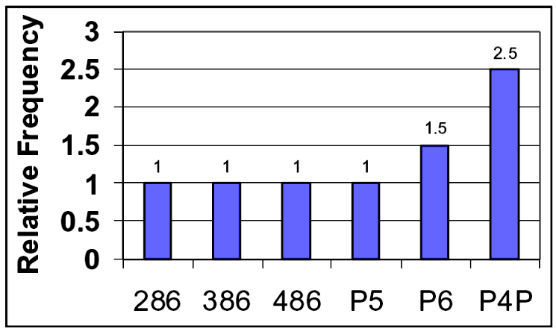
Figure 2: Relative frequencies of Intel’s processors

Figure 2 shows that the 286, Intel386™, Intel486™ and Pentium® (P5) processors had similar pipeline depths– they would run at similar clock rates if they were all implemented on the same silicon process technology.
They all have a similar number of gates of logic per clock cycle. The P6 microarchitecture lengthened the processor pipelines, allowing fewer gates of logic per pipeline stage, which delivered significantly higher frequency and performance. The P6 microarchitecture approximately doubled the number of pipeline stages compared to the earlier processors and was able to achieve about a 1.5 times higher frequency on the same process technology.
The NetBurst microarchitecture was designed to have an even deeper pipeline (about two times the P6 microarchitecture) with even fewer gates of logic per clock cycle to allow an industry-leading clock rate. Compared to the P6 family of processors, the Pentium 4 processor was designed with a greater than 1.6 times higher frequency target for its main clock rate, on the same process technology. This allows it to operate at a much higher frequency than the P6 family of processors on the same silicon process technology.
Different parts of the Pentium 4 processor run at different clock frequencies. The frequency of each section of logic is set to be appropriate for the performance it needs to achieve. The highest frequency section (fast clock) was set equal to the speed of the critical ALU-bypass execution loop that is used for most instructions in integer programs. Most other parts of the chip run at half of the 3GHz fast clock since this makes these parts much easier to design. A few sections of the chip run at a quarter of this fast-clock frequency making them also easier to design. The bus logic runs at 100 MHz, to match the system bus needs.
As an example of the pipelining differences, Figure 3 shows a key pipeline in both the P6 and the Pentium 4 processors: the mispredicted branch pipeline. This pipeline covers the cycles it takes a processor to recover from a branch that went a different direction than the early fetch hardware predicted at the beginning of the machine pipeline. As shown, the Pentium 4 processor has a 20-stage misprediction pipeline while the P6 microarchitecture has a 10-stage misprediction pipeline. By dividing the pipeline into smaller pieces, doing less work during each pipeline stage (fewer gates of logic), and the clock rate can be a lot higher.

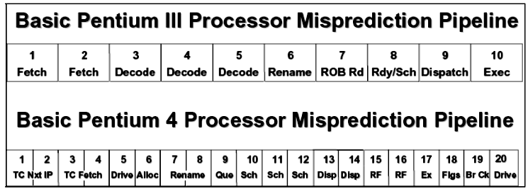

Figure 3: Misprediction Pipeline.

4- Netburst Microarchitecture
Figure 4 shows a more detailed block diagram of the NetBurst microarchitecture of the Pentium 4 processor. The top-left portion of the diagram shows the front end of the machine. The middle of the diagram illustrates the out-of-order buffering logic, and the bottom of the diagram shows the integer and floating-point execution units and the L1 data cache. On the right of the diagram is the memory subsystem.

4.1- Front End
The front end of the Pentium 4 processor consists of several units as shown in the upper part of Figure 4. It has the Instruction TLB (ITLB), the front-end branch predictor (labeled here Front-End BTB), the IA-32 Instruction Decoder, the Trace Cache, and the Microcode ROM.

Trace Cache
The Trace Cache is the primary or Level 1 (L1) instruction cache of the Pentium 4 processor and delivers up to three uops per clock to the out-of-order execution logic. Most instructions in a program are fetched and executed from the Trace Cache. Only when there is a Trace Cache miss does the NetBurst microarchitecture fetch and decode instructions from the Level 2 (L2) cache. This occurs about as often as previous processors miss their L1 instruction cache. The Trace Cache has a capacity to hold up to 12K uops. It has a similar hit rate to an 8K to 16K byte conventional instruction cache.

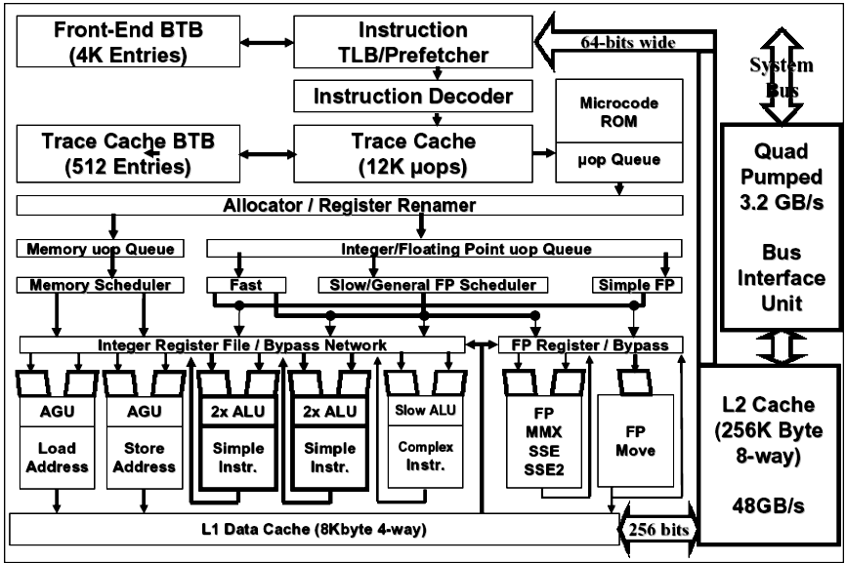

Figure 4: Pentium® 4 processor microarchitecture

IA-32 instructions are cumbersome to decode. The instructions have a variable number of bytes and have many different options. The instruction decoding logic needs to sort this all out and convert these complex instructions into simple uops that the machine knows how to execute. This decoding is especially difficult when trying to decode several IA-32 instructions each clock cycle when running at the high clock frequency of the Pentium 4 processor.
A high-bandwidth IA-32 decoder, that is capable of decoding several instructions per clock cycle, takes several pipeline stages to do its work. When a branch is mispredicted, the recovery time is much shorter if the machine does not have to re-decode the IA-32 instructions needed to resume execution at the corrected branch target location. By caching the uops of the previously decoded instructions in the Trace Cache, the NetBurst microarchitecture bypasses the instruction decoder most of the time thereby reducing misprediction latency and allowing the decoder to be simplified: it only needs to decode one IA-32 instruction per clock cycle.
The Execution Trace Cache takes the already-decoded uops from the IA-32 Instruction Decoder and assembles or builds them into program-ordered sequences of uops called traces. It packs the uops into groups of six uops per trace line. There can be many trace lines in a single trace. These traces consist of uops running sequentially down the predicted path of the IA-32 program execution. This allows the target of a branch to be included in the same trace cache line as the branch itself even if the branch and its target instructions are thousands of bytes apart in the program.
Conventional instruction caches typically provide instructions up to and including a taken branch instruction but none after it during that clock cycle. If the branch is the first instruction in a cache line, only the single branch instruction is delivered that clock cycle. Conventional instruction caches also often add a clock delay getting to the target of the taken branch, due to delays getting through the branch predictor and then accessing the new location in the instruction cache. The Trace Cache avoids both aspects of this instruction delivery delay for programs that fit well in the Trace Cache.
The Trace Cache has its own branch predictor that directs where instruction fetching needs to go next in the Trace Cache. This Trace Cache predictor (labeled Trace BTB in Figure 4) is smaller than the front-end predictor, since its main purpose is to predict the branches in the subset of the program that is currently in the Trace Cache. The branch prediction logic includes a 16-entry return address stack to efficiently predict return addresses, because often the same procedure is called from several different call sites. The Trace-Cache BTB, together with the front-end BTB, use a highly advanced branch prediction algorithm that reduces the branch misprediction rate by about 1/3 compared to the predictor in the P6 microarchitecture.

Microcode ROM
Near the Trace Cache is the microcode ROM. This ROM is used for complex IA-32 instructions, such as string move, and for fault and interrupt handling. When a complex instruction is encountered, the Trace Cache jumps into the microcode ROM which then issues the uops needed to complete the operation. After the microcode ROM finishes sequencing uops for the current IA-32 instruction, the front end of the machine resumes fetching uops from the Trace Cache.
The uops that come from the Trace Cache and the microcode ROM are buffered in a simple, in-order uop queue that helps smooth the flow of uops going to the out of- order execution engine.

ITLB and Front-End BTB
The IA-32 Instruction TLB and front-end BTB, shown at the top of Figure 4, steer the front end when the machine misses the Trace Cache. The ITLB translates the linear instruction pointer addresses given to it into physical addresses needed to access the L2 cache. The ITLB also performs page-level protection checking. Hardware instruction prefetching logic associated with the front-end BTB fetches IA-32 instruction bytes from the L2 cache that are predicted to be executed next. The fetch logic attempts to keep the instruction decoder fed with the next IA-32 instructions the program needs to execute.
This instruction prefetcher is guided by the branch prediction logic (branch history table and branch target buffer listed here as the front-end BTB) to know what to fetch next. Branch prediction allows the processor to begin fetching and executing instructions long before the previous branch outcomes are certain. The front-end branch predictor is quite large–4K branch target entries–to capture most of the branch history information for the program. If a branch is not found in the BTB, the branch prediction hardware statically predicts the outcome of the branch based on the direction of the branch displacement (forward or backward). Backward branches are assumed to be taken and forward branches are assumed to not be taken.

IA-32 Instruction Decoder
The instruction decoder receives IA-32 instruction bytes from the L2 cache 64-bits at a time and decodes them into primitives, called uops, that the machine knows how to execute. This single instruction decoder can decode at a maximum rate of one IA-32 instruction per clock cycle.
Many IA-32 instructions are converted into a single uop, and others need several uops to complete the full operation. If more than four uops are needed to complete an IA-32 instruction, the decoder sends the machine into the microcode ROM to do the instruction. Most instructions do not need to jump to the microcode ROM to complete. An example of a many-uop instruction is string move, which could have thousands of uops.

4.2- Out-of-Order Execution Logic
The out-of-order execution engine consists of the allocation, renaming, and scheduling functions. This part of the machine re-orders instructions to allow them to execute as quickly as their input operands are ready.
The processor attempts to find as many instructions as possible to execute each clock cycle. The out-of-order execution engine will execute as many ready instructions as possible each clock cycle, even if they are not in the original program order. By looking at a larger number of instructions from the program at once, the out-of-order execution engine can usually find more ready-to-execute, independent instructions to begin. The NetBurst microarchitecture has much deeper buffering than the P6 microarchitecture to allow this. It can have up to 126 instructions in flight at a time and have up to 48 loads and 24 stores allocated in the machine at a time.

