Lecture No. 2
-Three dimensional stresses and Strains-

2-1 General.
Consider a cube of infinitesimal dimensions shown in figure (1), All stresses acting on this cube are identified on the diagram. The subscripts (τ) are the shear stress, associate the stress with a plane perpendicular to a given axis, the second designate the direction of the stress, i.e.
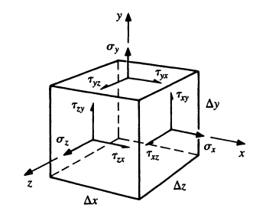
τ_{xy}
Face Direction
The stress symbols in figure (1),
shows that three normal stresses: -
σ_{x} = τ_{xx}, σ_{y} = τ_{yy} , σ_{z} = τ_{zz}
and six shearing stresses, τ_{xy} , τ_{xz} ,
τ_{yx} , τ_{yz} , τ_{zx} , τ_{zy.} Figure (1)
The force vector (P) has only three components P_{x} , P_{y} and P_{z}.
$$\begin{matrix}P_{x} \\ P_{y} \\ P_{z}\end{matrix}$$
And stress vector: -
$\begin{matrix}σ_{x} & τ_{xy} & τ_{xz} \\ τ_{yx} & σ_{y} & τ_{yz} \\ τ_{zx} & τ_{zy} & σ_{z}\end{matrix}$ = $\begin{matrix}τ_{xx} & τ_{xy} & τ_{xz} \\ τ_{yx} & τ_{yy} & τ_{yz} \\ τ_{zx} & τ_{zy} & τ_{zz}\end{matrix}$ ..….2.1
This is a matrix representation of the stress tensor. It is a second –rank tensor requiring two indices to identify its elements or components. A vector is first- rank tensor, and scalar is a zero tensor.
Sometimes, for brevity, a stress tensor is written in identical natation as τ_{ij} , where i, j and k designations x, y and z.
The stress tensor is symmetric, i.e. τ_{ij}= τ_{ji} or
τ_{xy}= τ_{yx}
τ_{xz}= τ_{zx} …2.2
τ_{yz}= τ_{zy}

2-2 Two dimensional stress (Biaxial stress): -
For a two dimensional case of plane stress where (σ₃=0).
Where:-
σ_{y}
$σ$= Normal stress
τ_{xy}
τ = Shear stress
σ_{x}
$σ_{ij}$=$\begin{matrix}σ_{x} & τ_{xy} & 0 \\ τ_{yx} & σ_{y} & 0 \\ 0 & 0 & 0\end{matrix}$

2-3 Three dimensional stress (Triaxial stress): -
There are nine components of stress. Moment equilibrium can be used to reduce the number of stress components to six.
y
τ_{xy}= τ_{yx}
x
σ_{y}
τ_{xz}= τ_{zx}
z
τ_{yz}= τ_{zy}
τ_{yz}
τ_{yx}

τ_{xy}
Stresses in 3D is represented by vector
τ_{xz}
σ_{x}
σ_{x}
tensor: -
σ_{ijk} = $\begin{matrix}σ_{x} & τ_{xy} & τ_{xz} \\ τ_{yx} & σ_{y} & τ_{yz} \\ τ_{zx} & τ_{zy} & σ_{z}\end{matrix}$
σ_{y}
A homogenous linear equation has a solution only if the determinant of the coefficient matrix is equal to zero this called Eigenvalue problem. Such as
$\begin{matrix}σ_{x} & τ_{xy} & τ_{xz} \\ τ_{yx} & σ_{y} & τ_{yz} \\ τ_{zx} & τ_{zy} & σ_{z}\end{matrix}$= $\begin{matrix}0 \\ 0 \\ 0\end{matrix}$ …2.3
In case that the equation is in eigenvalue problem such as: -
$\begin{matrix}σ_{x} & τ_{xy} & τ_{xz} \\ τ_{yx} & σ_{y} & τ_{yz} \\ τ_{zx} & τ_{zy} & σ_{z}\end{matrix}$= 0 ...2.4
The determinant can be expanded to yield the equation
$σ^{3}-{I_{1}σ}^{2}+I_{2}σ-I_{3}=0$ . ..2.5
Where I₁, I₂ and I₃ are the first, second and third invariants of the Cauchy stress tensor.
$I_{1}=σ_{x}+σ_{y}+σ_{z}$ ..2.6
$I_{2}=σ_{x}σ_{y}+σ_{x}σ_{z}+σ_{y}σ_{z}-{τ_{xy}}^{2}-{τ_{xz}}^{2}-{τ_{yz}}^{2}$ ...2.7
$I_{3}=σ_{x}σ_{y}σ_{z}+2τ_{xy}τ_{xz}τ_{yz}-σ_{x}{τ_{yz}}^{2}-σ_{y}{τ_{xz}}^{2}-σ_{z}{τ_{xy}}^{2}$ ...2.8
There are three roots the characteristic equation 2.5, σ₁, σ₂ and σ₃. Each root is one of the principal stresses. The direction cosines can be found by substituting the principal stresses into the homogenous equation 2.3 and solving. The direction cosines define the principal direction or planes.
σ _{max} ≥ σ_{in} ≥ σ_{min}
σ_{in}
σ₁≥ σ₂ ≥ σ₃
σ_{min}

σ _{max}
$τ_{12=\frac{σ_{1}-σ_{2}}{2}}$ ……2.9
$τ_{23=\frac{σ_{2}-σ_{3}}{2}}$ ..….2.10
$τ_{13=\frac{σ_{1}-σ_{3}}{2}}$ =τ_{max} ..….2.11
2-4 Poisson’s Ratio (υ): -
Biaxial and Triaxial deformation another type of elastic deformation is the change in transverse dimensions accompanying axial tension or compression.
Experiments show that if a bar is lengthened by axial tension, there is a reduction in the transverse dimensions. Simeon D. Poisson showed in 1811 that the ratio of the unit dimensions or strain in these directions is constant for stresses within the proportional limit,

Poisson’s Ratio (υ) =$-\frac{Lateral strain}{Longitudinal Strain}$ …2.12
=$-\frac{ε_{y}}{ε_{x}}=-\frac{ε_{z}}{ε_{x}}$
Where: -
$ε_{x}=Strain in x-direction$.
$ε_{y}=Strain in y-direction$.
$ε_{z}=Strain in z-direction$.

Note: - Minus sign indicates a decrease in transverse dimension position as in the case of tensile elongation.
δd
d
$ε_{L}=\frac{δL}{L}$
δL
$ε_{d}=\frac{δd}{d}$
$∴ν=-\frac{δd/d}{δL/L}$

2-5 Three Dimensional Strains: -
For Tri-axial stress state,
If $σ_{y},σ_{z}=0→ε_{x}=\frac{σ_{x}}{E}$
If $σ_{x},σ_{z}=0→ε_{y}=\frac{σ_{y}}{E} and ε_{x}=-υ\frac{σ_{y}}{E}$
Now, If $σ_{x},σ_{y}=0→ε_{z}=\frac{σ_{z}}{E} and ε_{x}=-υ\frac{σ_{z}}{E}$
$∴ε_{x}=\frac{σ_{x}}{E}-υ\frac{σ_{y}}{E}-υ\frac{σ_{z}}{E}$
$∴ε_{y}=\frac{σ_{y}}{E}-υ\frac{σ_{x}}{E}-υ\frac{σ_{z}}{E}$ …2.13
$∴ε_{z}=\frac{σ_{z}}{E}-υ\frac{σ_{x}}{E}-υ\frac{σ_{y}}{E}$
So, the principal strains in terms of principal stresses,
$∴ε_{1}=\frac{1}{E}(σ_{1}-νσ_{2}-υσ_{3})$
$∴ε_{2}=\frac{1}{E}(σ_{2}-νσ_{1}-υσ_{3})$ …2.14
$∴ε_{3}=\frac{1}{E}(σ_{3}-νσ_{1}-υσ_{2})$

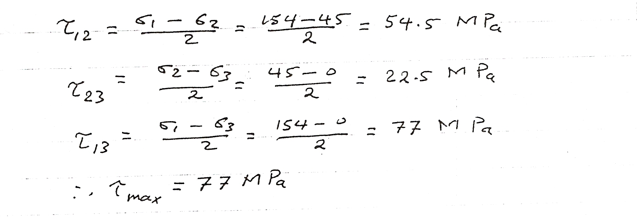

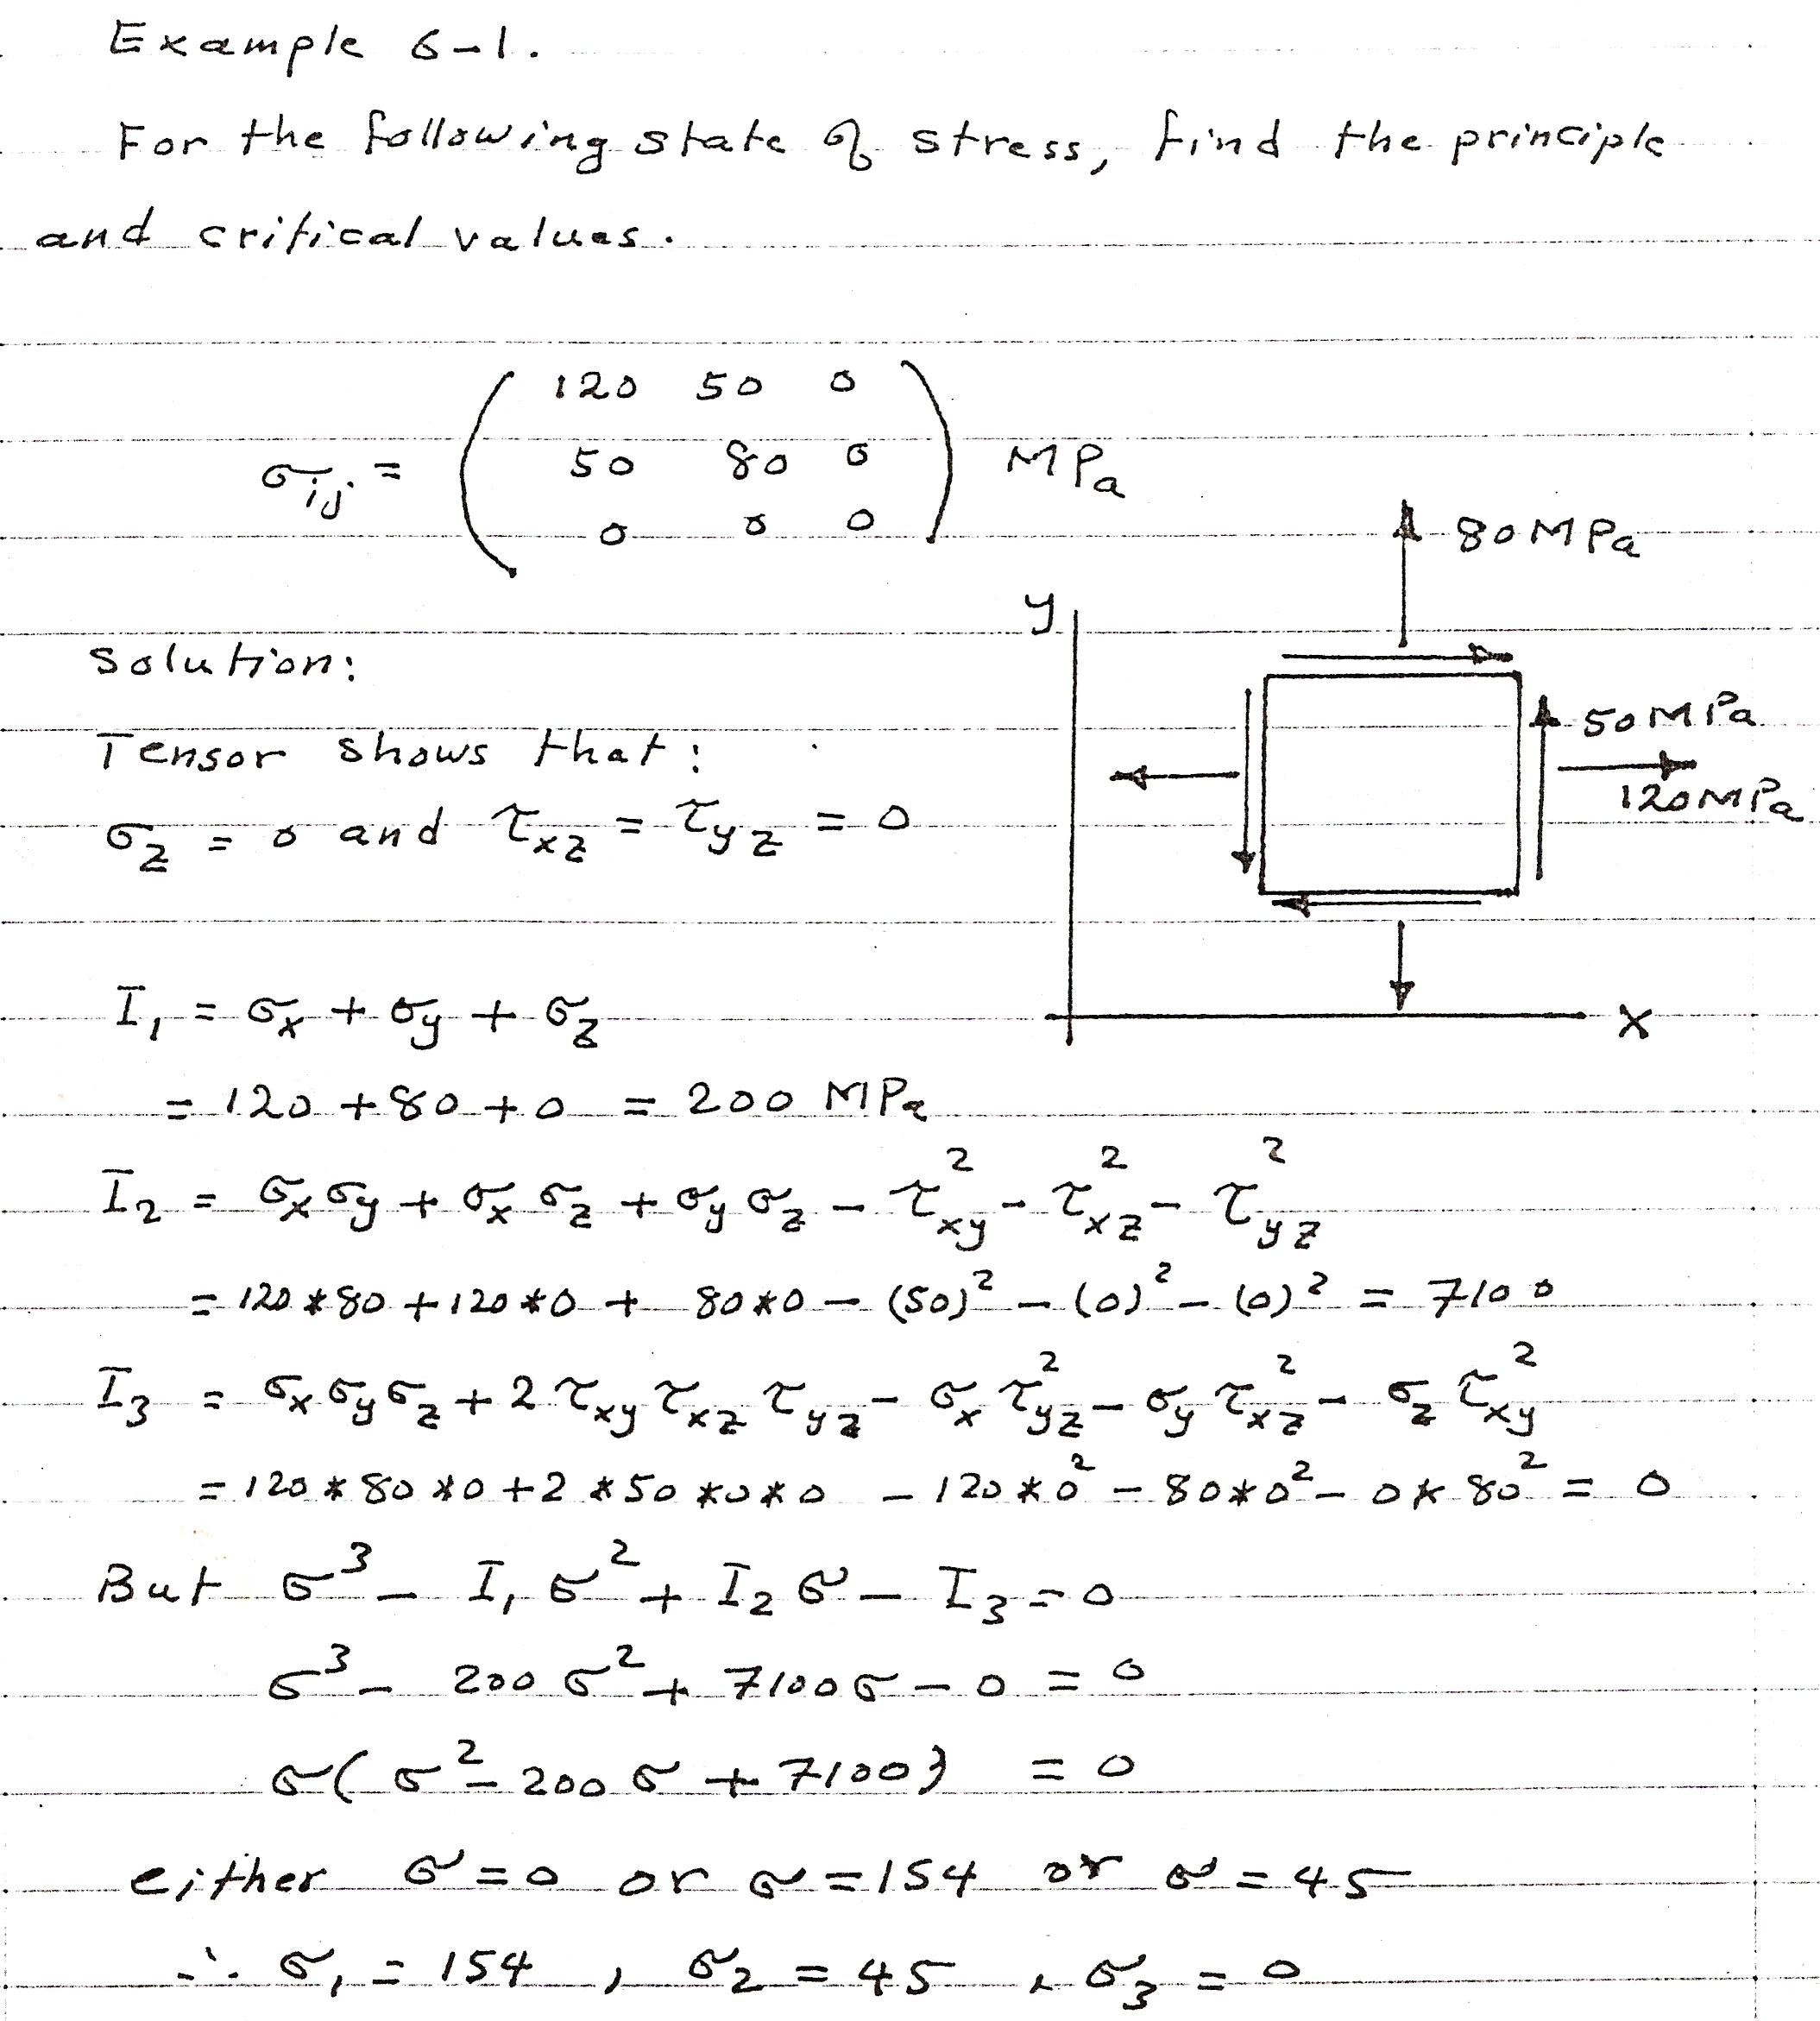

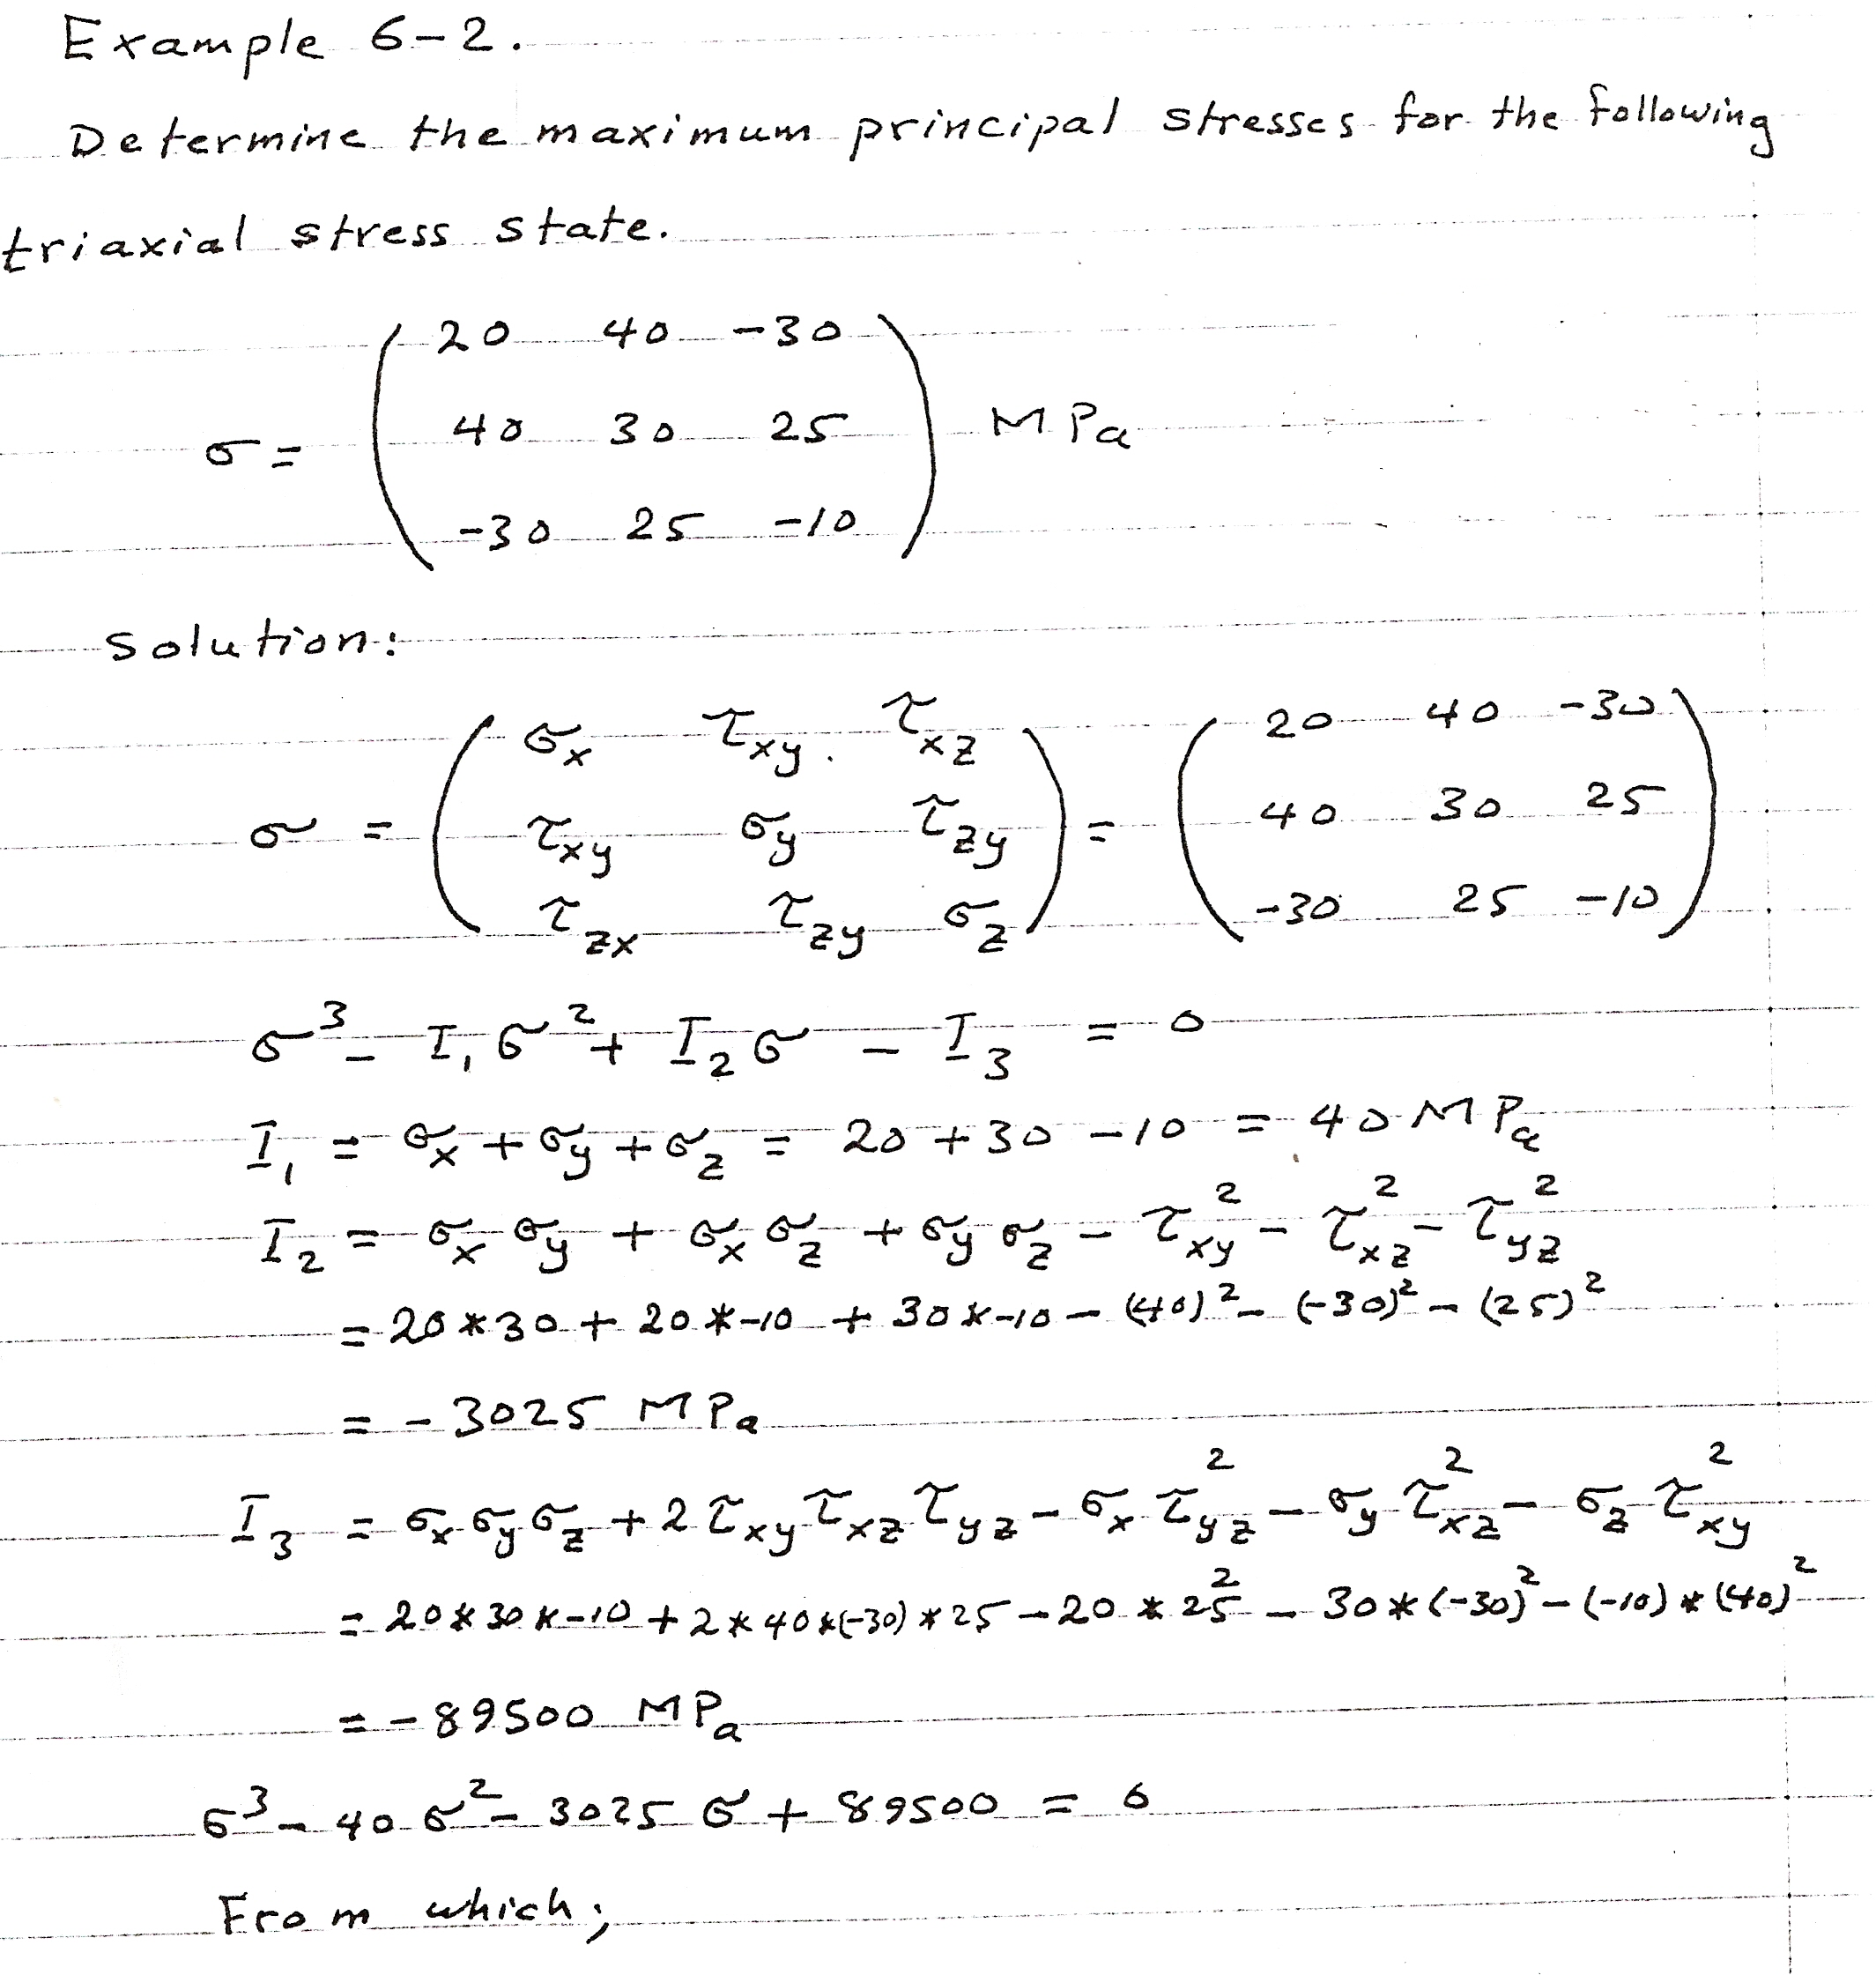

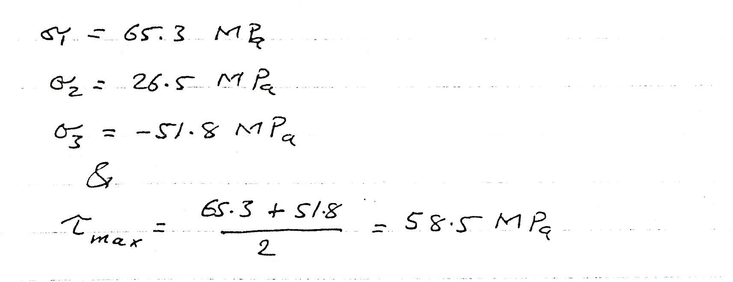

…………………………….End…………………………

