Basic Cryptography
Al-Mustanseriya University Class: Third Year
Engineering College Subject: Ciphering & Data Security
Computer and Software Engineering Dep. Lecture -3-

Terminology
Encryption is the process of encoding a message so that its meaning is not obvious; decryption is the reverse process, transforming an encrypted message back into its normal, original form. Alternatively, the terms encode and decode or encipher and decipher are used instead of encrypt and decrypt. That is, we say that we encode, encrypt, or encipher the original message to hide its meaning. Then, we decode, decrypt, or decipher it to reveal the original message. A system for encryption and decryption is called a cryptosystem.
The original form of a message is known as plaintext, and the encrypted form is called ciphertext. This relationship is shown in figure 2.1. For convenience, we denote a plaintext message P as a sequence of individual characters P = <p₁, p₂, …, p_{n}>. Similarly, ciphertext is written as C = <c₁, c₂, …, c_{m}>. For instance, the plaintext message "I want cookies" can be denoted as the message string <I, ,w,a,n,t, , c,o,o,k,i,e,s>. It can be transformed into ciphertext <c₁, c₂, …, c₁₄>, and the encryption algorithm tells us how the transformation is done.

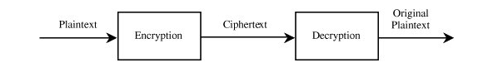
We use this formal notation to describe the transformations between plaintext and ciphertext. For example, we write C = E(P) and P = D(C), where C represents the ciphertext, E is the encryption rule, P is the plaintext, and D is the decryption rule. What we seek is a cryptosystem for which P = D(E(P)). In other words, we want to be able to convert the message to protect it from an intruder, but we also want to be able to get the original message back so that the receiver can read it properly.

Encryption Algorithms
The cryptosystem involves a set of rules for how to encrypt the plaintext and how to decrypt the ciphertext. The encryption and decryption rules, called algorithms, often use a device called a key, denoted by K, so that the resulting ciphertext depends on the original plaintext message, the algorithm, and the key value. We write this dependence as C = E(K, P). Essentially, E is a set of encryption algorithms, and the key K selects one specific algorithm from the set. We see later in this chapter that a cryptosystem, such as the Caesar cipher, is keyless but that keyed encryptions are more difficult to break.
Sometimes the encryption and decryption keys are the same, so P = D(K, E(K,P)). This form is called symmetric encryption because D and E are mirror-image processes. At other times, encryption and decryption keys come in pairs. Then, a decryption key, K_{D}, inverts the encryption of key K_{E} so that P = D(K_{D}, E(K_{E},P)). Encryption algorithms of this form are called asymmetric because converting C back to P involves a series of steps and a key that are different from the steps and key of E. The difference between symmetric and asymmetric encryption is shown in figure 2.2.
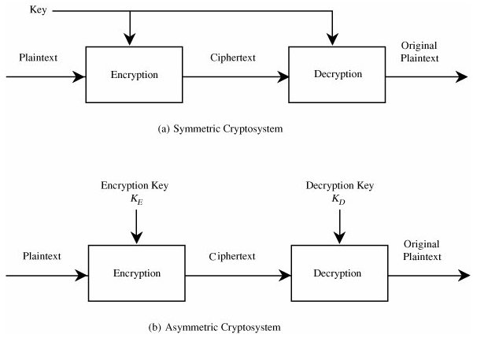

There are many types of encryption. In the next two sections we look at two simple forms of encryption: substitutions, in which one letter is exchanged for another, and transpositions, in which the order of the letters is rearranged.
Concepts
A secret key cipher is composed of two algorithms
encryption algorithm E
decryption algorithm D
The same key K is used for encryption & decryption K has to be distributed beforehand
Notations
Encrypt a plaintext P using a key K & an encryption algorithm E
C = E(K,P)
Decrypt a ciphertext C using the same key K and the matching decryption algorithm D
P = D(K,C)
Note: P = D(K,C) = D(K, E(K,P))
Ciphers:
Classical Ciphers
Substitution Ciphers
Transposition Ciphers
Substitution Ciphers
Substitution Ciphers
Shift Ciphers (Caesar Cipher)
Monoalphabetic
Polyalphabetic
Ceaser Cipher
The Caesar cipher is a substitution cipher, named after Julius Caesar. Operation principle:
each letter is translated into the letter a fixed number of positions after it in the alphabet table. The fixed number of positions is a key both for encryption and decryption.
The Caesar cipher
An example
For a key K=3,
plaintext letter: ABCDEF...UVWXYZ
ciphtertext letter: DEF...UVWXYZABC
Hence
TREATY IMPOSSIBLE
is translated into
WUHDWB LPSRVVLEOH
Caesar Cipher (Another example)
Earliest known substitution cipher (shift cipher)
Replaces each letter by 3rd next letter
Transformation can be defined as:
a b c d e f g h i j k l m n o p q r s t u v w x y z
d e f g h i j k l m n o p q r s t u v w x y z a b c
Caesar Cipher
If each letter is assigned a number (a=0, z=25), Encryption/Decryption defined as:
C = E(p) = (P + 3) mod (26)
P = D(c) = (C – 3) mod (26)
Example:
meet me after the toga party
phhw ph diwhu wkh wrjd sduwb
Caesar Cipher: Encryption Example
K = 7
P = Rome is the greatest empire
C = yvtl pz aol nylhalza ltwpyl
Caesar Cipher: Decryption Example
K = 7
C = yvtl dhz uva ibpsa pu h khf
P = Rome was not built in a day
Caesar Cipher: Decryption with Unknown Key
C=tfnriujuzvdrepkzdvjsvwfivkyvziuvrkyjkyvmrczrekevmvikrjkvfwuvrkyslkfetv
tfnriuj uzv drep kzdvj svwfiv kyvzi uvrkyj; kyv mrczrek evmvi krjkv fw uvrky slk fetv
P = Cowards die many times before their deaths; the valiant never taste of death but once. (K = 17)
Julius Caesar by William Shakespeare
Polyalphabetic Ciphers
Improve security using different cipher letters for different occurrences of same plaintext letter. Make cryptanalysis harder with more letters to guess and flatter frequency distribution. Use a key to select which cipher letter is used for each letter of the message. Repeat from start after end of key is reached
Vigenère Cipher
Simplest polyalphabetic substitution cipher. Effectively multiple Caesar ciphers
Key is multiple letters long K = k1 k2 ... kd
ith letter specifies ith alphabet to use
Repeat from start after d letters in message
Decryption simply works in reverse
Example of Vigenère Cipher
Write the plaintext out
Write the keyword repeated
Use each key letter as a Caesar cipher key
Encrypt the corresponding plaintext letter
Eg using keyword deceptive
plaintext: wearediscoveredsaveyourself
key: deceptivedeceptivedeceptive
ciphertext: zicvtwqngrzgvtwavzhcqyglmgj
Security of Vigenère Cipher
Much more secure than the ciphers we discussed earlier
Have multiple ciphertext letters for each plaintext letter
Hence letter frequencies are obscured
But not totally lost
Security of Vigenère Ciphers
Need to determine key size, since then can attack each Caesar cipher
Repetitions in ciphertext give clues to period
Find same plaintext an exact period apart which results in the same ciphertext
E.g, repeated “VTW” in previous example is at a distance of 9 (zicvtwqngrzgvtwavzhcqyglmgj)

