Definitions of transient-response specifications.
The performance of the control system can be expressed in the term of transient response to a unit step input function because it is easy to generate. Let us consider a second-order control system in which a unit step input signal is given and it is also considered that the system is initially at rest. That is all initial conditions of the system are zero. The time response characteristics of the system at underdamped condition is drawn below.
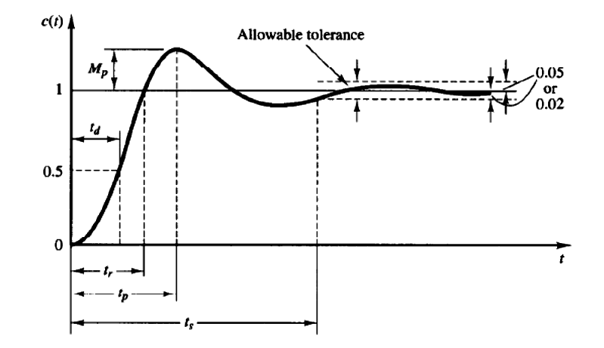

There are number of common terms in transient response characteristics and which are:
1. Delay time (td) is the time required to reach at 50% of its final value by a time response signal during its first cycle of oscillation.
2. Rise time (tr) is the time required to reach at final value by a under damped time response signal during its first cycle of oscillation. If the signal is over damped, then rise time is counted as the time required by the response to rise from 10% to 90% of its final value.
In order to derive the expression for the rise time we have to equate the expression for c(t) = 1. From the above we have:
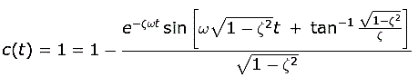
On solving above equation we have expression for rise time equal to
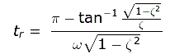
3. Peak time (tp) is simply the time required by response to reach its first peak i.e. the peak of first cycle of oscillation, or first overshoot.
On differentiating the expression of c(t) we can obtain the expression for peak time. dc(t)/ dt = 0 we have expression for peak time,
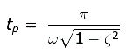
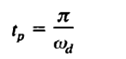
4. Maximum overshoot (Mp) is straight way difference between the magnitude of the highest peak of time response and magnitude of its steady state. Maximum overshoot is expressed in term of percentage of steady-state value of the response. As the first peak of response is normally maximum in magnitude, maximum overshoot is simply normalized difference between first peak and steady-state value of a response.
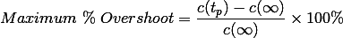
Now it is clear from the figure that the maximum overshoot will occur at peak time tp hence on putting the value of peak time we will get maximum overshoot as
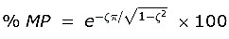
5. Settling time (ts) is the time required for a response to become steady. It is defined as the time required by the response to reach and steady within specified range of 2% to 5% of its final value. Settling time is given by the expression:
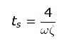

6. Steady-state error (ess ) is the difference between actual output and desired output at the infinite range of time.

Deriving an Expression of Rise Time:
The expression of underdamped second-order control system with unit step input function,
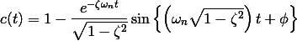
Where
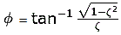
Again, as per definition, the magnitude of output signal at Rice times is 1. That is c(t) = 1, hence
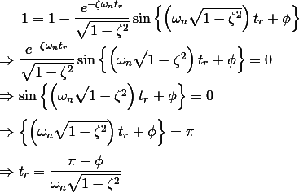

Deriving an Expression of Peak Time:
As per definition at the peak time, the response curve reaches to its maximum value. Hence at that point,
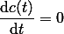
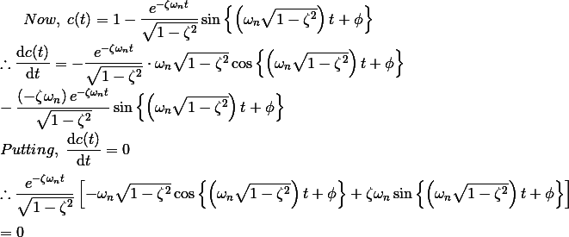
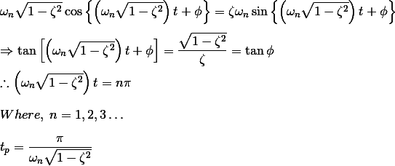
The maximum overshoot occurs at n = 1.

Deriving an Expression of Maximum Overshoot:
If we put the expression of peak time in the expression of output response c(t), we get,
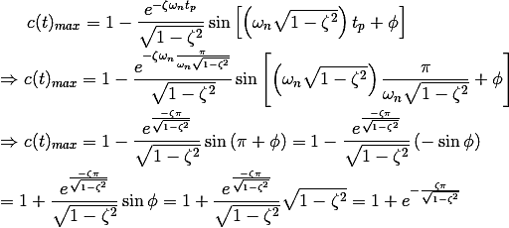
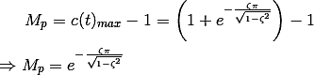

Deriving an Expression of Settling Time
It is already defined that settling time of a response is that time after which the response reaches to its steady-state condition with value above nearly 98% of its final value. It is also observed that this duration is approximately 4 times of time constant of a signal. At the time constant of a second-order control system is 1/ζ ωn, the expiration of settling time can be given as
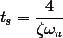
Now we will see the effect of different values of ζ on the response. We have three types of systems on the basis of different values of ζ.
1. Under damped system : A system is said to be under damped system when the value of ζ is less than one. In this case roots are complex in nature and the real parts are always negative. System is asymptotically stable. Rise time is lesser than the other system with the presence of finite overshoot.
2. Critically damped system: A system is said to be critically damped system when the value of ζ is one. In this case roots are real in nature and the real parts are always repetitive in nature. System is asymptotically stable. Rise time is less in this system and there is no presence of finite overshoot.
3. Over damped system: A system is said to be over damped system when the value of ζ is greater than one. In this case roots are real and distinct in nature and the real parts are always negative. System is asymptotically stable. Rise time is greater than the other system and there is no presence of finite overshoot.
4. Sustained Oscillations: A system is said to be sustain damped system when the value of zeta is zero. No damping occurs in this case.

