Time Response of Second-Order Control System
The order of a control system is determined by the power of s in the denominator of its transfer function. If the power of s in the denominator of transfer function of a control system is 2, then the system is said to be second-order control system. The general expression of transfer function of a second order control system is given as
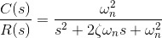
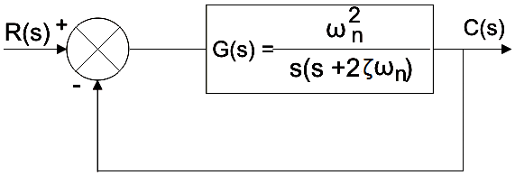
Here, ζ and ωn are damping ratio and natural frequency of the system respectively and we will learn about these two terms in detail later on. Therefore, the output of the system is given as
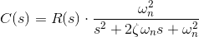
Characteristics equation of time response of second-order control system:
The general equation of transfer function of second order control system is given as:
If the denominator of the expression is zero,
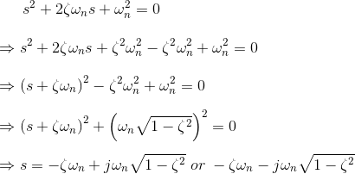
And , α = ζωn
Then , s = ± α +jωd
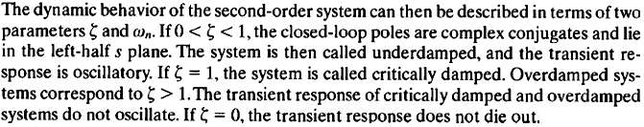
If we consider a unit step function as the input of the system,
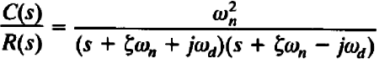
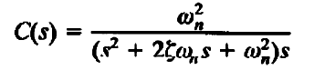
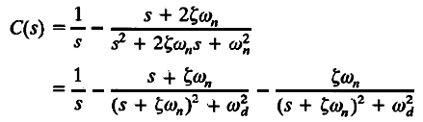
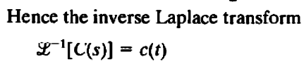
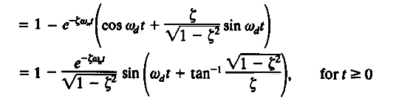
The error of the signal of the response is given by
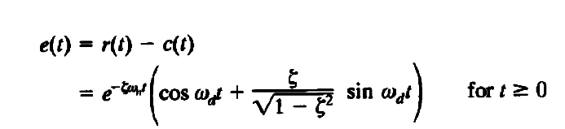
From the above expression it is clear that the error of the signal is of oscillation type with exponentially decaying magnitude when ζ < 1. The frequency of the oscillation is ωd and the time constant of exponential decay is 1/ζωn. Where, ωd, is referred as damped frequency of the oscillation, and ωn is natural frequency of the oscillation. The term ζ affects that damping a lot and hence this term is called damping ratio.
