Time Response of First Order Control Systems
When the maximum power of s in the denominator of a transfer function is one, the transfer function represents a first order control system. Commonly, the first order control system can be represented as
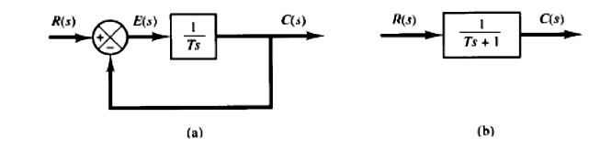
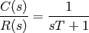
Time Response for Step Function
Now a unit step input is given to the system, then let us analyze the expression of output
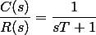
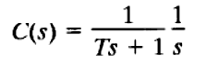
It is seen from the error equation that if the time approaching to infinity, the output signal reaches exponentially to the steady-state value of one unit. As the output is approaching towards input exponentially, the steady-state error is zero when time approaches to infinity.
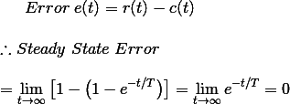
Let us put t = T in the output equation and then we get,
This T is defined as the time constant of the response and the time constant of a response signal is that time for which the signal reaches to its 63.2% of its final value.
Now if we put t = 4T in the above output response equation, then we get,
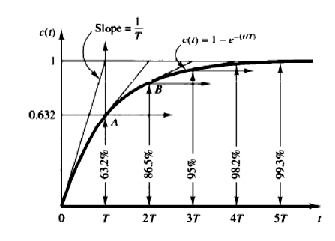

When actual value of response, reaches to the 98% of the desired value, then the signal is said to be reached to its steady-state condition. This required time for reaching the signal to 98% of its desired value is known as setting time and naturally setting time is four times of the time constant of the response. The condition of response before setting time is known as transient condition and condition of the response after setting time is known as steady-state condition. From this explanation it is clear that if the time constant of the system is smaller, the response of the system reaches to its steady-state condition faster.
Time Response for Ramp Function
Now a unit ramp input is given to the system, then let us analyze the expression of output
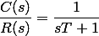
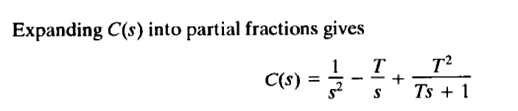
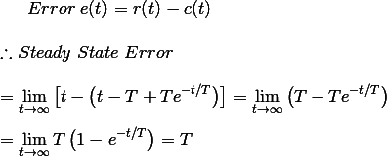
In this case during steady-state condition, the output signal lags behind input signal by a time equal to the time constant of the system. If the time constant of the system is smaller, the positional error of the response becomes lesser.

