Examples for steady-state error:

1. For the system shown in Figure below, find the following:
a. The closed-loop transfer function
b. The system type
c. The steady-state error for an input of 5u(t)
d. The steady-state error for an input of 5tu(t)

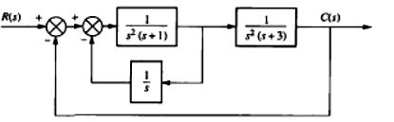
Sol.

2. Given the system of fig. below, design the value of k so that for input of 100tu(t), there will be a 0.01 error in steady state

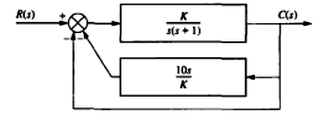

Sol.

3. For unity feed –back system which have the open loop system is:
Find the steady-state error for the inputs, 25u(t), 37tu(t), 47t²u(t).

Sol.
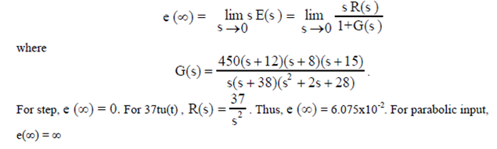

4. For the system shown in Figure below, find the steady-state error for the inputs, 15u(t), 15tu(t)

Sol.
5. Determine the step, ramp, and parabolic error constants of the following unity-feedback control systems. The forward-path transfer functions are given.
Sol.

6. Find the position, velocity, and acceleration error constants for the system given in Fig. below.

Sol.

