Modeling of Dynamic Systems
المحاضرة الرابعة
One of the most important tasks in the analysis and design of control systems is the mathematical modeling of the systems. The two most common methods of modeling linear systems are the transfer function method and the state-variable method. The transfer function is valid only for linear time-invariant systems, whereas the state equations can be applied to linear as well as nonlinear systems.
A control system may be composed of various components including mechanical, thermal, fluid, pneumatic, and electrical; or it may be sensors, actuators, and computers. In this section, we consider systems that are modeled by ordinary differential equations. The main objectives are:
• modeling of mechanical systems.
• modeling of electrical systems.
Introduction to Modeling of Mechanical Systems:
Mechanical systems may be modeled as systems of lumped masses (rigid bodies) or as distributed mass (continuous) systems. The latter are modeled by partial differential equations, whereas the former are represented by ordinary differential equations.
Translational Motion
The motion of translation is defined as a motion that takes place along a straight or curved path. The variables that are used to describe translational motion are acceleration, velocity, and displacement.
Newton's law of motion states that the algebraic sum of external forces acting on a rigid body in a given direction is equal to the product of the mass of the body and its acceleration in the same direction. The law can be expressed as:
Σ forces = Ma
external
where M denotes the mass, and a is the acceleration in the direction considered. Fig. 1 illustrates the situation where a force is acting on a body with mass M. The force equation is written as
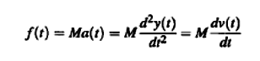
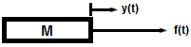

Fig.1 force- mass system
where a(t) is the acceleration, v(t) denotes linear velocity, and y(t) is the displacement of mass M, respectively.
For linear translational motion, in addition to the mass, the following system elements are also involved:

• Friction for translation motion. Whenever there is motion or tendency of motion between two physical elements, frictional forces exist. The frictional forces encountered in physical systems are usually of a nonlinear nature. Three different types of friction are commonly used in practical systems: viscous friction, static friction, and Coulomb friction.

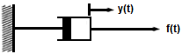
• Viscous friction. Viscous friction represents a retarding force that is a linear relationship between the applied force and velocity. The schematic diagram element for viscous friction is often represented by a dashpot, such as that shown in Fig. 2. The mathematical expression of viscous friction is:
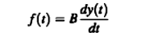
Fig.2 dashpot for viscous friction

where B is the viscous frictional coefficient.
• Linear spring. In practice, a linear spring may be a model of an actual spring or a compliance of a cable or a belt. In general, a spring is considered to be an element that stores potential energy.
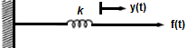
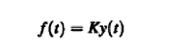

Fig.3 force- spring system

where K is the spring constant, or simply stiffness. Eq. above implies that the force acting on the spring is directly proportional to the displacement (deformation) of the spring. The model representing a linear spring element is shown in Fig. 3.
The following table shows the basic translational mechanical system properties with their corresponding basic SI and other measurement units.

Parameter | Symbol Used | SI Units | Other Units
Mass | M | kilogram  (kg) | slug  ft/sec²
Distance | y | meter (m) | ft  in
Velocity | v | m/scc | ft/sec  in/sec
Acceleration | a | m/sec² | ft/sec²  in/sec²
Force | f | Newton  (N) | pound  (lb force)  dyne
Spring Constant | K | N/m | lb/ft
Viscous Friction Coefficient | B | N/m/sec | lb/ft/sec

Example-1- Consider the mass-spring-friction system shown in Fig. 1 (a). The linear motion concerned is in the horizontal direction. The free-body diagram of the system is shown in Fig. 1 (b). The force equation of the system is:
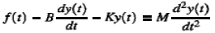
Eq.1

The last equation may be rearranged by equating the highest-order derivative term to the rest of the terms:
Eq.2

Fig.1
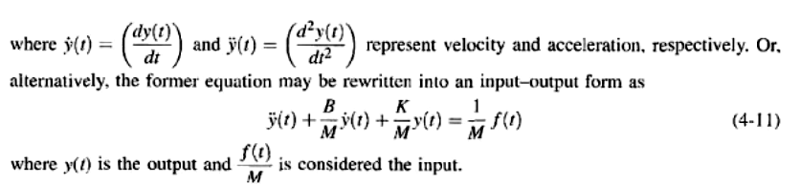

Eq.3
For zero initial conditions, the transfer function between Y(s) and F(s) is obtained by taking the Laplace transform on both sides of Eq. (3) with zero initial conditions:
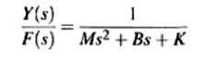
Introduction to Modeling of Simple Electrical Systems
First we address modeling of electrical networks with simple passive elements such as resistors, inductors, and capacitors.
Modeling of Passive Electrical Elements
Consider Fig. 1, which shows the basic passive electrical elements: resistors, inductors, and capacitors.
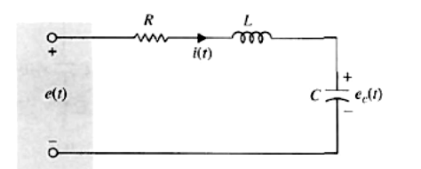
Fig. 1
Resistors: Ohm's law states that the voltage drop, e_{R} (t), across a resistor R is proportional to the current i(t) going through the resistor. Or:
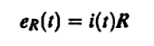
Inductors: The voltage drop, e_{L}(t), across an inductor L is proportional to the time rate of change of current i(t) going through the inductor. Thus,
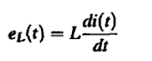
Capacitor: The voltage drop, e_{C}(t), across a capacitor C is proportional to the integral current i(t) going through the capacitor with respect to time. Therefore,
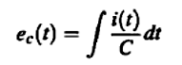

Modeling of Electrical Networks
The classical way of writing equations of electric networks is based on the loop method or the node method, both of which are formulated from the two laws of Kirchhoff, which state:
-Current Law or Loop Method: The algebraic summation of all currents entering a node is zero.
-Voltage Law or Node Method: The algebraic sum of all voltage drops around a complete closed loop is zero.

Example-2- Let us consider the RLC network shown in Fig. below. Using the voltage law

e(t) =e_{R} + e_{L} + e_{C}

where
e_{R} = Voltage across the resistor R
e_{L} = Voltage across the inductor L
e_{C}= Voltage across the capacitor C
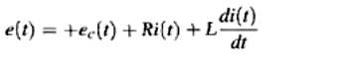
Or:
Eq.1

Using current in C
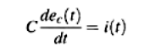

and taking a derivative of Eq. (1) with respect to time, we get the equation of the RLC network as:
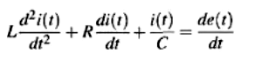
By taken Laplace transform
