Transfer Function of Control System
المحاضرة الثالثة
A control system consists of an output as well as an input signal. The output is related to the input through a function called transfer function. This function is represented by a block and the complete diagram of control system using these blocks which represent transfer function and arrows which represent various signals, is collectively known as block diagram of a control system. For any control system there exist a reference input termed as excitation or cause which operates through a transfer operation termed as transfer function and produces an effect resulting in controlled output or response. Thus the cause and effect relationship between the output and input is related to each other through a transfer function.

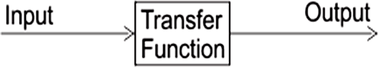

In Laplace Transform, if the input is represented by R(s) and output is represented by C(s), then the transfer function will be

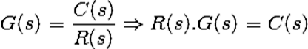

That is, transfer function of the system multiplied by input function gives the output function of the system.

It is not necessary that output and input of a control system are of same category. For example, in electric motors the input is electrical signal whereas the output is mechanical signal since electrical energy required to rotate the motors. Similarly in an electric generator, the input is mechanical signal and the output is electrical signal, since mechanical energy is required to produce electricity in a generator.
For mathematical analysis of a system, all kinds of signals should be represented in a similar form. This is done by transforming all kinds of signal to their Laplace form. Also the transfer function of a system is represented by Laplace form by dividing output Laplace transfer function by input Laplace transfer function. Hence a basic block diagram of a control system can be represented as
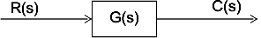
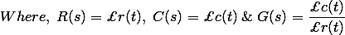
Where, r(t) and c(t) are time domain function of input and output signal respectively.

Methods of obtaining a Transfer function:
There are major two ways of obtaining a transfer function for the control system .These ways are:

* Block diagram method: It is not convenient to derive a complete transfer function for a complex control system. Therefore the transfer function of each element of a control system is represented by a block diagram. Block diagram reduction techniques are applied to obtain the desired transfer function.

* Signal Flow graphs: The modified form of a block diagram is a signal flow graph. Block diagram gives a pictorial representation of a control system. Signal flow graph further shortens the representation of a control system.
Transfer Function (Single-Input, Single-Output Systems).
Let us consider that the input-output relation of a linear time-invariant system is described by the following nth-order differential equation with constant real coefficients:
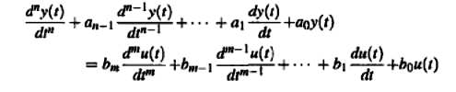
(Eq.1)
The coefficients a₀, a₁, …… a_{n-1} and b₀, b₁, …… b_{m} are real constants. Once the input u(t) for t >= t₀ and the initial conditions of y(t) and the derivatives of y(t) are specified at the initial time t = t₀ , the output response y(t) for t >= t₀ is determined by solving Eq. 1.

To obtain the transfer function of the linear system that is represented by Eq. (1), we simply take the Laplace transform on both sides of the equation and assume zero initial conditions. The result is
(Eq.2)
The transfer function between u(t) and y(t) is given by

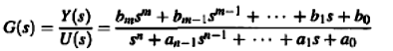
(Eq.3)
Transfer Function (Multivariable Systems)
The definition of a transfer function is easily extended to a system with multiple inputs and outputs. A system of this type is often referred to as a multivariable system. In a multivariable system, a differential equation of the form of Eq. (1) may be used to describe the relationship between a pair of input and output variables, when all other inputs are set to zero. Because the principle of superposition is valid for linear systems, the total effect on any output due to all the inputs acting simultaneously is obtained by adding up the outputs due to each input acting alone.
In general, if a linear system has p inputs and q outputs, the transfer function between the jth input and the ith output is defined as

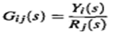
(Eq.4)

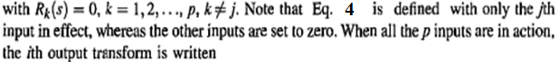
(Eq.5)

Transfer Function of Closed Loop Control System:
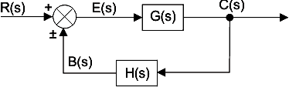
In a closed loop control system, a fraction of output is fed-back and added to input of the system. If H (s) is the transfer function of feedback path, then the transfer function of feedback signal will be B(s) = C(s)H(s). At summing point, the input signal R(s) will be added to B(s) and produces actual input signal or error signal of the system and it is denoted by E(s).
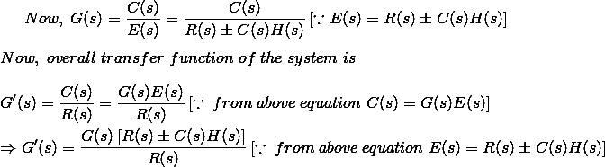

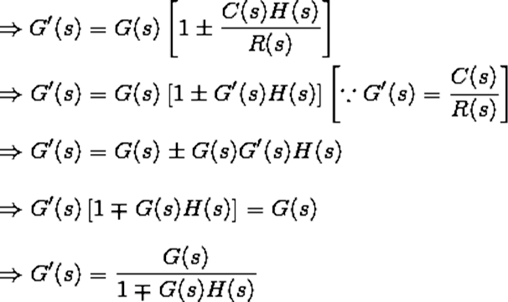
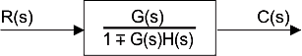

Block Diagram of Multi-Input Systems (Systems with Disturbance):
An important ease in the study of control systems is when a disturbance signal is present. Disturbance (such as heat loss in (he example in Fig. 3-D usually adversely affects the performance of the control system by placing a burden on the controller/actuator components. A simple block diagram with two inputs is shown in Fig.3-19. In this case, one of the
inputs, D(s), is known as disturbance, while R(s) is the reference input. Before designing a proper controller for the system, it is always important to learn the effects of D(s) on the system.
We use the method of superposition in modeling a multi-input system. Superposition: For linear systems, the overall response of the system under
multi-inputs is the summation of the responses due to the individual inputs, i.e., in this case:
