Multiple sclerosis (MS)
Definition:
- Multiple sclerosis is a complex inflammatory disease of the central nervous system (CNS) leading to scars particularly in the white matter of the brain and spinal cord.
- The name refers to two features of the disease:
multiple describes the number of CNS lesions , and
sclerosis refers to the demyelinated lesions.
- Today, these lesions are usually called plaques, rather than scleroses.
- Multiple sclerosis, also known as disseminated sclerosis or encephalomyelitis disseminates.

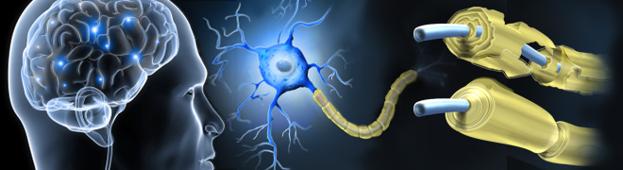

- Multiple sclerosis (MS) is an inflammatory disease in which the fatty myelin sheaths around the axons of the brain and spinal cord are damaged, leading to demyelination and scarring as well as a broad spectrum of signs and symptoms.

Multiple sclerosis takes numerous forms, through new symptoms in either:
- Relapsing forms (Relapsing-Remitting) … new symptoms occurring either in attacks
- Progressive forms… accumulating over time (gradual worsening of symptoms and there are no periods of remission).
- Between attacks… symptoms may go away completely, but permanent neurological deficits often occur, especially as the disease advances.

- MS affects the ability of nerve cells in the brain and spinal cord to communicate with each other effectively.

Epidemiology:
- Disease is more common in women. Internationally it is about two times more common in women than in men, while in persons over fifty it affects males and females equally.
- Disease onset usually occurs in young adults.
- The number of new cases that develop per year is 2.5 per 100,000.

PATHOPHYSIOLOGY
- Development of an autoimmune disorder with areas of CNS demyelination and axonal transection.
Demyelination
- During immune response, cells identify antigens and interpret components of myelin as foreign (antigen-presenting cells APC).
- T cells penetrate the blood–brain barrier by attachment to adhesion molecules and production of matrix metalloproteinases that cause blood–brain barrier breakdown.
- B cells likely cross previously damaged sections of the blood–brain barrier to arrive in the CNS, B-cell antibodies also initiate the complement cascade which causes myelin degradation.
- The blood–brain barrier prevents the entry of T cells into the central nervous system. However, it may become permeable to these types of cells because of an infection or a virus.
- When the blood–brain barrier regains its integrity, typically after the infection or virus has cleared, the T cells are trapped inside the brain.
Axonal Transection
- Transection of the axon disrupts nerve signals completely and irreversibly.
- Axonal transection begins as early as 2 weeks after diagnosis and continues throughout the course of the disease.
- MS results in a thinning or complete loss of myelin and, as the disease advances, the cutting (transection) of the neuron's axons.

- A repair process, called remyelination, which takes place in early phases of the disease, but the oligodendrocytes are unable to completely rebuild the cell's myelin sheath, repeat attacks lead to successively less effective remyelinations, till a scar-like plaque built up around the damaged axons.

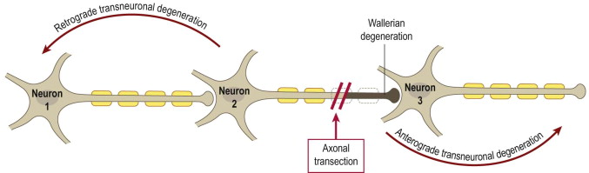

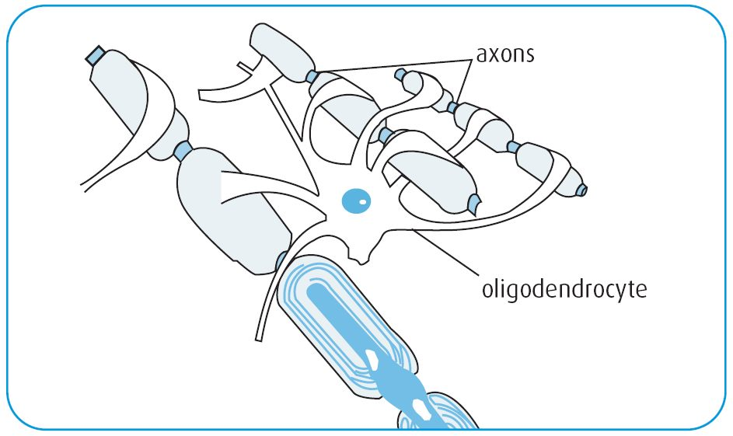

Signs and symptoms
- Symptoms of MS usually appear in
- episodic acute periods of worsening (called relapses, exacerbations, attacks, or "flare-ups")
- gradually progressive deterioration of neurologic function,
- Combination of both.

Initial symptoms of MS:
Symptom | Percent of cases | Symptom | Percent of Cases
Sensory loss | 37% | Lhermitte’s phenomenon | 3%
Optic neuritis | 36% | Pain | 3%
Weakness | 35% | Dementia | 2%
Paresthesia | 24% | Visual loss | 2%
Diplopia | 15% | Facial palsy | 1%
Ataxia | 11% | Impotence | 1%
Vertigo | 6% | Myokymia | 1%
Paroxysmal Attacks | 4% | Epilepsy | 1%
Bladder dysfunction | 4% | Falling | 1%

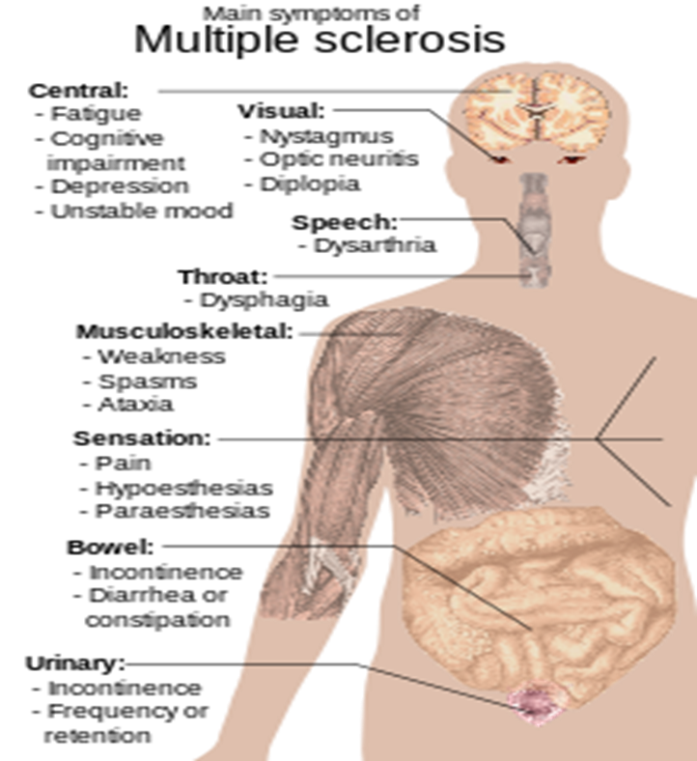
The main measure of disability and severity is the Expanded Disability Status Scale (EDSS);
Pyramidal - weakness or difficulty moving limbs
Cerebellar - ataxia, loss of coordination or tremor
Brainstem - problems with speech, swallowing and nystagmus
Sensory - numbness or loss of sensations
Bowel and bladder function
Visual function
Cerebral (or mental) functions
Most patients with EDSS scores <3.5 have Relapsing-Remitting Multiple Sclerosis (RRMS), walk normally, and are generally not disable; by contrast, patients with EDSS scores>5.5 have progressive MS (SPMS or PPMS), are gait-impair and typically, occupationally disable.

Etiology:
Inheritance Theory
- Genetic component; there is a 5% risk for family members of MS patients.
- Gender: Women are more likely to have MS than men by a 2:1 ratio, because women are in general more likely to have an Auto immune Disease.
- Racial group: Whites are more than twice as likely as other races to develop MS.

Environmental factors
- MS is more common in people who live farther from the equator, although many exceptions exist.
- Decreased sunlight exposure has been linked =Decreased vitamin D production and intake.
- Severe stress may be a risk factor although evidence is weak
- Smoking has also been shown to be an independent risk factor for developing MS.
- Vaccinations were investigated as causal factors for the disease.
- Diet and hormone intake.
- Gout; low levels of uric acid have been found in people with MS as compared to normal individuals. This led to the theory that uric acid protects against MS, although its exact importance remains unknown.
- Infection: They believe MS is a delayed reaction to a viral infection contracted during childhood by a genetically susceptible person. The older are the higher the risk for MS.
- Other potential causes of MS-like symptoms:

- Lupus
- Migraine
- Inflammatory process
- Encephalitis
- Stroke
- Tumor of the brain or spinal cord

Multiple sclerosis relapses are often unpredictable, occurring without warning:
- Relapses occur more frequently during spring and summer.
- Viral infections such as the common cold, influenza, or gastroenteritis increase the risk of relapse.
- Stress may also trigger an attack.
- Pregnancy affects the susceptibility to relapse, with a lower relapse rate at each trimester of gestation. During the first few months after delivery, however, the risk of relapse is increased.
Diagnosis;
1. Neuroimaging
2. Analysis of cerebrospinal fluid, evidence of chronic inflammation
3. Magnetic resonance imaging of the brain
4. Brain responses can be examined using visual and sensory evoked potentials.

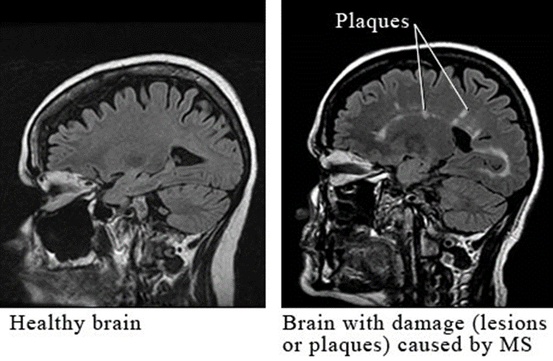

Clinical courses
- Relapsing remitting,
- Secondary progressive,
- Primary progressive, and
- Progressive relapsing.

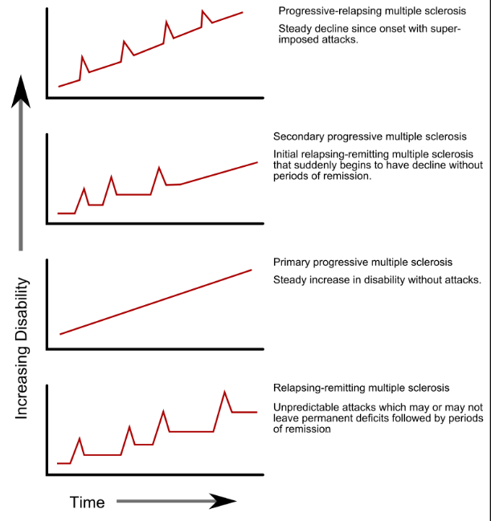

Prognostic indicators in multiple sclerosis;

Indicator | Favorable Prognosis | Unfavorable Prognosis
Age at onset | <40 years | >40 years
Gender | Female | Male
Initial symptoms | Optic neuritis or sensory | Motor or cerebellar
Attack frequency | in early low | High
Course of disease | Relapsing/remitting | Progressive

Treatment of multiple sclerosis;
- Although there is no known cure for multiple sclerosis, several therapies have proven helpful.
- The primary aims of therapy are;
1. Returning function after an attack
2. Preventing new attacks
3. Preventing disability.

Treatment of Acute attacks;
- Administration of high doses of intravenous corticosteroids, cortisone medication include in methylprednisolone, dexamethasone, prednisone, used to shorten the attack.
- These potent anti-inflammatory drugs diminish the swelling within the brain and spinal cord that is seen as cells of the immune system invade and attack the nervous system.
Treatment of Acute Relapses
The mechanism of action of corticosteroids used for acute relapses is not completely clear, but may involve the following actions:
- Prevention of inflammatory cytokine activation;
- Inhibition of T-cell activation;
- Prevention of immune cells from entering the CNS;
- Increased death of activated immune cells
Methylprednisolone is usually given 1 g/day intravenously as one or divided doses for 3 to 5 days. Or oral prednisone 125 mg/day
Treatment of Chronic MS
- General drugs that affect the immune system include azathioprine (Imuran®) and methotrexate orally.

Disease-Modifying Therapies:
1. Subcutaneous interferon beta1a (Rebif)
2. Intramuscular interferon beta 1a (Avonex)
3. Interferon beta 1b (Betaseron)
4. Glatiramer acetate (Copaxone) immunomodulatory& neuroprotective (reduce frequency of relapses, more than reducing the progression of disability).
5. Mitoxantrone (Novantrone), it is effective in slowing the progression of secondary-progressive MS and extending the time between relapses in both relapsing-remitting MS and progressive-relapsing MS.
It is infused intravenously over 30 minutes to reduce the chance of cardiotoxicity.
6. Other approved drugs;
- Natalizumab: given by intravenous (IV) infusion at monthly intervals
- Fingolimod and teriflunomide are taken through a daily single dose 1.25 or 5 mg once daily (inhibits rapidly dividing cells, including activated T cells)

Beta Interferons
Mechanism of Action:
- Decrease in T-cell activation, decreasing cytokine secretion
- Limiting the number of T cells that get into the brain.
- Suppression of matrix metalloproteinases, maintaining the integrity of the blood brain barrier.
- Promotion of formation of Th-2 cells rather than Th-1 cells, decreasing inflammation.
- Inhibition of viruses, important if MS has a viral etiology.

Adverse Effects ;
- Neutralizing Antibodies: Antibodies to beta interferon can form over time and reduce the clinical effect of beta interferon.
- The clinical effect of neutralizing antibodies is seen 18-24 months after treatment, disappear with continued treatment
- Frequency and route of administration affect neutralizing antibody development:
Subcutaneous interferon beta-1b>subcutaneous interferon beta-1a; > intramuscular interferon beta-1a.

Symptomatic Therapies
- Spasticity stiffness - Baclofen, Tizanidine, Diazepam, Dantrolene
- Optic Neuritis- Methlyprednisolone, oral steroids
- Fatigue- Antidepressant, amantadine
- Pain- Codeine, Aspirin
- Sexual Dysfunction- Viagra, Papaverine
- Tremor- Isoniazid, Primidone, Propranolol
- Incomplete bladder emptying and incontinence; Catheterization, anticholinergics, antidepressants with antimuscarinic.

Alternative Treatments

- Acupuncture
- Aromatherapy
- Cannabis (Marijuana)
- Cold Immersion
- Dietary Supplements
- Herbal Medication
- Homeotherapy
- Injection of Venom such as snake and bee
- Massage
- Reflexology
- Tai Chi
- Yoga

