**Decision Analysis**

**(Probabilities)**

Decision analysis is the application of an analytical method for systematically comparing different decision options. Decision analysis graphically displays choices and facilitates the calculation of values needed to compare these options. It assists with selecting the best or most cost-effective alternative. Decision analysis is a tool that has been used for years in many fields. This method of analysis assists in making decisions when the decision is complex and there is uncertainty about some of the information.

**steps in Decision analysis**

**Step 1: Identify the research question.**

The specific decision to be evaluated should be clearly defined by answering the questions: What is the objective of the study?

For example the decision is whether to add a new antibiotic to an institutional formulary to treat infections.

**Step 2: Specify Alternatives**

* Ideally the most effective treatments or alternatives should be compared.
* In pharmacotherapy evaluations, makers of new products may compare or measure themselves against a standard (i.e., older, more well-established) therapy.
* Decision analysis could compare more than two treatment options (e.g., it could compare the five most common statins) or an intervention versus no intervention (e.g., a diabetes clinic versus no clinic).
* For the example problem, the use of the new medication (antibiotic A) will be compared with that of the current standard (antibiotic B).

**Step 3: Draw the Decision Analysis Structure or tree**

Once these stages have been completed, we can build our decision tree.

A decision tree has five principal components:

1. ***Starting point****:* at which point in the process we begin the evaluation of the intervention.
2. ***All treatment alternatives under investigation****:* the different strategies under investigation.
3. ***Decision nodes*** ■: there should only be one decision node: the policy decision of whether to use one strategy or the other.
4. ***Chance nodes •***: these are uncertain events and will have probability values attached to them.
5. ***Outcome/time horizon*** ◄: the outcome being used must be defined and the point at which evaluation ends (time horizon).

The decision tree in Figure 8.1 shows two alternatives for treating urinary tract infections (UTIs).



The starting point is the patient group who has been diagnosed with a UTI that now needs to be treated. At the decision node, the policy decision is whether to treat this group of patients with the standard current treatment (drug T) or whether to use a newer, more costly agent, drug C.

There is no 'do nothing' option here because current practice is to treat symptomatic UTIs, to alleviate symptoms, and also to prevent complications such as pyelonephritis. It would, however, be possible to include more antibiotics in the model and have more arms in the tree, if it were felt to be necessary.

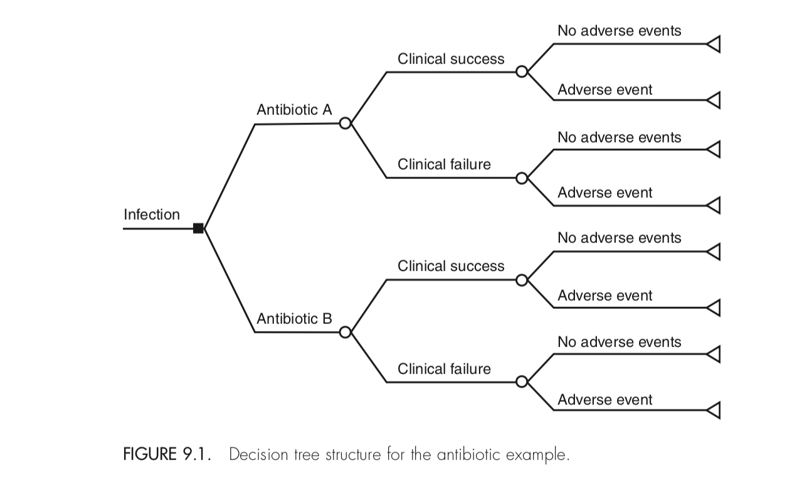The probabilistic event here is whether or not the antibiotic is successful in treating the infection.see figure 9.1.

**step 4: specify possible costs, outcomes, and probabilities**

For each option, information should be obtained for the probability of occurrence and the consequences of the occurrence. Probabilities are assigned for each branch of the chance nodes, and the sum of the probabilities for each branch must add up to 1.00. Consequences are reported as monetary outcomes, health- related outcomes, or both. Decision analysis articles should provide a listing of the probability, cost, and outcome estimates used in the analysis, including where or how the estimates were obtained (e.g., literature review, clinical trial, expert panel). Table 9.1 lists these data for the antibiotic example.

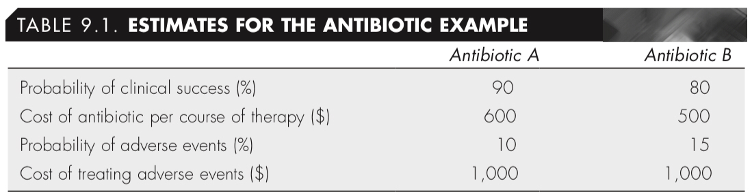

**step 5: perform calculations**

At each terminal node, the probability of a patient having that outcome is calculated by multiplying the probability of each arm from the choice node to the terminal node. The total costs for each terminal node are calculated by adding up the costs over all of the branches from the choice node to the terminal node. The product of the costs multiplied by the probability (C × P) is calculated for each node and then summed for each option.

In our example, each of the two options (antibiotic A versus antibiotic B) has four possible terminal endpoints: success/no adverse events, success/adverse events, failure/no adverse events, and failure/adverse events. Table 9.2 and Figure 9.2 show the calculations used to estimate the average expected cost per treatment. Note that the sum of the probabilities for the four terminal endpoints equals 1.00. For patients taking antibiotic A, the costs can range from $600 (for medication and no adverse events) to $1,600 (for medication and treatment of adverse events), and the average cost is $700 per patient. Similarly, for patients taking antibiotic B, the costs can range from $500 (for medication and no adverse events) to $1,500 (for medication and treatment of adverse events), and the average cost is $650 per pa- tient. These calculations show that antibiotic B is less expensive even when includ- ing the costs of treating adverse events. But because antibiotic A is a better clinical option (higher probability of success and lower probability of adverse events), decision makers could use either the incremental cost-effectiveness ratio (ICER) or the incremental net benefit (INB) calculations to determine whether to add antibiotic A to the formulary.

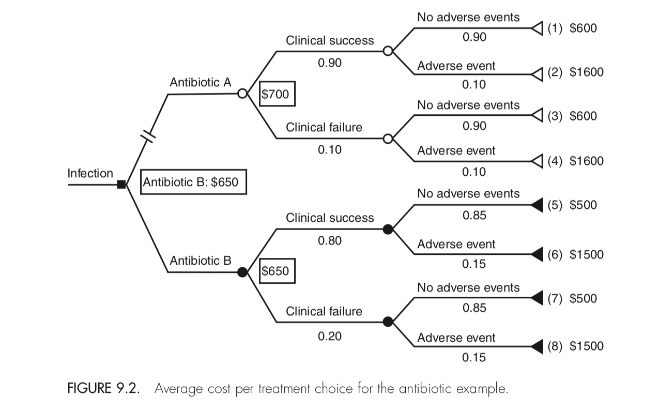

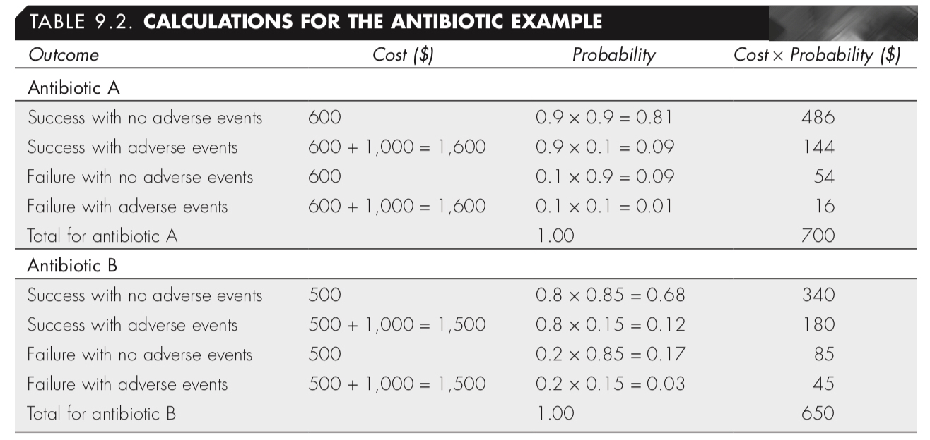

The calculated ICER would be:



If it is decided that each extra successful outcome is worth at least $500 (patient discharged from the hospital faster, prevention of second round of treatment costs with another antibiotic, and so on), then antibiotic A would be added to the formulary. See Example 9.1 for incremental net benefit (INB).calculations using a

**Step 6: Conduct a Sensitivity Analysis**

Because some uncertainty surrounds the estimates used to construct these models, a sensitivity analysis is conducted.

**Markov modeling**

A simple decision tree may not be capable of modeling chronic disease states. A model trying to represent a chronic disease, such as relapsing-remitting multiple sclerosis must be capable of reflecting changes in and out of health states. These may be referred to as random processes that evolve over time. They are random because we do not know when they will occur in the disease progression. Markov models are particularly useful for representing the use of interventions to manage chronic health states.

A decision-analytical model may become unnecessarily complex, as patients will move in and out of health states many times. An alternative method for presenting these events is shown in Figure 8.4.



This shows a simplified version of what can happen to a person with relapsing-remitting multiple sclerosis. When they are symptom free there is a probability they will have a relapse, stay symptom free or die. When they are experiencing symptoms, there is a probability they will become symptom free, the relapse may continue, or they may die. When a patient dies, they cannot return to the other health states. Therefore, death is referred to as the 'absorbing' state.