College of Pharmacy
Fourth year. Clinical Pharmacy
Infectious Diseases
Urinary Tract Infections
Introduction
1-Infections of the urinary tract represent a wide variety of clinical syndromes including urethritis, cystitis, prostatitis, and pyelonephritis.

2-A urinary tract infection (UTI) is defined as the presence of microorganisms in the urine that cannot be accounted for by contamination.

3-Lower tract infections include cystitis (bladder), urethritis (urethra), prostatitis (prostate gland), and epididymitis.

4-Upper tract infections involve the kidney and are referred to as pyelonephritis.

5-Uncomplicated UTIs are not associated with structural or functional abnormalities that may interfere with the normal flow of urine or the voiding mechanism.

6-Complicated UTIs are the result of a predisposing lesion of the urinary tract, such as an abnormality of the urinary tract, stone, indwelling catheter, prostatic hypertrophy, obstruction, or neurologic deficit that interferes with the normal flow of urine and urinary tract defenses.

7-Recurrent UTIs, two or more UTIs occurring within 6 months or three or more within 1 year, are characterized by multiple symptomatic episodes with asymptomatic periods occurring between these episodes.

8-These infections are due to reinfection or to relapse. Reinfections are caused by a different organism and account for the majority of recurrent UTIs. Relapse represents the development of repeated infections caused by the same initial organism.

Pathophysiology
1-The bacteria causing UTIs usually originate from bowel flora of the host. Organisms typically gain entry into the urinary tract via three routes: the ascending, hematogenous (descending), and lymphatic pathways.

2-The most common cause of uncomplicated UTIs is E. coli, accounting for more than 80%–90% of community-acquired infections.

3-Additional causative organisms are Staphylococcus saprophyticus, Klebsiella pneumoniae, Proteus spp., Pseudomonas aeruginosa, and Enterococcus spp.

4-The urinary pathogens in complicated or nosocomial infections may include E. coli, which accounts for less than 50% of these infections, Proteus spp., K. pneumoniae, Enterobacter spp., P. aeruginosa, staphylococci, and enterococci. Enterococci represent the second most frequently isolated organisms in hospitalized patients.

5-Most UTIs are caused by a single organism; however, in patients with stones, indwelling urinary catheters, or chronic renal abscesses, multiple organisms may be isolated.

Clinical presentation
1-The typical signs and symptoms of urinary tract infections are:
- Lower UTI: Dysuria, urgency, frequency, nocturia, and suprapubic heaviness, gross hematuria, and costovertebral tenderness.
- Upper UTI: Flank pain, fever, nausea, vomiting, and malaise.

2-Symptoms alone are unreliable for the diagnosis of bacterial UTIs. The key to the diagnosis of a UTI is the ability to demonstrate significant numbers of microorganisms present in urine specimen.

3-Older patients frequently do not experience specific urinary symptoms, but they will present with altered mental status, change in eating habits, or gastrointestinal (GI) symptoms.

4-The presence of pyuria in a symptomatic patient correlates with significant bacteriuria.

5-The most reliable method of diagnosing UTIs is by quantitative urine culture.

Treatment
Goals of Treatment:
1-Eradicate the invading organisms, prevent or treat systemic consequences of infection, prevent recurrence of infection, and decrease the potential for collateral damage with excessively broad antimicrobial therapy.

2-The initial selection of an antimicrobial agent for the treatment of UTI is primarily based on the severity of the presenting signs and symptoms, the site of infection, and whether the infection is determined to be complicated or uncomplicated.

3-Other considerations include antibiotic susceptibility, side-effect potential, cost, current antimicrobial exposure, and the comparative inconvenience of different therapies.

Pharmacologic Therapy
1-Eradication of bacteria from the urinary tract is directly related to the sensitivity of the organism and the achievable concentration of the antimicrobial agent in the urine.

2-Most E. coli remain susceptible to trimethoprim–sulfamethoxazole, although resistance is increasing. In light of rising resistance and in order to decrease the overuse of broad-spectrum antimicrobials, agents such as nitrofurantoin and fosfomycin are now considered first-line treatments along with trimethoprim–sulfamethoxazole in acute uncomplicated cystitis.

3-Table 1 presents an overview of various therapeutic options for outpatient therapy for UTI. Table 2 describes empiric treatment regimens for specific clinical situations.

Table 1: Overview of Outpatient Antimicrobial Therapy for Lower Tract Infections in Adults

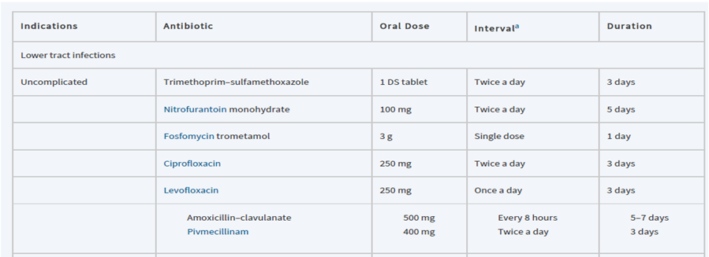
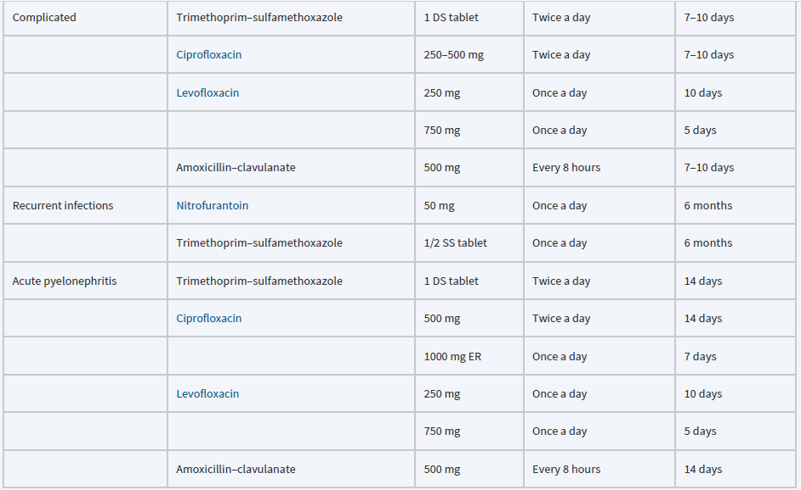
a Dosing intervals for normal renal function. DS, double strength; SS, single strength.

Table 2: Evidence-Based Empirical Treatment of UTIs and Prostatitis

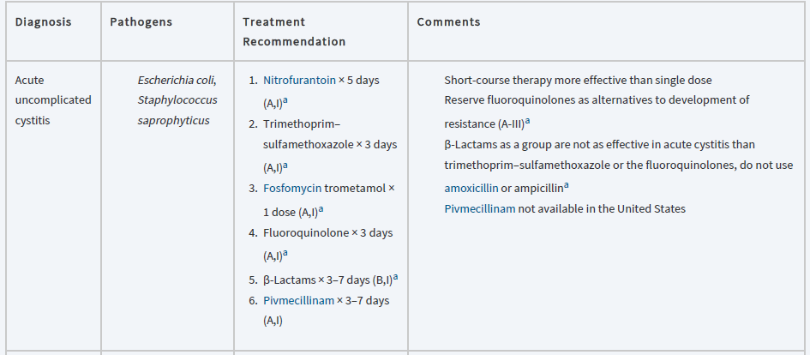
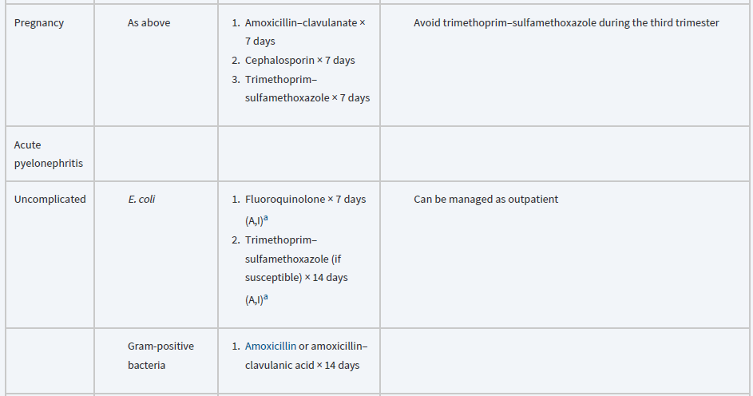
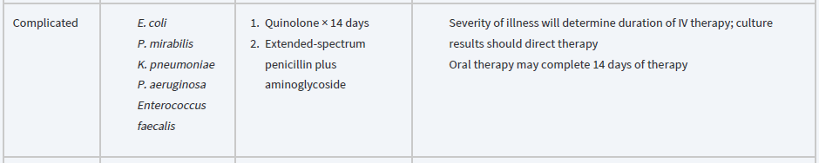
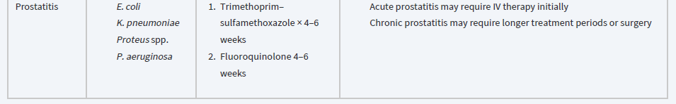

Acute Uncomplicated Cystitis
1-These infections are predominantly caused by E. coli, and antimicrobial therapy should be directed against this organism initially.

2-Because the causative organisms and their susceptibilities are generally known, a cost-effective approach to management is recommended that includes a urinalysis and initiation of empiric therapy without a urine culture.

3-Short-course therapy (3-day therapy) with trimethoprim–sulfamethoxazole or a fluoroquinolone (eg, ciprofloxacin or levofloxacin, but not moxifloxacin) is superior to single-dose therapy for uncomplicated infection.

4-Fluoroquinolones should be reserved for patients with suspected or possible pyelonephritis due to the collateral damage risk. Instead, a 3-day course of trimethoprim–sulfamethoxazole, a 5-day course of nitrofurantoin, or a one-time dose of fosfomycin should be considered as first-line therapy.

5-In areas where there is more than 20% resistance of E. coli to trimethoprim–sulfamethoxazole, nitrofurantoin or fosfomycin should be utilized. Amoxicillin or ampicillin is not recommended because of the high incidence of resistant E. coli. Follow-up urine cultures are not necessary in patients who respond..

Complicated Urinary Tract Infections
Acute Pyelonephritis
1-The presentation of high-grade fever (>38.3°C) and severe flank pain should be treated as acute pyelonephritis, and aggressive management is warranted.

2-Severely ill patients with pyelonephritis should be hospitalized and IV drugs administered initially. Milder cases may be managed with oral antibiotics in an outpatient setting.

3-At the time of presentation, a Gram stain of the urine should be performed, along with urinalysis, culture, and sensitivities.

4-In the mild to moderately symptomatic patient for whom oral therapy is considered, an effective agent should be administered for 7–14 days, depending on the agent used.

5-Fluoroquinolones (ciprofloxacin or levofloxacin) orally for 7–10 days are the first-line choice in mild-tomoderate pyelonephritis. Other options include trimethoprim–sulfamethoxazole for 14 days.

6-If a Gram stain reveals gram-positive cocci, Streptococcus faecalis should be considered and treatment directed against this pathogen (ampicillin).

7-In the seriously ill patient, the traditional initial therapy is an IV fluoroquinolone, an aminoglycoside with or without ampicillin, or an extended spectrum cephalosporin with or without an aminoglycoside.

8-If the patient has been hospitalized in the last 6 months, has a urinary catheter, or is in a nursing home, the possibility of P. aeruginosa and enterococci infection, as well as multiple-resistant organisms, should be considered. In this setting, ceftazidime, ticarcillin–clavulanic acid, piperacillin, aztreonam, meropenem, or imipenem, in combination with an aminoglycoside, is recommended. If the patient responds to initial combination therapy, the aminoglycoside may be discontinued after 3 days.

9-Follow-up urine cultures should be obtained 2 weeks after the completion of therapy to ensure a satisfactory response and to detect possible relapse.

Urinary Tract Infections in Men
1-Therapy in men requires prolonged treatment. A urine culture should be obtained before treatment, because the cause of infection in men is not as predictable as in women.

2-If gram-negative bacteria are presumed, trimethoprim–sulfamethoxazole or a fluoroquinolone is a preferred agent. Initial therapy is for 10–14 days.

3-For recurrent infections in men, cure rates are much higher with a 6-week regimen of trimethoprim–sulfamethoxazole.

Recurrent Infections
1-Recurrent episodes of UTI (reinfections and relapses) account for a significant portion of all UTIs.

2-These patients are most commonly women and can be divided into two groups: those with fewer than two or three episodes per year and those who develop more frequent infections.

3-In patients with infrequent infections (ie, fewer than three infections per year), each episode should be treated as a separately occurring infection. Short-course therapy should be used in symptomatic female patients with lower tract infection.

4-In patients who have frequent symptomatic infections, long-term prophylactic antimicrobial therapy may be instituted. Therapy is generally given for 6 months, with urine cultures followed monthly.

5-In women who experience symptomatic reinfections in association with sexual activity, voiding after intercourse may help prevent infection. Also, self-administered, single-dose prophylactic therapy with trimethoprim–sulfamethoxazole taken after intercourse significantly reduces the incidence of recurrent infection in these patients.

6-Women who relapse after short-course therapy should receive a 2-week course of therapy.

7-In patients who relapse after 2 weeks, therapy should be continued for another 2–4 weeks.

8-If relapse occurs after 6 weeks of treatment, urologic examination should be performed, and therapy for 6 months or even longer may be considered.

Special conditions
Urinary Tract Infection in Pregnancy
1-In patients with significant bacteriuria, symptomatic or asymptomatic treatment is recommended to avoid possible complications during the pregnancy.

2-Therapy should consist of an agent with a relatively low adverse-effect potential (cephalexin, amoxicillin, or amoxicillin/clavulanate) administered for 7 days.

3-Tetracyclines should be avoided because of teratogenic effects and sulfonamides should not be administered during the third trimester because of the possible development of kernicterus and hyperbilirubinemia. Also, the fluoroquinolones should not be given because of their potential to inhibit cartilage and bone development in the newborn.

Catheterized Patients
1-When bacteriuria occurs in asymptomatic, short-term catheterized patients (<30 days), the use of systemic antibiotic therapy should be withheld and the catheter removed as soon as possible. If the patient becomes symptomatic, the catheter should again be removed, and treatment as described for complicated infections should be started.

2-The use of prophylactic systemic antibiotics in patients with short-term catheterization reduces the incidence of infection over the first 4–7 days.

3-In long-term catheterized patients, however, antibiotics only postpone the development of bacteriuria and lead to emergence of resistant organisms.

Reference: Joseph T. DiPiro, Robert L. Pharmacotherapy: A Pathophysiologic Approach, 11th Edition. 2021.

