Beautiful Bamboo

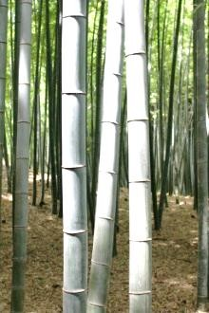Bamboo has long been woven into the cultures of many countries, where it has historically been used for everything from food and fodder to musical instruments and construction material. For centuries, millions of people have depended on this plant, which is known as “friend of the people” in China, and “wood of the poor” in India. But the demand for bamboo has been increasing in other parts of the world as well, especially as it relates to furniture, accent pieces, and flooring. More and more, people are seeing the value and beauty of using bamboo in their homes to achieve modern-day fashion with an ethnic flavor. Entire books have been written on the subject, including Big Bad Bamboo and Bamboo, Family Style.
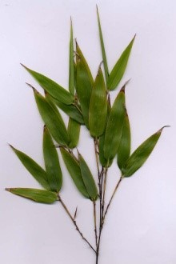There are many different sizes and varieties of bamboo. It is both tropical and subtropical, growing in climates as diverse as jungles and mountainsides. Actually giant, woody grasses, it is very adaptable, with some species deciduous and others evergreen. Although there isn't yet a complete knowledge about this plant, there are believed to be between 1100 and 1500 different species of bamboo. The color range is from light green leaves and culms (stems) to dark, rich shades of green or some combination thereof.

