PITUITARY GLAND DISORDERS
&
Adrenocortical Dysfunction
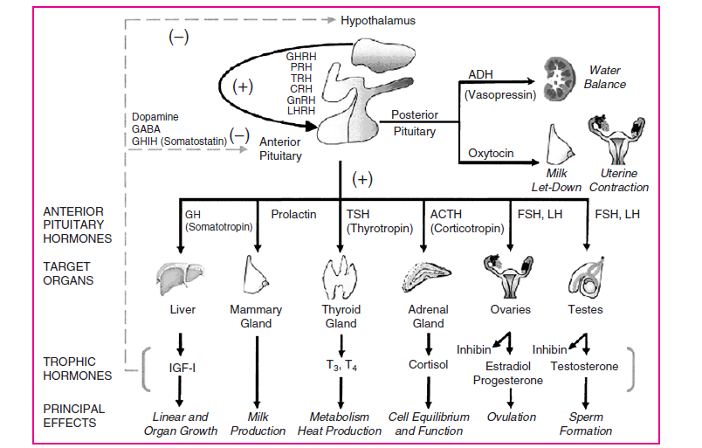
Hypothalmic- Pituitary – (Target – Organ) Axis

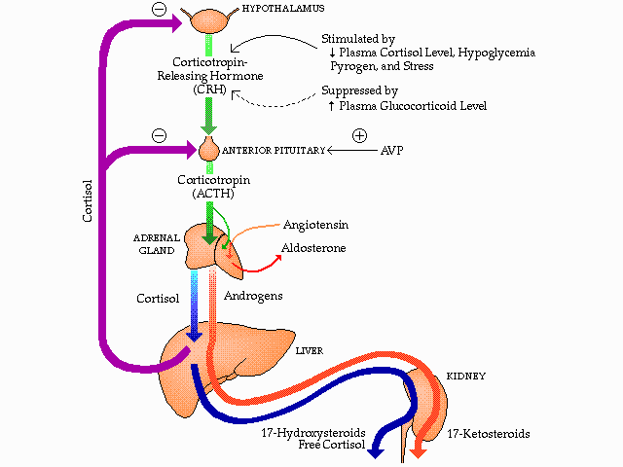
Hypothalamus-Pituitary-Adrenal Axis

Cushing'S Syndrome
Definition -Cushing syndrome is a disorder caused by persistent glucocorticoid excess.
- “poly-glandular syndrome” (Cushing's disease) was caused by primary pituitary dysfunction.
- Pseudo-Cushing's syndrome, a non-endocrine disorder characterized by some of the clinical and biochemical manifestations of Cushing's syndrome, is associated with major depressive disorders and alcoholism.
Cushing Syndrome Etiology
ACTH-dependent Disorders | Etiology
Cushing's disease | Pituitary ACTH hypersecretion
Ectopic ACTH syndrome | Ectopic (nonpituitary) ACTH secretion
Ectopic CRH syndrome | Ectopic (nonhypothalamic) CRH secretion causing pituitary ACTH hypersecretion
Iatrogenic/Factitious | Exogenous ACTH administration
ACTH-independent Disorders | Etiology
Iatrogenic | Exogenous glucocorticoid administration
Factitious | Exogenous glucocorticoid administration
Adrenal adenomas and carcinomas | HPA-axis independent cortisol production
Micronodular and macronodular adrenal hyperplasia | Increased cortisol secretion
ªMost common ACTH-dependent disorder.
^{b}Most common ACTH-independent disorder.
ACTH, adrenocorticotropic hormone; CRH, corticotropin-releasing hormone; HPA, hypothalamus-pituitary-adrenal.

Epidemiology –
- Cushing's disease causes about 70% of all cases of ACTH-dependent Cushing's syndrome.
- Women are three to eight times more likely than men .
- Women more likely to have adrenal tumor-associated Cushing's syndrome.
- in men, more likely to have Ectopic ACTH secretion-associated Cushing's syndrome is more common, most likely reflecting the increased incidence of lung cancer in men
Signs and Symptoms-
The clinical manifestations of Cushing's syndrome are
- insidious in onset
- include multiple organ systems;
- none is pathognomonic.
- Signs and symptoms depend on absence of androgen excess, and other tumor-related effects (adrenal carcinoma or ectopic ACTH syndrome)
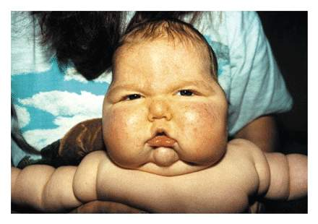

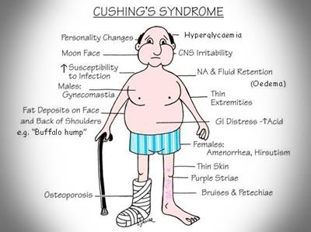

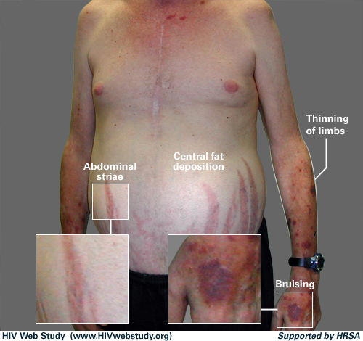

Cushing's Syndrome Signs and Symptoms
General | Cardiovascular | Skin | Endocrine and Metabolic
Centripetal obesity  Elevated intraocular pressure  Headache  Insomnia  Proximal muscle weakness  Psychiatric (emotional lability, depression, irritability, anxiety, mild paranoia) | Edema (ankle)  Heart failure  Hypertension | Acne  Ecchymoses  Facial plethora  Fungal skin infections  Hirsutism  Hyperpigmentation  Skin atrophy  Wide (>1 cm) purple striae | Decreased libido  Delayed bone growth (children)  Glucose intolerance  Hypercalciuria  Hypokalemic alkalosis  Impotence  Leukocytosis  Menstrual irregularities  Osteopenia, osteoporosis  Polyuria  Renal calculi

General
- Progressive central, obesity, , involving the face, neck, trunk, and abdomen; the extremities are spared.
- Facial fat accumulation in the cheeks produces moon faces,.
- Fat pads fill and bulge above the supraclavicular fossae and the dorso-cervical fat pad enlarges creating the characteristic “buffalo hump.”
- Exophthalmos, caused by increased retro-orbital fat, may be present.
- proximal muscle Weakness, wasting, is caused by the catabolic effects of cortisol on muscle tissue. Patients with severe disease may be unable to climb stairs, get up from a deep chair, or raise their arms.
Cardiovascular
- Moderate hypertension (diastolic blood pressure >100 mmHg) is common. The elevated blood pressure is caused by increased peripheral vascular sensitivity to adrenergic agonists and mineralocorticoid excess.
- Dependent edema is another sign of mineralocorticoid excess.
- Congestive heart failure has been reported in almost half of patients more than 40 years of age.
Dermatologic
- Atrophic and fragile skin with a loss of subcutaneous fat making the subcutaneous blood vessels visible.
- Easy bruisability due to Loss of connective tissue.
- Striae, caused by stretched skin, appear purplish or reddish because the thin, transparent skin reveals the color of venous blood in the dermis. Striae, often more than 1 cm wide, appear most often on the breasts, hips, buttocks, upper abdomen, shoulders, and upper thighs and in the axillae.
- Thinning scalp hair is common. Chronic ACTH elevation (e.g., ectopic ACTH syndrome) is associated with hyperpigmentation of light-exposed skin (e.g., face, neck, arms) and scars.
Endocrine and Metabolic
- Osteopenia and osteoporosis are caused by cortisol osteoblast inhibition, resulting in back pain, vertebral compression fractures, pathologic rib fractures, and, less commonly, long bone fractures.
- Hypercalciuria and renal caliculi may be present.
- Glucose intolerance and hyperinsulinemia are common. True diabetes mellitus occurs in less than 20% of patents, probably in those with a familial predisposition; ketoacidosis is rare.
- Oligomenorrhea in women, impotence in men, and decreased libido in both sexes are common.
- Androgen excess is manifested by oily facial skin, acne, mild facial hirsutism, and virilization (deep voice, temporal balding, clitoral hypertrophy).
Psychological
- Psychological complications including emotional lability, agitated depression, loss of energy, irritability, anxiety, panic attacks, and mild paranoia, Insomnia
- increased appetite and weight gain.

Other
- increased risk of thromboembolic events.
- Glucocorticoids suppress immune function and inflammatory and febrile responses, but infection occurs only with severe hypercortisolemia. Intraocular pressure is reversibly increased.

Diagnosis
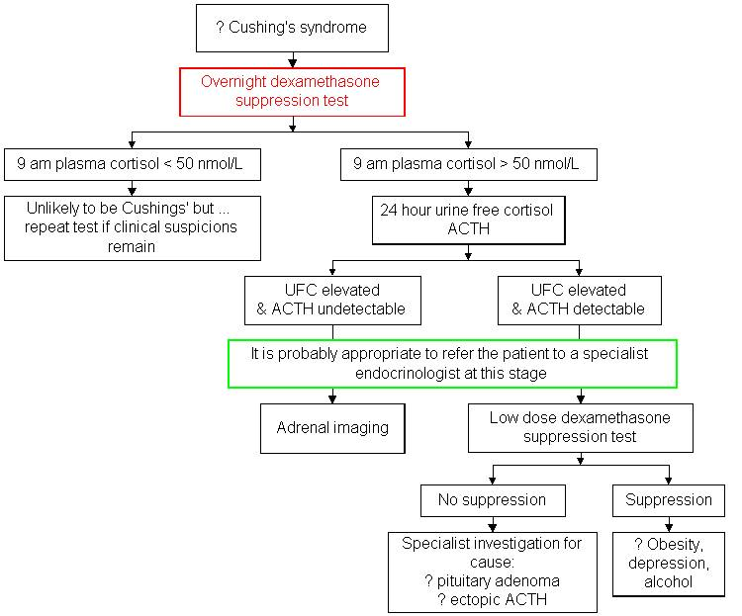

Treatment-
Therapeutic Plan
- The treatment depends on the Etiology
- Slowly tapering the steroid over several weeks as tolerated and
- Managing the adverse physiologic consequences of excessive chronic glucocorticoid administration (e.g., control hyperglycemia with diet and hypoglycemic medications; control the elevated blood pressure with antihypertensive medications;
- Monitor for and treat infections;
- Replace potassium; calcium; supplement the glucocorticoid dosage when the patient has an acute illness, injury, or surgery).
- Selective surgical removal of the pituitary microadenomas (transsphenoidal adenectomy).
- Pituitary irradiation is indicated for those who failed or are unable to tolerate pituitary surgery.
Pharmacotherapy
The three categories of medications used to treat Cushing's syndrome include the
(a) Steroidogenic inhibitors,
(b) Neuromodulators of ACTH secretion
(c) Glucocorticoid receptor antagonists
Steroidogenic Inhibitors
Ketoconazole
- Ketoconazole inhibits the first step in cortisol synthesis (side-chain cleavage),
- Treatment is initiated with 200 mg orally every day and increased at 4- to 7-day intervals until UFC concentrations decrease to the upper limits of normal. Treatment typically requires a daily dose of 600 to 800 mg.
- Antacids, histamine₂ antagonists, antisecretory agents, and sucralfate decrease the absorption of ketoconazole. Isoniazid and rifampin decrease ketoconazole levels and should be avoided.
- Ketoconazole can inhibit the metabolism of many drugs. Careful clinical monitoring, including serum drug levels when appropriate, is indicated when ketoconazole is given concomitantly with drugs that are metabolized in the liver, such as warfarin, cyclosporine, and phenytoin
Metyrapone
- Metyrapone blocks the final step in cortisol synthesis
- Metyrapone is used when dose-limiting side effects occur with ketoconazole or as part of combination therapy with other steroidogenic inhibitors.
- The initial dose of metyrapone is 250 mg daily; doses up to 2,000 mg per day are well tolerated.
- Metyrapone induces hepatic mixed-function oxidases; concurrent use of phenytoin or phenobarbital requires careful clinical monitoring.
Aminoglutethimide
- Aminoglutethimide inhibits cortisol synthesis, but the effects are short-lived due to a compensatory rise in ACTH.
- The duration of effect is longer in patients with
= cortisol-secreting adenocarcinomas
= combination with metyrapone or pituitary irradiation.
- Treatment is initiated with 250 mg four times daily and increased as required to normalize UFC concentrations;
- Aminoglutethimide induces the metabolism of dexamethasone, but has no effect on the metabolism of cortisone.
Mitotane
- Mitotane metabolite binds to adrenocortical cellular mitochondria, destroying the cells. also inhibits cortisol synthesis
- Used most commonly with pituitary irradiation, and with other steroidogenic inhibitors.
- Treatment is initiated with 500 mg once daily at bedtime and increased as required to normalize UFC concentration.
- Concomitant glucocorticoid replacement therapy is required during and after mitotane therapy.
- Mitotane accumulates in fatty tissues and persists in plasma for several months after discontinuation
- Mitotane induces a state of mineralocorticoid deficiency.
- Replacement therapy with fludrocortisone is guided by signs and symptoms of volume depletion or excess.
Etomidate
- Etomidate, a hypnotic parenteral anesthetic medication,
- inhibits cortisol synthesis at low doses;
Neuromodulators
- Bromocriptine, a dopamine receptor agonist and prolactin inhibitor,
- cyproheptadine, a sedating antihistamine,
- valproate sodium, an antiepileptic, have all been used experimentally in the treatment of Cushing's syndrome.
- All three are thought to inhibit ACTH secretion but data are extremely limited.
Glucocorticoid Receptor Antagonists
Mifepristone
- competitively binds to glucocorticoid and progestin receptors, blocking agonist-induced activation.
- Serum cortisol concentrations are unaffected.
- Concomitant administration of spironolactone, (to control hypokalemia secondary to cortisol activation of mineralocorticoid receptors)
Nonpharmacologic Therapy---
Surgery
Irradiation

Medications for the treatment of Cushing's Syndrome
Medication | Dosage | Mechanism of Action | Major Side Effects
Ketoconazolea,b (Nizoral) | Initial: 200 mg tid  MD: 300–400 mg tid | Inhibits cortisol synthesis | Nausea, vomiting, abdominal pain, headache, sedation, gynecomastia, pruritus, decreased libido, impotence, edema, rash
Metyraponea (Metopirone) | Initial: 250 mg daily  MD: 500–750 mg tid-qid | Inhibits cortisol synthesis | Dizziness, sedation, hirsutism, nausea, ataxia, edema
Aminoglutethimidec (Cytodren) | 250 mg bid-tid | Inhibits cortisol synthesis | Transient generalized pruritic rash, headache, sedation, nausea, vomiting, anorexia, blurred vision, lethargy, dyscrasias
Mitotaneb (Lysodren) | Initial: 500 mg at bedtime  MD: 2–4 g/d (one-half at bedtime) | Inhibits cortisol synthesis;  Adrenocorticolytic | Nausea, vomiting, diarrhea, anorexia, rash, lethargy, dizziness, ataxia, leukopenia, hypercholesterolemia, hepatotoxicity
Etomidatea,b,d (Amidate) | 0.3 mg/kg/h IV | Inhibits cortisol synthesis | Sedation
Bromocriptinea,e (Parlodel) | 3.75–30 mg daily | Inhibits ACTH release | Nausea, dry mouth, headache, nasal congestion, postural hypotension
Cyproheptadinea,f (Periactin) | Initial: 8 mg daily  MD: Up to 24 mg daily | Inhibits ACTH release | Sedation, hyperphagia, weight gain
Valproatea,c (Depakene) | 200–400 mg tid | Inhibits ACTH release | Nausea, vomiting, abdominal pain, sedation, thrombocytopenia, hepatotoxicity, rash
Mifepristonea,g (Mifeprex) | 400 mg daily | Blocks glucocorticoid receptors | Headache, fatigue, nausea, vomiting, diarrhea, abdominal pain

Addison's Disease
Definition - At is primary adrenal insufficiency, rare disease most often caused by autoimmune-mediated destruction of the adrenal cortex,
Etiology
- Primary adrenal insufficiency (Addison's disease), Glucocorticoid deficiencies,
mineralocorticoid deficiencies,
Androgen deficiencies

More than 90% of patients have
autoimmune-associated Addison's disease.
infections, infiltrating diseases
hemorrhage or infarction, and tumors.

- Secondary adrenal insufficiency
caused by ACTH deficiency (is associated with glucocorticoid deficiency only) ; due to
=sudden withdrawal of chronically administered
exogenous glucocorticoids.
=hypothalamic or pituitary tumors or lesions,
= surgical removal of the pituitary,
= pituitary irradiation,
Signs and Symptoms
- Addison's disease has been called the “unforgiving master of non-specificity and disguise.”
- persistent vague symptoms, especially in the presence of other autoimmune disease,
- patients remain hypotensive despite maximal vasopressor therapy.
- The signs and symptoms range from vague feelings of unwellness to== acute syncope and mental status changes
- characteristic hyperpigmentation of the sun-exposed skin, the skin over areas of pressure or irritation (e.g., knuckles, knees), and mucosal membranes.
- Vitiligo and alopecia may be observed in patients with autoimmune disease.
- More than 90% of patients with Addison's disease present with biochemical abnormalities including hyponatremia, hyperkalemia, hypoglycemia, mild normocytic normo- chromic anemia, neutropenia, lymphocytosis, eosinophilia, hypercalcemia, mild hyperchloremic metabolic acidosis, elevated plasma creatinine, elevated aspartate transaminase, and elevated erythrocyte sedimentation rate.

An adrenal crisis
- Occurs in undiagnosed adrenal insufficiency and untreated stress.
- The signs and symptoms mimic septic shock and include profound anorexia and nausea and vomiting, severe dehydration, hypotension,
- shock unresponsive to vasopressors and inotropic agents, tachycardia, fever, hypoglycemia, progressively deteriorating mental status, and biochemical changes.

Acute Addison's disease
- Occur in the setting of previously normal adrenal function or may be superimposed on chronic adrenal insufficiency.

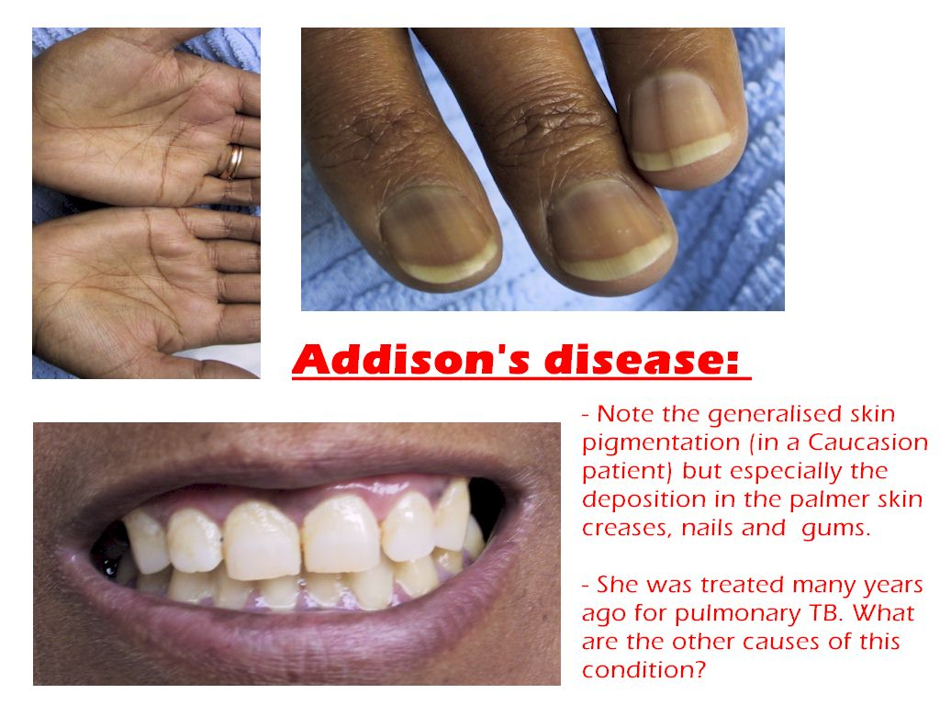

Treatment==Pharmacotherapy
Chronic Replacement Therapy
- Daily glucocorticoid and mineralocorticoid replacement therapy; androgen replacement therapy may be considered.
- The target cortisol replacement therapy is slightly higher than the physiologic cortisol production rate of approximately 12 to 15 mg per m² per day.
Dexamethasone
- The glucocorticoid of choice for
= chronic replacement therapy,&
= patient-initiated rescue therapy,&
= Initial treatment of an adrenal crisis before the diagnosis is confirmed.
- The dosage is titrated to a sense of well-being, blood pressure, and weight.
- Dexamethasone does not interfere with serum cortisol measurements and has the advantage of prolonged ACTH suppression.

Fludrocortisone
- The mineralocorticoid of choice for chronic replacement therapy.
- Fludrocortisone is approximately equipotent with aldosterone but is only available as an oral dosage form.
- The mineralocorticoid dosage is titrated to:
=relieve postural hypotension symptoms,
=normalize standing and sitting blood pressure, and
=normalize serum potassium and plasma renin activity.

- The current recommended regimen is dexamethasone 0.5 mg (0.25–0.75 mg) plus fludrocortisone 0.1 mg (0.05–0.2 mg) daily at bedtime;. Some patients need a small (5–10 mg) mid-afternoon supplemental hydrocortisone dose.

Dehydroepiandrosterone
- (DHEA) (25–50 mg daily),used for women mainly since the primary source of androgens are the adrenals,
- Androgen replacement therapy may improve mood, sense of well-being, and sexual function, but with a high incidence of side effects.

Acute Adrenal Crisis
- Acute adrenal insufficiency is life threatening.
- Empiric glucocorticoid replacement therapy and supportive therapy must be initiated before the diagnosis is confirmed
- Hydrocortisone is the drug of choice for the acute treatment of an Addisonian crisis or for short-term parenteral use;
- Dexamethasone may be substituted to avoid confounding the results of an anticipated ACTH stimulation test.
- The glucocorticoid dose is titrated to relieve clinical signs and symptoms and normalize the morning plasma ACTH.
- Hydrocortisone is tapered to maintenance doses over 1 to 3 days as the precipitating illness resolves.
- Saline and fluid loading; to treat Mineralocorticoid deficiency with specific aldosterone replacement therapy is not effective since it takes several days for the sodium-retaining effects to be apparent.
- Once the patient is stabilized, intravenous fluids are continued at a lower rate for another 1 to 2 days. Mineralocorticoid replacement therapy with fludrocortisone is started when the patient is stable and able to take oral medications.

Acute Adrenal Crisis
- Establish IV access with a large-gauge needle.
- Obtain blood for stat serum electrolytes, glucose, plasma cortisol, and ACTH.
- Rapidly infuse 2–3 L 0.9% sodium chloride or 5% dextrose/normal saline; subsequent rate depends on patient response.
- Inject hydrocortisone 100 mg IV every 6 hours.
- Taper the glucocorticoid over the next 2–3 days to standard replacement therapy if physiologic stress resolving.
- Initiate mineralocorticoid replacement therapy with fludrocortisone 0.1 mg daily when patient is able to eat
Chronic Replacement Therapy
- Dexamethasone 0.5 mg (0.25–0.75 mg) or prednisone 5 mg daily at bedtime. May add hydrocortisone 5–10 mg mid-afternoon if needed.
- Fludrocortisone 0.1 mg (0.05–0.2 mg) daily.
Self-care
Minor febrile illnesses or stress: Double or triple the glucocorticoid dose for 2–3 days. Continue usual mineralocorticoid dose. Contact physician if condition worsens or persists more than 3 days.
Emergency self-treatment of severe stress or trauma: Inject dexamethasone 4 mg IM. Get to a physician as soon as possible.
Pregnancy
Continue usual glucocorticoid and mineralocorticoid replacement doses; some women may need slightly higher doses during the third trimester. For women unable to take oral medications, give dexamethasone 1 mg IM daily plus 1–2 mg deoxycorticosterone acetate in oil daily. Give 25 mg IV hydrocortisone every 6 hours and adequate saline hydration during labor; increase the dose to 100 mg every 6 hours if labor is prolonged. Rapidly taper the doses to the patient's usual maintenance doses within 3 days of delivery.
Steroid Coverage for Hospitalized Patients
- Moderately stressful outpatient and inpatient procedures (barium enema, arteriogram, endoscopy): Give 100 mg IV hydrocortisone immediately prior to the procedure.
- Moderate illness: Give 50 mg IV or oral hydrocortisone twice daily. Rapidly taper to the patient's maintenance dose as the illness resolves.
- Major surgery: Give 100 mg IV hydrocortisone immediately before induction of anesthesia. Give 100 mg IV hydrocortisone every 8 hours for 24 hours following the surgery. Taper to the patient's maintenance dose by reducing the dose by 50% daily; adjust the taper based on clinical course.
- Severe illness: Give 100 mg IV hydrocortisone every 8 hours. Taper to the patient's maintenance dose by reducing the dose by 50% daily; adjust the taper based on clinical course.

PITUITARY GLAND DISORDERS

Growth Hormone Excess - Acromegaly

Clinical Presentation and Diagnosis

General
The patient will experience slow development of soft-tissue overgrowth affecting many body systems. Signs and symptoms may progress gradually over 10 to 15 years.

Symptoms
• Headache and compromised visual function (loss of peripheral vision and blurred vision) caused by the actual tumor mass and its close proximity to the optic structures.
• Loss of other hormonal functions (i.e., LH, FSH, TSH, and ACTH) caused by massive tumor size compressing the anterior pituitary lobe.
• (amenorrhea) Absence of regular menstrual periods, impotence, and decreased libido caused by disruption of the gonadotropin secretion.
• Excessive sweating, joint pain, nerve pain, and abnormal neurologic sensations (paresthesias) related to elevated GH and IGF-I levels.

Signs
• Coarsening of facial features
• Increased hand volume
• Increased ring and shoe size
• Increased spacing between teeth
• Increased acne/oily skin
• Enlarged tongue
• Deepening of voice
• Thick, irregular, patchy skin discoloration
• Enlarged nose, lips, and forehead (frontal bossing)
• Abnormal protrusion of the mandible (prognathia)
• Inappropriate secretion of breast milk (galactorrhea)
• Abnormal enlargement of interior organs (organomegaly)
• Carpal tunnel syndrome caused by nerve compression from the swollen tissue

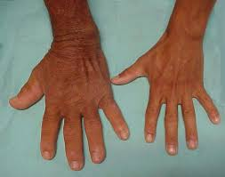

Additional Clinical Sequelae

• Cardiovascular diseases: hypertension, coronary heart disease, cardiomyopathy, left ventricular hypertrophy, and arrhythmia.
• Osteoarthritis and joint damage develop in up to 90% of patients.
•Sleep apnea and Respiratory disorders occur in up to 60% of patients.
• Type 2 diabetes mellitus develops in up to 40% of patients.
• Increase risk for the development of esophageal, colon, and stomach cancer.

Laboratory Tests
• GH level greater than 1 ng/mL (1 mcg/L) following an oral glucose tolerance test (OGTT) and elevated IGF-I level compared with age- and sex-matched control values.
• Glucose intolerance may be present in up to 50% of patients.

Other Diagnostic Tests
• Perform magnetic resonance imaging (MRI) examination and computed tomography (CT) of the pituitary to locate the tumor and validate the diagnosis.
• Measurement of GHRH may be helpful to detect ectopic tumors. Without obvious pituitary tumor but proven acromegaly,

Treatment ;

Goals for Management of Acromegaly
1. Normalize biochemical disease markers
a. Reduce GH to less than 1 ng/mL (1 mcg/L) after oral glucose
tolerance test (OGTT)a
b. Normalize IGF-I levels to age- and sex-matched control values
2. Ablate or reduce tumor size to relieve tumor mass effect
3. Preserve normal pituitary function
4. Improve clinical signs and symptoms
5. Alleviate significant morbidities

General Approaches to Treatment
❶ surgical resection of the pituitary tumor through transsphenoidal pituitary microsurgery is the treatment of choice for most patients with GH producing pituitary adenomas.

- microadenomas can be resected successfully,
- macroadenoma may be difficult if the tumor has already invaded the surrounding nerves and tissues.
In such cases, de bulking of the tumor, along with adjunctive radiation and/or pharmacotherapy, may improve treatment outcome.

❷ Pharmacologic Therapy
Somatostatin Analog (Growth Hormone–Inhibiting Hormone)

Octreotide- Lanreotide
- Somatostatin analogs are the mainstay of pharmacotherapy for the treatment of acromegaly when surgery and radiation are contraindicated or have failed.

- These agents mimic endogenous somatostatins and bind to the somatostatin receptors in the pituitary to cause potent inhibition of GH, insulin, and glucagon secretion.

- Octreotide is limited by its extremely short duration of action and requirement for subcutaneous administration at least three times a day.

- Most patients require octreotide in doses of 100 to 200 mcg three times daily.

- To improve patient tolerance to gastrointestinal (GI) adverse effects, start octreotide at 50 mcg every 8 hours. Transient GI disturbances such as diarrhea, abdominal pain, flatulence, constipation, and nausea are commonly associated with somatostatin analogs.

- Lanreotide 60 mg IM every 2 weeks - 120 mg every 7 days

Growth Hormone Receptor Antagonist
Pegvisomant
- Is the only genetically engineered GH-receptor antagonist that blocks the action of GH.
- Growth hormone receptor antagonist represents a novel approach to the treatment of acromegaly.

- Pegvisomant is indicated for patients:
=who do not tolerate other treatment
=fail other treatment options or
=for those with extremely elevated IGF-I levels (greater than 900 ng/mL or 900 mcg/L).

- Pegvisomant 10 mg SQ- 40 mg SQ daily

Dopamine Agonists
- In healthy adults= Dopamine is one of the neurotransmitters that can increase GH secretion.

In patients with acromegaly However, dopamine agonists administered to exert the opposite effect and suppress GH release from the tumor.

- Bromocriptine, The large doses of bromocriptine required to achieve the desired response often are associated with dose-limiting toxicity, such as GI discomfort and orthostatic hypotension.

- Cabergoline, the newer, selective long-acting agonist with improved tolerability,
- Dopamine agonists may be appropriate for patients with
= mildly elevated IGF-I levels
= who have GH and prolactin (PRL) co-secreting tumors.

Radiation Therapy
- Radiation therapy involves the use of radiation to kill rapidly growing tumor cells and often results in a reduction in tumor size.
- Radiation therapy is extremely effective but may take 10 to 20 years before the full effects become evident.
- A major complication resulting from radiation therapy is hypopituitarism, requiring lifelong hormone replacement

Growth Hormone Deficiency - Dwarfish
Clinical Presentation and Diagnosis of GH Deficiency in Children

General
- The patient will have a physical height that is greater than two standard deviations below the population mean for a given age and gender.

Signs
• The patient will present with reduced growth velocity and delayed skeletal maturation.
• Children with GH-deficient or GH-insufficient short stature also may present with abdominal obesity, prominence of the forehead, and immaturity of the face.

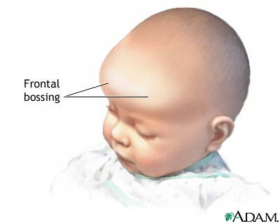

Laboratory Tests
• The patient will exhibit a peak GH level of less than 10 ng/mL (10 mcg/L) following a GH stimulation test.
• Reduced IGF-I and IGFBP-3 concentrations also may be present.
• hypoglycemia and hypothyroidism also may be noted.

Other Diagnostic Tests
• Perform MRI or CT of the hypothalamic-pituitary region to detect structural or developmental anomaly.

• Perform x-ray to estimate bone age
left wrist and hand for children over 1 year of age
knee and ankle for children younger than 1 year of age.

Clinical Presentation and Diagnosis of GH Deficiency in Adults

General
The patient likely will have
- a history of childhood-onset GH deficiency, hypothalamic or pituitary disorder,
- or three or four other pituitary hormone deficiencies caused by head trauma, tumor, infiltrative diseases, surgery, or radiation therapy.

Symptoms
• Reduced strength and exercise capacity
• Defective sweating
• Psychological problems
° Low self-esteem
° Depression
° Fatigue/listlessness
° Sleep disturbance
° Anxiety
° Social isolation
° Emotional lability and impaired self-control
° Poor marital and socioeconomic performance

Signs
• Increased fat mass (especially abdominal obesity)
• Reduced lean body mass
• Reduced muscle strength
• Reduced exercise performance
• Thin, dry skin; cool peripheries; poor venous access
• Depressed affect, labile emotions
• Impaired cardiac function

Laboratory Tests
• GH level of less than 5 ng/mL (5 mcg/L) following a GH stimulation
test.
• Low or low-normal IGF-I level also may be present.
• Increased low-density lipoprotein cholesterol, total cholesterol,
triglycerides; decreased high-density lipoprotein cholesterol.
• Reduced bone mineral density associated with an increased risk of
fracture.
• Increased insulin resistance and increased prevalence of
impaired glucose tolerance.
• GH deficiency may be accompanied by the loss of other
pituitary hormones.
Pharmacologic Therapy
Growth Hormone Therapy
- Recombinant GH therapy is the main pharmacologic treatment for GH deficiency in both children and adults.

- GH therapy requires daily subcutaneous or intramuscular administrations.

- Since two-thirds of GH secretion normally occurs during sleep, it is recommended to administer subcutaneous injections in the evening.

PROLACTIN --Hyperprolactinemia
Causes of Hyperprolactinemia
Physiologic Causes
Pregnancy-Stress (including exercise and hypoglycemia) -Sleep-Meal
Factores that Increased Prolactin Production
Ovarian: polycystic ovarian syndrome-PCOS
Pituitary tumors:--Adenomas
Microprolactinoma (less than 10 mm diameter)
Macroprolactinoma (greater than or equal to 10 mm diameter)
Hypothalamic stalk interruption (prevent dopamine from reaching the pituitary)
(inflammation)
Ectopic tumors
Factores that cause Hypothalamic Prolactin Stimulation
Primary hypothyroidism
Adrenal insufficiency
Factores that Reduced Prolactin Elimination
Chronic renal failure
Hepatic cirrhosis
Neurogenic Causes
Breast stimulation
Breast-feeding
Chest-wall injury (e.g., surgery, herpes zoster)
Abnormal Molecules
Macroprolactinemia
Seizures
Idiopathic (Unknown)
Medication-Induced Hyperprolactinemia
Dopamine Antagonists
Antipsychotics-Phenothiazines-Metoclopramide-Domperidone
Dopamine-Depleting Agents
Reserpine⟨-Methyldopa
Prolactin Stimulators
Serotonin reuptake inhibitors (SSRIs)-Dexfenfluramine-Estrogens
Progestins-Antiandrogens--Gonadotropin-releasing hormone analogs—Benzodiazepines-Tricyclic antidepressants (TCAs)
Monoamine oxidase inhibitors (MAOIs)---Protease inhibitors--Histamine2 receptor antagonists
Other
Isoniazid-Cocaine-Opioids-Verapamil

Clinical Presentation and Diagnosis
General
- Hyperprolactinemia most commonly affects women of reproductive age and is very rare in men.

Signs and Symptoms
Pre-menopausal women

- Headache and compromised or loss of vision
- Excessive hair growth (hirsutism) and acne
- Increased body weight

- Clinical presentation is associated with the degree of prolactin elevation:
= Prolactin greater than 100 ng/mL (100 mcg/L):
hypogonadism, galactorrhea, and amenorrhea
= Prolactin 51 to 75 ng/mL (51–75 mcg/L):
oligomenorrhea (infrequent menstruation).
= Prolactin 31 to 50 ng/mL (31–50 mcg/L):
decreased libido and infertility.

Men
- Decreased libido, decreased energy, erectile dysfunction, impotence,
- Infertility ,decreased sperm production, ,
- gynecomastia, and rarely, galactorrhea.
- Osteoporosis, reduced muscle mass.

Additional Clinical Sequelae
• risk for the development of osteoporosis.
• Risk for ischemic heart disease
Laboratory Tests
• Prolactin serum concentrations at rest will be greater than 20 ng/mL (20 mcg/L) in men or 25 ng/mL (25 mcg/L) in women with at least three measurements.
• Ηuman chorionic gonadotropin (®-hCG) level to exclude pregnancy.
• TSH level to exclude primary hypothyroidism.
• blood urea nitrogen and serum creatinine tests to exclude renal failure.

Other Diagnostic Tests
• MRI to locate the tumor, exclude a pseudoprolactinoma,
•bone mineral density test in patients with long-term hypogonadism.

Treatment ;
Goals for Management of Hyperprolactinemia
1. Normalize prolactin level
2. Improve clinical symptoms
3. Restore normal fertility
4. Restore and maintain normal gonadal function
5. Protect against development of osteoporosis
6. If a pituitary tumor is present:
• Ablate or reduce tumor size to relieve tumor mass effect.
• Preserve normal pituitary function.
• Prevent progression of pituitary tumor or hypothalamic disease.
General Approaches to Treatment
(1) Clinical observation,
(2) Pharmacologic therapy with dopamine agonists,
(3) Transsphenoidal pituitary adenomectomy,
(4) Radiation therapy

- Dopamine agonists are the first-line treatment of choice for all patients with hyperprolactinemia;
- transsphenoidal surgery and radiation therapy are reserved for patients who are resistant to or severely intolerant of pharmacologic therapy.
- Three dopamine agonists are used for the management of hyperprolactinemia, bromocriptine, cabergoline, and pergolide

Bromocriptine ( parlodel )
- Bromocriptine directly binds to the D2 receptors on the lactotroph cells to exert its effect.
- Bromocriptine normalizes prolactin level, restores menstrual cycles, and reduces tumor size in approximately 90% of patients.
- Adverse effects such as nausea, dizziness, and orthostatic hypotension often limit 5% to 10% of patients from continuing treatment
- Bromocriptine doe 0.625–1.25 ,2.5–15 mg/day max .40 mg/day 2 to 3 divided interval) at 1-week

Cabergoline (Dostinex)
- Cabergoline was developed with a higher affinity for dopamine D2 receptors than bromocriptine. It is a long-acting dopamine agonist capable of inhibiting pituitary prolactin secretion for at least 7 days after a single oral dose.
- The prolonged duration of action allows for once- or twice-weekly 0.5 mg/week 0.5 mg 1–2 mg/week 4.5 mg/week administration.
- Adverse effects of cabergoline appear to be significantly better tolerated than those of bromocriptine

Pergolide
- Pergolide is a dopamine agonist with affinity for D1 and D2 receptors.
- It is 10 to 1000 times more potent than bromocriptine on a milligram-per-milligram basis.
- This agent has a duration of action longer than 24 hours and offers the advantage of once-daily administration. 25 mcg/day at 25 mcg 50 mcg/day at 100 mcg/day Once daily
- pergolide to be as safe and effective as bromocriptine for lowering prolactin level and reducing tumor size.
- Because pergolide has been associated with daytime sedation, carefully advise patients to use caution in performing activities

Nonpharmacologic Therapy
- Surgical treatment is also considered in patients with non-prolactin-secreting tumors , transphenoidal adenomectomy may be necessary.
- Radiation therapy is reserved for failures of both pharmacologic therapy and surgery

Management of Hyperprolactinemia in Pregnancy
- women who become pregnant while on a dopamine agonist should discontinue treatment immediately to minimize fetal exposure.
- Because cabergoline has a prolonged half-life, women who plan to become pregnant should discontinue the drug at least 1 month before planned conception

Anterior and posterior hypopituiterisim

Ref = textbook of therap
Pharmaco therp- principle & practice

