DEFINITION

Thyroid disorders

- Thyroid disorders include a variety of disease states affecting thyroid hormone production or secretion that result in alterations in metabolic stability.

- Hyperthyroidism and hypothyroidism are the clinical and biochemical syndromes resulting from increased and decreased thyroid hormone production, respectively.

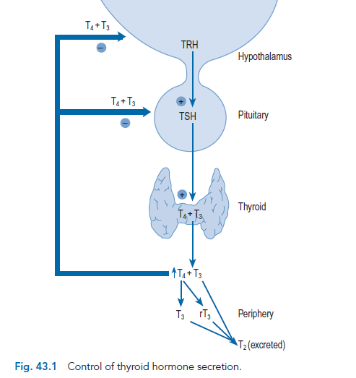

Thyrotoxicosis ( Hyperthyroidism)
Etiology &PATHOPHYSIOLOGY
• Thyrotoxicosis results when tissues are exposed to excessive levels of T4, T3, or both.

• TSH-secreting pituitary tumors release biologically active hormone that is unresponsive to normal feedback control.
The tumors may co-secrete prolactin or growth hormone; therefore, patients may present with amenorrhea, galactorrhea, or signs of acromegaly.

• In Graves’ disease, hyperthyroidism results from the action of thyroid-stimulating antibodies (TSAb) These stimulatory imunoglobulins are known as thyroid receptor antibodies (TRABs).
These immunoglobulin G antibodies bind to the thyrotropin -receptor on the surface of the thyroid cell and activate the enzyme adenylate cyclase in the same manner as TSH.

• An autonomous thyroid nodule (toxic adenoma) is a discrete thyroid mass whose function is independent of pituitary control.
Hyperthyroidism usually occurs with larger nodules (i.e., those greater than 3 cm in diameter).

• In multinodular goiters (Plummer’s disease), follicles with a high degree of autonomous function coexist with normal or even nonfunctioning follicles. Thyrotoxicosis occurs when the autonomous follicles generate more thyroid hormone than is required.

• Painful sub-acute (granulomatous or de- Quervain’s) thyroiditis is believed to be caused by viral invasion of thyroid parenchyma.

• Painless (silent, lymphocytic, postpartum) thyroiditis is a common cause of thyrotoxicosis; its etiology is not fully understood and may be heterogeneous; autoimmunity may underlie most cases.

• Thyrotoxicosis factitia is hyperthyroidism produced by the ingestion of exogenous thyroid hormone.
This may occur when thyroid hormone is used for inappropriate indications, when excessive doses are used for accepted medical indications, or when it is used surreptitiously by patients.

• Amiodarone - induced thyrotoxicosis (2% to 3% of patients) or hypothyroidism. It interferes with type I 5'-deiodinase, leading to reduced conversion of T4 to T3, and iodide release from the drug may contribute to iodine excess. Amiodarone also causes a destructive thyroiditis with loss of thyroglobulin and thyroid hormones.

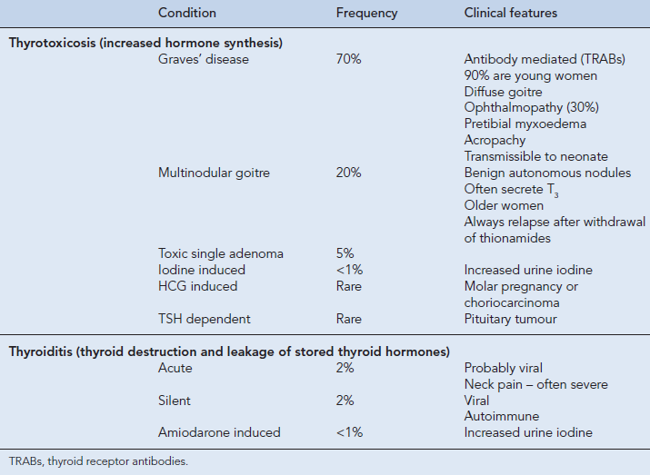

CLINICAL PRESENTATION
Symptoms of thyrotoxicosis include
- nervousness, anxiety, emotional lability,
- palpitations, easy fatigability, heat- intolerance,
- loss of weight concurrent with an increased appetite, increased frequency of bowel movements,
- proximal muscle weakness (noted on climbing stairs or arising from a sitting position), and scanty or irregular menses in women.

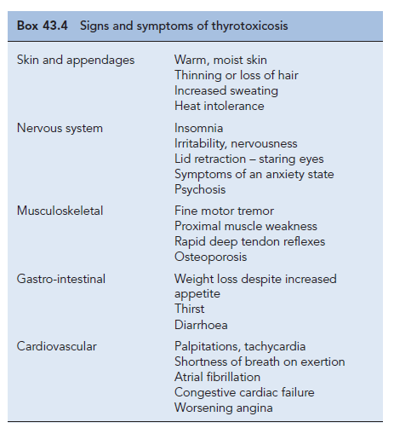

• Graves’ disease is manifested by hyperthyroidism, diffuse thyroid enlargement, and the extrathyroidal findings of exophthalmos, pretibial myxedema, and thyroid acropachy.

The thyroid gland is usually diffusely enlarged, with a smooth surface and consistency varying from soft to firm. In severe disease, a thrill may be felt and a systolic bruit may be heard over the gland.

• In subacute thyroiditis, patients complain of severe pain in the thyroid region, which often extends to the ear on the affected side. Low-grade fever is common, and systemic signs and symptoms of thyrotoxicosis are present.
The thyroid gland is firm and exquisitely tender on physical examination.

• Painless thyroiditis has a triphasic course that mimics that of painful subacute thyroiditis. Most patients present with mild thyrotoxic symptoms; lid retraction and lid lag are present but exophthalmos is absent.
The thyroid gland may be diffusely enlarged, but thyroid tenderness is absent.

• Thyroid storm is a life-threatening medical emergency characterized by severe thyrotoxicosis, high fever (often greater than 39.4°C [103°F]), tachycardia, tachypnea, dehydration, delirium, coma, nausea, vomiting, and diarrhea.
Precipitating factors include infection, trauma, surgery, radioactive iodine (RAI) treatment, and withdrawal from antithyroid drugs.

DIAGNOSIS
• True hyperthyroidism indicates an elevated 24-hour radioactive iodine uptake (RAIU)
the patient’s thyroid gland is overproducing T 4 , T 3 , or both (normal RAIU 10% to 30%). Conversely, a low RAIU indicates that the excess thyroid hormone is not a consequence of thyroid gland hyperfunction but is likely caused by thyroiditis or hormone ingestion.

• TSH-induced hyperthyroidism is diagnosed by elevated free thyroid hormone levels, and elevated serum immune-reactive TSH concentrations.
Because the pituitary gland is extremely sensitive to even minimal elevations of free T 4 , a “normal” or elevated TSH level in any thyrotoxic patient indicates inappropriate production of TSH.

• TSH-secreting pituitary adenomas are diagnosed by demonstrating lack of TSH response to thyrotropin-releasing hormone stimulation, inappropriate TSH levels, elevated TSH -subunit levels, and radiologic imaging.

• In thyrotoxic Graves’ disease, there is an increase in the overall hormone production rate with a disproportionate increase in T 3 relative to T 4

• Toxic adenomas ( hyperthyroidism with larger nodules). there may be isolated elevation of serum T3 with autonomously functioning nodules, a T3 level must be measured to rule out T3 toxicosis if the T4 level is normal.

• In multi-nodular goiters, a thyroid scan shows patchy areas of autonomously functioning thyroid tissue.

• Painful sub-acute thyroiditis ,a low RAIU indicates the excess thyroid hormone is not a consequence of thyroid gland hyperfunction.

• During the thyrotoxic phase of painless thyroiditis, the 24-hour RAIU is suppressed to less than 2%. Antithyroglobulin and antimicrosomal antibody levels are elevated in more than 50% of patients.

• Thyrotoxicosis factitia, the RAIU is low because thyroid gland function is suppressed by the exogenous thyroid hormone. Measurement of plasma thyroglobulin reveals the presence of very low levels.

DESIRED OUTCOME
• The therapeutic objectives for hyperthyroidism are to normalize the production of thyroid hormone; minimize symptoms and long-term consequences; and provide individualized therapy based on the type and severity of disease, patient age and gender, existence of nonthyroidal conditions, and response to previous therapy.

TREATMENT
Nonpharmacologic Therapy
• Surgical removal of the thyroid gland should be considered in patients with a large gland (>80 g), severe ophthalmopathy, or a lack of remission on antithyroid drug treatment.

• If thyroidectomy is planned, propylthiouracil (PTU) or methimazole (MMI) is usually given until the patient is biochemically euthyroid (usually 6 to 8 weeks), followed by the addition of iodides (500 mg/day) for 10 to 14 days before surgery to decrease the vascularity of the gland. Levothyroxine may be added to maintain the euthyroid state while the thionamides are continued.

• Propranolol has been used for several weeks preoperatively and 7 to 10 days after surgery to maintain a pulse rate less than 90 beats/min. Combined pretreatment with propranolol and 10 to 14 days of potassium iodide also has been advocated.

• Complications of surgery include persistent or recurrent hyperthyroidism (0.6% to 18%), hypothyroidism (up to about 49%), hypoparathyroidism (up to 4%), and vocal cord abnormalities (up to 5%). The frequent occurrence of hypothyroidism requires periodic follow-up for identification and treatment.

Antithyroid Pharmacotherapy

Thioureas (Thionamides)
propylthiouracil (PTU) or methimazole (MMI)

- PTU and MMI block thyroid hormone synthesis by inhibiting the peroxidase enzyme system of the thyroid gland, thus preventing oxidation of trapped iodide and subsequent incorporation into iodotyrosines and ultimately iodothyronine (“organification”); and by inhibiting coupling of MIT and DIT to form T4 and T3.
PTU (but not MMI) also inhibits the peripheral conversion of T4 to T3.

• Usual initial doses include PTU 300 to 600 mg daily (usually in three or four divided doses) or MMI 30 to 60 mg daily given in three divided doses.

• Improvement in symptoms and laboratory abnormalities should occur within 4 to 8 weeks, at which time a tapering regimen to maintenance doses can be started.
Dosage changes should be made on a monthly basis because the endogenously produced T4 will reach a new steady-state concentration in this interval. Typical daily maintenance doses are PTU 50 to 300 mg and MMI 5 to 30 mg.

• Antithyroid drug therapy should continue for 12 to 24 months to induce a long-term remission.

• Patients should be monitored every 6 to 12 months after remission. If a relapse occurs, alternate therapy with RAI is preferred to a second course of antithyroid drugs, as subsequent courses of therapy are less likely to induce remission.

• Major adverse effects include agranulocytosis (with fever, malaise, gingivitis, oropharyngeal infection, and a granulocyte count less than 250/mm3), aplastic anemia, a lupus-like syndrome, polymyositis, GI intolerance, hepatotoxicity, and hypoprothrombinemia. If it occurs, agranulocytosis almost always develops in the first 3 months of therapy; routine monitor ing is not recommended because of its sudden onset. Patients who have experienced a major adverse reaction to one thiourea should not be converted to the alternate drug because of cross-sensitivity.
Iodides

Iodide
- Acutely blocks thyroid hormone release, inhibits thyroid hormone biosynthesis by interfering with intra-thyroidal iodide use, and decreases the size and vascularity of the gland.
• Symptom improvement occurs within 2 to 7 days of initiating therapy, and serum T4 and T3 concentrations may be reduced for a few weeks.

• Iodides are often used as adjunctive therapy to prepare a patient with Graves’ disease for surgery, to acutely inhibit thyroid hormone release and quickly attain the euthyroid state in severely thyrotoxic patients with cardiac decompensation, or to inhibit thyroid hormone release after RAI therapy.

• Potassium iodide is available as a saturated solution or as Lugol’s solution, containing 6.3 mg of iodide per drop. When used to prepare a patient for surgery, it should be administered 7 to 14 days preoperatively.

• Adverse effects include hypersensitivity reactions (skin rashes, drug fever, rhinitis, conjunctivitis); salivary gland swelling; “iodism” (metallic taste, burning mouth and throat, sore teeth and gums, symptoms of a head cold, and sometimes stomach upset and diarrhea); and gynecomastia.

Beta-Blockers
- Used widely to ameliorate thyrotoxic symptoms such as palpitations, anxiety, tremor, and heat intolerance.
- Propranolol and nadolol partially block the conversion of T4 to T3, but this contribution to the overall therapeutic effect is small.

• B-Blockers are usually used as adjunctive therapy with antithyroid drugs, RAI, or iodides when treating Graves’ disease or toxic nodules; in preparation for surgery; or in thyroid storm.

• Propranolol doses required to relieve adrenergic symptoms vary, but an initial dose of 20 to 40 mg four times daily is effective for most patients (heart rate less than 90 beats/min). Younger or more severely toxic patients may require as much as 240 to 480 mg/day.

Side effects include nausea, vomiting, anxiety, insomnia, lightheadedness, bradycardia, and hematologic disturbances.

• Centrally acting sympatholytics (e.g., clonidine) and calcium channel antagonists (e.g., diltiazem) may be useful for symptom control when contraindications to B-blockade exist.

Radioactive Iodine

• RAI (Sodium iodide 131) is the agent of choice for Graves’ disease, toxic autonomous nodules, and toxic multinodular goiters. Pregnancy is an absolute contraindication to the use of RAI.

• B-Blockers are the primary adjunctive therapy to RAI, since they may be given anytime without compromising RAI therapy.

• Patients with cardiac disease and elderly patients are often treated with thionamides prior to RAI ablation because thyroid hormone levels will transiently increase after RAI treatment due to release of preformed thyroid hormone.

• Antithyroid drugs are not routinely used after RAI because their use is associated with a higher incidence of post-treatment recurrence or persistent hyperthyroidism.

• If iodides are administered, they should be given 3 to 7 days after RAI to prevent interference with the uptake of RAI in the thyroid gland.

• Hypothyroidism commonly occurs months to years after RAI. The acute, short-term side effects include mild thyroidal tenderness and dysphagia. Long-term follow-up has not revealed an increased risk for development of thyroid carcinoma, leukemia, or congenital defects.

Treatment of Thyroid Storm

• The following therapeutic measures should be instituted promptly: (1) suppression of thyroid hormone formation and secretion; (2) antiadrenergic therapy; (3) administration of corticosteroids; and (4) treatment of associated complications or coexisting factors that may have precipitated the storm.

• PTU in large doses is the preferred thionamide because it interferes with the production of thyroid hormones and blocks the peripheral conversion of T4 to T3.
• Iodides, which rapidly block the release of preformed thyroid hormone, should be administered after PTU is initiated to inhibit iodide use by the overactive gland.
• Antiadrenergic therapy with the short-acting agent esmolol is preferred because it can be used in patients with pulmonary disease or at risk for cardiac failure and because its effects can be rapidly reversed.
• Corticosteroids are generally recommended, but there is no convincing evidence of adrenocortical insufficiency in thyroid storm; their benefits may be attributed to their antipyretic action and stabilization of blood pressure.

• General supportive measures, including acetaminophen as an antipyretic (aspirin or other nonsteroidal antiinflammatory drugs may displace bound thyroid hormone), fluid and electrolyte replacement, sedatives, digoxin, antiarrhythmics, insulin, and antibiotics should be given as indicated. Plasmapheresis and peritoneal dialysis have been used to remove excess hormone in patients not responding to more conservative measures.

TABLE 20-2 Drug Dosages Used in the Management of Thyroid Storm
Drug Regimen
Propylthiouracil 900–1,200 mg/day orally in four or six divided doses
Methimazole 90–120 mg/day orally in four or six divided doses
Sodium iodide Up to 2 g/day IV in single or divided doses
Lugol’s solution 5–10 drops three times a day in water or juice
Saturated solution of potassium iodide 1–2 drops three times a day in water or juice
Propranolol 40–80 mg every 6 hours
Dexamethasone 5–20 mg/day orally or IV in divided doses
Prednisone 25–100 mg/day orally in divided doses
Methylprednisolone 20–80 mg/day IV in divided doses
Hydrocortisone 100–400 mg/day IV in divided doses
Hypothyroidism
Etiology &PATHOPHYSIOLOGY
- The vast majority of hypothyroid patients have thyroid gland failure (primary hypothyroidism).

- The causes include chronic autoimmune thyroiditis (Hashimoto’s disease), iatrogenic hypothyroidism, iodine deficiency, enzyme defects, thyroid hypoplasia, and goitrogens.

- Pituitary failure (secondary hypothyroidism) is an uncommon cause resulting from pituitary tumors, surgical therapy, external pituitary radiation, postpartum pituitary necrosis, metastatic tumors, tuberculosis, histiocytosis, and autoimmune mechanisms.

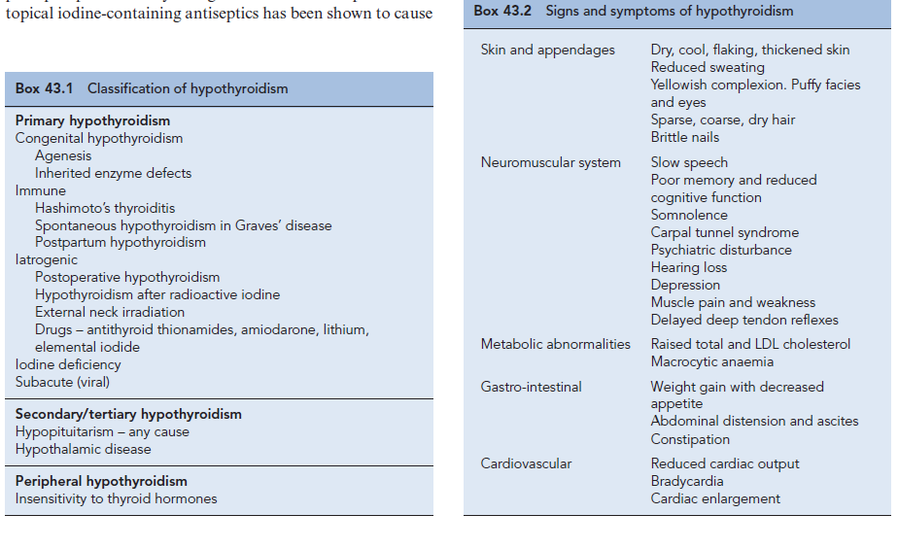
CLINICAL PRESENTATION
• Adult manifestations of hypothyroidism include dry skin, cold intolerance, weight gain, constipation, weakness, lethargy, fatigue, muscle cramps, myalgia, stiffness, and loss of ambition or energy. In children, thyroid hormone deficiency may manifest as growth retardation.

• Physical signs include coarse skin and hair, cold or dry skin, periorbital puffiness, bradycardia, and slowed or hoarse speech. Objective weakness (with proximal muscles being affected more than distal muscles) and slow relaxation of deep tendon reflexes are common. Reversible neurologic syndromes such as carpal tunnel syndrome, polyneuropathy, and cerebellar dysfunction may also occur.

• (secondary hypothyroidism) patients have clinical signs of generalized pituitary insufficiency such as abnormal menses and decreased libido, or evidence of a pituitary adenoma such as visual field defects, galactorrhea, or acromegaloid features.

• Myxedema coma is a rare consequence of decompensated hypothyroidism manifested by hypothermia, advanced stages of hypothyroid symptoms, and altered sensorium ranging from delirium to coma. Untreated disease is associated with a high mortality rate.

DIAGNOSIS
- A rise in the TSH level is the first evidence of primary hypothyroidism.

- Many patients have a free T4 level within the normal range (compensated hypothyroidism).

- As the disease progresses, the free T4 concentration drops below the normal level.

- The T3 concentration is often maintained in the normal range despite a low T4.

- Pituitary failure (secondary hypothyroidism) should be suspected in a patient with decreased levels of T4 and inappropriately normal or low TSH levels.

DESIRED OUTCOME
• The treatment goals for hypothyroidism are to normalize thyroid hormone concentrations in tissue, provide symptomatic relief, prevent neurologic deficits in newborns and children, and reverse the biochemical abnormalities of hypothyroidism.

TREATMENT OF HYPOTHYROIDISM

• Levothyroxine (L-thyroxine, T4) is the drug of choice for thyroid hormone replacement and suppressive therapy.

• Because T3 (and not T4) is the biologically active form, levothyroxine administration results in a pool of thyroid hormone that is readily and consistently converted to T3.

• Young patients with long-standing disease and patients older than 45 years without known cardiac disease should be started on 50 mcg daily of levothyroxine and increased to 100 mcg daily after 1 month.

• The recommended initial daily dose for older patients or those with known cardiac disease is 25 mcg/day titrated upward in increments of 25 mcg at monthly intervals to prevent stress on the cardiovascular system.

• The average maintenance dose for most adults is about 125 mcg/day, but there is a wide range of replacement doses, necessitating individualized therapy and appropriate monitoring to determine an appropriate dose.

• Levothyroxine is the drug of choice for pregnant women, and the objective of the treatment is to decrease TSH to 1 mIU/L and to maintain free T4 concentrations in the normal range.

• Cholestyramine, calcium carbonate, sucralfate, aluminum hydroxide, ferrous sulfate, soybean formula, and dietary fiber supplements may impair the absorption of levothyroxine from the GI tract. Drugs that increase nondeiodinative T4 clearance include rifampin, carbamazepine, and possibly phenytoin. Amiodarone may block the conversion of T4 to T3.

• Excessive doses of thyroid hormone may lead to heart failure, angina pectoris, and myocardial infarction. Allergic or idiosyncratic reactions can occur with the natural animal-derived products. Excess exogenous thyroid hormone may reduce bone density and increase the risk of fracture.
TREATMENT OF MYXEDEMA COMA

• Immediate and aggressive therapy with IV bolus levothyroxine, 300 to 500 mcg, has traditionally been used.
Initial treatment with IV liothyronine or a combination of both hormones has also been advocated because of impaired conversion of T4 to T3.

• Glucocorticoid therapy with IV hydrocortisone 100 mg every 8 hours should be given until coexisting adrenal suppression is ruled out.

• Maintenance levothyroxine doses are typically 75 to 100 mcg IV until the patient stabilizes and oral therapy is begun.

• Supportive therapy must be instituted to maintain adequate ventilation, euglycemia, blood pressure, and body temperature. Underlying disorders such as sepsis and myocardial infarction must be diagnosed and treated.

Calcium and parathyroid hormone

- The effects of PTH on bone are complex.
- The two major cell types in bone are osteoblasts and osteoclasts.
- Osteoblasts are responsible for the synthesis of extracellular bone matrix and priming of its subsequent mineralisation.
- Osteoclasts decalcify and digest the protein matrix of bone, liberating calcium. PTH stimulates osteoclast mediated bone resorption but, in addition, has an anabolic effect on bone, with an increase in osteoblast number and function.

Hypoparathyroidism / hypocalcaemia
- Hypoparathyroidism is the clinical state which may arise either from failure of the parathyroid glands to secrete PTH or from failure of its action at the tissue level.

Aetiology
- Hypoparathyroidism occurs as a result of surgery for thyroid disease or after neck exploration and resection of adenoma causing hyperparathyroidism.
- Other causes include autoimmune parathyroid destruction
- Transient hypoparathyroidism with symptomatic hypocalcaemia can occur in neonates.
- The condition pseudo-hypoparathyroidism occurs in patients with defects of the PTH receptor such that though PTH levels are normal (or raised), calcium is low.

- Acute symptomatic hypocalcaemia and hypomagnesaemia complicating the use of omeprazole and other protein pump inhibitors. These patients are severely magnesium depleted and have an acquired hypoparathyroidism which is reversible on stopping the offending drug

Box 43.7 Causes of hypocalcaemia
Hypoparathyroidism
Pseudohypoparathyroidism
Vitamin D deficiency/malabsorption/insensitivity
Acute and chronic renal failure
Chronic alcoholism
Hypomagnesaemia
Drug induced (protein pump inhibitors)
Acute pancreatitis

Clinical manifestations
- Most of the clinical features of hypoparathyroidism are due to hypocalcaemia.

Box 43.6 Signs and symptoms of hypocalcaemia
Numbness and tingling in the extremities and around the mouth
Muscle spasm (tetany)
Epilepsy
Irritability
Cataracts (prolonged hypocalcaemia)
Chvostek’s sign (facial spasm on tapping the 7th cranial nerve)
Trousseau’s sign (spasm of hand when blood pressure cuff
inflated above systolic pressure)

Investigations
- Hypocalcaemia associated with undetectable or low plasma PTH levels
- Hyperphosphataemia is often present.
- Pseudohypoparathyroidism is associated with excessive PTH secretion and reduced target organ responsiveness.
- Drugs that may produce hypocalcaemia

Treatment
- Severe, acute hypocalcaemia with tetany should be treated with intravenous calcium gluconate.
- Initially, 10 mL of 10% calcium gluconate is given by slow intravenous injection.
- If further parenteral therapy is required, 20 mL of 10% injection should be added to each 500 mL of intravenous fluid and given over 6 h.
- The plasma magnesium level should always be measured in patients with hypocalcaemia, and if low, magnesium therapy instituted.
- For chronic treatment, Maintenance treatment for hypoparathyroidism is easily achieved with a vitamin D preparation to increase intestinal calcium absorption,

- Calcitriol and its synthetic analogue alfacalcidol are much easier to use. Alfacalcidol restores normocalcaemia within 1 week and its effects only persist for 1 week following withdrawal, permitting greater flexibility in dosage manipulation.

Hyperparathyroidism
- Hyperparathyroidism occurs when there is increased production of PTH by the parathyroid gland.
- Primary hyperparathyroidism causes hypercalcaemia.
- Secondary hyperparathyroidism reflects a physiological response to hypocalcaemia or hyperphosphataemia.

Epidemiology
- The incidence is two to three times higher in women than in men, and the disease most commonly presents between the third and fifth decades.

Etiology
- Primary hyperparathyroidism is due to the development of either single parathyroid adenomas or rarely (<5%) hyperplasia of all four glands.
- secondary hyperparathyroidism associated chronic renal failure and vitamin D deficiency.
- Chronic renal failure is the commonest cause. In the early stages of the disease, a rise in the plasma phosphate concentration causes stimulation of PTH release and, in more advanced renal impairment, reduced 1 alpha-hydroxylation of vitamin D results in reduced intestinal calcium absorption, hypocalcaemia and further stimulation of the parathyroid glands.
- Tertiary hyperparathyroidism occurs in a minority of patients with end-stage renal failure when hyperplastic parathyroid glands become autonomous and secrete PTH in levels that raise calcium levels above normal.

Clinical manifestations
- The clinical features of primary hyperparathyroidism are:

Anorexia, weight loss
Polydipsia, polyuria
Mental changes: poor concentration and memory
Fatigue
Nausea, dyspepsia and vomiting
Constipation
Hypertension
Renal stones
Conjunctival and corneal ‘calcium’ deposits
Bone pain and deformity
Pathological fractures

Investigations
- Hypercalcaemia is the primary biochemical abnormality in primary hyperparathyroidism.
- Phosphate levels are often decreased and PTH levels are either inappropriately normal in the face of hypercalcaemia or elevated.
- In a patient with borderline elevation of calcium and a normal PTH, the benign condition familial hypocalciuric hypercalcaemia (FHH) must be excluded.
- Urine calcium excretion is increased in primary hyperparathyroidism and low in FHH.
- There are many other causes of hypercalcaemia, including malignancy (including myeloma), drugs (thiazides, excess vitamin D), thyrotoxicosis, immobilisation and sarcoidosis.
- In all these situations, PTH levels are undetectable as the normal parathyroid glands appropriately switch off production of PTH in the face of hypercalcaemia.
- The most common cause of symptomatic hypercalcaemia in clinical practice is that associated with malignancy and this diagnosis must always be excluded.

Treatment
- Surgical removal of the adenoma is the only curative treatment for primary hyperparathyroidism;
- Some studies have indicated that over 50% of untreated patients with primary hyperparathyroidism show no deterioration over 5 years, but the longer-term effects on renal function and bone mass remain unknown. In practice, many patients are observed and their specific problems separately addressed. Thus, patients receive bisphosphonates for osteoporosis, anti-hypertensives, acid-lowering therapy and laxatives.

- The main indications for surgical treatment are persistent hypercalcaemia > 2.85 mmol/L, symptomatic hypercalcaemia, renal impairment, renal stones and progression of osteoporosis.
- Postoperatively, temporary hypocalcaemia (hungry bones) is common.
- In patients with bone disease, treatment with alfacalcidol and calcium supplements should be started on the day before the operation. Approximately 10% of surgically treated patients develop permanent hyperparathyroidism.

Drug Preparations Activity
- Ergocalciferol (calciferol, vitamin D2)
- Calciferol injection 7.5 mg (300,000 units/mL) Requires renal and hepatic activation
- Calciferol tablets 250 cg (10,000 units) and 1.25 mg (50,000 units)
- Calcium and ergocalciferol tablets (2.4 mmol of calcium + 400 units of ergocalciferol)
- Colecalciferol (vitamin D3) A range of preparations containing calcium (500–600 mg) and colecalciferol (200–440 units) Requires renal and hepatic activation
- Alfacalcidol (1 alpha-hydroxycolecalciferol) Alfacalcidol capsules, 250 ng, 500 ng and 1 ucg Requires hepatic activation
- Alfacalcidol injection, 2 ucg/mL
- Calcitriol (1,25-dihydroxycholecalciferol) Calcitriol capsules, 250 ng and 500 ng
- Active Calcitriol injection, 1 ucg/mL
- Dihydrotachysterol Dihydrotachysterol oral solution, 250 mg/ml Requires hepatic activation

Treatment of hypercalcaemia
- Severe hypercalcaemia is a common medical emergency.
- In practice, rehydration and parenteral bisphosphonates, for example, pamidronate 60 mg in 250 mL normal saline over 30 min, will normalize calcium over 72 h in most patients.

Table 43.7 Treatment of hypercalcaemia
Mechanism Treatment
Increase urinary calcium excretion
Normal saline plus loop diuretic

Reduce bone resorption
Bisphosphonates
Calcitonin
Gallium, mithramycin
Reduce gastro-intestinal absorption
Glucocorticoids in calcitriol
dependent (vitamin D excess,
sarcoid and some lymphoma
patients)
Chelation Intravenous E DTA or phosphate

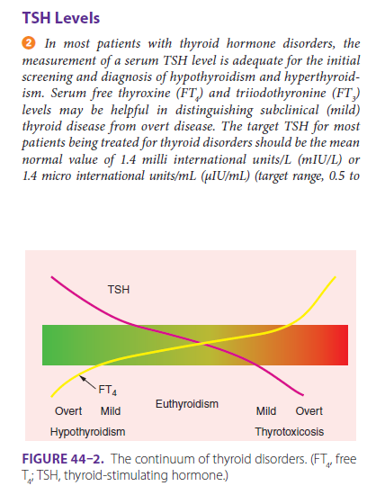

Ref. Pharmacotherapy handbook + walker 2012
