Hypertension

(high blood pressure)It can be defined as a condition where blood pressure is elevated to an extent that clinical benefit is obtained from blood pressure lowering. Blood pressure measurement includes systolic and diastolic components, and both are important in determining an individual's cardiovascular risk.

Complications of hypertension
•Myocardial-infarction
•Stroke
- Cerebral/brain stem infarction
- Cerebral hemorrhage
- Lacunar syndrome
- Multi-infarct disease
•Hypertensive encephalopathy /malignant hypertension
•Dissecting aortic aneurysm
•Hypertensive nephrosclerosis
•Peripheral vascular disease

Absolute risk is highest in those who already have evidence of cardiovascular disease, such as previous myocardial infarction, transient ischaemic attack or stroke, or who have other evidence of cardiovascular dysfunction such as electrocardiogram (ECG) or echocardiograph abnormality. Risk is also increased in the elderly and in people with diabetes or renal failure and is further enhanced by other risk factors such as smoking, dyslipidaemia, obesity and sedentary lifestyle. In those under the age of 75, men are at greater risk than women.

Causes of hypertension
Primary hypertension(90–95%) •Essential hypertension
Secondary hypertension(5–10%)
•renal-diseases
•Endocrine diseases
– Steroid excess:hyperaldosteronism(Conn'ssyndrome); hyperglucocorticoidism(Cushing'ssyndrome)
_ Growth hormone excess:acromegaly
– Catecholamine excess:pheochromocytoma
– Others:pre-eclampsia
•vascular causes– Renal artery stenosis:fibromuscular hyperplasia ;renal arteryatheroma;coarctation of the aorta.
•Drugs
– Sympathomimeticamines
_ Oestrogens(e.g.combined oral contraceptive pills)
_Ciclosporin, Erythropoietin, NSAIDs ,Steroids

Hypertension is exacerbated by other factors, for example, high salt or alcohol intake or obesity.

Regulation of blood pressure
The mean blood pressure is the product of cardiac output and total peripheral resistance. In most hypertensive individuals, cardiac output is not increased and high blood pressure arises as a result of increased total peripheral resistance caused by constriction of small arterioles.
Minute-to-minute changes in blood pressure are regulated by the baroreceptor reflex, while the renin–angiotensin–aldosterone system is important for longer term salt, water and blood pressure control.

Long-term
1. increases in shear stress can cause vascular remodelling of the endothelium which lead to the formation of a procoagulant rather than anticoagulant surface.
2.At the same time, systems that lead to vascular relaxation, for example nitric oxide, are overcome by increased sensitivity to vasoconstrictor substances such as endothelin which predispose to vascular disease and further increases in peripheral resistance which lead to a vicious cycle increasing blood pressure further due to the increase in vascular resistance.
3.Other substances with a role in controlling blood pressure include atrial natriuretic peptide, bradykinin and antidiuretic hormone. Some new therapies seek to treat high blood pressure by modifying responses to these substances, for example, the endothelin antagonist darusentan.

Clinical presentation
Severe cases may present with headache, visual disturbances or evidence of target organ damage (stroke, ischaemic heart disease or renal failure).
Malignant (accelerated) hypertension
Malignant or accelerated hypertension is an uncommon condition characterized by greatly elevated blood pressure (usually >220/120 mmHg) associated with evidence of ongoing small vessel damage. Fundoscopy may reveal papilloedema, haemorrhages and/or exudates, while renal damage can manifest as haematuria, proteinuria and impaired renal function. The condition may be associated with hypertensive encephalopathy, which is caused by small vessel changes in the cerebral circulation associated with cerebral oedema. The clinical features are confusion, headache, visual loss, seizures and coma. Brain imaging (particularly MRI) usually demonstrates extensive white matter changes. Malignant hypertension is a medical emergency that requires hospital admission and rapid control of blood pressure over 12–24 h towards normal levels.

Diagnosis of hypertension
All adults have their blood pressure measured every 5 years. Those with high normal (130–139 mmHg systolic or 85–89 mmHg diastolic) or previous high readings should have annual measurement. Blood pressure should be measured using a well-maintained sphygmomanometer of validated accuracy. Blood pressure should initially be measured in both arms and the arm with the highest value used for subsequent readings. The subject should be relaxed and, at least at the first presentation, blood pressure should be measured in both the sitting and the standing positions. An appropriate sized cuff should be used since one that is too small will result in an overestimation of the patient's blood pressure. The arm should be supported level with the heart and it is important that the patient does not hold their arm out since isometric exercise increases blood pressure

Some people develop excessive and unrepresentative blood pressure rises when attending the doctor's surgery, so-called ‘white coat’ hypertension. These patients can be diagnosed if they use a blood pressure machine themselves at home or by 24-h ambulatory blood pressure monitoring. Home blood pressure measurement is inexpensive.

Assessment of the hypertensive patient
Laboratory analysis should include a full blood count, electrolytes, urea, creatinine and urinalysis. In some patients, further investigations may be appropriate, for example, ultrasound of the abdomen or isotope renogram where renal disease is suspected. A renin–angiotensin ratio is a useful screening test to investigate for possible hyperaldosteronism while serum metanephrine and urinary catecholamines may detect underlying phaeochromocytoma.

Treatment Non-pharmacological approaches
weight loss results in reduction in blood pressure of about 2.5/1.5 mmHg/kg. diet emphasizes fruit, vegetables, and low-fat dairy produce in addition to fish, low-fat poultry and whole grains while minimising red meat, should reduce their salt intake, for example, by not adding salt to food on the plate. A daily sodium intake of <100 mmol (i.e. 6 g sodium chloride or 2.4 g elemental sodium) Regular aerobic exercise, at a level appropriate to the individual subject, at least 3 times a week for at least 30 min derives maximum benefit. Alcohol intake should be restricted to two (females) or three (males) units per day. Although smoking does not affect blood pressure, it increases cardiovascular risk and patients should quit or, if this is not possible, reduce their cigarette consumption.

Treatment thresholds
Patients with severe hypertension (>220/120 mmHg confirmed on several readings on the same occasion) should be treated immediately and some guidance suggests that dual therapy should be commenced immediately in patients with blood pressure >20 mmHg above their target as monotherapy is unlikely to be fully effective.
Patients with blood pressures in the range 160-220/100–120 mmHg should be monitored over several weeks and treated if blood pressure remains in this range.
Patients whose blood pressure is in the range 140–159/90–99 mmHg should be observed annually unless they have evidence of target organ damage.
Patients with blood pressure in the range 135–139/85–89 mmHg should be reassessed annually, while those with blood pressure lower than this can be rechecked every 5 years.
optimum target blood pressure was <140/85 mmHg with little benefit in lowering to lower levels of 120/70 mmHg but also little evidence of harm.

Antihypertensive drug classes

β-Adrenoreceptor antagonists
The mode of action of β-adrenoreceptor antagonists in hyper-tension is uncertain. β-Adrenoreceptor blockade reduces cardiac output in the short term and during exercise. They also reduce renin secretion by antagonising β-receptors in the juxta-glomerular apparatus. Non-selective β-blockers may give rise to adverse effects as a result of antagonism of β2-adrenoceptors, that is, asthma and worsened intermittent claudication. However, the so-called ‘cardioselective’ (β1-selective) β-blockers are not entirely free of these adverse effects. Patients who develop very marked bradycardia and tiredness may tolerate a drug with partial agonist activity such as pindolol. . The combination of thiazide and a β-blocker should, therefore, be avoided if possible, particularly in those who are at risk of developing diabetes

Diuretics: There is substantial clinical trial evidence that benefit is obtained from the use of thiazide, for example, bendroflumethiazide, hydrochlorothiazide, or thiazide-like, for example, chlortalidone, indapamide, diuretics in hypertension; these drugs are both inexpensive and well tolerated by most patients. Their diuretic action is achieved by blockade of distal renal tubular sodium reabsorption. Initially, they reduce blood pressure by reducing circulating blood volume but in the longer term they reduce total peripheral resistance, suggesting a direct vasodilatory action. Although generally well tolerated, thiazide and thiazidelike diuretics may cause hypokalaemia, small increases in LDL-cholesterol and triglyceride, and gout associated with impaired urate excretion. Erectile dysfunction is also common. Most blood pressure lowering occurs with very low doses of thiazide diuretics. Increasing the dose substantially increases the risk of metabolic disturbance without causing further blood pressure reduction.

Loop diuretics are no more effective at lowering blood pressure than thiazides unless renal function is significantly impaired or the patient is receiving agents that inhibit the renin–angiotensin system. They are also a suitable choice if heart failure is present.

Spironolactone, an aldosterone antagonist, is not suitable for first-line therapy but is an increasingly important treatment option for patients with resistant hypertension. Where hyperaldosteronism is suspected, spironolactone may prove to be effective. Spironolactone is a potassium sparing diuretic and should be used with caution especially if used in combination with ACE inhibitors or angiotensin receptor blockers ARBs), and should almost always be avoided with other potassium sparing diuretics, for example, amiloride.

Renin-angiotensin-aldosteroneantagonists ACE inhibitors block the conversion of angiotensin I to angiotensin II, while ARBs block the action of angiotensin II at the angiotensin II type 21 receptor. Since angiotensin II is a vasoconstrictor and stimulates the release of aldosterone, antagonism results in vasodilation and potassium retention as well as inhibition of salt and water retention. ACE inhibitors also block kininase production and, thus, prevent the breakdown of bradykinin. This appears to be important in the aetiology of ACE inhibitor induced cough, which is a troublesome side effect in 10–20% of users. ARBs do not inhibit kininase and are an appropriate choice for patients who are intolerant of ACE inhibitors because of cough. ACE inhibitors are also associated with a significant incidence of angioedema, which can in severe cases cause dangerous swelling of the pharyngolargyngeal area leading to stridor, threatening the patient's airway. This adverse reaction is commoner in black subject

Calcium channel blockers: These agents block slow calcium channels in the peripheral blood vessels and/or the heart. The dihydropyridine group work almost exclusively on l-type calcium channels in the peripheral arterioles and reduce blood pressure by reducing total peripheral resistance. In contrast, the effect of verapamil and diltiazem are primarily on the heart, reducing heart rate and cardiac output. Long-acting dihydropyridines are preferred because they are more convenient for patients and avoid the large fluctuations in plasma drug concentrations that may be associated with adverse effects. Although effective for lowering blood pressure and preventing cardiovascular events, adverse effects are common, for example, oedema and flushing. Gum hypertrophy may occur with dihydropyridines and constipation with verapamil.

α-Adrenoreceptorblockers prevent noradrenaline (norepinephrine)
induced vasoconstriction. As a result, they reduce total peripheral resistance and blood pressure. Prazosin was originally used but had the disadvantage of being short-acting and causing first-dose hypotension. Newer agents such as doxazosin and terazosin have a longer duration of action.

Centrally acting agents : Methyldopa and moxonidine inhibit sympathetic outflow from the brain, resulting in a reduction in total peripheral resistance. Methyldopa is not widely used because it has pronounced central adverse effects, including tiredness and depression. It continues to be used in pregnancy, since it does not cause fetal abnormalities. It is also occasionally used in patients with resistant hypertension. Moxonidine is a newer agent that blocks central imidazoline and α2-adrenoceptors found within the medulla oblongata of the brain. It can cause side effects of dry mouth, headache, fatigue and dizziness, although it appears to have fewer central adverse effects than methyldopa. Other centrally acting agents such as clonidine and reserpine are almost never used in modern practice because of their pronounced adverse effe
Other agents
Hydralazine can be used as add-on therapy for patients with resistant hypertension but is not well tolerated as it is a profound vasodilator and may occasionally be associated with drug-induced systemic lupus erythematosus. Sodium nitroprusside is a direct-acting arterial and venous dilator that is administered as an intravenous infusion for treating hypertensive emergencies and for the acute control of blood pressure during anaesthesia. Recent additions to the licensed armory of antihypertensive agents include the renin antagonist aliskiren.

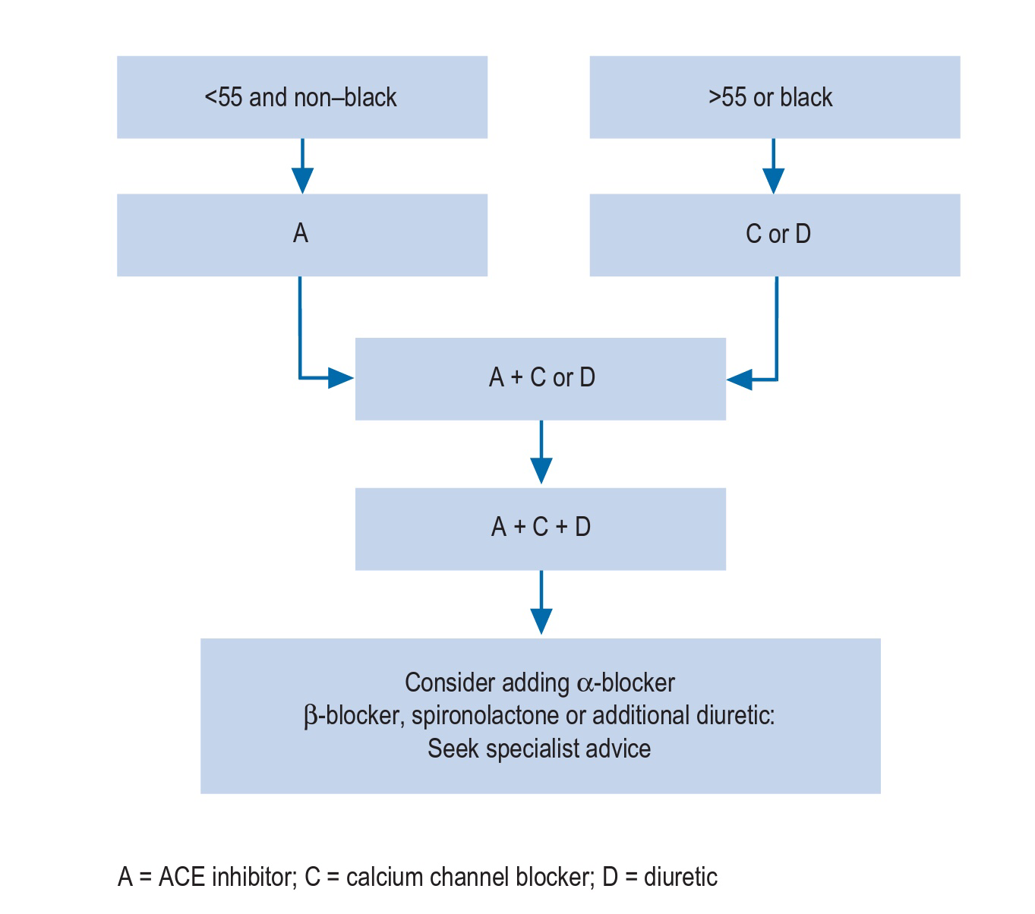
Recommendations for drug sequencing
Special patient groups
Race
African Caribbean people have reduced plasma renin activity and, as a result, ACE inhibitors and ARBs are also less effective. They obtain particular benefit from reduced salt intake and are also sensitive to diuretic and calcium channel blockers, while β-blockers appear less effective, at least when used as monotherapy. However, combinations of β-blockers and thiazides should be avoided when possible because of the higher risk of diabetes.

Elderly
Isolated systolic hypertension (systolic >160 mm Hg, diastolic <90 mmHg) is common in the elderly and there is irrefutable evidence that drug treatment is beneficial in this group .Calcium channel blockers and low-dose thiazide diuretics are safe and effective treatments for elderly hypertensive people and their use is endorsed by large-scale clinical trials. β-Blockers are less effective at reducing blood pressure.

Diabetes In type 1 diabetes, the presence of hypertension often indicates the presence of diabetic nephropathy. In this group, blood pressure reduction and ACE inhibition slow the rate of decline in renal function. To achieve adequate blood pressure control, combinations of drugs will be needed. Thiazides, β-blockers, calcium channel blockers and α-blockers are all suitable as add-on treatments to ACE inhibitors which should be first-line therapy. Target blood pressure should be <130/80 mmHg or <125/75 mmHg if there is diabetic nephropathy. In type 2 (non-insulin dependent) diabetes, there is no evidence that one group of drugs is more or less effective than any other.

Renal disease In patients with chronic renal impairment, good blood pressure control slows the progression of renal dysfunction. ACE inhibition reduces the incidence of end-stage renal failure but it is not clear if this is a specific effect or non-specific action as a result of blood pressure lowering. ACE inhibitors also reduce 24-h protein loss and should be used in patients with 24-h protein excretion of >3 g or rapidly progressive renal dysfunction. Salt restriction is particularly important in managing hypertension in renal disease. Thiazide diuretics are ineffective in patients with significant renal dysfunction and loop diuretics should be used when a diuretic is needed.

Stroke
The question ‘what to do with blood pressure in the setting of acute stroke?’ has remained an evidence-free zone until fairly recently. Blood pressure naturally rises then falls in the days and hours following acute stroke and some have argued that elevated levels are necessary to maintain brain circulation due to the failure of cerebral autoregulatory mechanisms around the time of stroke. The theory that lowering blood pressure could reduce cerebral perfusion due to a lack of the usual autoregulatory mechanisms is counterweighted by the potential for further damage due to cerebral oedema.
Pregnancy :An increased blood pressure before 20 weeks gestation usually indicates pre-existing chronic hypertension that may not have been previously diagnosed.Hypertension diagnosed after 20 weeks gestation may also indicate chronic hypertension, which may have been masked during early pregnancy by the fall in blood pressure that occurs at that time. Patients with elevated blood pressure in pregnancy are at increased risk of pre-eclampsia and intrauterine growth retardation. They need frequent checks of their blood pressure, urinalysis and fetal growth. Pre-eclampsia is diagnosed when the blood pressure increases by 30/15 mmHg from measurements obtained in early pregnancy or if the diastolic blood pressure exceeds 110 mmHg and proteinuria is present. There is consensus that blood pressure should be treated with drugs if it exceeds 150–160/100–110 mmHg, although some clinicians use a lower threshold, for example, 140/90 mmHg. Methyldopa is the most suitable drug choice for use in pregnancy because of its long-term safety record. Calcium channel blockers, hydralazine and labetalol are also used. β-Blockers, particularly atenolol, are used less often as they are associated with intrauterine growth retardation. Although diuretics reduce the incidence of pre-eclampsia they are little used in pregnancy because of concerns about decreasing maternal blood volume. ACE inhibitors and ARBs are contraindicated, as they are associated with oligohydramnios, renal failure and intrauterine death.

Use of combined oral contraceptives results, on average, in an increase of 5/3 mmHg in blood pressure. Progesterone-only preparations do not cause hypertension so often but are less effective for contraception, especially in younger women. Combined oral contraceptives are not absolutely contraindicated in hypertension unless other risk factors for cardiovascular disease, such as smoking, are present.

Ancillary drug treatment
Aspirin The use of aspirin reduces cardiovascular events at the expense of an increase in gastro-intestinal complications. Its use should be restricted to patients who have no contraindications and either: • have evidence of established vascular disease or have no evident cardiovascular disease but who are over 50 years of age and have either evidence of target organ damage or a 10-year cardiovascular disease risk of >20%. Blood pressure should be controlled (<150/90 mmHg) before aspirin is instituted.

Lipid-lowering therapy Lipid-lowering therapy, usually with a statin, should be prescribed to patients under 80 years of age with a total cholesterol >3.5 mmol/L who either have pre-existing vascular disease or a 10-year cardiovascular risk of >20%.

