Baldwin’s Rules For Ring Closer
The presence of cyclic structures in the basic framework of many complex and biologically interesting molecules has made their formation a fundamental process in organic synthesis. Therefore, ring-forming processes have garnered the attention of synthetic chemists for many years. A series of guidelines that describe the propensity of various systems to participate in ring forming reactions was put forth by J. E.Baldwin in the 1970's. This set of guidelines, which describe the relative ease of ring formations, has become known as Baldwin’s rules of ring closure and has proved a useful tool in evaluating the feasibility of ring forming reactions. Baldwin described his rules in terms of three features of the reaction nomenclature:
- The ring size being formed (indicated through a numerical prefix)
3 membered rings = 3
4 membered rings = 4
etc.
- The hybridized state of the carbon atom (Y) undergoing the ring closing reaction
if Y= Sp3 center; then Tet (tetrahedral)
if Y= Sp2 center; then Trig (trigonal)
if Y= Sp center; then Dig (digonal)
- Indicate where displaced electrons end up
- if the displaced electron pair ends up outside the ring being formed; then Exo

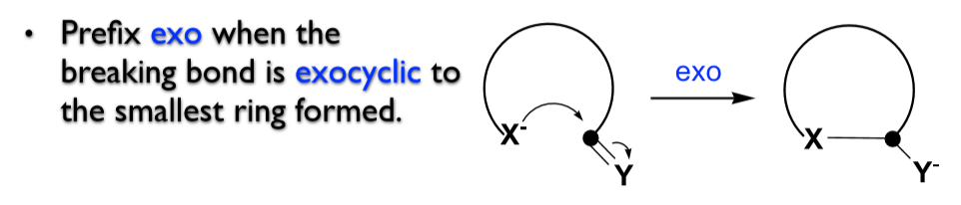

- if the displaced electron pair ends up within the ring being formed; then Endo
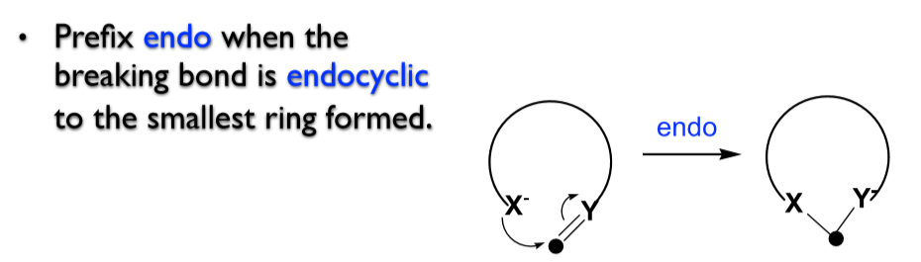

- Ring forming reaction is designated as Favored or Disfavored.
Disfavored does not imply the reaction can't or won't occur, it only means the reaction is more difficult than favored reactions.

Example

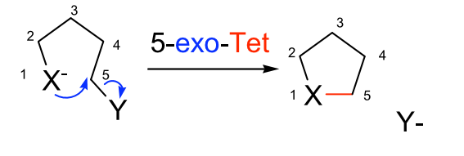

Rules (Suggestions) for Ring Closure

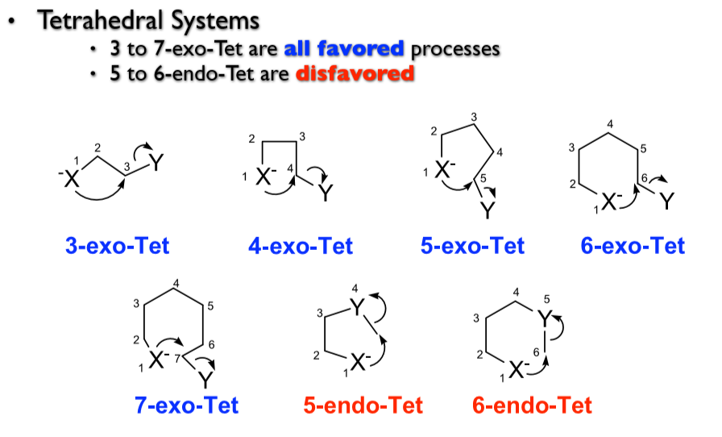

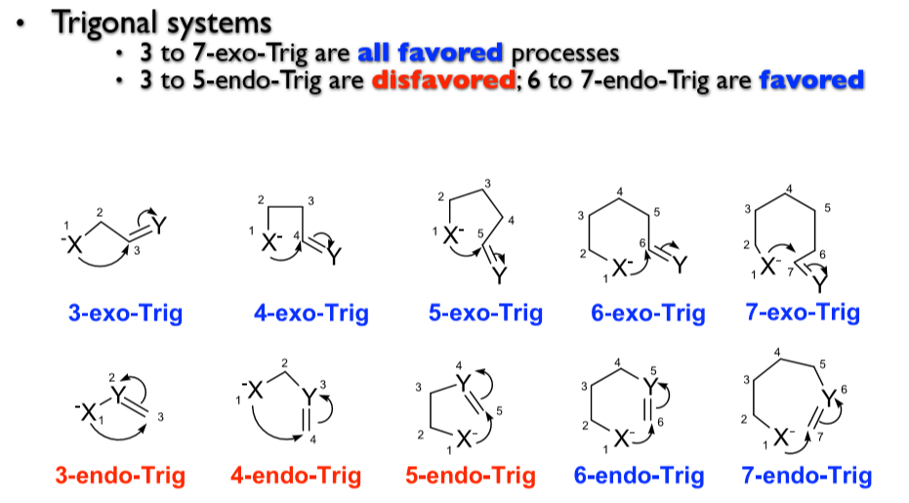

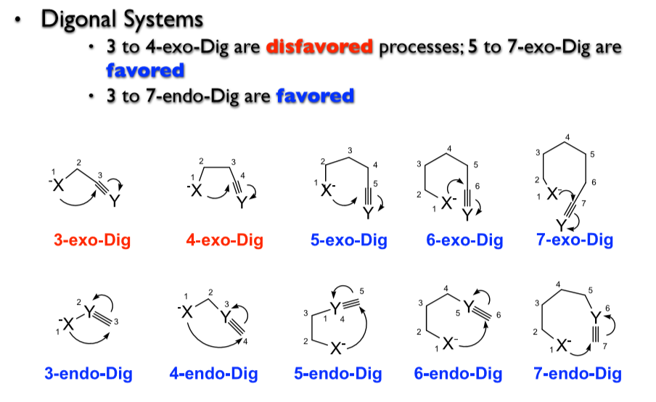

Summary

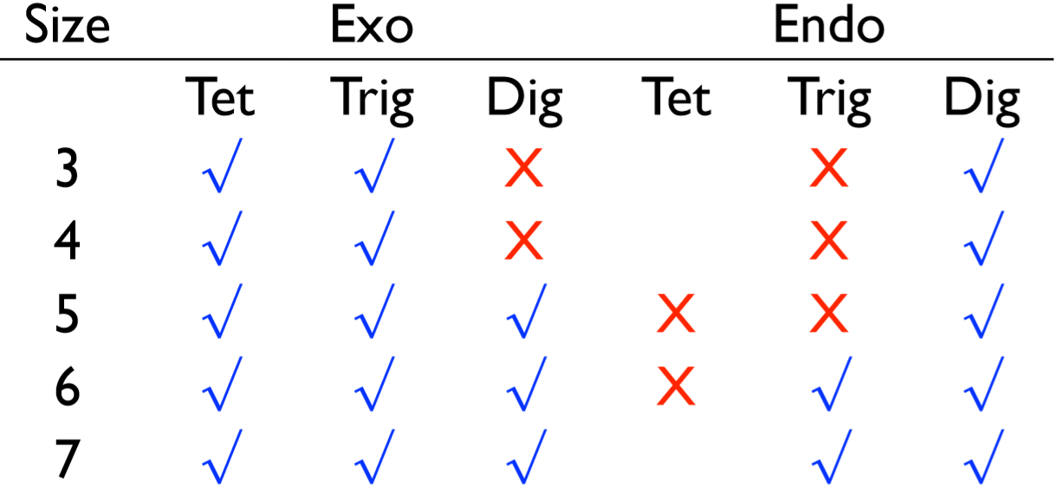

- Reaction at saturated carbons (substitution reaction S_{N}2 mechanism)
Cyclization of halide alkyl amine (intramolecular reaction)
Note: All exo-Tet cyclization are favored
Example 1

Example 2

Example 3

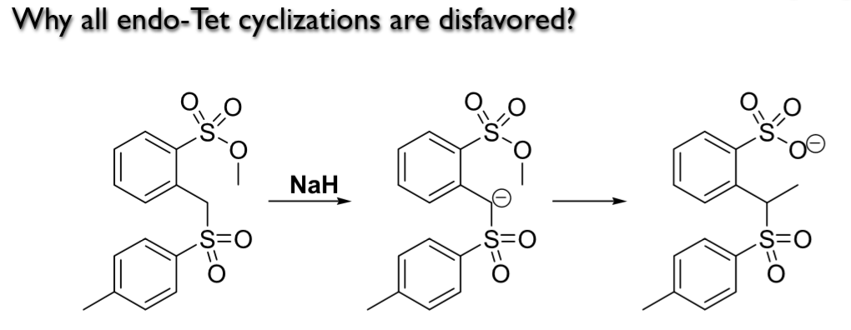

Mechanism
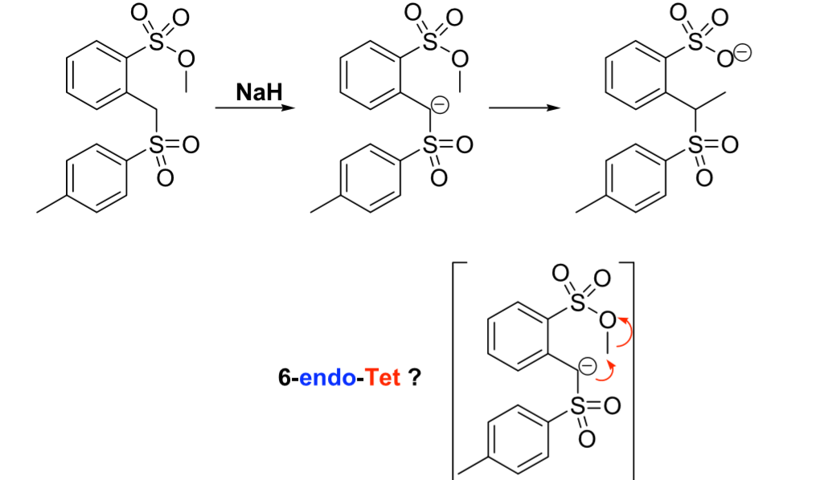

- Reaction at unsaturated carbon

The groups of unsaturated:

C=C, C=O, C=N

C=C each carbon has same polarity, so the attack takes place on the carbon atom. The cyclization reaction takes place exo and endo.

C=O and C=N the polarity of oxygen and nitrogen are higher than that of carbon, so the attack occurs on the carbon atom. The cyclization reaction takes place exo.

- Reaction of carbonyl compounds

Example1 (Addition Reactions)

Example2 (Substitution Reactions)

- Reactions of C=C

The reaction of α, β-unsaturated aldehyde (chalcone) with phenyl hydrazine to form hydrazones as intermediates. These hydrazone intermediates on treatment with glacial acetic acid in ethanol isomerizes to pyrazolines the probable mechanism for the formation of pyrazoline

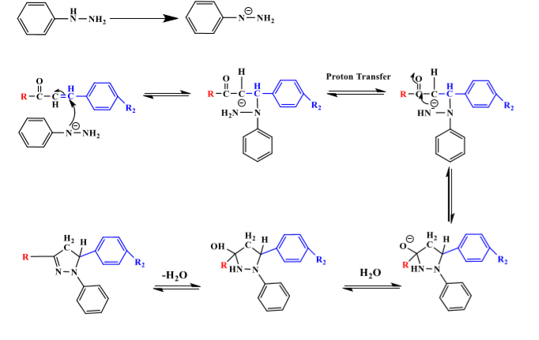

- Reaction of C=N (imine group)
Synthesis of β-lactam:

Mechanism

Example

- Cyclization of triple bonds

There are three types of triple bonds

The ring closer occurs for all types on the carbon atom.

- Reaction of alkyne

Example1

Mechanism

Example2

- Reaction of nitrile

Example

Mechanism

