Al-Mustansiriyah University
College of Pharmacy
Department of Pharmaceutical Chemistry


PRACTICAL ORGANIC CHEMISTRY
FOR PHARMACY STUDENTS
2013/2014
PART I

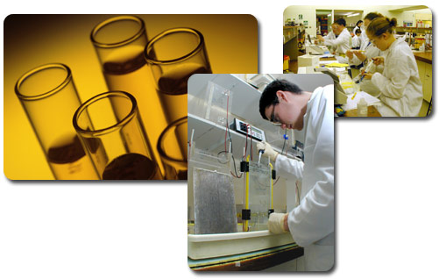
By
Instructors
Ayad Kareem
Luma Amer
Inas Ali
Zena Hussain

TABLE OF CONTENTS

Subject: Page:

1-Laboratory Safety Rules ……………………………………………….…….…. 3
2-Common Organic Laboratory Apparatus ……..…………………………….... 10
3-Experiment 1 (Melting Point Determination) ……………......….……...…... 16
4-Experiment 2) Boiling Point Determination) ………….……….…………..... 19
5-Separation and Purification of Organic compounds ……...................……… 21
6-Experiment 3 (Solution and Filtration) …………………………..………….... 22
7-Experiment 4 (Recrystallization) ……………………………………....………. 25
8-Experiment 5 (Distillation) ………………………………………….….………. 28
9-Experiment 6 (Extraction) ………………………………………….….……….. 31
10-Qualitative Analysis of Organic Compounds ……….……………….……… 33
11-Experiment 7 (Elementary Analysis, Sodium Fusion) …….….…….……… 34
12-Experiment 8 (Determination of Solubility Class) .…………….…..……….. 36

Laboratory Safety Rules
Goggles/Eye Safety
- You must wear chemical spill protection safety goggles whenever anyone in the lab room is handling chemicals. They must be flexible fitting, hood ventilation goggles,
Eye and Face Protection
If you forget your goggles, there are plenty of pairs in the labs in the drawers by the TA's desk. You are never charged a "rental fee" if you forget your goggles.
Do not wear contacts in the labs, even under goggles. Soft lenses can be affected by solvent vapors, possibly even fusing to the eye. Contacts also make it difficult to rinse your eyes quickly and properly if you spill something in them.
If you spill a chemical in your eye:
If you get any chemical at all in your eye, immediately begin rinsing it in the eye wash, holding your eye open. You're instructor or another student will come to your assistance and help you ascertain the seriousness of the exposure.

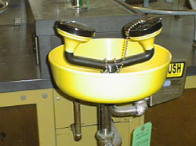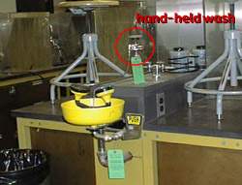
Fig.1 There is eyewash in each lab room location of eyewash - note the hand-held Pull-out safeties wash just above the eyewash
Personal Protection Equipment (PPE):
Personal protection equipment in the teaching laboratory includes safety goggles (discussed above), gloves, and lab coats and aprons. In industrial situations, PPE might include full suits of protective clothing, including boots and a face/head shield. Respirators are used when handling very toxic chemicals. If you are required to use a respirator, you will need to be trained in its use. Chemical labels specify the type of PPE required when handling a particular chemical.

Clothing: worn to lab is part of your personal protection equipment. You must be covered from the top of the shoulders to well below the knees. (A bare middle is right at the edge of the lab bench where it can come into contact with spilled chemicals.) Your feet must be covered–sandals are not appropriate in the chemical lab. Very loose fitting garments, such as ties and wide sleeves, as well as long unrestricted hair pose a hazard and must be restrained.
Special health problems
If you are aware that you have allergies to specific chemicals or drugs, or to UV light, or if you have asthma or other health problems, you may want to consult your doctor before taking organic chemistry lab. Feel free to discuss any questions you may have with the Laboratory Coordinator. And please note:
You may not take organic chemistry lab if you are pregnant.

Overview of how to handle flammable, volatile, health hazardous and corrosive chemicals
One goal of the organic chemistry teaching lab staff is to teach each student how to safely handle organic chemicals. Not only is this necessary for you to have a safe experience in organic lab, it is useful knowledge for almost any job you have after college, as well as for handling cleaning solvents and other chemicals in your home. Also read the Hazards of Chemicals and the Handling of Waste Chemicals sections on this site:
General Guide for Handling Chemicals in the Laboratory
Knowing what the hazards are is one thing, and knowing how to handle chemicals with these hazards is another. The goal of the following sections is to teach you how to handle chemicals with the most common hazards you will encounter. The chemicals most frequently used in the organic chemistry laboratories are chosen as examples for each type of hazard.
- Flammable Chemicals (examples: diethyl ether, acetone, hexanes, ethanol, methanol)
The method for proper handling of these flammable chemicals depends on their flammability rating, as given by a number 4-0 in the red area of a label. The rating for diethyl ether is "4" while acetone, methanol, ethanol, and hexanes are "3". Ether is extremely flammable and any spark or simply heat can ignite it. The other four solvents listed here will readily burn, but they are not as likely to spontaneously combust. (Ether is also quite volatile, and its vapors can travel quickly away from the immediate work area. This fact increases its flammability danger.)
Never use ether in a lab that has an open flame anywhere in the room. Be careful not to spill any flammable solvent (especially ether) on a heating mantle or hot plate. Keep them away from electrical outlets.
In case of fire:
- If your clothing catches fire, immediately drop to the floor and roll to smother the flames and call for help.
- If a compound or solvent catches on fire, if you can, quickly cover the flames with a piece of glassware
- If it is feasible, use a fire extinguisher to put the fire out.
- Do not put water on an organic chemical fire because it will only spread the fire.
- If the fire is large, do not take chances: evacuate the lab and the building immediately and tell your instructor or the Coordinator what has happened
- If no one in authority is available, pull the fire alarm in the hallway
- If no one in authority is available, call 122 from a safe phone.
- If the fire alarm sounds for any reason, leave the room immediately and exit the building.
The types and use of fire extinguishers is covered in a separate org. chem. web page:
- Fire Extinguishers
- Volatile Chemicals (examples: hexanes, acetone, methylene chloride, diethyl ether)
Diethyl ether and methylene chloride are the most volatile of the chemicals that you will use in the organic chem. teaching labs. If they are accidentally inhaled, they can cause irritation of the respiratory tract, intoxication, drowsiness, nausea, or even central nervous system depression. Note that diethyl ether presents a special problem because it is not only volatile, it is also extremely flammable.
Our student laboratories have been retrofitted with Plexiglas student hoods. The front of each student hood has a plastic covering, allowing access to the hood. All of the student hoods - there are 20 in each lab room - are ventilated by the fan located in the
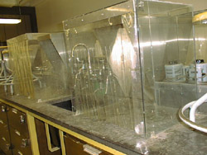 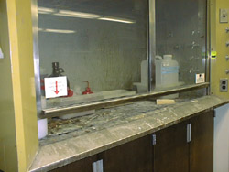 Fig.2 A student hood, note the flaps on the front face the main hood, note that it nearly closed

Main hood. If you pull the plastic flaps to one side or put them on top of the student hood, this action will decrease the ventilation efficiency not only of your student hood, but of the student hoods of each and every other student in the lab room. Therefore, leave the flaps down whenever possible. The main hood must also be kept nearly closed as often as possible.
Work in your student hood whenever possible, especially when you are handling volatile chemicals. If you need to carry volatile chemicals through the lab, carry them in a covered container.
Everyone in the lab must work together to reduce the amount of volatile chemicals released into the lab room!
If you inhale vapors:
Leave the area immediately - at least into the hallway. Tell your instructor or the Coordinator; they will take you outside into the fresh air, and if necessary provide first aid or take you to get medical attention.
- Contact Health Hazards of Solvents and Organic Chemicals (examples: methanol, ethanol, hexanes, acetone, methylene chloride, diethyl ether)
The health hazard of a chemical is designated by a number 4-0 in the blue area of a label. None of the chemicals you will use has a "4" rating; most are 1 or 2. If you had a one-time overexposure to the above chemicals, you might suffer a minor or a serious injury. If you protect yourself properly by wearing gloves, lab coat, goggles, and closed-toed shoes, and if you are careful not to spill chemicals, you are not likely to come into contact with these chemicals.
In the past, chemicals have been spilled by students and left where they were in the lab, especially by the balances. This could cause serious harm to another student, so be sure to clean up a chemical spill promptly. Often in the Lab Manual, you will be directed to clamp reaction flasks and vacuum flasks. The reason for this is two-fold: so that you do not lose your product and so that you do not spill chemicals.
If you spill a chemical on yourself:
Immediately rinse the affected area with lots of water. Use soap if you wish, but never try to "treat" the spill with another solvent or chemical unless directed to do so by your instructor. If the affected area remains more than slightly red after the rinsing period, seek medical attention.
- Hazards of Corrosives (examples: hydrochloric acid, sulfuric acid, phosphoric acid, nitric acid, sodium hydroxide)

Strong acids and bases are used frequently in the organic chemistry teaching labs. At full strength, they have a health rating of "3", meaning that short exposure could cause serious injury. (As they are diluted, the health rating drops about one number in rating for each 1:10 dilution.) If spilled on your skis, they cause a chemical burn. They are very harmful to your eyes. If you breathe in a big whiff of vapors, you will feel a burning in your nasal and respiratory passages.
Handle corrosives with great care so as not to spill them or inhale their vapors. Always wear goggles, gloves, protective clothing, and shoes. The heavier style of Playtex gloves are recommended for use when handling corrosives.
If you spill a corrosive on yourself:
Immediately rinse the affected area with lots of water. Use soap if you wish, but never try to "treat" the spill with another solvent or chemical unless directed to do so by your instructor. If the affected area remains more than slightly red after the rinsing period, seek medical attention.

Waste Chemical Handling
How hazardous chemical waste are collected in the Organic Chemistry Teaching Labs: rules and how you can do your part to reduce the amount of hazardous waste produces.

Glassware Safety
Use common sense when handling glassware. Keep glassware away from the edge of the bench top. Always clamp your reaction flask and the suction flask securely to a ring stand to prevent them from falling over. Check each piece of glassware for hairline or star cracks before using it. When doing a distillation, clamp each piece of glassware securely. If you do break a piece of glassware, do not leave it in the sink or on the bench top because someone may inadvertently get cut. Wearing thick gloves use a brush and dustpan to sweep up the broken glass. Place the broken glassware in one of the "Broken Clean Glassware" containers located in the labs.
If your reaction requires the use of a heating mantle or steam bath, glassware or the clamps used to hold glassware can become hot enough to cause a thermal burn on your skin. Wear heavy gloves to prevent this. Cuts can be also prevented by wearing thick gloves, especially while washing glassware. Protect your feet by wearing closed-toed shoes, not only to protect your feet from dropped glassware, but to protect them from broken pieces of glass which may be on the floor from a previous lab section. Always wear your goggles to protect your eyes from flying broken glassware.

Equipment and Electrical Safety
If your reaction is heated with a heating mantle, hot plate, or steam bath, remember that the glassware or the clamps used to hold glassware can become hot enough to cause a thermal burn on your skin. Wear heavy gloves to prevent this.
Use electrical equipment (heating mantles, Variacs, stir motors, hot plates) properly to prevent electrical shock. Check the cord or plug to make sure that it is not damaged or frayed; if it is, tell your TA. Always disconnect the plug from the socket by pulling firmly on the plug: Do not yank it out by the cord! Keep water away from all electrical equipment.
Electrical cords that are left running across the floor are a trip hazard. Tripping and falling is especially dangerous in a chemistry lab, when a student might be carrying a corrosive or flammable chemical. Always wrap the cords firmly around stir motors, hot plates, and Mel Temps before you return them to the shelves for storage.

If you cut or burn yourself:
If you cut yourself, wash the wound immediately with large amounts of cool water. If it is your neighbor who has been hurt, be prepared to help them if they are unable to help themselves. Apply direct pressure to stop the bleeding as necessary. If the bleeding is profuse, elevate the affected limb. Watch for evidence of shock and contact you're instructor or the Lab Coordinator as necessary. Thermal burns are treated by covering the affected area with cool water or ice. After a while, you can apply a pain-relieving cream. If the burn looks like it is more than just a reddening of the skin, seek medical attention.

Emergency Response
A thorough covering of Emergency Response procedures is beyond the scope of this web page. Be assured that your TAs and Coordinator have been trained in these procedures. If you are interested, go to the emergency procedures links below for more information.

Safety Rules:
- Wear safety goggles. You may only remove your goggles if no one in the lab room is using chemicals or washing glassware.
- Contact lenses must not be worn.
- Wear protective clothing: You should be covered from the top of your shoulder to below your knees. A laboratory coat is suitable, especially if you are not well-protected by the clothes you have chosen to wear to lab. Wear closed-toed shoes. Gloves are highly recommended at all times.
- Food and drink are not allowed in the lab room.
- You may not use personal music players during your laboratory session.
- No smoking.
- Work in your student hood at all times. Cover containers of compounds during transport through the lab.
- Prevent breakage by handling glassware with care at all times.
- Prevent chemical spills and glassware breakage by clamping flasks containing chemicals whenever possible. This is especially true for reaction and vacuum flasks.
- Place broken glassware in the proper receptacle.
- Report frayed electrical cords to your TA.
- Wrap cords firmly around equipment before you put it away to avoid trip hazards.
- Use a Bunsen burner only when directed by your TA.
- Place hazardous waste in the proper container.
- When the fire alarm sounds, leave the building immediately.
- Keep a clear pathway to the exits: Do not bring your bike or skateboard to lab and keep all personal items off the floor or close to the wall by the coat rack.
- Never conduct experiments in the laboratory alone.
- No unauthorized experiments.

COMMON ORGANIC LABORATORY APPARATUS

Fig.3. Common organic laboratory apparatus

COMMON ORGANIC LABORATORY APPARATUS

Fig.4. Common organic laboratory apparatus

COMMON ORGANIC LABORATORY APPARATUS

Fig.5. Common organic laboratory apparatus

COMMON ORGANIC LABORATORY APPARATUS

Fig.6. Common organic laboratory apparatus

COMMON ORGANIC LABORATORY APPARATUS

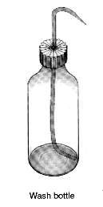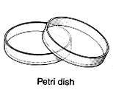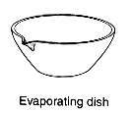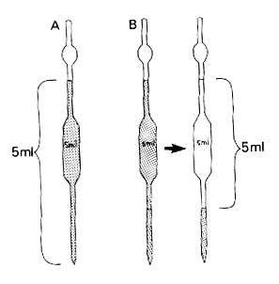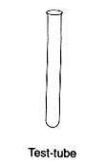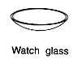
Bulb pipette

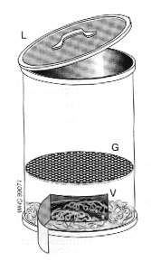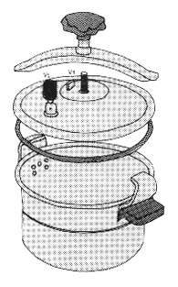
Dissectors
Fig.7. Common organic laboratory apparatus
COMMON ORGANIC LABORATORY APPARATUS

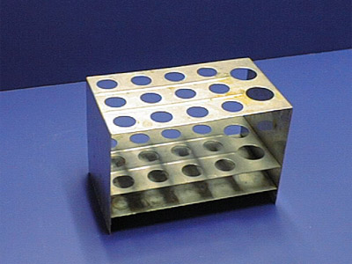 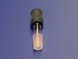
Test tube rack thermometer adaptor

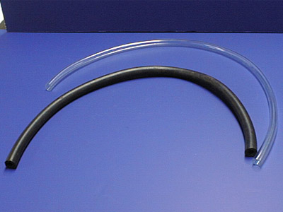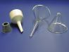
Rubber tubes filtering funnels

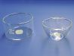
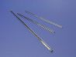
Crystallizing dish stir rod

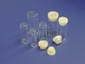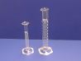
Vials graduated cylinders

Fig.8. Common organic laboratory apparatus

Experiment 1
MELTING POINT DETERMINATION

The melting point (mp) of a substance is one of the physical properties that chemists use to identify a substance. The melting point of solid crystalline compound is the temperature at which the solid begins to change into liquid under a pressure of one atmosphere, or it is the temperature at which there is equilibrium between liquid and solid states. If the resultant liquid is cooled, solidification will occur at the same temperature, i.e. the melting point and the freezing point for a pure substance are identical. (The melting point is considered as a criterion of purity of a compound and is useful for identification of organic compounds).
A pure crystalline organic compound usually has a sharp and characteristic melting point range of 0.5 to 1ºC. The “melting point range” is determined by recording the temperature at which melting first T1 begins and the temperature at which melting is complete T2. You may recall that impurities depress the melting (freezing) point of a substance. They also increase the range of melting. When a sample melts at a lower than expected temperature over an extended range, this is a sign that the sample was not pure. The same idea will apply for pure organic compounds if they undergo slight decomposition before reaching the melting point. The decomposition products act as impurities that decrease the melting point and increase the melting point range.
A technique known as a “mixed melting point” may be used as additional evidence in identifying a given compound. Suppose that you have two solid samples (A and B) with the same melting point. If you do not know whether these two samples are the same or different, you can mix them and measure the melting point for the resultant mixture. If A and B are different, one of them will act as an impurity for the other and the measured melting point will be lower than the original one with a higher melting point range. On the other hand, if the measured melting point is the same as the original one, A and B represent the same compound.

Procedure:
The method used for the determination of the melting point is called the “Capillary Tube Method”:
  - About 0.1 gram of the dry organic substance is placed on a glass slide and finely powdered with glass spatula. The open end of the capillary tube is pushed into the powder until the length of material is 3 –5 mm.
  - The capillary tube is attached to a thermometer (by a rubber ring) in such a way that its closed end is attached to the bottom of the thermometers bulb.
  - Then both of them are placed in an oil bath (paraffin, glycerin), the rubber ring should be above the surface of the oil bath.
  - Heating is started gradually with continuous stirring.
  - The range between the temperature at which the powdered solid inside the Capillary tube begins to liquefy T1 and the temperature at which a clear liquid is observed inside the capillary tube T2 is recorded as observed melting point range.
  - After completing the experiment the oil liquid must be allowed to cool before using it again.

Fig.9. Melting point apparatus

Modern Melting Point Apparatus:
The Gallenkamp melting point apparatus is a precision instrument designed for the determination of single or mixed melting points of solid up to a maximum temperature of 350 ⁰ C.
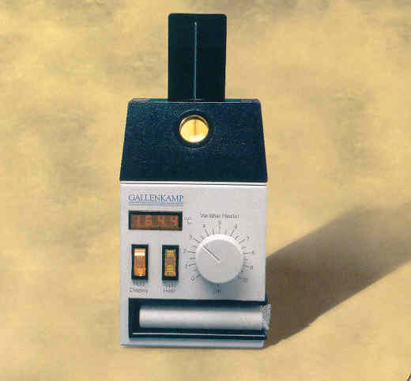
Fig.10. The Gallenkamp melting point apparatus
Procedure:

  - Make sure the melting temperature apparatus has cooled to near room temperature if it has been used recently.
  - Insert your capillary tube into a slot that will hold the tube next to the
heating block.
  - Make sure the thermometer is set to zero and switch “ON” the on-off
switch for the heating block.
  - Look through the eyepiece to see the solid sample as the temperature is increasing.
  - Observe both the temperature at which melting begins and at which the last crystal disappears.
  - Report a range such as 88 - 90 ⁰C, turn off the apparatus.
- If you do not know the melting point of a compound (as in this experiment), first take a crude melting point by heating rapidly. Then cool the apparatus to about 20 ⁰C below the crude melting point, and then take a more careful measurement on a second sample of compound.

Table of melting points data of some solid organic compounds.

Compound | M.P ( ⁰C ) | Notes
Naphthalene | 80 - 82 | Record your notes seen
Benzoic acid | 121 - 122 | =
Salicylic acid | 158 - 159 | =
Succinic acid | 184 - 185 | =

Questions:
• In the determination of the melting point, would too rapid heating of the oil bath result in a higher or lower melting point observation?

• If you were given a known substance for the melting point determination, how could you prove it to be the specific compound and not another compound with the same melting point?

• What is the effect of an insoluble impurity, such as charcoal, on the observed melting point of the compound?

Experiment 2
BOILING POINT DETERMINATION

If sufficient quantities of material are available, the boiling point can be determined by simple distillation. The boiling point (BP) of an organic liquid is the temperature at which its vapor pressure equals the atmospheric pressure over the liquid, or it’s the temperature at which the vapor and liquid phases are in equilibrium at a given pressure. The boiling is considered as a criterion of purity of a compound and is useful for identification of organic compounds.
Similar to the melting point the boiling point may be sharp or may vary over a temperature range. Pure liquids have sharp boiling points while mixtures show a boiling point range.
The atmospheric pressure plays an important role in determination of the boiling point correctly. Reduction of the pressure leads to a decrease or a depression in the boiling point and vice versa.

Procedure:
  - A 5 cm capillary tube closed from one end is inverted upside down in boiling tube is attached to a thermometer by a rubber ring.

Fig.11.The boiling tube is attached to a thermometer by a rubber ring.

  - Place them in a clean and dry test tube containing a small quantity of a liquid whose boiling point is to be measured (the rubber ring should be above the surface of the liquid).

  - The whole assembly is to be placed in an oil bath.

  - Start heating with continuous stirring until a rapid stream of bubbles comes out of the capillary tube (inside the liquid).

  - Remove the flame and allow the oil bath to cool so that the bubble stream will become slower and slower as the temperature drops until a point is reached at which bubbling ceases and the liquid starts to rise inside the capillary tube.

  - Record this temperature as the boiling point.

Table of boiling points for some liquid organic compounds

Compound | B.P ( ⁰C ) | Notes
Acetone | 56.5 | Record your notes seen
Methanol | 64.7 | =
Hexane | 68.7 | =
Toluene | 110.6 | =

Questions:
• What effect has a change in pressure on the boiling point?

• Why should the rubber ring be above the surface of the liquid whose boiling point
is to be measured?

SEPARATION AND PURIFICATION OF
ORGANIC COMPOUNDS

The separation and purification of organic compounds is important way to get pure organic compounds. Products of organic reactions are seldom pure products as a result of side reactions. Pure compounds are also subject to partial decomposition on standing for some time or on exposure to light, air, heat, moisture, etc. (for example acetyl salicylic acid, commonly called aspirin, decomposes to salicylic acid). Therefore, the process of separation and purification of organic compounds becomes an important technique to get pure compounds.
Generally, organic compounds are separated and purified by the following methods:
1- Solution and filtration.
2- Crystallization.
3- Distillation.
4- Extraction.
5- Sublimation.
6- Chromatographic methods as TLC, GC.

Experiment 3
SOLUTION AND FILTRATION

When a solid or a liquid* (solutes can be solids or liquids, while solvents are liquids) dissolves, the structural units – ions or molecules, become separated from each other and the solvent molecules occupy the space between them.
The solubility of organic compounds can be divided into two major types;
- Solubility in which the chemical reaction is the driving forces, for example, acid-base reactions:

Benzoic acid Sodium benzoate
(Water insoluble) (Water soluble)

- Solubility in which only simple miscibility is involved, for example, ethyl ether in carbon tetrachloride.
The first type is used to identify the functional groups involved in the compound, while the second type is used to determine solvents for recrystallization and chemical reactions.
The filtration is an important procedure after completing the reaction either to separate the solid product (precipitate) or to get rid of insoluble impurities or reactant materials. The desired soluble compound is recovered from the filtrate by evaporating the solvent.
The liquid is poured into a filter paper fitted in a funnel and either the precipitate is collected or the filtrate that contains the desired soluble compound is collected. In this method we take the advantage that one compound in the mixture is readily soluble in a given solvent whereas the remainder of the mixture may be relatively insoluble.

Filtering Techniques:
1- Gravity Filtration:
• Flute filter paper. Fluting is desirable when a rapid filtration is necessary, as in the filtration of the hot solution during a recrystallization.

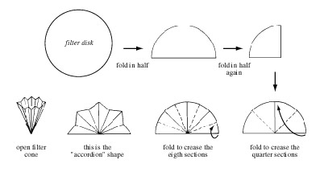
Fig.12: Fluting a filter paper (paper folded with many pleats to give a large surface)

• Place filter paper in the funnel. Place the funnel either directly on top of the beaker or on a ring stand above the beaker (see Fig. 4 below).

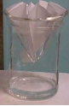
Fig.13. A beaker containing a stem less funnel. Note that the filter paper is fluted; however, that is not necessary for all applications.

• Wet the filter paper using a small amount of the liquid that is the solvent of the mixture being filtered.
• After the filtrate has been collected, pass a small amount of the wash liquid through the filter paper to wash the residue.

2- Vacuum Filtration with Buchner funnel:
• Select a Buchner funnel of appropriate size for the amount of residue you are collecting, not the amount of filtrate. Put a piece of filter paper in the funnel that fits exactly and wet the paper using a small amount of solvent.
• Place the funnel in a filter flask and connect the rubber tubing (see Fig. 4 below).

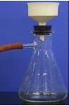
Fig. 14. A Buchner funnel in a filter flask, with rubber tubing connected to an aspirator.

• Using rubber tubing, the filter flask is connected to a trap, which in turn is connected to an aspirator, which provides the vacuum.
• Pour 15 ml of solvent through the funnel to wet the filter paper. Discard this water. Reconnect the flask to the aspirator.
• After the filtrate has been collected, pass a small amount of pure solvent through the filter to wash the residue.

3- Vacuum Filtration with Filter Crucible:
• To use a filter crucible, set up vacuum filtration by placing the filter crucible in a holder and placing that in a filter flask (see Fig. 3 below).

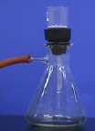

Fig. 15. A filter crucible in a crucible holder in a filter flask, with rubber tubing connected to an aspirator.

Procedure:
An impure mixture containing about 0.5 gm of benzoic acid and 0.5 gm of sugar (glucose) is to be dissolved in about 10 ml of distilled water. The sugar will dissolve in water while benzoic acid remains precipitated. Then perform filtration, by which the benzoic acid remains as the precipitate on the filter paper while the sugar goes with the filtrate as a solution. The sugar can be recovered from the filtrate by evaporating the solvent (water).
To test that the precipitate (on the filter paper) is the benzoic acid, sodium bicarbonate solution is to be added on this precipitate. The benzoic acid will be dissolved due to the formation of soluble sodium benzoate and bubbles of the evolved CO2 gas will be seen.

Questions:
• If you have a mixture of urea and salicylic acid how can you separate them using
solution and filtration method?

• After separation of urea from the mixture in the above question, give a way for
determining the efficiency of your method, i.e. the purity of your product.

• Why is fluted filter paper used in gravity filtration?

Experiment 4
RECRYSTALLIZATION

Solid organic compounds when isolated from organic reactions are usually impure; they are usually contaminated with small amounts of other compounds that are produced along with the desired compound. The purification of impure crystalline compounds is usually done by recrystallization from a suitable solvent or a mixture of solvents.
The purification of solids by crystallization is based upon differences in their solubility in a given solvent or a mixture of solvents.

Choosing a solvent for recrystallization:
The proper choice of a solvent is an important part of the art of crystallization. The ideal solvent should:
  - Be chemically inert toward the solute.
  - Dissolve the solute readily at its boiling point but sparingly at low temperatures (0 – 25 ⁰C).
  - Dissolve impurities either very easily or not at all.
  - Be highly volatile so that it can readily be evaporated from the crystals.
  - Not be flammable, of low cost, and of low toxicity.

Practically, to choose a good solvent take about (0.1 gm) of the compound to be purified (a pure sample) and try to dissolve it in (1 ml) of the solvent; if it dissolves in the cold solvent, the solvent will not be good for recrystallization; if it dissolves in the solvent with heating, the solvent will be good for recrystallization; if it does not dissolve in the solvent even with heating, the solvent will not be good for recrystallization. Solvents extensively used for recrystallization include water, ethanol, chloroform, ether, acetone, and benzene.

Decolorizing charcoal:
Frequently, samples to be purified may contain soluble colored impurities that may cause the solution and the crystals to be colored when they should be colorless; they dissolve in the boiling solvent and are adsorbed on the crystals produced upon cooling.
These impurities can be removed by treating the colored sample with decolorizing (activated) charcoal that is composed of fine carbon particles with a large active surface on which the colored impurities will be adsorbed.
Charcoal is added to the hot solution before boiling and the solution is kept hot at or near the boiling point for about 3-5 minutes with shaking to wet the charcoal. The solution is then filtered through a fluted filter paper. No more charcoal than actually needed should be used because any excess amount will cause the desired compound to be adsorbed on the charcoal.
Charcoal is not added at the boiling point of the solvent because its particles function as thousands of boiling chips causing the solution to boil over and foam.

Recrystallization using mixed solvents:
This is applied when your compound is readily soluble in a solvent at room temperature, and at the same time is not soluble in another solvent. The two solvents must be completely miscible with each other such as alcohol and water, ether and pentane, and glacial acetic acid and water. So the compound is dissolved in the solvent that it is soluble in, charcoal is used if required, and the solution is filtered to get rid of the insoluble impurities. Then the over solvent (in which the compound is insoluble) is added to the filtrate gradually until turbidity appears. The mixture is then left aside to facilitate crystallization.

Procedure:
Take an unknown weight of compound such as acetanilide and start dissolving it in a small volume of solvent such as water with heating until the entire sample dissolves. Remove the solution from the Bunsen burner and leave it aside for a minute to cool. Then add a small quantity of charcoal and resume heating again with stirring for 3-5 minutes. Filter the mixture while being hot. Leave the filtrate to cool at room temperature to induce crystallization. Observe the produced crystals.

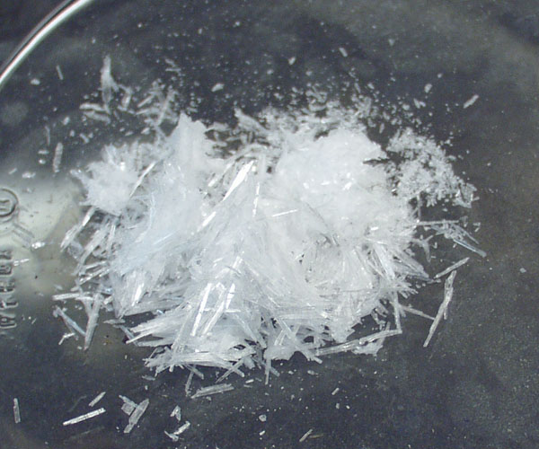
Fig. 16: purified crystals of acetanilide

Notes:
1- If crystallization does not take place scratch the sides or the bottom of the container below the surface of the solution with in glass rod, add a small crystal of the pure compound, or evaporate some of solvent to induce the crystallization process.

2- The funnel, filter paper, and the container of the solution should be kept hot through out the filtration process to prevent the deposition of the crystals on the filter paper or on the neck of funnel. Therefore, it is recommended to wash the filter paper after completing the filtration process with a small amount of the hot solvent.

3- Use a minimum volume of the solvent to prevent the loss of the compound because large volumes of the solvent will keep most of the compound dissolved in it.

4- Drying of the purified substance can be achieved by air drying, oven drying, freeze drying, or using desiccators containing a drying agent such as anhydrous calcium chloride.

Questions:
• What is the reason for using activated carbon during crystallization?
• Why are stem less funnels used instead of long stem funnels to filter hot solutions
through fluted filter paper?
• Why is decolorizing charcoal removed by gravity filtration instead of by suction
filtration?

Experiment 5
DISTILLATION

Distillation is process of purification of liquid organic compounds by conversion to the vapor state with the aid of heat, and condensation of the vapor state with the aid of heat, and condensation of the vapors to the liquid state.
The temperature at which the liquid distills is definite value (at a given pressure)for every pure organic compound and is known as the boiling point.

Aim of the experiment:
  - Purification of liquid organic substances.
  - Determination of the boiling point.
  - Separation of liquid organic substances from each other or from a nonvolatile solid compound.
Distillation limited to a certain extent because some organic compounds decompose when an attempt is made to distill them at a normal atmospheric pressure.

Types of Distillation:
  - Simple distillation: This method is used for the separation of liquids having boiling points ranging from 30 °C to 150 °C and is stable to heat.

  - Vacuum distillation. (Distillation under reduced or diminished pressure): This method is used for the separation of liquids with high boiling points or is unstable to heat. These difficulties may be overcome by lowering the pressure over the substance, thus lowering the boiling point and the temperature necessary to effect the distillation (diminished-pressure distillation).

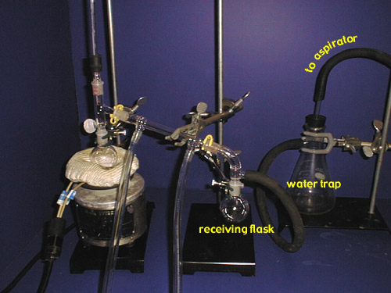

Fig. 17: Vacuum distillation

3- Steam distillation: This method is used for the purification of non-
volatile organic compounds and which are immiscible with water.

  - Fractional distillation: This method is used for the separation of two or
more liquids with different boiling points. Fractional distillation is the
process of collecting separate fractions according to controlled boiling
ranges during the distillation of a mixture of substances.

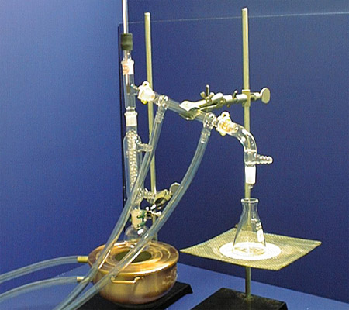

Fig .18: Fractional distillation

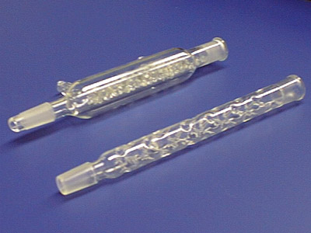

Fig .19: condensers for Fractional distillation

Azeotropic mixture is a mixture composed of two or more liquids that form a constant-boiling mixture that boils at a certain temperature. It is impossible to separate them by fractional distillation. For example, a mixture of approximately 95% ethyl alcohol and 5% water produces a constant-boiling mixture (Azeotropic mixture) which boils at 78.15 °C.
Other examples of Azeotropic mixtures include:
• Benzene and ethanol
• Carbon tetrachloride and methanol
• Amine and phenol
• Formic acid and water
• Toluene and acetic acid
• Ethanol, Benzene, and water

Simple distillation:
A single, individual organic substance is readily distilled with ordinary distillation apparatus (see the figure), which consists of a distillation flask fitted with a thermometer and water-cooled condenser. Two or three pieces of broken porcelain chips are placed in the flask with the substance to be distilled; they prevent bumping by producing a constant stream of bubbles that keeps the liquid in motion. If the liquid is quite volatile (low boiling), the flask is heated by a water bath rather than by a flame.

Fig. 20. Apparatus for simple distillation
Useful notes:
• Pure compound distill over a very narrow range of temperatures.
• The boiling point is affected by impurities; some may increase the boiling point, others may decrease it, and some may not affect it. For example the addition of sodium chloride to water results in raising the boiling point of water. The effect observed here is the lowering of the vapor pressure of water that is, the tendency of the molecules to escape has been diminished.
• Usually the first few milliliters contain water or volatile impurities; the second portion contains the pure substance.

Procedure:
1- Put (100 ml) of ethanol in a boiling flask.
2- Add 2-3 pieces of boiling chips.
3- Start the water running slowly through the condenser.
4- Heat until boiling.
5- Adjust the temperature so that distillation proceeds at 2-3 drops per second.
Discard the first 2-3 ml of the distillate.
6- Continue distillation until you collect 30-60 ml.
7- Record the boiling point of your liquid, ethanol.

Questions:
• Explain why the first vapor in the distillation of two simple substances differs in composition from that of the original mixture?

• How can you overcome the problem of decomposition of certain organic liquids during distillation process?

Experiment 6
EXTRACTION
PARTIAL SOLUBILITY IN IMMISIBLE SOLVENTS

Extraction is a method of separation and purification of organic compounds that depends on the ability of the compound to dissolve in two immiscible solvents, e.g. water and chloroform.
Immiscible solvents are mixtures of liquids that are insoluble in each other. Such solvents will form two layers; the upper layer is for the liquid with the lower density and the lower layer is for the liquid with the higher density.
The process of extraction with immiscible solvents is generally employed for the isolation of dissolved compounds from solutions, isolation of solid compounds from mixtures, or removal of undesirable impurities from mixtures (washing). Some times it is used in organic chemistry laboratories to remove an organic compound from a solution when the use of distillation is not convenient.
Ether, one of the most important organic solvents, is used extensively as an extracting solvent. It is very slightly soluble in water and its efficiency in use can be improved considerably by the addition of a small amount of an ionizable salt, such as sodium chloride or potassium carbonate, to the water layer. This leads to an increase in the polar property of this solution that result in a decrease in the solubility of a non polar compound. Therefore, ethanol, which is completely miscible with water, becomes an immiscible liquid with respect to the water layer when the water is saturated with a salt such as sodium chloride. This is known as the “salting out” process.

Choosing a solvent for extraction:
A good solvent for extraction should:
1- Readily dissolve the substance to be extraction.
2- Have a low boiling point so that it can be readily removed
3- Not react with the solute or the other solvent.
4- Not be flammable.
5- Show little or no water solubility (immiscible with water).
6- Be in expensive.

No solvent meets all these criteria. For example, ether is probably the most common solvent used for extraction but it is flammable. However, ether;
1- Has a high solvating power for hydrocarbons and for oxygen containing
compounds.
2- Is highly volatile having a boiling point of 34.6 °C so that it can be easily removed
from the extract at low temperatures, thus even highly sensitive compounds are not
likely to decompose.
3- Is very slightly soluble in water.

Procedure:
A mixture of p-toluidine (a base); 2-naphthol (a weak acid), is to be separated into its components by extraction. Obtain from your instructor a (3.0 g) sample of the two component mixture and dissolve it in (25 ml) ether.
Pour the solution into a (125 ml) separatory funnel. To extract the basic component (p-toluidine) from the mixture, add a solution of (3 ml) concentrated hydrochloric acid in (25 ml) water and shake thoroughly, following the technique for using a separatory funnel, (see figure). Draw off the lower (aqueous) layer into a (125 ml) Erlenmeyer flask and repeat the extraction tow more times. Finally extract with (10 ml) water to remove excess hydrochloric acid that may be dissolved in the ether layer.
Combine the three acid extracts with the water extract and set them aside.

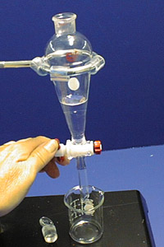

Fig. 21: Separatory funnel

To separate the acidic component (2-naphthol) from the mixture, extract the remaining ether solution three times with (25 ml) of 10% aqueous sodium hydroxide and once with (10ml) water. Combine the alkaline and water layers and set them aside.
Neutralize the combined acidic extracts by adding 10% aqueous sodium hydroxide until the solution is alkaline to litmus paper. Extract the alkaline solution twice with (25 ml) portions of ether, separating the first (25 ml) ether and combining it later with the second (25 ml) ether. Add enough, anhydrous calcium chloride to cover the bottom of the small Erlenmeyer flask, and swirl the mixture occasionally for 15 minutes. Then decant the ether solution into a small beaker of known weight and place it in the hood to allow the ether to evaporate. Weigh the residue (p-toluidine or the basic component) and determine its melting point. Store the compound in a corked test tube if it is to be saved until a later lab period.
Neutralize the combined alkaline extracts by adding concentrated hydrochloric acid drop by drop until the solution is acid to litmus paper. The solution may be kept cool with ice during neutralization. Recover the precipitated 2-naphthol (acidic component) by vacuum filtration using a Buchner or Hirsch funnel. Weigh the product and determine its melting point.

Questions:
• Why it’s necessary to remove the stopper from a separatory funnel when liquid is
being drained from it through the stopcock?

• In extraction by ether and water, does the ether layer lie above or bellow water
layer?

• Indicate three properties that a compound must possess in order for it to function as
an extraction solvent.

QUALITATIVE ANALYSIS OF
ORGANIC COMPOUNDS

Qualitative analysis of organic compounds deals with the identification of unknown organic compounds whether being a single compound or contained in a mixture.
In the latter case the unknown compound requires careful separation prior to the start of the identification steps.
The qualitative analysis of any organic compound consists of the following steps:

1- Physical properties.
• State of the organic compound (solid, liquid, gas).
• Determination of the melting point or boiling point.
• Color and odor of the compound.
• Determination of the solubility group (solubility classification according to the
general families).
• Make an ignition test (aromatic compounds often burn with a smoky flame).

2- Chemical properties.
• Effect of the compound and its solution on litmus paper.
• Determination of elements in the organic compound (N, S, X).
• Detection of the organic groups, i.e. group classification to get more specific
families.
• Specific classification tests.
• Preparation of derivatives.

Experiment 7
ELEMENTARY ANALYSIS, SODIUM FUSION

This method for detection of nitrogen, sulfur, and halogen in organic compounds depends upon the fact that fusion of substances containing these elements with sodium yields NaCN, Na2S, and NaX (X = Cl, Br, I). These products can, in turn, be readily identified. The method has the advantage that the most usual elements other than C, H, and O present in organic compounds can all be detected following a single fusion, although the presence of sulfur sometimes interferes with the test for nitrogen.

Procedure:
Place sodium in a Pyrex test tube and support the tube in a vertical position (see figure 22).

Fig.22. sodium fusion apparatus

Have a burner with small flame ready to move under the tube and heat until the sodium first melts and then vapor rise 1.5 – 2.0 cm in the tube. Remove the burner and at once drop the sample onto the hot sodium. If the substance is a liquid add 2 drops of it. If there is a flash or small explosion the fusion is complete. Then let the tube cool to room temperature, be sure it is cold, add a drop of methanol, and let it react (heat effect). Repeat until 10 drops have been added with a stirring rod break up the char to uncover sodium. When you are sure that all sodium has reacted, empty the tube into other test tube, hold the small tube pointing away from you or a neighbor, add 1ml of distill water. Boil and stir the mixture and pour the water into the larger tube; repeat with 1 ml more distill water. Then filter the solution. The alkaline filtrates are used for the tests that follow:

a) Nitrogen. Place 50 mg of powdered iron (II) sulfate (this is a large excess) in a test tube, add 0.5 ml of the alkaline solution from the fusion, heat the mixture gently with shaking to the boiling point, and then-without cooling-acidify with dilute sulfuric acid (hydrochloric acid is unsatisfactory). A deep blue precipitate indicates the presence of nitrogen.
b) Sulfur. Dilute one drop of the alkaline solution with 1 ml of water and add a drop of sodium nitroprusside; a purple coloration indicates the presence of sulfur.

c) Halogen. Acidify 0.5 ml of the alkaline solution from the fusion with dilute nitric acid and, if nitrogen or sulfur has been found present, boil the solution (hood) to expel HCN or H2S. On addition of a few drops of silver nitrate solution, halide ion is precipitated as silver halide. Filter and wash with water, and then with 1 ml of concentrated ammonia solution. If the precipitate is white and readily soluble in ammonium hydroxide solution it is AgCl; if it is pale yellow and not readily soluble it is AgBr; if yellow and insoluble it is AgI. Fluorine is not detected in this test since silver fluoride is soluble in water.

Experiment 8
DETERMINATION OF SOLUBILITY CLASS

Solubility class determination is useful for knowing the type of the functional group, the polarity of the compound, the molecular weight, and acidity degree. Solvent that are used in the determination of the solubility class are:
1. Water 2. Ether 3. 5% NaOH
4. 5% NaHCO3 5. 5% HCl 6. Conc. H2SO4
The first step is testing the solubility of the compound in water. Generally, the compound is said to be soluble in any solvent if it dissolves to the extent of 3% (3gm/100 ml or 0.1 gm/3 ml). This is achieved by dissolving about 0.1 gm of the solid compound or 3 drops of the liquid compound in gradually increasing volumes of the solvent up to3 ml (maximum allowed volume is 3 ml) with continuous shaking to determine whether the compound is soluble or insoluble in that solvent.
Bellow is a very useful scheme for solubility classification:

Fig.23.Solubility classification scheme

The steps of solubility classification:
1. Water.
Water is a polar solvent with a dielectric constant equals to 80. It has the ability to form hydrogen bonding and can act either as an acid or a base. Therefore it can dissolve:
• Salts of ammonium ion (NH4⁺) or organic acids salts with alkali metal cations.
• Ionic compounds.
• Polar compounds “like dissolve like”.
• Organic compounds with low molecular weight (less than 5 carbon atoms) such as
alcohols, aldehydes, ketones, and carboxylic acids.
Water is the first solvent used in determining the solubility class of a compound. The result will be either water soluble or insoluble. If the compound is water soluble, the next step will be testing its solubility in ether.

2. Ether.
Ether is a non-polar solvent with a dielectric constant of 4.3. It cannot form hydrogen bonding (unassociated liquid). Therefore, it differs from water in that it cannot dissolve ionic compounds such as salts.
Ether dissolves most water insoluble compounds; therefore, in determining the solubility class, it is important only for water-soluble compounds.
Accordingly two probabilities are there:
1- Compounds those are soluble in both water and ether and such compounds:
• Are non-ionic.
• Contain five or less carbon atoms.
• Contain an active group that is polar and can form hydrogen bonding.
• Contain only one strong polar group.
This division of compounds is given S₁ class, e.g., aldehydes, ketones, aliphatic
acids, Etc.
2- Compounds those are soluble in water but not in ether and such compounds:
• Are ionic.
• Contain two or more polar groups with no more than four carbon atoms per
each polar group. This group is classified as S₂ class. Examples of this group are:
- High molecular weight compounds such as halogen derivatives.
- Ionic salts such as of carboxylic acids and amines.
- Compounds with more than active group such as poly hydroxylated compounds and carbohydrates.
Note that solubility in ether is tested only for water soluble compounds. For water insoluble compounds use the left side of the solubility classification scheme, i.e. test solubility in sodium hydroxide rather than ether.

5% NaOH & 5%NaHCO3.
Water insoluble compounds must be tested first in 5% NaOH solutions which is an alkaline solvent. It reacts with water insoluble compounds that are capable of donating protons such as acids (strong and weak). The stronger the acid the weaker the base it can react with. Water insoluble compounds that dissolve in 5% NaOH solution must also be tested for solubility in 5% NaHCO3 solution.
Therefore, for water insoluble acidic compounds NaOH solution may be called as a detecting solvent whereas NaHCO3 solution may be called as a sub classifying solvent. Again if the compound is soluble in 5% NaOH solution, its solubility in 5% NaHCO3 solution must be tested to determine its degree of acidity. On the other hand, you don’t have to test the solubility in 5% NaHCO3 solution if the compound is insoluble in 5% NaOH solution but, rather, shift to the left and use HCl.
Two probabilities are there:
1- The compound is soluble in both solvents and this group is given A1 class. This class includes strong acids that have the ability to react with weak bases (carboxylic acids), and phenols with electron withdrawing groups (e.g., -NO2). Protons are weakly attached to them.
2- The compound is soluble in 5% NaOH solution only and this group is given A2 and it includes phenols, amides, and amino acids.

5% HCl.
If the compound is insoluble in water and sodium hydroxide solution (and, hence, is insoluble in sodium bicarbonate solution), this means that the compound is not an acid but, rather, is either a basic compound or a neutral compound. Hydrochloric acid, which can dissolve basic compounds such as amines, is used for such a compound.
If the compound dissolves in 5% HCl, it is related to class B. This class includes primary, secondary, and tertiary amines.

Conc. H2SO4.
If the compound is insoluble in water, sodium hydroxide, and hydrochloric acid, tests its solubility in concentrated sulfuric acid. If the compound is soluble in conc.H2SO4, it belongs to class N which includes neutral compounds as alcohols, aldehydes, ketones, esters, ethers (of high molecular weight), and unsaturated hydrocarbons. On the other hand, compounds that are insoluble in conc. H2SO4 belong to class I which includes inert aliphatic hydrocarbons.

Questions.
• From the stand point of structure, predict the solubility of each of glucose, tert-
butyl amine, β-naphthol, n-butyl butyrate, and 2-pentene?

• In testing the solubility of any organic compound in a given solvent. Why in the
solvent added in gradually increasing volumes?

