Liver Cirrhosis

Definition:

- Irreversible condition result of fibrosis scarring and hepotocellular regeneration constitute the major responses of the liver to a variety of long standing inflammatory, toxic, metabolic and congestive insults

- The normal lobular architecture is replaced by interconnecting bands fibrous tissue surrounding nodules derived from foci of regenerated hepatocytes;

- As a result, distortion of vascular bed ---- obstruction of hepatic blood flow portal hypertension, intrahepatic shunting, collaterals (eseophageal varises)

- Normal hepatocyte function is disturbed

Etiology
- Alcohol Abuse

- Hepatitis C (most common in Western world; mainly blood and blood products
contaminated needles, dialysis patient)

- Hepatistis B (in Third world)

- Schistomiasis ----fibrosis of portal venous branches, however lobular
architecture is well preserved

- Chronic right heart failure

- Drugs: amiodarone, methotrexate

- Genetics
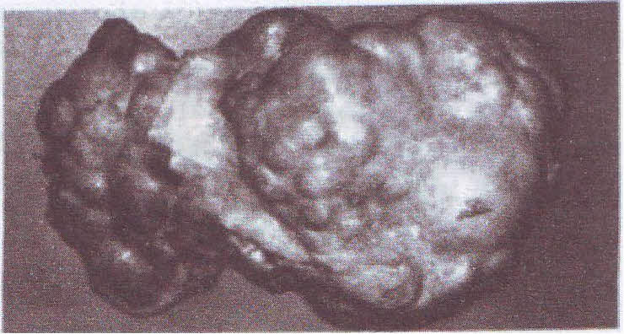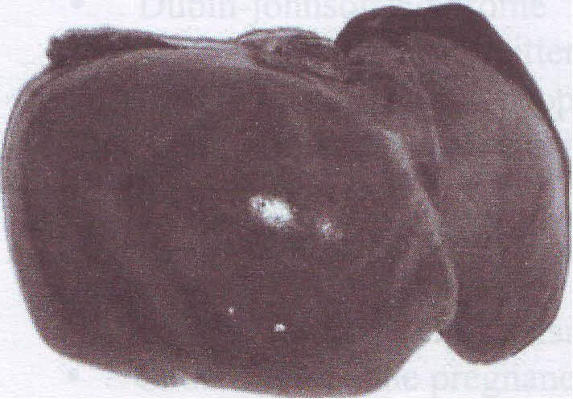

Types:
- Well-compensated cirrhosis; no symptoms & no features of hepatocellular dysfunction
- Decompensated cirrhosis ---- hepatocellular dysfunction

CLINICAL AND LABORATORY FEATURES ARE USUALLY DIVIDED INTO FOUR CATEGORIES:
1-Size and consistency of the liver
Size: e.g, in end-stage liver disease of hepatitis B or C --- size is small, scarred, and shrunken
in alcoholic cirrhosis --- fat infiltration may lead to marked enlargement of the liver
Consistency: firm to hard
2- Features attributable to hepatocellular dysfunction. These result from both intrinsically "sick" hepatocytes and shunting of portal blood away from hepatocytes----failure to extract toxins and metabolites
- Jundice-----biphasic because of failure to conjugate or release conjugated bilirubin from hepatocytes
- Spider angiomas: focal network of dilated capillaries radiating from a central arterioles on the skin and mucous membranes (mainly bee. Of failure of hepatic detoxification processes)
- Palmar erythema: persistent redness of the palms due to congestion of capllaries
3- Laboratory findings
- serum aminotransferases [aspartate aminotransferase (AST formerly known
as SGOT) and alanine aminotransferase (ALT formerly known as SGPT)] released from normal turnover of liver cells
persistently high 111 --- leakage of injured rather than dead (necrotic) hepatocyte
if not extraordinary high ---- hepatocellular necrosis
2. Alkaline phosphatase
Present in a high cone. in biliary canaliculi
If 1 x3 times normal ----- obstructive rather than necrotic cause of hepatotoxic process
It usually 1 30% to 50% above the upper limit in geriatric patients Therefore, if fractionation of alkaline phosphatase show high hepatic isoenzyme or gamma glutamly transpeptides is high ---- confirm hepatic toxicity
- Serum albumin is non specific, however Hypoalbuminemia «3gm/dl) unresponsive to therapy ---- bad prognosis
- Prothrombin time prolonged (hyporothrombinemia) &
unresponsive to vitamin k IV ---- hepatocellular disease
- Low BUN/ high blood ammonia
4-Features attributable to portal hypertension
- Splenomegaly ----thrombocytopenia & leukopenia due to sequestration of platelets and leukocytes in enlarged spleen (hypersplenism) ---- however, clinically not significant
- Ascites
- Variceal bleeding
5-Extrahepatic features related to specific diseases causing cirrhosis
6-Non specific, anorexia, nausea, abdominal discomfort, weight loss.

Pathophysiology

- Portal hypertension can develop from prehepatic, intrahepatic, or posthepatic damage.
- The most common cause of portal hypertension, which is intrahepatic (sinusoidal) damage.
- Normal hepatic blood flow; 1 L/min
- The progressive destruction of hepatocytes combined with an increase in fibroblasts and connective tissue culminates in cirrhosis. Fibrosis scar tissue nodules modify the basic architecture of the liver, disrupting hepatic blood flow and normal liver function.
- Damaged hepatic architecture---increased resistance to portal venous flow Increased pressure in the portal vein----collateral veins develop between portal and systemic circulation ---- collateralls are not a new veins, but they are normal veins which are distended due to pressure
- The most important collaterals are those which are those formed submucosa of the gastric fundus and esophagus ---- severe haemorrhage of varices in the esophagus (Variceal hemorrhage)
Variceal hemorrhage is presented with the following signs and symptoms

Signs and Symptoms
- Hematemesis (coffee ground vomitus), hematochezia (the passage of bloody stool melena and the patient has signs of anemia, [decrease Hgb, ↓BP, ↑HR&RR)
- This lead to shock, stop spontaneous, or recur ---- mortality rate 30-60%
- Thrompocytopenia may further complicate the case
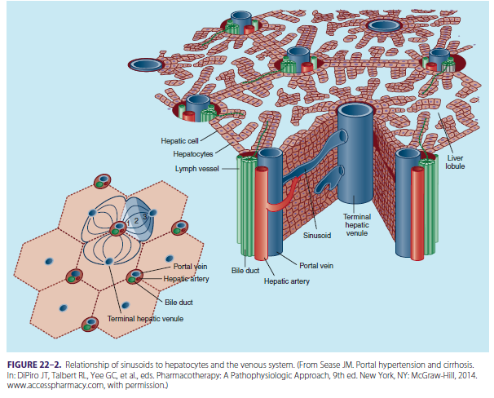

COMPLICATIONS OF LIVER DISEASE
Ascites /
- The pathophysiology of ascites, portal hypertension, and cirrhosis are interrelated
- Cirrhotic changes and subsequent decreases in synthetic function lead to decreased albumin production (hypoalbuminemia).
- Albumin is the primary intravascular protein responsible for maintaining vascular
oncotic pressure;
- Low serum albumin levels, elevated hydrostatic pressure, and increased capillary permeability allow fluid to leak from the vascular space into body tissues.
- This results in ascites, peripheral edema, and fluid in the pulmonary system.
- Obstruction of hepatic sinusoids and hepatic lymph nodes also allows fluid to seep into the peritoneal cavity, further contributing to ascitic fluid formation.
- Lowered effective intravascular volume decreases renal perfusion; the kidney reacts by activating the RAAS, increasing plasma renin activity, aldosterone production, and sodium retention.
- The subsequent increase in intravascular volume furthers the imbalance of intravascular oncotic pressure, allowing even more fluid to escape to the extravascular spaces, increasing ascites and peripheral edema.
- Patients with ascites retain sodium and water, not only through elevated aldosterone concentrations (from increased production and decreased clearance), but also through increases in ADH and sympathetic nervous system activation.
- Patients may become dilutional hyponatremic if there is a decrease in free water excretion.

Treatment
a. Attainment of negative sodium balance

Dietary sodium restriction (less than 2000 mg/day), fluid restriction to less than 1.5 L/day if serum sodium is less than 120–125 mmol/L

Diuretics
(a) Patients with minimal fluid overload may be treated with spironolactone alone (doses up to 400 mg/day); however, a combination of furosemide and spironolactone is preferable as initial therapy in most patients.

(b) When used in combination, a ratio of 40 mg of furosemide to every 100 mg of spironolactone is an appropriate starting regimen.
Amiloride 10–40 mg/day may be substituted for spironolactone in patients who develop tender gynecomastia.

(c) If tense ascites is present, may use large-volume paracentesis.
Administer albumin at a dose of 6–8 g/L of ascitic fluid removed (if more than 5 L is removed at one time).

iv. No upper limit of weight loss if massive edema is present, 0.5 kg/day in patients without edema

v. The goal is to achieve 78 mmol or more urinary sodium excretions per day with diuretics.

vi. Monitor for electrolyte imbalances, renal impairment, and gynecomastia (spironolactone).

b. Discontinue drugs associated with sodium/water retention such as NSAIDs.
Hepatorenal Syndrome HRS

- HRS is a decline renal function in the setting of cirrhosis that is not caused by intrinsic renal disease.
Type 1 HRS is characterizedby rapid deterioration of renal function (acute kidney injury [AKI]) in the presence of decompensated cirrhosis that is not reversible with volume repletion.
- Untreated it is rapidly fatal with a 50% mortality rate at 14 days.
- Renal artery vasoconstriction (stimulated by the sympathetic nervous system) and decreased mean arterial pressure (mediated by nitric oxide) decrease renal perfusion and precipitate renal failure.
- The kidneys attempt to counteract this drop in renal perfusion through RAAS activation. Production of renin stimulates a cascade that causes fluid retention and peripheral vasoconstriction in an attempt to increase renal blood flow.
- Prostaglandin E2 and prostacyclin production are increased to stimulate renal vasodilation
Type 2 HRS has similar pathophysiology to type 1 HRS but is characterized by a less
acute decline in renal function.
Treatment
- A common regimen involves giving albumin 1 g/kg on day of diagnosis (day 1), followed by 20 to 40 g on subsequent treatment days.
- This regimen is used in combination with Midodrine (an α-agonist) and Octreotide. The initial midodrine dose is 7.5 mg orally three times daily; Octreotide is administered subcutaneously (as opposed to IV during variceal bleeding) 100 mcg three times daily. Both drugs can be titrated as tolerated to achieve increases in mean arterial pressure of at least 15 mm Hg.
- Terlipressin, a vasopressin analog available in Europe, has been used with success in patients with HRS, but it is not currently available in the United States.

Hepatic Encephalopathy HE
- In severe hepatic disease, systemic circulation bypasses the liver; substances that are normally hepatically metabolized accumulate in the systemic circulation. These metabolic by-products, especially nitrogenous waste, are neurotoxic.
- Ammonia (NH3) is just one of the toxins implicated in HE.
- It is a metabolic by-product of protein catabolism; it is also generated by bacteria in the GI tract. In a normally functioning liver, hepatocytes degrade ammonia to form urea, which is renally excreted.
- In cirrhosis, conversion to urea is reduced and ammonia accumulates, resulting in encephalopathy.

Treatment
a. Assess need for airway support and remove possible precipitating factors.
b.Reducing the nitrogen load in the gut
c. Lactulose
- Lactulose is the foundation of pharmacologic therapy to prevent and treat HE. It is a nondigestible synthetic disaccharide laxative; it is hydrolyzed in the gut to an osmotically active compound that draws water into the colon and stimulates defecation
- Lactulose is usually initiated at 15 to 30 mL two to three times per day and titrated to a therapeutic goal of two to four soft bowel movements daily
- May be continued over the long term for the prevention of recurrent encephalopathy

- Flatulence, diarrhea, and abdominal cramping are common adverse effects.
d. Antibiotics
- Targeted at reducing the number of intraluminal urease-producing bacteria that may be associated with excess NH3 production

- Neomycin (3–6 g/day in three or four divided doses × 1–2 weeks; then 1–2 g/day
maintenance) or
- metronidazole (250 mg orally 2 times/day) may be used; neomycin is considered as effective as lactulose.

- Rifaximin is as effective as lactulose and other nonabsorbable antibiotics and may be better tolerated. Approved dose for reduction in overt encephalopathy in patients 18 years and older is 550 mg 2 times/day.

e. Other possible treatments
i. Benzodiazepine antagonists such as flumazenil may be used in cases of suspected
benzodiazepine overdose.
ii. Zinc supplementation should used in patients with documented zinc deficiency.
Gastroesophageal Varices

- The splanchnic system drains venous blood from the GI tract to the liver.
- In portal hypertension, there is resistance to drainage from the originating organ; collateral vessels (varices) develop in the esophagus, stomach, and rectum to compensate for the increased blood volume.
- Varices divert blood meant for hepatic circulation back to the systemic circulation, which decreases clearance of medications and potential toxins through loss of first-pass metabolism.
- Varices are weak superficial vessels; any additional increase in pressure can cause them to rupture and bleed.

Management of acute variceal bleeding

- Fluid resuscitation and hemodynamic stabilization. Maintain hemoglobin concentration of about 8 g/dL. Administration of fresh frozen plasma or platelet may be considered for patients with considerable coagulopathy.

- Octreotide (a synthetic somatostatin analog) causes selective vasoconstriction of the splanchnic bed, decreasing portal venous pressure with few serious side effects.
The most common octreotide dose is a 50-mcg IV loading dose followed by a 50 mcg/hour continuous IV infusion.
Therapy should continue for at least 24 to 72 hours after bleeding has stopped. Some clinicians continue octreotide for a full 5 days because this is the time frame with highest risk of rebleeding.

- Endoscopy to assess the extent of disease with potential intervention

i. Sclerotherapy:(( possible sclerosing agents include ethanolamine and sodium tetradecyl sulfate)
Effective in discontinuing bleeding in 80%–90% of patients; may be associated with complications such as perforation, ulceration, stricture, and bacteremia;

ii. Endoscopic variceal band ligation may be used as an alternative to sclerotherapy; fewer complications

Nondrug measures to control acute bleeding

(a) Balloon compression applied directly to bleeding varices
(c) Transjugular intrahepatic portosystemic shunt: Results in shunting of blood from the portal circulation; however, may be associated with complications such as bleeding and infection
(d) Surgery

Prevention of variceal bleeding
i. Primary prophylaxis

(a) A screening EGD (esophagogastroduodenoscopy) is recommended

(b) Pharmacologic therapy is not recommended in patients who have not yet developed varices.

(c) Patients with small varices and no history of bleeding, but meeting the criteria for
increased risk should receive preventive drug therapy with nonselective β-blockers.

(d) Nonselective β-blockers are indicated in all patients with medium/large varices and no history of bleeding. (blockade of β2-receptors prevents splanchnic vasodilation)
An endoscopic variceal ligation (EVL) can be used if nonselective β-blockers are contraindicated.

(e) Long-acting nitrates (isosorbide mono- or dinitrate) should not be used for primary prophylaxis.

ii. Secondary prophylaxis

(a) All patients with a history of variceal bleeding should receive secondary prophylaxis to prevent recurrent bleeding.

(b) A combination of endoscopic variceal band ligation and nonselective β-blockers is considered the most effective regimen.

(c) Combining nonselective β-blockers with nitrates leads to slightly better reductions in
rebleeding rates; bu there is a higher incidence of adverse effects with the combination.

(d) The transjugular intrahepatic portosystemic shunt is very effective in preventing recurrent bleeding; however, it is associated with a 30%–40% incidence of encephalopathy; reserve for medically unresponsive patients

Spontaneous Bacterial Peritonitis (SBP) /
- SBP is an acute bacterial infection of peritoneal (ascitic) fluid in the absence of intra-abdominal infection or intestinal perforation; up to 30% of patients with ascites develop SBP.
- Another possible mechanism of SBP is the hematogenous spread of bacteria into the peritoneal space.
- Low protein ascites (less than 1 g/dL [10 g/L]) is also associated with increased rates of SBP; presumably low protein is correlated to low antibacterial activity.
- Enteric gram-negative aerobes (Escherichia coli, Klebsiella pneumoniae) are the most common bacteria isolated from patients with SBP

Treatment

a., Treatment should be initiated promptly in patients with clinical and laboratory features consistent with SBP. Because of the high associated mortality

b. Predictors of poor outcomes include bilirubin more than 8 mg/dL, albumin less than 2.5 g/dL, creatinine more than 2.1 mg/dL, hepatic encephalopathy, hepatorenal syndrome, and upper GI bleeding.

c. Antibiotic therapy plus albumin if patient meets criteria for use (see below)
i. Cefotaxime (2 g every 8–12 hours) or ceftriaxone (2 g/day intravenously) .Treatment duration: 5–10 days; most studies suggest that a 5-day treatment period is as
effective as a 10-day period.

ii. Other agents, such as fluoroquinolones, may be used.

iii. Avoid aminoglycosides because of the high risk of renal failure in patients with cirrhosis and SBP

e. Albumin
i. Rationale: The hemodynamics of patients with cirrhosis reflect a state of intravascular
hypovolemia and organ hypoperfusion; SBP is thought to enhance this effect, resulting in
progressive renal hypoperfusion and precipitation of renal failure or hepatorenal syndrome.

ii. The regimen most commonly used
(a) Albumin dosing: 1.5 g/kg on admission; 1 g/kg on hospital day 3
(b) In addition, should give antibiotic treatment; cefotaxime was used in this study

f. Prevention
a. Prophylactic oral antibiotics are used to prevent SBP in high-risk patients

b. Antibiotic regimens are similar for both primary and secondary prevention:
i. Fluoroquinolones: Norfloxacin or ciprofloxacin
ii. Trimethoprim/sulfamethoxazole 1 double-strength tablet 5 times/week (Monday through Friday)

c. Primary prevention
i. For acute upper GI bleeding (7-day course during hospitalization only), give ceftriaxone ornorfloxacin 400 mg 2 times/day.

ii. May also consider for indefinite use in patients without GI bleeding if ascitic fluid protein concentration is less than 1.5 g/dL and at least one of the following is present: SCr more than 1.2 mg/dL, BUN more than 25 mg/dL, sodium less than 130 mg/dL, or Child-Pugh score more than 9 with bilirubin more than 3 mg/dL

iii. Use norfloxacin 400 mg once daily or trimethoprim/sulfamethoxazole.

d. Secondary prevention
i. All patients recovering from an initial episode of SBP should be treated with oral
prophylactic antibiotics (norfloxacin or trimethoprim/sulfamethoxazole) indefinitely.

ii. Consider patient for liver transplantation because 2-year survival is 25%–30% after recovery.
Alcoholic Liver Disease
- Alcohol dehydrogenase oxidizes ethanol in body tissues, primarily the liver, causing inflammation and fibrosis
- Alcoholic liver disease progresses through several distinct phases
—from fatty liver ------to alcoholic hepatitis------ and finally cirrhosis.
- Changes in metabolism account for the fatty liver, hypertriglyceridemia, and acidemia observed in alcoholic liver disease.
- Fatty liver and alcoholic hepatitis may be reversible with cessation of alcohol intake.
- The scarring of cirrhosis is permanent, but maintaining abstinence from alcohol can decrease complications and slow progression to end-stage liver disease.
- Continuing to drink alcohol speeds the advancement of liver dysfunction and cirrhotic complications.

Pharmacotherapy 2016
/ ACCP 2016

