Acute Renal Failure
Definition
- Acute renal failure (ARF) or acute kidney injury (AKI), is characterized clinically by an abrupt decrease in renal function over a period of hours to days, resulting in the accumulation of nitrogenous waste products (azotemia) and the inability to maintain and regulate fluid, electrolyte, and acid–base balance.
- The diagnostic criteria for ARF is based on an increase in serum creatinine or the presence of oliguria.
- Criteria have recently been introduced for the definition and staging of the condition; the acronym RIFLE is used (Risk, Injury, Failure, Loss and End-stage renal disease (ESRD)), which is now becoming established in clinical practice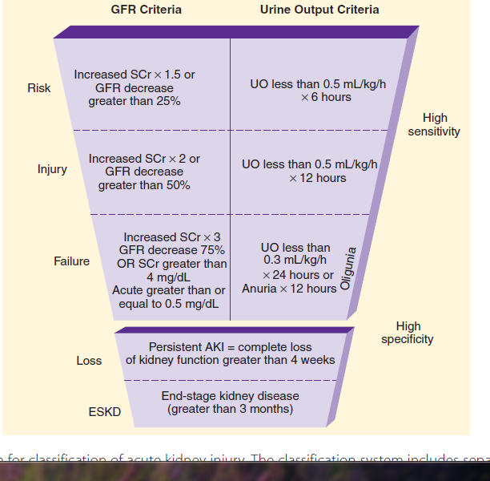

Table 30-1 Causes of Acute Renal Failure
Classification | Common Clinical Disorders
Prerenal Azotemia | Intravascular Volume Depletion = HYPOVOLAEMIA
 | Hemorrhage (surgery, trauma)
 | Dehydration (gastrointestinal losses, aggressive diuretic administration)
 | Severe burns
 | Hypovolemic shock
 | Sequestration (peritonitis, pancreatitis) Cirrhosis with ascite
 | Decreased Effective Circulating Volume = Decrease C O
 | Cardiomyopathy
Hypotension,
Congestive heart failure
 | Shock Syndromes =SYSTEMIC DILATATION
 | Antihypertensive vasodilating medications
 | Septic shock
 | Anaphylaxis
 | Increased Renal Vascular Occlusion or Constriction
 | Bilateral renal artery stenosis
 | Unilateral renal stenosis in solitary kidney
 | Renal artery or vein thrombosis (embolism, atherosclerosis)
 | Vasopressor medications (phenylephrine, norepinephrine)
 | Afferent Arteriole Vasoconstrictors
 | Cyclosporine
 | Nonsteroidal anti-inflammatory drugs
 | Efferent Arteriole Vasodilators
 | Angiotensin-converting enzyme inhibitors
 | Angiotensin II–receptor antagonists
Intrinsic Acute Renal Failure | Glomerular Disorders
 | Glomerulonephritis
 | Systemic lupus erythematosus
 | Malignant hypertension
 | Vasculitic disorders (Wegener's granulomatosis)
 | Acute Tubular Necrosis
 | Prolonged prerenal states
 | Drug induced (contrast media, aminoglycosides, amphotericin B)
 | Acute Interstitial Nephritis
 | Drug induced (quinolones, penicillins, sulfa drugs)
Postrenal Acute Renal Failure | Ureter Obstruction (Bilateral or Unilateral in Solitary Kidney)
 | Malignancy (prostate or cervical cancer)
 | Prostate hypertrophy Anticholinergic drugs (affect bladder outlet muscles)
 | Renal calculi

- The kidneys are pre-disposed to haemodynamic injury owing to hypovolaemia or hypoperfusion.
- This relates to the high blood flow through the kidneys in normal function; the organs represent 5% of total body weight but receive 25% of blood flow.
- Furthermore, the renal microvascular bed is unique;
firstly, the glomerular capillary bed is on the arterial side of the circulation; secondly, the peri-tubular capillaries are down-stream from the glomerular capillary bed.
Finally, renal cells are highly specialised and are, therefore, pre-disposed to ischaemic and inflammatory injury.

Clinical manifestations
- The signs and symptoms of ARF are often non-specific and the diagnosis can be confounded by coexisting clinical conditions.
- The patient may exhibit signs and symptoms of volume depletion or overload, depending upon the precipitating conditions, course of the disease and prior treatment.

ARF with volume depletion
- In those patients with volume depletion, a classic pathophysiological picture is likely to be present, with tachycardia, postural hypotension, reduced skin turgor and cold extremities (see Table 17.4).
- The most common sign in ARF is oliguria, where urine production falls to less than 0.5 mL/kg/h for several hours.
- This is below the volume of urine required to effectively excrete products of metabolism to maintain a physiological steady state.

ARF with volume overload
- In those patients with ARF who have maintained a normal or increased fluid intake as a result of oral or intravenous administration, there may be clinical signs and symptoms of fluid overload
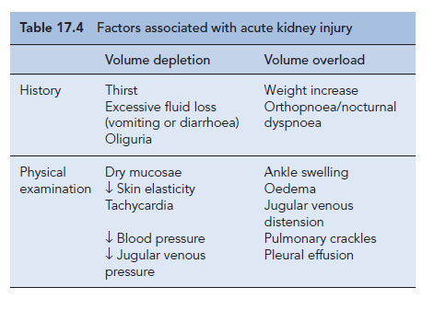
Diagnosis and clinical evaluation
- In hospitalised patients, ARF is usually diagnosed incidentally by the detection of increasing serum creatinine and/or a reduction in urine output.

Monitoring fluid balance in ARF
- Maintaining appropriate fluid balance in ARF is a critical component of the clinical management of the patient.

- Detailed clinical assessment includes:
1. Measurement of BP which needs to be interpreted in respect of the baseline for the
affected patient together with the patient's heart rate.
2. the presence of 3rd (and 4th) heart sounds; the presence of these indicate cardiac
strain associated with fluid overload.
3. Presence of added sounds in the chest, in particular fine inspiratory crackles that are
found in some patients with pulmonary oedema.
4. A chest X-ray for the presence of pulmonary oedema.
5. Pulse oximetry to assess arterial oxygen saturation.
6. Whilst the presence of pitting oedema of the legs or sacrum indicates longer term fluid
overload, it may be a useful marker of overall endothelial function and the potential
for extravascular fluid accumulation.
7. Decreased skin turgor is a sign of fluid loss.
Intravascular monitoring
- Central venous pressure (CVP) assesses circulating volume and, therefore, the degree of fluid deficit, and reduces the risk of pulmonary oedema following over-rapid transfusion.
- CVP should usually be maintained within the normal range of 5–12 cmH2O.
- Most patients with ARF do not require invasive monitoring to the extent described above and recover with supportive care based on careful clinical observations.

Monitoring key parameters in ARF
- Serum electrolytes including potassium, bicarbonate, calcium, phosphate and acid–base balance should be measured on a daily basis.
- In patients with severe ARF, acid–base balance may need assessing every few hours as this may direct fluid replacement, respiratory support and dialysis treatment.

Course and prognosis

Pre-renal ARF
- The majority of cases will recover within days of onset following prompt correction of the underlying causes.
- the kidney function usually stabilizes to the pre-event baseline, in some patients long-term kidney function resets to lower than previous values.

- ATN may be divided into three phases.

Oliguric phase
- where patients have sustained pre-renal ARF
- patient move from early reversibility to a situation where uraemia and hyperkalaemia develop
- the patient may die unless renal replacement therapy (RRT) with dialysis is started.
- The oliguric phase is usually no longer than 7–14 days but may last for 6 weeks.

Diuretic phase is followed,
- which is characterised by a urine output that rises over a few days to several litres per day.
- This phase lasts for up to 7 days and corresponds to the recommencement of tubular function.
- The onset of this phase is associated with an improving prognosis unless the patient sustains an intercurrent infection or a vascular event.

Recovery phase Finally
- where tubular cells regenerate slowly over several months,
- the glomerular filtration rate often does not return to initial levels.
- The elderly recover renal function more slowly and less completely.

ACE inhibitors and ARBs are not directly nephrotoxic and can be used in most patients with kidney disease.

1-profound hypotension can occur if they are initiated in susceptible patients such as those who are receiving high dose diuretics as treatment for fluid overload. This might result in the development of pre-renal ARF.

2-ACE inhibitor use is contraindicated when a patient has bilateral renal artery stenosis, or renal artery stenosis in a patient with a single functioning kidney.

- If an ACE inhibitor or ARB is initiated under these circumstances then pre-renal ARF may ensue.
- This may occur since the renin–angiotensin system is stimulated by low renal perfusion resulting from stenotic lesions in the arteries supplying the kidneys, most often at the origin of the renal artery from the abdominal aorta.
- Angiotensin II is produced which causes renal vasoconstriction, in part, through increased efferent arteriolar tone.
- This creates a ‘back pressure’ which paradoxically maintains glomerular filtration pressure in an otherwise poorly perfused kidney.
- If angiotensin II production is inhibited by an ACE inhibitor, or the effect is blocked by an ARB, then efferent arteriole dilatation will result.
- Since increased efferent vascular tone maintains filtration in such patients, then the overall result of ACE inhibitor or ARB therapy will be to reduce or shut down filtration at the glomerulus and put the patient at risk of pre-renal ARF.

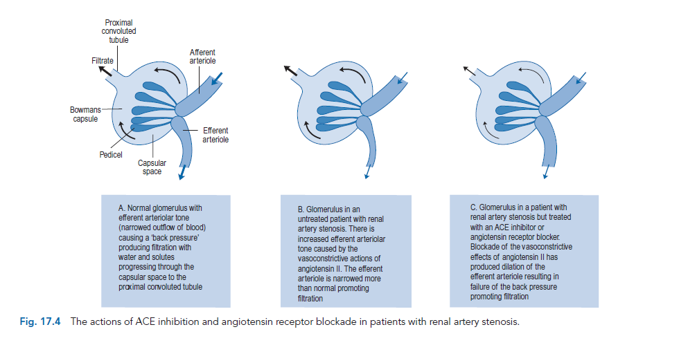
Management
- Early preventive and supportive strategies
- Identification of patients at risk = pre-existing CKD, diabetes, jaundice, myeloma and the elderly

- Withdrawal and avoidance of nephrotoxic agents Irrespective of whether the aetiology of the ARF directly involves nephrotoxic drugs.
- Particular care should be taken with ACE inhibitors, NSAIDs, radiological contrast media, and aminoglycosides. The doses should be adjusted of any drugs that are renally excreted or have active metabolites that are excreted renally.

Optimisation of renal perfusion

- Restoration of renal perfusion would improve renal blood flow, reducing renal vasoconstriction and flushing nephrotoxins from the kidney.

- The use of crystalloids in the form of 0.9% sodium chloride is an appropriate choice of intravenous fluid since it replaces both water and sodium ions in a concentration approximately equal to serum.
- The effect of fluid replacement on urine flow and intravascular pressures should be carefully monitored.
- fluid loading with 1–1.5 L saline at <0.5 L/h is unlikely to cause harm .
- The use of inotropes such as noradrenaline and cardiac doses of dopamine should be restricted to non-renal indications.

Establishing and maintaining an adequate diuresis
- Doses of up to 100 mg/h of furosemide can be given by continuous intravenous infusion. to produce a more effective dieresis with a lower incidence of side effects than seen with bolus administration.
- Higher infusion rates may cause transient deafness.
- The addition of small oral doses of metolazone may also be considered.
- Metolazone is a weak thiazide diuretic alone but produces a synergistic action with loop diuretics.

Mannitol.
- The rationale for using mannitol in ARF arises from the concept that tubular debris may contribute to oliguria.
- mannitol can cause volume overload. Consequently, mannitol is now not recommended for patients with ARF.

Dopamine.
- Dopamine at low dose acts as a renal vasodilator in normal kidneys,
but in renal failure it is a renal vasoconstrictor even at a low dose.
- Dopamine has alpha and beta adrenergic effects.
- Recently, fenoldapam, a pure dopaminergic D1 agonist has a trend towards benefit in recovery of renal function from ARF.

Non-dialysis treatment of Established ARF

Uraemia and intravascular volume overload
- The symptoms of uraemia include nausea, vomiting and anorexia, and result principally from accumulation of toxic products of protein metabolism including urea.
- Unfortunately, severely ill patients are unable to tolerate any kind of diet.
- The use of enteral or parenteral nutrition should be considered at an early stage.
- Restricting NaCl intake to about 1–2 g/day if the patient is not hyponatraemic and total fluid intake to less than 1 L/day plus the volume of urine and/or loss from dialysis.

- Care should be taken with the so-called ‘low salt’ products, as these usually contain KCl, which will exacerbate hyperkalaemia.

Hyperkalaemia
- Acidosis also aggravates hyperkalaemia by provoking potassium leakage from healthy cells.
- The condition may be life-threatening causing cardiac arrhythmias and, if untreated, can result in asystolic cardiac arrest.
- Dietary potassium should be restricted to less than 40 mmol/ day and potassium supplements and potassium-sparing diuretics removed from the treatment schedule.
- Emergency treatment of hyperkalaemia consists of the following:

- 10–30 mL (2.25–6.75 mmol) of calcium gluconate 10% intravenously over 5–10
min; this improves myocardial stability but has no effect on the serum potassium levels.

- 50 mL of 50% glucose together with 8–12 units of soluble insulin over 10 min.
to stimulates intracellular potassium uptake, thus removing it from the serum.

3. Nebulised salbutamol has also been used to lower potassium; however, this is not
effective for all patients and does not permanently lower potassium.

Acidosis
- The inability of the kidney to excrete hydrogen ions may result in a metabolic acidosis.
- This may contribute to hyperkalaemia.
- It may be treated orally with sodium bicarbonate 1–6 g/day in divided doses
or 50–100 mmol of bicarbonate ions
(preferably as isotonic sodium bicarbonate 1.4% or 1.26%, 250–500 mL over 15–60 min) intravenously may be used.

Hypocalcaemia
- Calcium malabsorption, probably secondary to disordered vitamin D metabolism, can occur in ARF.
- Hypocalcaemia usually remains asymptomatic, as tetany of skeletal muscles or convulsions does not normally occur until serum concentrations are as low as 1.6–1.7 mmol/L (normal 2.20–2.55 mmol/L).
- Oral calcium supplementation with calcium carbonate is usually adequate,
- Effervescent calcium tablets should be avoided as they contain a high sodium or potassium load.

Hyperphosphataemia
- Hyperphosphataemia can occur in ARF but rarely requires treatment.
- phosphate-binding agents may be used to retain phosphate ions in the gut.
- The most commonly used agents are calcium containing such as calcium carbonate or calcium acetate and are given with food.

Infection
- Bladder catheters, central catheters and even peripheral intravenous lines should be used with care to reduce the chance of bacterial invasion.
- Antibiotic therapy should be broad spectrum until a causative organism is identified.

Other problems
Uraemic gastro-intestinal erosions
- As a result of reduced mucosal cell turnover owing to high circulating levels of uraemic toxins.
- proton pump inhibitors should be used with caution in hospitals where there are significant rates of Clostridium difficile diarrhoea, as they may pre-dispose to the development of this organism.
- H2 antagonists are an appropriate alternative.

Nutrition
There are two major constraints concerning the nutrition of patients with ARF:
• patients may be anorexic, vomiting and too ill to eat;
• oliguria associated with renal failure limits the volume of enteral or parenteral nutrition that can be given safely.

Renal replacement therapy
- Renal replacement therapy is indicated in a patient with ARF when life is at risk.

- Generally, replacement therapy is urgently indicated in ARF to:
1. remove uraemic toxins when severe symptoms are apparent, for example, impaired
consciousness, seizures, pericarditis, rapidly developing peripheral neuropathy
2. remove fluid resistant to diuretics, for example, pulmonary oedema
3. correct electrolyte and acid–base imbalances, for example, hyperkalaemia >6.5
mmol/L or 5.5–6.5 where there are ECG changes, increasing acidosis (pH < 7.1 or
serum bicarbonate <10 mmol/L) despite bicarbonate therapy, or where bicarbonate is
not tolerated because of fluid overload.

Forms of renal replacement therapy
The common types of renal replacement therapy used in clinical practice are:
• haemodialysis
• haemofiltration
• haemodiafiltration
• peritoneal dialysis

- In all types of renal replacement therapy, blood is presented to a dialysis solution across some form of semi-permeable membrane that allows free movement of low molecular weight compounds.
- The processes by which movement of substances occur are:

• Diffusion. Diffusion depends upon concentration differences between blood and dialysate and molecule size.
• Ultrafiltration. A pressure gradient (either +ve or −ve) across a semi-permeable membrane will produce a net directional movement of fluid from relative high to low pressure regions.
• Convection. الحمل الحراري Any molecule carried by ultrafiltrate may move passively with the flow by convection. Larger molecules are cleared more effectively by convection.

Haemodialysis
- This is placed in a vein (the jugular, femoral or sub- clavian), which has an arterial lumen through which the blood is removed from the patient
and a venous lumen by which it is returned to the patient after passing through a dialyser.

- Heparin is added to the blood as it leaves the body to prevent the dialyser clotting.
- Blood is then actively pumped through the artificial kidney before being returned to the patient
- In those patients at high risk of haemorrhage, the amount of heparin used can be reduced or even avoided altogether.
- Dialysis fluid flows around the membrane countercurrent (opposite) to the flow of blood in order to maximise diffusion gradients.
- The dialysis solution is essentially a mixture of electrolytes in water with a composition approximating to extracellular fluid into which solutes diffuse.
- By manipulating the hydrostatic pressure of the dialysate and blood circuits, the extent and rate of water removal by ultrafiltration can be controlled.

- Haemodialysis can be performed in either intermittent or continuous schedules. The latter regimen is preferable in the critical care situation, providing 24-h control, and minimizing swings in blood volume and electrolyte composition that are found using intermittent regimens.
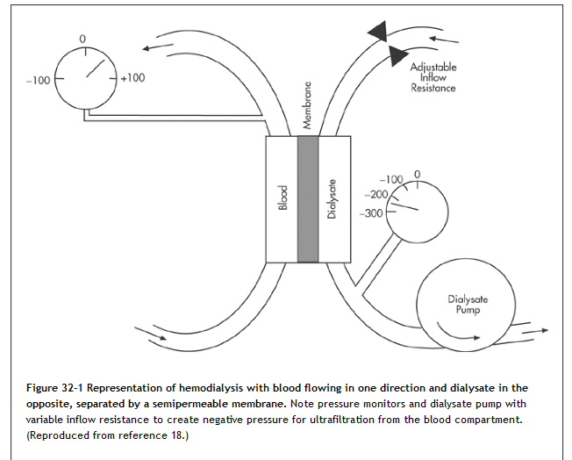
Haemofiltration
- A similar arrangement to haemodialysis is employed but dialysis fluid is not used.
- The hydrostatic pressure of the blood drives a filtrate, similar to interstitial fluid, across a high permeability dialyser (passes substances of molecular weight up to 30,000) by ultrafiltration.
- Solute clearance occurs by convection.
- In continuous arterio-venous haemofiltration (CAVH), blood is diverted, usually from the femoral artery, and returned to the femoral vein; this is now very seldom used.
- In continuous venovenous haemofiltration (CVVH), a dual lumen vascular catheter is inserted into a vein (as described above).
Haemodiafiltration
- Haemodiafiltration is a technique that combines the ability to clear small molecules, as in haemodialysis, with the large molecule clearance of haemofiltration.
- It is, however, more expensive than traditional haemodialysis, but does offer potential benefits.

Acute peritoneal dialysis
- Acute peritoneal dialysis is rarely used now for ARF except in circumstances where haemodialysis is unavailable.
- A semi-rigid catheter is inserted into the abdominal cavity. Warmed sterile peritoneal dialysis fluid (typically 1–2 L) is instilled into the abdomen, left for a period of about 30 min and then drained into a collecting bag
- The process may be repeated up to 20 times a day, depending on the condition of the patient.
- Acute peritoneal dialysis is relatively cheap and simple, does not require specially trained staff or the facilities of a renal unit.
- It is associated with a high incidence of peritonitis and permits protein loss, as albumin crosses the peritoneal membrane.

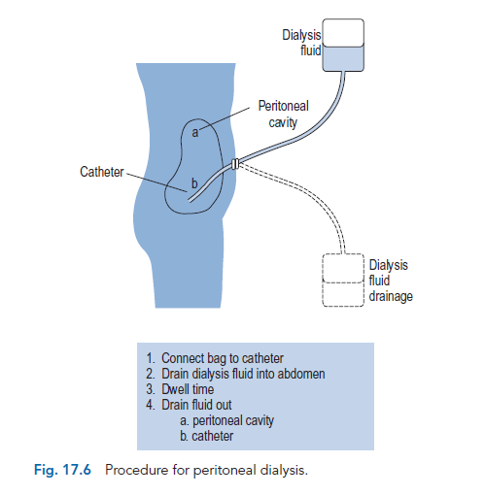
Drug dosage in renal replacement therapyDrug characteristics that favour clearance by the glomerulus are similar to those that favour clearance by dialysis or haemofiltration. These include:
• low molecular weight
• high water solubility
• low protein binding
• small volume of distribution
• low metabolic clearance
Unfortunately, a number of other factors inherent in the dialysis process affect clearance; they include:
• duration of dialysis procedure
• rate of blood flow to dialyser
• surface area and porosity of dialyser
• composition and flow rate of dialysate
For peritoneal dialysis other factors come into play and include:
• rate of peritoneal exchange
• concentration gradient between plasma and dialysate
Reference – Walker 2012

