Chronic Kidney Disease
Definition of CKD =
Structural or functional abnormalities of the kidneys for >3 months from early to late-stage disease,
as manifested by either:
1. Kidney damage, with or without decreased GFR, as defined by
    - pathologic abnormalities
    - markers of kidney damage, including abnormalities in the composition of the blood or urine or abnormalities in imaging tests
2. GFR <60 ml/min/1.73 m², with or without kidney damage
- Estimated glomerular filtration rates (eGFR) range from 90 mL/minute/1.73 m² in the early stages to 15 mL/minute/1.73 m² in the late stages of disease is known as end-stage renal disease (ESRD).
- Complications include fluid and electrolyte abnormalities, anemia, cardiovascular disease, hyperparathyroidism, bone disease, and malnutrition.

- Patients with ESRD require renal replacement therapy in the form of dialysis or transplantation to sustain life.

- The prevalence of chronic kidney disease (CKD) increases with age and is greater in females and some ethnic populations.
- CKD is classified according to severity from 1 to 5, where 5 is the most advanced and 1 the least.

The renin-angiotensin-aldosterone system (RAAS)

- Most of the renal effects of this system are through regulating intraglomerular pressures and salt and water balance.
- First, In patients with CKD, intra-renal pressures are often low and sympathetic overactivity is common; lead to increased renin secretion.
This can occur with normal or elevated systemic blood pressure. this promote production of the mineralocorticoid hormone aldosterone, and promotes antidiuretic hormone (ADH) release,
In combination, these lead to salt and fluid retention, high intravascular volumes, hypertension and oedema.
- Second, a direct vasoconstrictor and promotes systemic and (preferential) renal hypertension on the efferent glomerular arteriole.
Vasoconstriction at this site is mediated by a high density of angiotensin II receptors. When these receptors are ligated by angiotensin II, there is increased intra- glomerular pressures. Whilst this leads to an overall increase in GFR in the short-term, over a longer period glomerular hypertension promotes accelerated glomerular scarring and worsening CKD.
- In addition there is a local immune modulatory role for this system. Both resident (e.g. tubular epithelial) cells and inflammatory (monocytes and macrophages) cells, they express the angiotensin II receptor and activation through this receptor leads to an enhanced inflammatory and fibrotic phenotype of the cell.
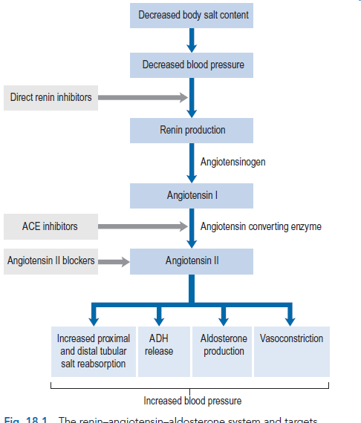
Measurement of renal function
Serum creatinine
- This becomes important in advanced CKD (stages 4 and 5) and limits the value of measuring serum creatinine to determine renal function in advanced CKD
Glomerular filtration rate equation
- Eight eGFR equations were validated for the MDRD(Modification of Diet in Renal Disease Study) equation
eGFR (mL/min/1.73m2) = 186 x [serum creatinine (μmol/L)/88.4]–1.154 x [age]–0.203 x [0.742 if female] x [1.212 if African-American]
Creatinine clearance Measurements
- of creatinine clearance (ClCr) require accurate collection of 24 h urine samples with a serum creatinine sample midway through this period.
- Fig. 18.3 Creatinine clearance calculation

Cockroft–Gault equation
- The Cockroft–Gault equation uses weight, sex and age to estimate creatinine clearance and was derived using average population data
- (Fig. 18.4 The Cockroft–Gault formula.

Estimates of glomerular filtration rate in paediatric patients
- Using the Schwartz formula or the Counahan– Barratt method which both rely upon inclusion of the height of the child in estimating creatinine clearance, since height correlates with muscle mass.
Urea
- Urea is also used in the assessment of renal function despite a variable production rate and diurnal fluctuation in response to the protein content of the diet
- it may also be elevated by dehydration or an increase in protein catabolism such as that accompanying gastro-intestinal haemorrhage, severe infection, trauma (including surgery) and high-dose steroid therapy.
- Serum urea levels are, therefore, an unreliable measure of renal function, but can be used as an indicator of the patient's general condition and state of hydration.

Stages of Chronic Kidney Disease
Table 31-1 Staging of Chronic Kidney Disease Based on eGFR
Stage | Description | eGFR (mL/min/1.73 m²)
 | At increased risk | ≥90 (with CKD risk factors)
1 | Kidney damage with normal or ↑ ↑ eGFR | ≥90
2 | Kidney damage with mild ↓ eGFR | 60–89
3 | Moderate ↓ eGFR | 30–59
4 | Severe ↓ eGFR | 15–29
5 | Kidney failure | <15 (or need for renal replacement therapy)

Significance of CKD
- CKD is of progression to end-stage renal disease, and a strong association with accelerated cardiovascular disease, similar in diabetics.
- Patients with CKD 1–3 are frequently asymptomatic.

- The reduction of GFR is insufficient to cause uraemic symptoms and any minor abnormalities in the urine such as proteinuria or haematuria .

- There is association with high blood pressure which may be the cause or a consequence of renal damage. as it allows early modification of cardiovascular risk factors

- Patients with CKD stages 4 and 5 require specialist management of the complications of CKD such as anaemia and bone disease, whilst many will be undergoing preparation for renal replacement therapy.

Causes of CKD
- Ischaemic nephropathy has traditionally Vascular diseases (renal artery disease, hypertension, microangiopathy) been referred to under perfusion of the kidneys
- Diabetes mellitus (Diabetic Kidney Disease) is the most common metabolic disease that leads to CKD, whilst the predominant lesion is glomerular and referred to as diabetic nephropathy.
- All types of chronic glomerulonephritis (GN) or Glomerular diseases (autoimmune diseases, systemic infections, drugs, neoplasia) cause about 15% of cases of advanced CKD.
- Lower urinary tract disease or Tubulointerstitial diseases (urinary tract infection, stones, obstruction, drug toxicity) they represent 5–10% of all cases of CKD.

- Hereditary/congenital diseases / Cystic diseases (polycystic kidney disease) they represent 5% of CKD cases
- CKD to be unknown and this is the case in around 30% of patients who typically present with small kidneys and unremarkable immunological investigations.

Clinical manifestations
- Uraemic symptoms are rare in CKD stage 4, they become more apparent as the patient approaches end stage renal disease.
- The onset of symptoms is slow and insidious so that patients may not realize that they are unwell.
- End stage renal disease is characterized by the requirement of renal replacement therapy to sustain life and it is often accompanied by uraemia, anaemia, acidosis, osteodystrophy, neuropathy and is frequently accompanied by hypertension, fluid retention and susceptibility to infection

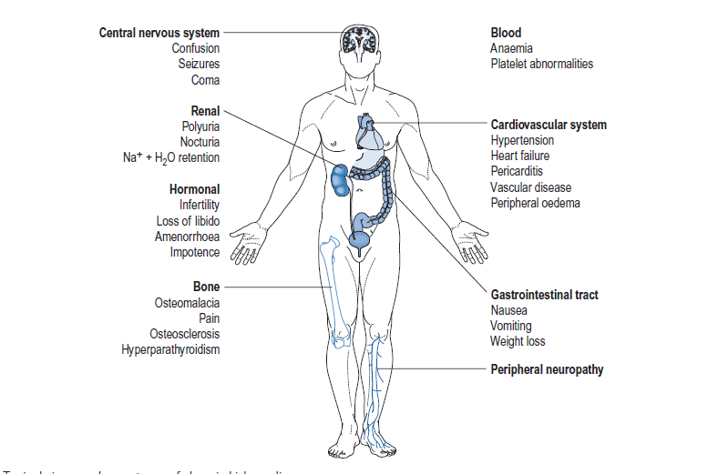

Urinary tract features
- The albumin creatinine ratio (ACR) of 3-30 mg/mmol is described as microalbuminuria while in nephrotic-range proteinuria it is >250 mg/mmol.

- Polyuria, results from medullary damage and the osmotic effect of a high serum urea level (>40 mmol/L).
The ability to concentrate urine is also lost in CKD, which together with failure of physiological nocturnal antidiuresis, invariably results in nocturia, where the patient will be wakened two or three times a night with a full bladder.

- Proteinuria is common in CKD and can be present , proteinuria (>1 g of protein in a 24-h collection, equivalent to an ACR >70 mg/mmol) usually indicates a glomerular aetiology. The presence and quantity of proteinuria are major determinants of progressive CKD.
- Haematuria can be either macroscopic or microscopic; macroscopic haematuria is likely to result from lower urinary tract pathology (such as bladder lesions) and microscopic haematuria is most often of glomerular origin

Hypertension and fluid overload
- Most patients with CKD will have hypertension and this may be a cause or a consequence (or a combination of both) of their kidney disease.

- Furthermore, raised blood pressure may exacerbate renal damage and lead to accelerated deterioration of CKD.

- Severe renal impairment leads to sodium retention, which in turn produces circulatory volume expansion with consequent hypertension. This form of hypertension is often termed ‘salt-sensitive’,

- Lesser degrees of renal impairment reduce kidney perfusion, which activates renin production, with subsequent angiotensin- mediated vasoconstriction.

- Treatment of blood pressure, irrespective of choice of therapy, generally improves the course of CKD. As the GFR falls to very low levels the kidneys are unable to excrete salt and water adequately, resulting in the retention of extravascular fluid.

- Eye damage in the form of hypertensive retinopathy may be found in those patients whose blood pressure has not been adequately controlled.

- Fluid retention can manifest as peripheral and pulmonary oedema and ascites. Oedema may be seen around the eyes on waking, the sacral region in supine patients and from the feet upwards in ambulatory patients.

Uraemia
- Some of the substances responsible for the toxicity of uraemia are intermediate in size between small, readily dialysed molecules and large non-dialysable proteins.
These are described as ‘middle molecules’ and include phosphate, guanidines, phenols and organic acids.
- symptomatic uraemia only occurs in very advanced CKD.

- The symptoms of uraemia include anorexia, nausea, vomiting, constipation, foul taste
- skin discolouration due to pigment deposition compounded by the pallor of anaemia often described as ‘muddy’, and associated with severe pruritus.

- Increased tendency to bleed, which can exacerbate pre-existing anaemia because of impaired platelet adhesion and modified interaction between platelets and blood vessels.

Anaemia
- Anaemia is a common consequence with CKD stages 4 and 5.
- The fall in haemoglobin level is a slow, insidious process. normochromic, normocytic haemoglobin levels falling to around 8 g/dL by end stage renal disease.

- Several factors contribute to the pathogenesis of anaemia in CKD, including shortened red cell survival, marrow suppression by uraemic toxins
and iron or folate deficiency associated with poor dietary intake
or increased loss from gastro-intestinal bleeding.

- However, the principal cause results from inadequate secretion of erythropoietin differentiation in bone marrow

- Hyperparathyroidism also reduces erythropoiesis by damaging bone marrow and therefore exacerbates anaemia associated with CKD.

- The RAAS is also involved in erythropoiesis since renin increases erythropoietin production and this explains how ACE inhibitors can cause small reductions in haemoglobin.

- Anaemia in CKD is a major cause of fatigue, breathlessness at rest and on exertion, lethargy and angina, feeling cold, poor concentration and reduced appetite and libido.

- The anaemia of CKD usually responds to treatment with erythropoietin-stimulating agents (ESAs).

Bone disease (renal osteodystrophy)
Renal osteodystrophy describes the four types of bone disease associated with CKD:

• secondary hyperparathyroidism
• osteomalacia (reduced mineralisation)
• mixed renal osteodystrophy (both hyperparathyroidism and osteomalacia)
• Adynamic bone disease (reduced bone formation and resorption).

- Cholecalciferol, the precursor of active vitamin D, is both absorbed from the gastro-intestinal tract and produced in the skin by the action of sunlight.
- Production of active vitamin D, 1,25-dihydroxycholecalciferol (calcitriol),

- Hydroxylation at the 25 position occurs in the liver, while hydroxylation of the 1-alpha position occurs in the kidney; this latter process is impaired in renal failure.

- The resulting deficiency in vitamin D leads to defective mineralisation of bone and subsequent osteomalacia in those with CKD stage 3 and beyond.

- The resulting secondary hyperparathyroidism produces a disturbance in the normal architecture of bone and this is termed osteosclerosis (hardening of the bone).
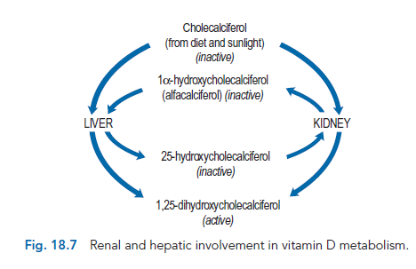

Neurological changes
- The most common neurological changes are non-specific and include inability to concentrate, memory impairment, irritability and stupor probably caused by uraemic toxins.

- Fits owing to cerebral oedema or hypertension may occur.

Muscle function
- Muscle symptoms are probably caused by general nutritional deficiencies and electrolyte disturbances, especially by hypocalcaemia.
- Muscle cramps and restless legs are common and may be major symptoms causing distress to patients, particularly at night.
- Rarely a proximal myopathy of shoulder and pelvic girdle muscles may develop.

Electrolyte disturbances

- Sodium patients may exhibit hypo- or hypernatraemia depending upon the condition and therapy employed.

Potassium
- Hyperkalaemia is a potentially dangerous condition as elevated potassium levels may be life-threatening cardiac arrest.
- Potassium levels of over 7.0 mmol/L are life-threatening and should be treated as an emergency.
- Hyperkalaemia may be exacerbated in acidosis as potassium shifts from within cells. ECG changes accompany any rise in serum potassium and become more pronounced as levels increase.
- the ECG assumes a sinusoidal appearance prior to cardiac arrest.

Hydrogen ions
- In renal failure, H+ is retained, causing acidosis; the combination of H+ with bicarbonate (HCO3–) results in the removal of some hydrogen as water,
- the elimination of carbon dioxide via the lungs, and a reduction in serum bicarbonate level.

Diagnosis, investigations and monitoring
- Dipstick tests enable simple, rapid estimation of a wide range of urinary parameters including pH, specific gravity, leucocytes, nitrites, glucose, blood and protein.
- Structural assessments of the kidney may be performed using a number of imaging procedures, including:
• ultrasonography
• intravenous urography (IVU)
• plain abdominal radiography
• computed tomography (CT), magnetic resonance imaging (MRI) and magnetic resonance angiography (MRA).

Treatment
• Reverse or arrest the process causing the renal damage (this may not be possible)
• Avoid conditions that might worsen renal failure
• Treat the secondary complications of CKD (renal anemia and bone disease)
• Relieve symptoms
• Implement regular dialysis treatment and/or transplantation at the most appropriate time.

Reversal or arrest of primary disease
- A postrenal lesion such as a ureter obstructed by a stone or a ureteric tumour may be successfully treated surgically.
- Glomerulonephritis may respond to immunosuppressants and/or steroids.
- Drug-induced renal disease is suspected the offending agent should be stopped.

These factors predominantly cause acute renal failure but they can cause acute on chronic failure and their reversal may prevent further deterioration.

Hypertension
- Antihypertensive therapy with certain agents might produce a transient reduction in GFR over the first 3 months of treatment as the systemic and glomerular blood pressure drop;
- The drugs used to treat hypertension in renal disease are generally the same as those used in other forms of hypertension,

- ACE inhibitors and ARBs protect the glomerulus ( through decreasing efferent glomerular arteriolar vasoconstriction and therefore intra-glomerular hypertension and hyperfiltration).

- Use of these drugs in patients with diabetic renal disease and proteinuric nondiabetic CKD must be exercised in the following settings:

• The drug should be stopped in Patients who sustain an early decline (in the first 7–10 days after ACE inhibitors/ARBs commencement) in kidney function.

• These agents are overused in Patients with non-proteinuric, non-diabetic CKD.

• Patients with an accelerated decline in kidney function in the months to years after commencement of ACE inhibitors/ARBs.

• Patients with an intercurrent acute illness, particularly those admitted to hospital. Hypotension or infection will put patients at an increased risk of AKI.

Management of symptoms associated with CKD
Gastro-intestinal symptoms
- Nausea and vomiting may persist after starting a low protein diet.
- Metoclopramide is useful to treat this, but sometimes accumulation of the drug and its metabolites may occur, leading to extrapyramidal side effects.

- Prochlorperazine or cyclizine may also be useful.

- The 5-HT3 antagonists such as ondansetron have also been shown to be effective.

- The anaemic patient often becomes less nauseated when treated with an erythropoiesis stimulating agent.

- Constipation is a common problem in patients with renal disease, partly as a result of fluid restriction and anorexia and partly as a consequence of drug therapy with agents such as phosphate binders.

- It is particularly important that patients managed with peritoneal dialysis do not become constipated, as this can reduce the efficacy of dialysis.

- Conventional laxative therapy may be used, such as bulk-forming laxatives or increased dietary fibre for less severe constipation Alternatively, a stimulant such as senna with enemas or glycerine suppositories may be used for severe constipation.

Pruritus
- Itching associated with renal failure can be extremely severe, distressing and difficult to treat.
- The mechanism responsible for the itching is: xerosis (dry skin), skin micro-precipitation of divalent ions, elevated PTH levels and increased dermal mast cell activity.
- Topical versions should not be used owing to the risk of allergy.
- Conventionally, oral antihistamines are used to treat pruritus;
- sedating antihistamines such as chlorphenamine or alimemazine may be useful, particularly at night.

Dietary modifications for uraemic symptoms
- many patients experience a symptomatic improvement when dietary protein intake is reduced through a reduction in the output of nitrogenous waste.
- There is some evidence that, as well as reducing the symptoms of uraemia, protein restriction slows the progression of CKD,

Fluid retention
- Oedema may occur as a result of sodium retention and the resultant associated water retention.
- Patients with CKD may also have hypoalbuminaemia following renal protein loss, and this can result in an osmotic extravasation of fluid and its retention in tissues.
- The daily fluid intake should be restricted to between one and three litres, depending upon the volume of urine produced by the patient (if any).

- Sodium restriction. can be reduced to 80 mmol/day .It is important to be aware of the contribution of sodium-containing medication, including some antibiotics, soluble or effervescent preparations, magnesium trisilicate mixture, Gaviscon, sodium bicarbonate and the plasma expanders hetastarch and gelatin.

- Potassium restriction. Patients are often put on a potassium-restricted diet by avoiding potassium-rich foods such as fruit and fruit drinks, vegetables, chocolate, beer, instant coffee and ice cream.

- Emergency treatment is necessary if the serum potassium level is above 7.0 mmol/L or if there are ECG changes. The most effective treatment is dialysis .

Anaemia
- Traditionally, the only treatment available was to give red blood cell transfusions,
but this is time-consuming, expensive, an infection risk, may lead to fluid and iron overload and promotes antibody formation,

- The introduction of ESAs, initially as recombinant human erythropoietins (Epoetin alfa and beta) have transformed the management of renal anaemia.

- Darbepoetin alfa is a novel erythropoiesis-stimulating protein (NESP) that is a recombinant hyperglycosylated analogue of epoetin which stimulates red blood cell production by the same mechanism as the endogenous hormone.

- Iron and folate deficiencies must be corrected before therapy is initiated, while patients receiving epoetin generally require concurrent iron supplements because of increased marrow requirements. Supplemental iron is often given intravenously owing to bioavailability problems with oral forms.

- An initial subcutaneous or intravenous epoetin dose of 50 units/kg body-weight three times weekly, increased as necessary in steps of 25 units/kg every 4 weeks, should be given to produce a haemoglobin increase of not more than 2 g/dL per month.

- The target haemoglobin concentration is commonly 10.5–12.5 g/dL with most aiming for a target around 11.5 g/dL.

- Once this has been reached, a maintenance dose of epoetin in the region of 33–100 units/kg three times a week or 50–150 units/kg twice weekly should maintain this level.
Acidosis
- Since the kidney is the main route for excreting H+ ions, CKD may result in a metabolic acidosis.
- This will cause a reduction in serum bicarbonate that may be treated readily with oral doses of sodium bicarbonate of 1–6 g/day.

- If acidosis is severe and persistent then dialysis may be required.
Neurological problems
- Neurological changes are generally caused by uraemic toxins and improve on the treatment of uraemia by dialysis or diet.
- Muscle cramps are common and are often treated with quinine sulphate.
- Restless legs may respond to low doses of clonazepam or co-careldopa.

Osteodystrophy
- The osteodystrophy of renal failure is due to three factors: hyperphosphataemia, vitamin D deficiency and hyperparathyroidism.

Hyperphosphataemia
- The management depends initially upon restricting dietary phosphate.

- Phosphate-binding agents = Calcium acetate is widely used as a phosphate binder can be used to reduce the absorption of orally ingested phosphate in the gut.

- Calcium carbonate has been used as a phosphate binder. Unfortunately, it is less effective as a phosphate binder than aluminium, and sometimes requires doses of up to 10 g daily.

- However, a small amount of aluminium may be absorbed by patients with CKD owing to poor clearance of this ion,

- Dialysis dementia was a disease observed among haemodialysis patients associated with aluminium deposition in the brain which can produce toxic effects including encephalopathy, osteomalacia, proximal myopathy and anaemia.

- Desferrioxamine (4–6 g in 500 mL of saline 0.9% per week) has been used to treat this condition by removing aluminium from tissues by chelation.
- Aluminium to cause constipation is an added disadvantage.

Vitamin D deficiency and hyperparathyroidism
- Vitamin D deficiency may be treated with the synthetic vitamin D analogues
1alpha-hydroxycholecalciferol (alfacalcidol) at 0.25–1 mcg/day
1,25-dihydroxycholecalciferol (calcitriol) at 1–2 mcg/day.

- The serum calcium level should be monitored, and the dose of alfacalcidol or calcitriol adjusted accordingly.
- Hyperphosphataemia should be controlled before starting vitamin D therapy since the resulting increase in the serum calcium concentration may result in soft tissue calcification.
- A new agent, paricalcitol, Cinacalcet

Renal transplantation
- The clinical outcomes of renal transplantation are now excellent.
- One-year patient and graft survival is 98% and 90–95%, respectively, and most patients who receive a transplant will never need to return to dialysis treatment.

- One of the major factors is the use of immunosuppressive drugs to control the response the immune system of the recipient mounts against the donor kidney. This is called an alloresponse.

Implementation of regular dialysis treatment
- End stage renal failure is the point at which the patient will die without the institution of renal replacement by dialysis or transplantation.
- Continuous ambulatory peritoneal dialysis (CAPD) involves a flexible non-irritant silicone rubber catheter (Tenckhoff catheter) that is surgically inserted into the abdominal cavity During the dialysis process thereafter, a bag typically containing 2.5 L of warmed dialysate and a drainage bag are connected to the catheter using aseptic techniques.
- Another form is known as automated peritoneal dialysis (APD) in which exchanges are carried out overnight while the patient sleeps. Dialysis fluid is exchanged – three to five times over a 10-h period with volumes of 1.5–3 L each time. During the day time the patient usually has a dwell of fluid within the abdominal cavity

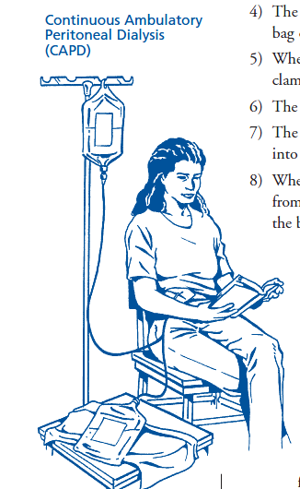
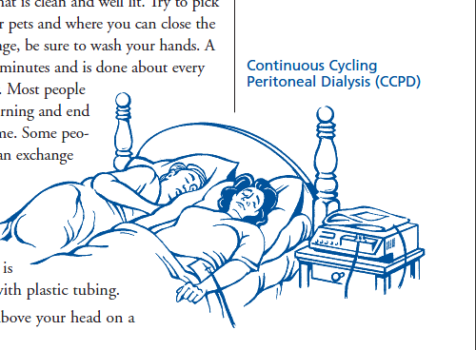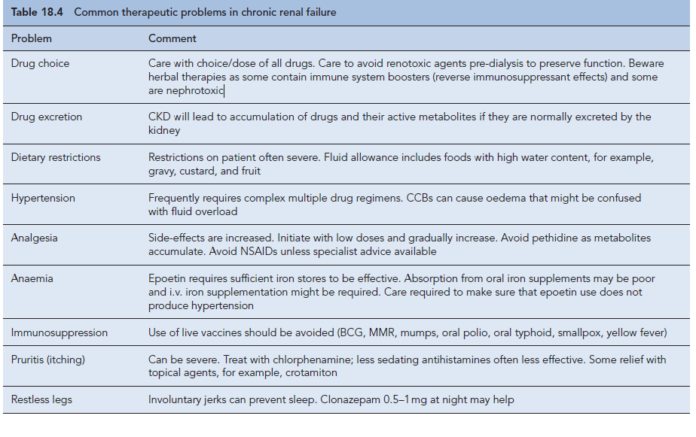

Reference =Walker 2012

