Stroke

Lecture objectives

- Explain the main types of stroke, incidence, prevalence and immediate symptoms
- Outline the therapeutic use of tissue plasminogen activator, aspirin, dipyridamole and clopridogel in management of stroke patients.
- Critically assess the pharmacological and non-pharmacological therapeutic options to treat the longer-term effects of stroke.
- Identify the main risk factors for stroke, and which can be modified.

Definitions
- Stroke
– A "neurological deficit of cerebrovascular cause that persists beyond 24 hours or is interrupted by death within 24 hours“ (WHO). “Brain Attack”

- Transient Ischaemic Attack (TIA)
– stroke symptoms that resolve completely within 24 hours.
– “Acute Ischaemic cerebrovascular syndrome

Epidemiology of Stroke:
- Stroke is the third leading cause of death and the leading cause of long-term disability among adults in the United States.
- Men are more commonly affected by stroke than women except in persons older than 85 years,among whom stroke incidence is highest.
Types of Stroke
Ischemic (85%)

• ischemic (or cerebral infarction) due to an occluded artery following thrombosis or embolism

•Interruption of blood supply (oxygen, nutrients) to neurones
•Neuronal death leads to loss of function

Haemorrhagic (15%)

•Intracranial bleeding, hemorrhagic due to a ruptured artery

•Damage can be caused by compression of tissue from an expanding haematoma, direct toxic effects of blood cells (free iron) and interruption of blood supply to neurons.
- The term hemorrhagic stroke does not include all intracranial hemorrhage.

• Surgical interventions required

- Hemorrhagic stroke cannot be reliably distinguished from ischemic stroke on clinical grounds alone.
- The presence of coma, meningismus, seizures at onset, vomiting, headache, and a diastolic blood pressure greater than 110 mm Hg makes the diagnosis of hemorrhagic stroke more Likely, but hemorrhagic stroke can present without any of these findings.
In the acute setting, head CT without contrast is the initial test of choice to confirm or exclude hemorrhagic stroke; subsequent MRI can identify acute ischemia or a nonvascular cause.
Signs of Stroke

- FAST - the Face -Arm –Speech - Time

- Assessment of three specific symptoms of stroke:
– Facial weakness - can the person smile? Has their mouth or eye drooped?
– Arm weakness - can the person raise both arms?

– Speech problems - can the person speak clearly and understand what you say?
-Time

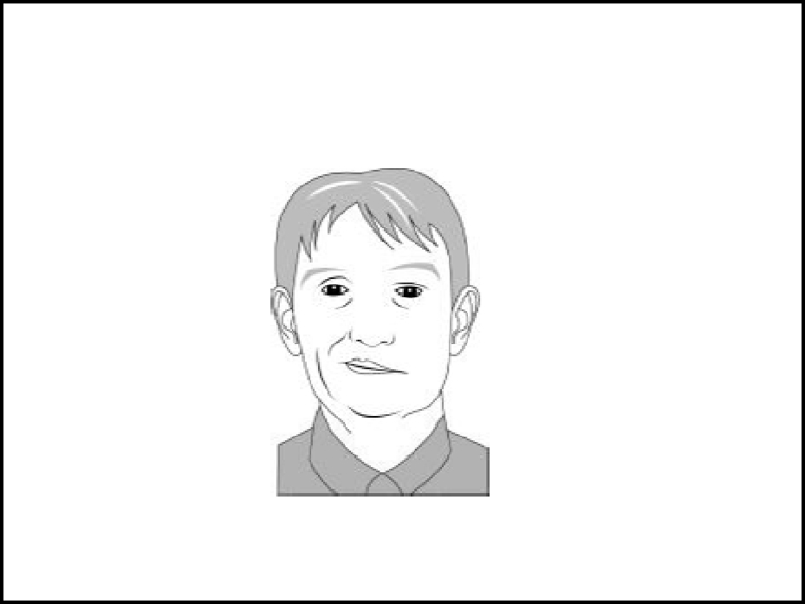

pathophysiology
Immediate consequence of the ischaemic insult at the core:
- Rapid depletion of oxygen leads to a cessation of oxidative phosphorylation, glucose and glycogen stores consumed within only 2-3 mins

- Accumulation of lactate and increases in CO₂ tension produces acidosis – inhibition of active transport mechanisms.

- Loss of calcium homeostasis

- Breakdown of membrane phospholipids and the release of free fatty acids

- Anoxic depolarisation/excessive release of glutamate into extracellular space and glutamate transporter reversal.

- Oedema neuronal swelling resulting from influx of ions and H₂O

- Necrotic cell death in core.

Risk factors

- Age

– The chance of having a stroke approximately doubles for each decade of life after age 55.
- Heredity (family history) and race

- Gender

– More common in men than in women, however more than half of total stroke deaths occur in women.
- Prior stroke, TIA or heart attack

Risk factors ( that can be controlled)

- High blood pressure

- Cigarette smoking

- Diabetes mellitus

- Carotid or other artery disease

- Atrial fibrillation or other heart disease including dilated cardiomyopathy heart valve disease and some types of congenital heart defects.

- Sickle cell disease

- High blood cholesterol

- Poor diet (sodium, saturated fat, cholesterol)

- Physical inactivity and obesity

Hypertension

• Lifestyle changes to promote a healthy cardiovascular system

e.g. Blood Pressure (BP) increase by 5 mm Hg increases stroke risk by 35-40%, decrease BP by 10 mm Hg decreases stroke risk by 40%


Strategies for treatment of stroke
- Enhance survival of patient
- rapid action Treatments aimed to prevent further strokes

- Prevention of further neuronal loss, repair of damaged neurones (damage limitation)

- Help patient restore lost function ?Neurorestoration – replacement of lost neurons
Acute Stroke management: (NICE guidelines)
- Ensure that people who have had a suspected TIA who are at high risk of stroke (ABCD score of 4 or above*) have:
– Aspirin (300 mg) started immediately

– Specialist assessment and investigation within 24 hours of symptom onset
– measures for secondary prevention introduced .

- Admit anyone with a suspected stroke directly to an acute stroke unit following initial assessment,
- Screen swallowing on admission before giving any oral food, fluid or medication

*ABCD scoring scheme is in appendix

ABCD score

- A – age (≥60 years, 1 point)

- B – blood pressure at presentation (≥140/90 mmHg, 1 point)

- C – clinical features (unilateral weakness= 2 points or speech disturbance without weakness= 1 point)

- D – duration of symptoms (≥60 minutes, 2 points or 10–59 minutes, 1 point).
Complications
Some of the long-term deficits arising from stroke= below
Some definitions…

- Ataxia uncoordinated muscle movements (often presenting as difficulty in walking)
- Dysphagia is the inability to swallow

- Dysphasia (also known as aphasia) is difficulty using and understanding spoken and written language.

- Agnosia inability to recognise objects or objects, persons, sounds, shapes, or smells

- Dysarthria is the misfunction of muscles in face resulting in an inability to form words)

- Dysphonia is when a stroke affects the muscles in the voice box, changing the way the voice sounds and making it hard to moderate the voice.
- Dyspraxia (or apraxia) is difficulty with complicated tasks, which means that the person may find it hard to speak or understand conversation
Pharmacological management of stroke

I) General treatment interventions
- Fluid and electrolyte control

- Excessive hydration or inadequate sodium suppl. May result in hyponatremia ---- forcing fluid into neurons ---- increase the damage from ischemia
- Hyponatremia ----- seizures ----- increase the metabolic demand on
compromised neurons

Therefore, initiate fluid therapy with a solution at least 0.45% saline
- Hyperglycemia control with insulin therapy to keep glucose cone. < 155 mg/ dL, since hyperglycemia may adversely affect ischemic infarction outcome
- Maintain mild hypertension for 1-2 days after stroke onset (bee. Hypotension may dec. cerebral blood flow --- expand ischemia)

- Assess the patient in general daily needs (nutrition, urination, defecation) bee of compromised ability due to neurological deficiency
11) Heparin/ LMWH

Used in progressive embolic stroke only to avoid conversion to hemorrhagic stroke

III) Thrombolytics

- In acute ischemic stroke to restore the blood flow more rapidly to neurons and prevent damage (within 2-3 hrs)

- If occlusion persists for 3-7 hours ----- permanent neurological damage

- Treatment with tP A should be initiated as soon as possible after the onset of stroke symptoms, preferably within 90 minutes

- Rapid diagnosis by C'T scan of ischemic stroke and immediate administration of tPA increases its efficacy and may limit the potential for hemorrhagic conversion of ischemic stroke

- The dose of tPA should not exceed 0.85 mg/ kg administered over 60 minutes, since higher doses increase the risk of intracranial hemorrhage

Thrombolytic agents

Tissue Plasminogen Activator (tPA)

    - Alteplase (Bayer)

    - Administered within 3 hours of stroke onset improves clinical outcome (death, disability) at 3 months
    - Usually administered in specialist neurology clinic (sometimes in A&E)
    - 90 μg/kg (max 90 mg): 10% initially by i.v. injection, remainder by i.v.

infusion over 60 mins.

    - Not appropriate for haemorrhagic stroke, increased risk of intracranial bleeding
- tPA is a serine protease enzyme which acts as a “clotbuster”

Less than 2% of stroke patients receive tPA!

Anti-platelet drugs

– Decrease platelet aggregation, inhibit thrombus formation
– Help prevent further strokes, do not restore the damage caused by initial ischaemic event.

Aspirin

– Cyclooxygenase inhibitor, reduces thromboxane2 synthesis in platelets

– Reduces likelihood of platelet aggregation

– Single dose (150 – 300 mg) given soon after ischaemic event, followed by 75 mg/d to prevent further cardiovascular events.
– aspirin decreases the risk of stroke by about 15%: this effect is uniform across aspirin doses from 50 to 1500 mg/d.
– Problems with aspirin???? – Further info:

Aspirin plus dipyridamole (NICE guidelines)

– Phosphodiesterase inhibitor, increases [cAMP] and acts as a vasodilator, also an Adenosine uptake inhibitor, increases extracellular [Adenosine], blocks platelet activation via activation of adenosine receptors

– Modified Release (MR) dipyridamole (persantin Retard) in combination with aspirin should be used as part of the prevention of stoke or heart attack in people who have had a stroke for a period of two years from the most recent event.

– After 2 years, or if the patient can’t tolerate MR dipyridamole, treatment should revert to standard care (including long-term treatment with low-dose aspirin).

– Dipyridamole absorption is pH-dependent and concomitant treatment with gastric acid suppressors (such as a proton pump inhibitor) will reduce drug availability
– http://www.nice.org.uk/nicemedia/pdf/TA090guidance.pdf

Clopidogrel

– Plavix (Bristol-Myers Squibb) and Iscover (Sanofi-Aventis) Clopilet (Sun Pharmaceuticals)
– Irreversible blockade of the adenosine diphosphate (ADP) P2Y12 receptor on platelet cell membranes to reduce platelet activation – UK NICE guidelines suggest Clopidogrel should be used on its own (within its license) for people who can’t take low-dose aspirin and

have either experienced a stroke or heart attack or have symptomatic peripheral arterial disease.

– Contraindications:

    - Severe neutropenia (Incidence: 1/2,000)

    - Thrombotic thrombocytopenic purpura (TTP) (Incidence: 4/1,000,000 patients treated)

    - Haemorrhage

– The incidence of haemorrhage may be increased by the co-administration of aspirin. Gastrointestinal Haemorrhage (Incidence: 2.0%) , Cerebral Haemorrhage (Incidence: 0.1 to 0.4%)

Treatment of depression following stroke

• Post stroke depression can be treated with conventional antidepressant medication

• No particular advantage of one class over another

• Prophylactic treatment with fluoxetine during the first 6 months post-stroke is associated with significant increase in survival in both depressed and non-depressed patients (68% on antidepressant vs. 36% on placebo) (Jorge et al 2003).

• Antidepressants can have side-effects such as falls, increased bleeding, seizures, and sedation.
Rehabilitation

- Restoration of function, relearning skills and abilities

- Physiotherapy (e.g. learning to walk)

- Speech and language therapy (e.g. learning to talk)
- Occupational therapy (e.g. shopping)
- Psychologist/Psychiatrist (adapting psychologically)

- Learning new skills

- Adapting to some of the limitations caused by a stroke

e.g. smaller meals to avoid choking, physical changes to home, wearing incontinence pads, communicating in different ways, mobility aids.

Support network

patience, positive, carers strike a balance between taking over and full independence

Complications

Physical | Communicative | Cognitive |  | Emotional
Motor deficits, | Language | Agnosia |  | Depression
Paralysis | difficulties |  | Anxiety disorder
abnormal muscle |  | Impairment of
tone | Dysarthria | memory
Ataxia |  | (Dementia) |  | Apathy
Coordination | Dysphasia | Confusion |  | Catastrophic
Dysphagia | Dysphonia | Impairments of |  | reaction
 |  |  |  | Pathologic affect
Visual/hearing loss | Dyspraxia | attention
 |  | perception |  | Psychosis, Mania
Sensory deficits |  | problem-
 |  | solving |  | Bipolar disorder
 |  | insight |  | are rare

