Breast Cancer

- Breast cancer begins in breast tissue in lobules (gland for milk production), and the ducts that connect the lobules to the nipple.
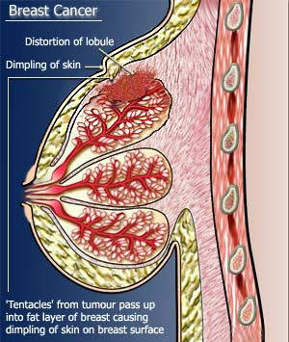
Types of breast tumor
- The most common type of benign breast tumour is called a fibroadenoma.
- This may need to be surgically removed to confirm the diagnosis. No other treatment is necessary.
- Malignant tumor (which can metastasis if untreated)

Etiology and Risk factor
The causes of breast cancer are unknown.
Risk factors can increase a woman’s chances of getting breast cancer:-
1-Age: It's rare in women under 35. (80%) of cases occur in women aged 50 or over.
2- lack of childbearing or breastfeeding
3-Hormonal factors: Exposure to the hormone esoestrogen and progesterone for long, uninterrupted periods can affect your breast cancer risk
4- Genetic factors (family history)
5- Lifestyle factors alcohol, smoke, obesity

Symptoms:-
•A lump in the breast
• A change in the size or shape of the breast
• dimpling of the skin or thickening in the breast tissue
• A nipple that’s turned in (inverted)
• Rash (like eczema) on the nipple
• Discharge from the nipple
• Swelling or a lump in the armpit.

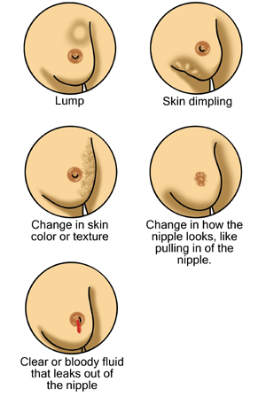

Diagnosis:-
- A mammogram: Mammograms are usually only done in women over 40.
Ultrasound: ultrasound is more useful than a mammogram in women under 40.
- Fine needle aspiration (FNA):
- Biopsy:
- CT (computerised tomography) scan:
- Blood tests: Occasionally, a blood test may be used to check whether the breast cancer cells are producing certain chemicals (tumour markers). But this isn’t usually done.

Stages of breast cancer
- Stage I ; tumor is less than 1 cm across, and has not spread into the surrounding areas.
- Stage II; anywhere from 1-2 cm across, and has spread into the surrounding areas including the lymph nodes
- Stage III (inflammatory breast cancer); Its more than 2 cm across and has spread to the lymph nodes.
A type of cancer most associated with this is called inflammatory breast cancer, because the breast is inflamed because the cancer is blocking the lymph nodes.
- Stage IV; The cancer has spread to other parts of the body such as the bones, liver or lungs. This is called secondary or metastatic breast cancer.

Types of breast cancer
- DCIS - ductal carcinoma in situ (non invasive)

It means that cells inside some of the ducts of breast have started to turn into cancer cells. There is very little chance that any of the cells have spread to the lymph nodes or elsewhere in the body.

Invasive ductal breast cancer

It is also called ductal carcinoma. A ductal carcinoma of the breast is a cancer that started in the cells that line the ducts of the breasts and has begun to spread into the surrounding breast tissue.
- Invasive lobular breast cancer

This means that the cancer started in the cells that line the lobules of the breast and has spread into the surrounding breast tissue.
It is most common in women between 45 and 55 years old.
If you have invasive lobular breast cancer diagnosed in one breast, there is a slightly higher risk of getting it in the other breast in the future.

- Inflammatory breast cancer
This is a rare type of breast cancer. It is called inflammatory because the breast tissue becomes inflamed. The cancer cells block the smallest lymph channels in the breast.

Symptoms of inflammatory breast cancer
Because the lymph channels are blocked, the breast may become
- Swollen
- Red
- Firm or hard
- Hot to the touch
The breast can also be painful in inflammatory breast cancer, but this is not always the case.
Treatment
- The first type of treatment for breast cancer is usually surgery.
- The type of surgery depends on the type of breast cancer you have.
- Surgery is usually followed by chemotherapy or radiotherapy or, in some cases, hormone or biological treatments.
The main treatments for breast cancer are:
- surgery
- radiotherapy
- chemotherapy
- hormone therapy
The type of treatment or the combination of treatments will depend on how the cancer was diagnosed and the stage it is at.
1-surgery
- Removing the breast cancer (lumpectomy): Lumpectomy is typically reserved for smaller tumors that are easily separated from the surrounding tissue.
- Removing the entire breast (mastectomy):Mastectomy is surgery to remove all of your breast tissue.
- Removing one lymph node (sentinel node biopsy):
- Removing several lymph nodes (Axillary lymph node dissection):
Removal of additional affected lymph nodes does not improve survival in cases of early breast cancer following a lumpectomy,
2- Radiation therapy
- External beam radiation is commonly used after lumpectomy for early-stage breast cancer.
- Doctors may also recommend radiation therapy after mastectomy for larger breast cancers.
Side effects: fatigue and sunburn-like rash.
3- Chemotherapy
- Either adjuvant (after surgery or radiation) systemic chemotherapy
- Neoadjuvant (before surgery) systemic chemotherapy.
Side effects: include hair loss, nausea, vomiting, fatigue and a small increased risk of developing infection.
4- Hormone therapy
- It is often used to treat breast cancers that are sensitive to hormones.
- Hormone therapy can be used after surgery or other treatments to decrease relapse.
- If the cancer has already spread, hormone therapy may shrink and control it.

Treatments that can be used in hormone therapy include:
- Tamoxifen
Is the most commonly used selective estrogen receptor modulator (SERM).
SERMs act by blocking estrogen from attaching to the estrogen receptor on the cancer cells, slowing the growth of tumors and killing tumor cells. Tamoxifen can be used in both pre- and postmenopausal women .
Possible side effects include fatigue, hot flashes, night sweats and vaginal dryness.
More significant risks include cataracts, blood clots, stroke and uterine cancer.
- Aromatase inhibitors
Medications that stop the body from making estrogen after menopause.
One group of drugs called aromatase inhibitors blocks the action of an enzyme that converts androgens in the body into estrogen. These drugs are effective only in postmenopausal women.
Aromatase inhibitors include anastrozole (Arimidex), letrozole (Femara) and exemestane (Aromasin).
Side effects of aromatase inhibitors include joint and muscle pain, as well as an increased risk of bone thinning (osteoporosis).
Fulvestrant (Faslodex), another drug, directly blocks estrogen (anti estrogen).
fulvestrant is generally used in postmenopausal women for whom other hormone-blocking therapy is not effective or who can't take tamoxifen Fulvestrant is given by injection once a month.

- Surgery [prophylactic oophorectomy ]
or medications to stop hormone production in the ovaries.
And may be called surgical menopause In premenopausal women

Prevention
Women may reduce their risk of breast cancer by maintaining a healthy weight, drinking less alcohol, being physically active and breastfeeding their children.

The benefits with moderate exercise such as brisk walking are seen at all age groups including postmenopausal women.

Tamoxifen and Raloxifene are able to reduce the risk of breast cancer but increase the risk of thromboembolism.

