Colorectal Cancer

Colorectal cancer is caused by the abnormal growth of epithelial cells which form the lining of the colon or rectum. These small growths (known as polyps) are often benign, although some have the potential to develop and become cancerous

Epidemiology
- Colorectal cancer is the third leading cause of cancer deaths in the U.S. adult population.
- Approximately 70% of these cancers will arise in the colon, whereas 30% will occur in the rectum.

Risk Factors
General
- Age is the primary risk factor --Age appears to be the biggest risk factor for the development of colorectal cancer with 70% of cases diagnosed in adults older than 65 years of age.
Dietary
- High-fat, low-fiber diets
- The risk of colorectal cancer appears to be inversely related to calcium and folate intake.
- Higher intake of calcium and vitamin D has been associated with a reduced risk of colorectal cancer in epidemiologic studies and polyp recurrence in polyp-prevention trials.
- Regular (at least two doses per week) nonsteroidal anti-inflammatory drug (NSAID) and aspirin use is associated with a reduced risk of colorectal cancer.
Lifestyle
- Alcohol, Smoking
- Obesity or physical inactivity
Comorbid Conditions
- Inflammatory bowel disease (ulcerative colitis and Crohn’s disease)
Hereditary or Genetic
- Familial adenomatous polyposis (FAP)
- Hereditary nonpolyposis colorectal cancer (HNPCC)
- Family history

Symptoms and diagnosis
- Early diagnosis of colorectal cancer has thepotential to improve survival rates; howeverearly symptoms (such as abdominal pain)may be confused with other diseases, meaning many patients have advanced disease when diagnosed.

Symptoms: Changes in bowel habits, anorexia, nausea and vomiting,weakness (if anemia is severe).
Signs:Blood in stool, weight loss, abdominal pain.

Almost 85% ofpatients referred to hospital have one or more of the following high-risk symptoms:
• Rectal bleeding
• A mass in the abdomen or rectum
• Change in bowel habit
• Perianal symptoms, such as abscesses or lesions

As the cancer becomes more advanced,other symptoms can develop. For example,excessive bleeding from the colon cancause anaemia, which leaves the patientfeeling breathless and tired.
If the cancerbegins to obstruct the colon, furthersymptoms include bloating, constipation and vomiting.

Methods of diagnosis vary from country to country but typically if a patient presents high-risk symptoms to their doctor they will be given a physical examination. If this raises any concerns, a number of additional tests may be performed:
• Colonoscopy – the entire length of thecolon is viewed using a colonoscope.
• Sigmoidoscopy – a small tube(sigmoidoscope) is used to view thelower colon.
• Double contrast barium enema – x-raysof the colon and rectum. Barium lines the colon allowing an outline to be viewed in an x-ray.

- A biopsy, where sample tissue is removedduring a colonoscopy or sigmoidoscopy,is required to confirm the diagnosis ofcolorectal cancer and determine how advanced the disease is.
- Fecal Occult Blood Testing (FOBT)

Staging and prognosis
- When colorectal cancer is diagnosed in the early stages, it is curable with surgical intervention and >90% of patients survive 5 years.
- The Tumor Node Metastasis (TNM) staging system is most commonly used for colon cancer.
Stage I indicates penetration into (but not through) the bowel wall.
Stage II generally indicates penetration through the bowel wall;
stage III indicates lymph node involvement; and
stage IV indicates metastatic disease.

- Optimal node sampling at the time of surgery is critical to staging and should include the evaluation of 12 to 17 lymph nodes.
- Patients with early-stage colorectal cancer often are asymptomatic; therefore, intensive screening programs as just described are advocated to reduce the mortality of this disease.
- Of patients with metastatic and recurrent colorectal cancer, 60% to 90% have elevated CEA (CarcinoEmberyonic Antigen) or CA-19–9 levels.
- Levels are elevated in relation to the stage and extent of disease, the degree of tumor differentiation, and the site of metastases.
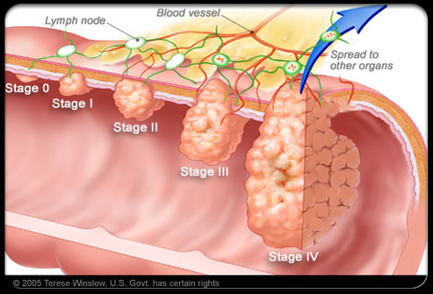

prognosis
- The overall 5-year survival rate for colorectal cancer patients is 65%, although this differs greatly depending on how advanced the cancer is.
- CEA levels every 3 months for the first 3 years, then every 6 months for the next 2 years, and then annually.⁴³
- Colonoscopy is repeated annually for several years and then every 3 to 5 years.
- More than 50% of patients who have recurrent disease also have elevated CEA levels.

Treatment
- The stage of colorectal cancer upon diagnosis is the most important prognostic factor for survival and disease recurrence.
- Stages I, II, and III disease are considered potentially curable and are aggressively treated in an attempt to cure these patients.
- Patients who develop stage IV disease are treated to reduce symptoms, avoid disease-related complications, and prolong survival.

Non pharmacologic Therapy
Operable Disease (Stages I–III)
- Surgery Individuals with stage I to III colorectal cancer should undergo a complete surgical resection of the tumor mass with removal of regional lymph nodes as a curative approach for their disease
- Radiation Therapy -Adjuvant radiation plus chemotherapy is considered standard treatment for patients with stage II or III rectal cancer after the surgical procedure is complete.

Metastatic Disease (Stage IV)
- Surgery-Select patients who have from one to three small nodules isolated to the liver, lungs, or abdomen may have a prolongation of survival, although cure is rare.
- Radiation -Symptom reduction is the primary goal of radiation for patients with advanced or metastatic colorectal cancer.

Pharmacologic Therapy
- Tumor recurrence is a significant problem associated with stage III colon and rectal cancers, with up to 60% of all surgically treated patients.
- Causes of these relapses may include peritoneal seeding caused by exfoliation of tumor cells in the colonic lumen and spillage during surgery.

Chemotherapy
- Currently, agents used in combination chemotherapy for the adjuvant treatment of colorectal cancer, improves disease-free survival (DFS).
- 5-Flurouracil-based chemotherapy is the standard regimen used in adjuvant treatment of colon cancer
- Triple-drug therapy (5-FU, leucovorin, and oxaliplatin ) (FOLFOX)–based chemotherapy is the standard regimen used in adjuvant colon cancer. It is usually given for 6 months).
- (FOLFIRI) based chemotherapy is of (5-FU, leucovorin, and irinotecan).

Biological therapies
- Adjuvant chemotherapy is standard therapy for patients with stage III colon cancer
- Ongoing trials are evaluating the role of the monoclonal antibodies Bevacizumab (targeting VEGF) and Cetuximab (targeting EGFR) in combination with FOLFOX in the adjuvant setting.

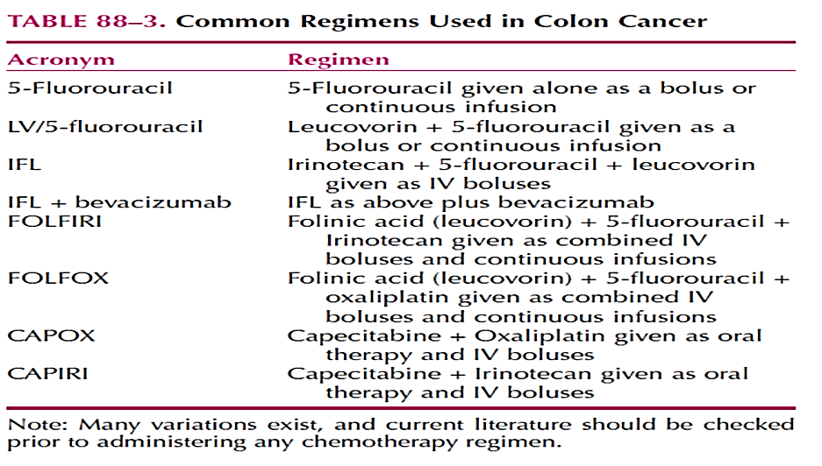
Some patients with advanced colorectal cancer who are not initially able to undergo surgery due to invasive tumours can be treated with chemotherapy before being considered for surgery (called neo adjuvant treatment).

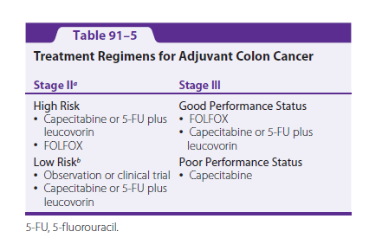

Chemotherapy for Metastatic Disease stage IV
- Metastasis to the liver via hematogenous spread (through the portal circulation) is the most common site of disease spread beyond the regional lymph nodes and occurs in 50% of patients with invasive disease.
- Traditional chemotherapy and targeted biological therapies are the mainstay of treatment for metastatic colon or rectal cancer and have improved the median survival time of these patients to more than 20 months
- (The most important factor in patient survival is not the initial regimen but whether or not patients receive all three active chemotherapy drugs (5-FU, irinotecan, and oxaliplatin) at some point in their treatment course.)

- Before using these agents, testing for KRAS mutation status should occur. Extensive literature exists documenting evidence demonstrating failure of EGFR inhibitors in patients whose tumors have a mutation in codon 12 or codon 13 of the KRAS gene.

