HEPATOBILIARU DISORDERS
Dr. NADIA HAMEED
Bilirubin Elimination
Bilirubin is the substance that gives bile its color. It is formed during the breakdown of red blood cells. In the process of degradation, the heme portion of the hemoglobin molecule is oxidized to form biliverdin, which is then converted bilirubin. Bilirubin, which is insoluble in plasma, is transported in the blood attached to plasma albumin and called (indirect, unconjugated) bilirubin. As it passes through the liver, this bilirubin is released from the albumin carrier molecule and moved into the hepatocytes. Inside the hepatocytes, uncongucated bilirubin is converted to conjugated bilirubin (, making it soluble in bile. Conjugated bilirubin is secreted as a constituent of bile, and in this form it passes through the bile ducts into the small intestine. In the intestine, approximately one half of the bilirubin is converted into a highly soluble substance called urobilinogen by the intestinal flora. Urobilinogen is either absorbed into the portal circulation or excreted in the feces. Most of the urobilinogen that is absorbed is returned to the liver to be re-excreted into the bile. A small amount of urobilinogen, approximately 5%, is absorbed into the general circulation and then excreted by the kidneys. Usually, only a small amount of bilirubin (0.1 to 1.2 mg/dL) is found in the blood. Laboratory measurements of bilirubin usually measure the free uncongucated and the conjugated bilirubin as well as the total bilirubin.
Jaundice. Jaundice (i.e., icterus), which results from an abnormally high accumulation of bilirubin in the blood leading to yellowish discoloration to the skin, sclera and deep tissues.
The hyperbilirubinemia may result from excessive destruction of red blood cells, impaired uptake of bilirubin by the liver cells, decreased conjugation of bilirubin, and obstruction of bile flow in the canaliculi of the hepatic lobules or in the intrahepatic or extrahepatic bile ducts. From an anatomic standpoint, jaundice can be categorized as prehepatic, intrahepatic, and posthepatic.
Causes of Jaundice
I//Prehepatic (Excessive Red Blood Cell Destruction)
- Hemolytic blood transfusion reaction
- Hereditary disorders of the red blood cell
- Sickle cell anemia
- Thalassemia
- Spherocytosis
- Acquired hemolytic disorders
- Hemolytic disease of the newborn
- Autoimmune hemolytic anemias
II// Intrahepatic
- Decreased bilirubin uptake by the liver
- Decreased conjugation of bilirubin
- Hepatocellular liver damage
- Hepatitis
- Cirrhosis
- Cancer of the liver
- Drug-induced cholestasis
III// Posthepatic (Obstruction of Bile Flow)
- Structural disorders of the bile duct
- Congenital atresia of the extrahepatic bile ducts
- Bile duct obstruction caused by tumors or stone (cholelithiasis).

Note: when the TSB lab test increased, conjugated and unconjugated bilirubin done:
If the unconjugated bilirubin increased so the cause is prehepatic and hepatic.
If the conjugated bilirubin is increased, so the cause is hepatic (after conjugation) and post hepatic (obstructive jaundice).

Liver Cirrhosis
Cirrhosis is a general term for a condition that destroys the normal architecture of the liver lobules.
It has the following important structural features:-
a. Destruction of liver parenchyma
b. Separation of the lobules by fibrous tissues
c. Formation of structurally abnormal nodules, and
d. Abnormal vascular architecture
classifications of cirrhosis
Cirrhosis is classified according to its causative agents and resultant pathologic configurations as :-
a. Biliary cirrhosis
b. post necrotic cirrhosis
c. Alcoholic cirrhosis
a) Biliary cirrhosis
- It is due to cholestasis which may be primary (idiopathic) or secondary to other conditions like bile duct obstruction or autoimmune diseases of the liver (autoimmune biliary cirrhosis)
- The obstruction in one area of biliary passage results in bile stasis; that causes injury and scarring around the hepatocytes with evidence of fibrosis.

b) Post necrotic cirrhosis
- It follows massive liver necrosis and involves the destruction of lobules and even lobes of the liver.
- It may occur after viral hepatitis, autoimmune hepatitis or after exposure to hepatotoxins such as certain drugs.

c) Alcoholic cirrhosis
- The most common cause of cirrhosis is excessive alcohol consumption
- At least 75% of alcohol related deaths are attributed to cirrhosis.

Stages in developments of alcoholic cirrhosis
1. Stage of fatty change
- Excessive accumulation of fat within liver cells causes liver enlargement
- Alcohols replace fat as a fuel for liver metabolism and impair mitochondrial ability to oxidize fat.
- Don’t usually produce symptoms
- It is reversible once the alcohol intake has been discontinued.
2. Stage of Alcoholic Hepatitis
- It is an intermediate stage between fatty changes and cirrhosis
- It is characterized by inflammation and necrosis of liver cells, thus is always serious and sometimes fatal.
- The necrotic lesions are generally patchy but may involve entire lobe.
- The stage is characterized by hepatic tenderness, paler, anorexia, nausea, jaundice, ascites and liver failure. Some patients may be asymptomatic.
3. Stage of cirrhosis
Cirrhosis is the end result of liver injury caused by fatty liver and alcoholic hepatitis. The normal liver structure is replaced by bans of fibrous tissue with areas of regenerating cells. As the disease progress liver shrinks.

Clinical Manifestations of cirrhosis
-The Manifestations of cirrhosis are variable, ranging from asymptomatic Hepatomegally to hepatic failure.
Early manifestations:
- Right upper quadrant pain
- Sensation of fullness
Late manifestation:-
- The late manifestations are related to portal hypertension and liver cell failure ( Hepatocellular failure )
● Portal Hypertension:-
The fibrotic bands cause narrowing of the portal vein to cause portal hypertension. It s followed by back ward congestion of all tributaries of portal veins.
●Hepatocellular failure results in:-
Decreased production of bile. jundice
Decreased plasma protein (Hypoalbuminemia) edema and ascitis
Decreased blood clotting factors. bleeding
Accumulation of metabolic bi-products and toxins like bilirubin, ammonia and other substances in the circulation since the liver loses its detoxification capacity. This is one of the reasons for hepatic coma to occur.

Liver Failure
The most severe clinical consequence of liver disease is hepatic failure. It may result from sudden and massive hepatic destruction as in fulminant hepatitis, or it may be the result of progressive damage to the liver, such as occurs in alcoholic cirrhosis.
Whatever the cause, 80% to 90% of hepatic functional capacity must be lost before hepatic failure occurs.
The manifestations of liver failure reflect the various synthesis, storage, metabolic, and excretory functions of the liver. Fetor hepaticus refers to a characteristic musty, sweetish odor of the breath in the patient with advanced liver failure.
Hematologic Disorders. Liver failure can cause anemia, thrombocytopenia, coagulation defects, and leukopenia. Anemia may be caused by blood loss, excessive red blood cell destruction, and impaired formation of red blood cells.
Endocrine Disorders. The liver metabolizes the steroid hormones. In liver failure Women may have menstrual irregularities (usually amenorrhea), loss of libido, and sterility. In men, testosterone levels usually fall, the testes atrophy, and loss of libido, impotence and gynecomastia occur. A decrease in aldosterone metabolism may contribute to salt and water retention by the kidney, along with a lowering of serum potassium resulting from increased elimination of potassium.
Skin Disorders. Telangiectasia, and spider nevi, are seen most often in the upper half of the body. Palmar erythema is redness of the palms, probably caused by increased blood flow from higher cardiac output. Clubbing of the fingers may be seen in persons with cirrhosis. Jaundice usually is a late manifestation of liver failure.
Hepatorenal Syndrome. The hepatorenal syndrome refers to a functional state of renal failure sometimes seen during the terminal stages of liver failure with ascites. It is characterized by progressive azotemia, increased serum creatinine levels, and oliguria hepatic encephalopathy and coma.
Hepatic Encephalopathy: central nervous system manifestations of liver failure. It is characterized by a lack of mental alertness to confusion, coma, and convulsions.
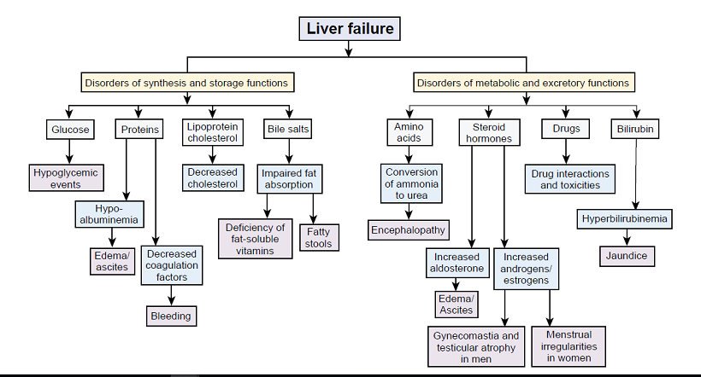

DISORDERS OF THE GALLBLADDER AND EXTRAHEPATIC BILE DUCTS
Cholelithiasis and Cholecystitis
Two common disorders of the gallbladder system are cholelithiasis (i.e., gallstones) and inflammation of the gallbladder (cholecystitis) or common bile duct (cholangitis).
Cholelithiasis Is the presence of one or more calculi (gallstones) in the gallbladder. In developed countries, about 10% of adults and 20% of people > 65 yr have gallstones. Gallstones tend to be asymptomatic.
The most common symptom is biliary colic; gallstones do not cause dyspepsia or fatty food intolerance. More serious complications include cholecystitis; biliary tract obstruction, sometimes with infection (cholangitis); and gallstone pancreatitis. Diagnosis is usually by ultrasonography.
If cholelithiasis causes symptoms or complications, cholecystectomy is necessary.
Three factors contribute to the formation of gallstones:
(1) abnormalities in the composition of bile, (2) stasis of bile, as in pregnancy and parentral nutrition (3) inflammation of the gallbladder.
Three risk factors for gallstones include (1)female sex, (2)obesity, (3) family history.
Most disorders of the biliary tract result from gallstones.
Pathophysiology
Biliary sludge is often a precursor of gallstones. It consists of Ca bilirubinate (a polymer of bilirubin), cholesterol microcrystals, and mucin. Sludge develops during gallbladder stasis, as occurs during pregnancy or use of TPN( total parenteral nutrition) . Most sludge is asymptomatic and disappears when the primary condition resolves. Alternatively, sludge can evolve into gallstones or migrate into the biliary tract, obstructing the ducts and leading to biliary colic, cholangitis, or pancreatitis.
. Approximately 75% of gallstones are composed primarily of cholesterol; the other 25% are black or brown pigment stones consisting of calcium salts with bilirubin. many stones have a mixed composition.
Acute and Chronic Cholecystitis
The term cholecystitis refers to inflammation of the gallbladder. Both acute and chronic cholecystitis are associated with cholelithiasis. Acute cholecystitis may be superimposed on chronic cholecystitis.
Acute cholecystitis: acute inflammation of the gall bladder wall along with mucosal swelling and ischemia resulting from venous congestion and lymphatic stasis. The gallbladder usually is markedly distended and Bacterial infections may arise secondary to the ischemia and chemical irritation.
We have two types
I// acute calculous cholecystitis:
Referred to acute inflammation of the gall bladder that contain stones and is precipitated by obstruction of gallbladder neck or cystic duct. It is the most common complication of gallstones and the most common reason for emergency cholecystectomy.
II// acute a calculous cholecystitis:
Referred to acute inflammation of the gallbladder without stones. Occurs in 10% only and the patients are usually seriously ill eg after sever trauma, major surgery, burn and septicemia. In these cases dehydration, bile stasis and sludging occur.
Clinical features and findings:
- pain becomes more pronounced in the right upper quadrant. The right subcostal region is tender (murphy sign) .
- Approximately 75% of patients have vomiting, and approximately 25% have jaundice.
- Fever
- high white blood cell by complete blood count. Total serum bilirubinTSB, aminotransferase, and alkaline phosphatase levels usually are elevated.
Chronic cholecystitis:
Chronic cholecystitis results from repeated episodes of acute cholecystitis but in most instances it develops de novo. Chronic cholecystitis is almost always associated with gallstones but these do not seem to have direct role in the initiation of chronic inflammation. It is believed that supersaturation of bile predispose to both chronic inflammation and stones formation.

Pancrease

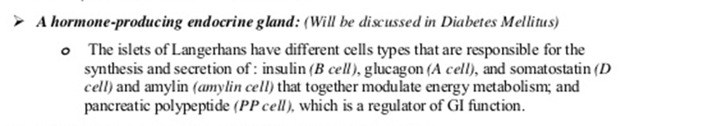
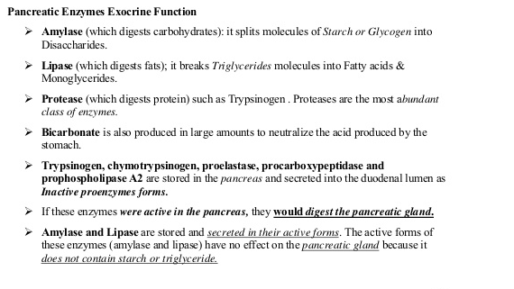

Acute Pancreatitis
Acute pancreatitis represents an inflammation of the pancreasthat ranges from a mild self-limited disease, consisting of inflammation and interstitial edema, to an acute hemorrhagic pancreatitis that is associated with massive necrosis of tissue. Acute hemorrhagic pancreatitis is a severe, life-threatening disorder associated with the escape of activated pancreatic enzymes into the pancreas and surrounding tissues.
Causes:
- 20% idiopathic
- most cases result from gallstones (stones in the common duct)
- alcohol abuse
These are the three most common causes.
- Non gallstone obstruction of pancreatic duct eg by tumor
- Drugs: thiazides and frusemide diuretics
- Trauma: by accident or during surgery (iatrogenic)
- Others like metabolic disorders, ischemia and infections especially with mump
Pathogenesis:
- Autodigestion of pancreatic substances by pancreatic enzymes. Trypsin have central role because it activate other enzymes (lipases and elastases) and activate kinin and factor XII which intern activate complement and clotting systems.
- Pancreatic duct obstruction allowing accumulation of an enzyme rich interstitial fluid that causes tissue injury and compromising blood flow.
- The alcoholic pancreatitis occur due to direct toxic effect of alcohol on pancreatic cells and alcohol consumption lead to contraction of sphincter of Oddi.
Clinical features: The most common initial symptom is severe epigastric and abdominal pain that radiates to the back. Tachycardia, hypotension, cool and clammy skin, and fever often are evident. Signs of hypocalcemia may develop, probably as a result of the precipitation of serum calcium in the areas of fat necrosis. Shock may develop due to electrolyte disturbance, increased vascular permeability and loss of blood.
Lab findings: Hypocalcemia occurs in approximately 25% of patients. Total serum amylase is the test used most frequently in the diagnosis of acute pancreatitis. Serum amylase levels increase within the first 24 hours after onset of symptoms and remain elevated for 48 to 72 hours. The serum lipase level also increases during the first 24 to 48 hours and remains elevated for5 to 14 days.
Cause of death in acute pancreatitis : shock, DRDS, renal failure.
Chronic pancreatitis:
Is characterized by long standing inflammation and fibrosis with destruction of the exocrine pancreas. In the late stage the islets also destructed and lost. At this point, signs of diabetes mellitus and the malabsorption syndrome (e.g., weight loss, fatty stools [steatorrhea]) become apparent.
Causes:
- Chronic alcoholism (the most common cause)
- Long standing pancreatic duct obstruction (by pseudocyst,calculi, neoplasm)
- Tropical pancreatitis: seen in Africa and Asia and attributed to malnutrition
- Hereditary pancreatitis due to mutation in genes encoding trypsin inhibitors.

