Lecture 1 Pharmacy practice and the healthcare system

Impact of pharmacy on patient care

There are five main areas in which pharmacy makes major contributions to health outcomes:

1 Management of prescribed medicines:
– drug development
– dispensing of medicine
– counselling
2 Management of chronic conditions:
– repeat prescribing
– monitoring therapeutic outcomes
– improvement in quality of life
3 Management of common ailments:
– counselling
– recommendation of line of action
4 Promotion and support of healthy lifestyles:
– health education
– health screening
5 Advice and support for other healthcare professionals:
– provision of information on clinical and technical aspects of use of medicines
– participation in research and development programmes to transfer science into practice.

Pharmacist interventions in the healthcare system
• Ensuring rational use of medicines: participation in the development of formularies, clinical guidelines and protocols, and analysis of prescribing information and drug use evaluation data.
• Disease management: contributing towards enhancement of compliance, adherence to evidence-based clinical guidelines and monitoring patient outcomes.
• Management of drug therapy: ensuring that safe and effective drug products are used and are accessible, collaboration with health professionals to ensure that prescribing is carried out for definite objectives, accessing patients’ profiles and medical records, undertaking counselling about safe use of drugs, patient monitoring to identify problems and suggest actions to solve problems.

Patient pharmaceutical needs assessment
By identifying patients who would mostly benefit from pharmacist interventions, pharmacist-dedicated services can be directed towards individual patient groups to ensure minimal drain of resources while at the same time giving patients the pharmacy service particular to their needs.

The patient pharmaceutical needs assessment should take the following into consideration:

• Access to pharmacy facilities: Do patients who are house-bound have access to a pharmacist domiciliary service? Do patients visiting a pharmacy have access to the pharmacist? Do patients feel that they need more time with the pharmacist during outpatient visits at hospital clinics?
• Need for compliance aids: Do patients require memory aids or pill boxes to organise their medication?
• Social behaviour: Patients living on their own who may not have family or friends able to support them through their medication.
• Does the patient have special needs?

Identifying groups of patients with special needs
• Patients suffering from certain diseases, such as:
– acute myocardial infarction
– chronic pain
– mental health problems
– learning difficulties
• Age groups: extremes of age – the young and the elderly
• Drug treatment:
– narrow therapeutic index drugs
– expensive drugs: consider use of generic formulations – what are the pharmaceutical implications of switching to a different pharmaceutical formulation?
• Taking medicines for chronic disease:
– repeat prescriptions
– medication review
• Patients in particular health settings:
– hospital, residential home, nursing home
• Patients transferring from one health setting to another.

Achieving cost-effective patient care
Within a healthcare system, pharmacists can participate in the four domains necessary for cost-effective patient care (Figure 2.1).

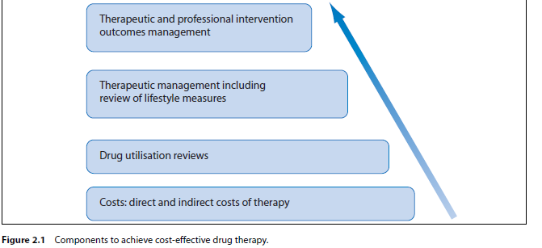

Quality assurance
This establishes an acceptable level of performance and incorporates mechanisms to identify when that standard of performance is not met.
Quality improvement
This comprises information-driven processes that involve the implementation of monitoring procedures to ensure that adequate standards are obtained and maintained. It has two main components: total quality management (TQM) and continuous quality improvement (CQI).

Total quality management (TQM)
• Defines measures of quality
• Measures current performance
• Analyses process
• Identifies improvement actions.

See Table 2.1 for a comparison of quality improvement and quality assurance.

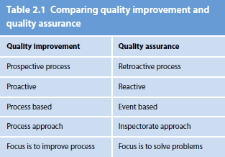

Measuring outcomes
• Use diagnostic results
• Use medical records
• Maintain databases that provide information to allow periodical reviews
• Assess patient satisfaction.

Assessing outcomes
• Clinical: response to treatment
• Functional: improvement in physical function
• Financial: cost-effective therapy
• Perceptual: patient’s satisfaction with outcomes, care received and providers.

Difficulties in implementation of outcomes management
• Compilation of data is time-consuming
• Resistance from health professionals.

Case example for quality assessment in a hospital
• Documentation and analysis of pharmacist intervention on the ward
• Cost-effectiveness study of medications used
• Patient satisfaction questionnaire – developed to assess patient satisfaction with outcomes of therapy, care received, atmosphere on ward, communication with health professionals.

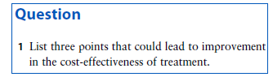

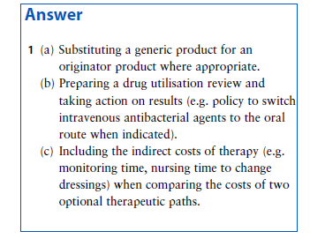

Lecture 2 Health promotion

Background
• Health promotion: a process enabling people to increase control over and to improve their health.
• Health education: giving information and working towards improving individual attitude and behaviour changes to sustain healthy living.

In health promotion, pharmacists provide information and skills to individuals so that they can prevent specific diseases and participate in services for early detection and treatment of disease. The process involves a behavioural change approach such as in advising individuals on the importance of preventing and managing obesity.

Themes of health promotion in community pharmacies
• Smoking cessation programmes
• Diet, exercise and body weight
• Cardiovascular disease risk factors and prevention
• Sun exposure
• Travel medicine
• Patient concordance with treatment
• Immunisation programmes
• Sexual health
• Screening tests
• Alcohol and drug abuse.

Information transmitted
The information presented should be educational but at the same time acceptable to busy patrons. An entertaining presentation helps to make the information attractive and prompts the individual to take notice of the message being transmitted.
The impact of the information transmitted depends on the methods used to convey the information.
The information presented has to be understandable by the individual. Pharmacists are in a position of interpreting scientific information so as to convey the message to the individuals in an understandable manner.

Factors influencing health promotion activities in community pharmacies

Positive factors
• Environment within the pharmacy conducive to health promotion
• Accessibility of the pharmacy
• Communication skills of community pharmacist
• Strong pharmacist–patient relationship.

Negative factors
• Lack of resource materials
• Lack of space
• Lack of confidentiality
• Improper time management of the pharmacy personnel.

Planning a health promotion campaign
• Identify area(s) to be addressed
• Establish targets to be achieved
• Identify resources that can be used and are already available
• Develop a practical and realistic implementation programme
• Establish evaluation methods
• Set an action plan.

Question
1 List five points helpful in counselling patients on smoking cessation.

Answer
(a) Act as a role model by not smoking and not allowing smoking on the premises (e.g. putting up no smoking signs).
(b) Provide patient with information on the risks associated with smoking (e.g. use patient leaflets about smoking).
(c) Encourage abstinence by directly advising the patient on how to quit and highlighting benefits of stopping smoking (e.g. effects on family members particularly patients with cardiovascular disease and children).
(d) Refer patient to smoking cessation support groups (e.g. programmes organised by the local health promotion centre).
(e) Follow up on the use of smoking cessation products and maintenance strategies (e.g. schedule a follow-up visit).

Lecture 3 Pharmaceutical care plans

Background
• Clinical pharmacy (CP) is the discipline concerned with the use of medicines in patients. It requires the application of pharmaceutical science in order to solve drug therapy problems in individual patients.
• Pharmaceutical care (PC) is the integration of clinical pharmacy knowledge, skills and attitudes into a system of multidisciplinary care which aims to provide quality assurance of medicines in use.

Pharmaceutical care process:
Quality assurance of pharmacotherapy:
Factors to be considered
• Comorbidity
• Polypharmacy
• Incomplete information about the patient’s background and drug history
• Clinical uncertainty
• Patients’ responses may be unpredictable
• Evidence base for use of a medicine or a combination may be lacking
• Pharmaceutical care is a monitoring and enquiry strategy to validate the treatment plan.

The practice
Achieving rational drug therapy
• Accurate diagnosis
• Knowledge of the pathophysiology of disease
• Knowledge of basic pharmacology and pharmacokinetics
• Ability to transfer knowledge into effective bedside action
• Reasonable expectations of these relationships so as to anticipate the effect of drugs
• Plan of therapy.

Medication-related problems
• Untreated indication
• Improper drug selection
• Subtherapeutic dosage
• Failure to receive medication
• Overdosage
• Adverse drug reactions
• Drug interactions.

The system
Preparing a pharmaceutical care plan
The preparation of a pharmaceutical care plan can be divided into four stages:
1 Define the patient’s healthcare needs
2 Specify pharmacotherapeutic goals
3 Identify therapy recommendations
4 Develop patient monitoring.

Define the patient’s healthcare needs
• All actual or potential (e.g. due to comorbidities) healthcare problems
• To alleviate actual problems
• To avoid potential problems.

Specify pharmacotherapeutic goals
• Management of condition
• Prevention of side-effects
• Prevention of related conditions.

Identify therapy recommendations
• Drug selection
• Dose and dosing frequency
• Route of administration
• Length of therapy.

Once the patient’s healthcare needs are defined and the pharmacotherapeutic goals established (pharmaceutical care issues), healthcare providers need to collaborate and go through a decision making process to identify a therapeutic regimen which may include non-pharmacological approaches. This therapeutic plan has to be verified and confirmed by different members of the healthcare professions (Figure 12.2).

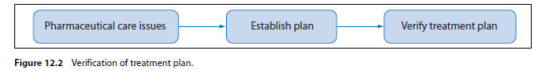
Patient monitoring
• Quantitative and qualitative parameters (i.e clinical assessment)
• Define pharmacotherapeutic end-points
• Determine monitoring frequency.

See Figure 12.3 for monitoring treatment delivery.

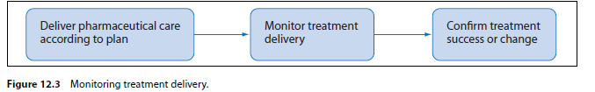
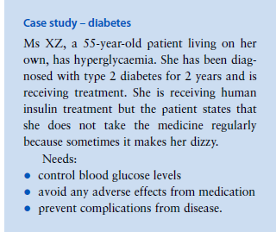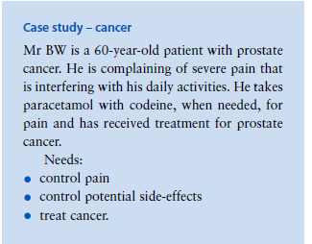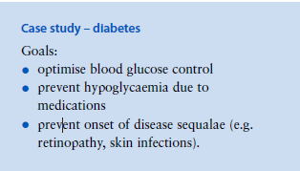
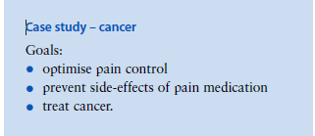

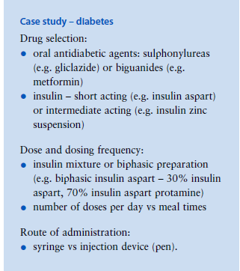
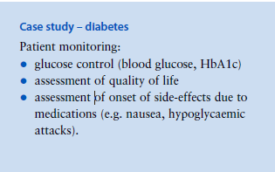
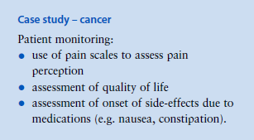

Example of pharmacist care plan in community pharmacy setting
• Patients with diabetes participate in monthly consultations with community pharmacists.
• Pharmacist contributes to education of the patient, clinical assessment and recommending referrals as necessary.

Education
• Glucose and lipid management
• Training on self-monitoring blood glucose and interpretation of results
• Medication management.

Clinical assessment
• Feet, skin, blood pressure, body weight.

Follow-up and referral
• Referral as needed

Outcome measures
• HbA1c
• Home blood glucose measurements
• Health-related quality-of-life measurement
• Evaluation of patient satisfaction with pharmacy services

Question
1 Outline the features to be considered in a pharmaceutical care plan for a patient with chronic hypertension.

Answer
1 (a) Determine the objectives of care in hypertension.
(b) Establish the importance of nonpharmacological measures (e.g. diet and exercise).
(c) Use evidence-based guidelines to devise a treatment plan.
(d) Identify the optimal treatment options for the particular patient, taking into consideration co-morbidities and individual patient risks.
(e) Promote adherence to therapy and lifestyle modifications.
(f) Identify signs of comorbidities (e.g. ischaemic heart disease, heart failure, kidney disease, diabetes, impairment of vision).
(g) Monitor blood pressure regularly and encourage patient to take up self-monitoring.
(h) Monitor clinical parameters (e.g. blood glucose levels, lipid profile, creatinine clearance).
(i) Monitor for the occurrence of drug-related problems (e.g. side-effects, patient safety).
(j) Verify compliance, assess outcomes and confirm treatment or suggest changes.
(k) Refer patient back to prescriber or secondary care interface as necessary.

