Acute Coronary Syndromes:ACS
Unstable Angina and Non–ST-Segment Elevation
Myocardial Infarction (ST-Segment Elevation)
- Unstable Angina (also known as pre-infarction angina, crescendo angina, and angina at rest),
- Non–ST-Segment Elevation myocardial infarction (NSTEMI), and
- ST-Segment Elevation myocardial infarction (STEMI).
- On presentation, the ultimate diagnosis usually cannot be determined because the diagnosis of MI requires the presence of biomarkers such as creatinine kinase (CK) or troponin. are not available for the first 12 to 24 hours.
- Patients who have ST-segment elevation acute coronary syndromes (e.g., acute MI) are candidates for immediate reperfusion therapy
- Patients at intermediate or high risk should be hospitalized for acute treatment and assessment of potential long-term treatment strategies.
- Patients at low risk may be treated without admission to the hospital.

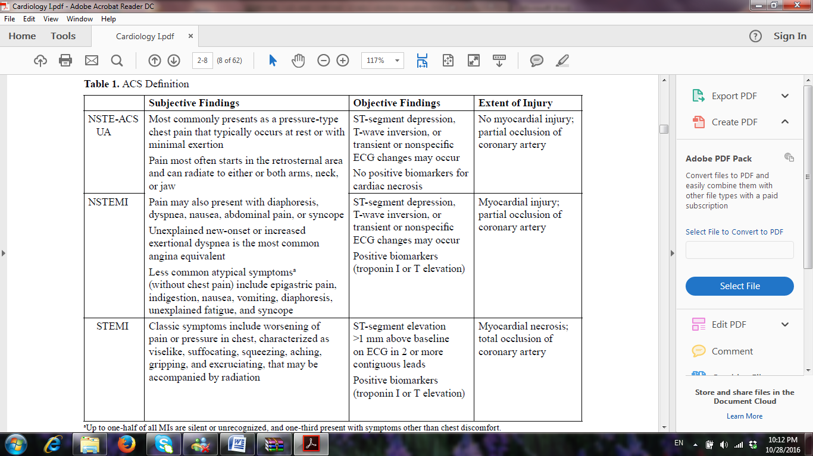

- Patients presenting with ischemic chest pain but without ST segment elevation and without laboratory evidence of infarction are classified as having unstable angina,
- Patients with a history consistent with ischemic chest pain, without ST segment elevation, but who develop a positive cardiac injury profile (i.e., elevated troponin) within hours of presentation are (referred to as NSTEMI or NSTE-ACS).
- Patients with NSTEMI and unstable angina continue to have some blood flow, although limited, through the affected coronary artery.
- Patients with NSTEMI usually thrombi comprised largely of platelets and fibrinogen. Thrombolytic therapy is not beneficial in these patients and is a major point of differentiation.
- The presence of ST segment elevation is used to identify patients who will benefit from thrombolytic therapy. A new Q wave, new bundle branch block, or ST segment elevation is consistent with a STEMI.

Management of (USA) Unstable Angina and Non–ST-Segment Elevation ( NSTEMI )
- The pathophysiology of USA is closely related to that of MI, and similar treatment strategies are used in both disease states.
- The treatment of USA include medical therapy as well as revascularization procedures.
- Typically, revascularization with PCI is reserved for patients who are considered intermediate to high risk for developing adverse cardiovascular outcomes in the next 30 days or whose condition does not stabilize with medical therapy.
- β-blockers should be administered acutely. Nitrates,both sublingually and then intravenously, CCBs are effective, but should be reserved for patients who have ischemia refractory to β-blockade.

- A 325-mg dose of chewable aspirin should be administered to all patients. The combined use of aspirin (81–325 mg daily) and clopidogrel (300 mg load, 75 mg orally every day) acutely and for up to 1 year in patients with USA/NSTEMI has been shown to decrease the risk of cardiovascular death, MI, or stroke at 30 days and up to 1 year.

- The beneficial effects of UFH, LMWH, the synthetic pentasaccharide fondaparinux, as well as the direct thrombin inhibitor bivalirudin.are additive to aspirin in the prevention of acute MI and death.
- The Gp IIb/IIIa receptor antagonists are potent antiplatelet agents in patients with USA/NSTEMI being treated medically or who undergo PCI.
These agents have a unique mechanism of action in that they block the final common pathway in platelet aggregation,and more potent in terms of their antiplatelet effects than aspirin or clopidogrel.

The Gp IIb/IIIa receptor antagonists currently are recommended ;

(a) whom catheterization and PCI is planned;
(b) who have continuing ischemia despite treatment with aspirin,
UFH/LMWH/fondaparinux/bivalirudin, nitrates, β-blockers,
and clopidogrel; and/or
(c) who have other high risk features, such as elevated troponin or
ST-segment changes on the initial ECG.

Myocardial Infarction

- Acute myocardial infarction (AMI), now referred as (STEMI), is a cellular death or necrosis occurring in the setting of severe or prolonged ischemia.
- STEMI is the result of complete occlusion in a coronary artery.
- STEMI is a medical emergency requiring immediate intervention.
- Until the 1980s, patients with AMI were treated symptomatically. Their pain was controlled; arrhythmic complications were treated; and bed rest, nitrates, and β-blockers minimized the amount of oxygen required by the heart.
- Thrombolytics and percutaneous coronary intervention (PCI) are now considered first-line therapies unless a contraindication is present.
Pathophysiology of atherosclerosis;
- thrombus formation overlying a lipid-rich atheromatous plaque that has undergone fissuring or rupture.
- Damage to the plaque results in blood being exposed to collagen and fatty acids;
- this in turn activates platelets, the first step in thrombosis and formation of a fibrin clot.

- Rarely, coronary artery spasm may cause an AMI in a patient with normal coronary arteries
- Most infarctions are located in a specific region of the heart and are described as such (e.g., anterior, lateral, inferior).
- An anterior wall infarction carries a worse prognosis than an inferior or lateral wall infarction.
- Some patients develop permanent electrocardiographic abnormalities (Q waves) following an AMI.
The terminology has changed:
- Q-wave MI is now called STEMI and
- Non–Q-wave MI is now called Non–ST Segment Elevation MI (NSTEMI) or Non–ST Segment Elevation Acute Coronary Syndrome (NSTE-ACS).

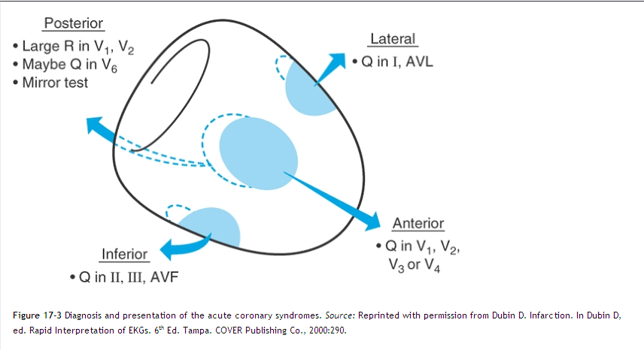

Clinical Presentation

Diagnosis of STEMI:
- prolonged substernal chest pain or pressure, shortness of breath, diaphoresis, nausea, and vomiting.
- confused with indigestion or other gastrointestinal (GI) complaints.
- Atypical pain e in nature and location. The pain might be described as burning, and it may occur in the arms, shoulder, neck, jaw, or back.
- The chest discomfort often as pressure or as a tight band around the chest rather than pain.
- Men commonly complain of chest pain, whereas women present with nausea and diaphorsis.

- Elderly patients present with hypotension or cerebrovascular symptoms rather than chest pain.
- left ventricular or right ventricular dysfunction may be present
- Severe hypertension due to pain or, conversely, may be hypotensive.
- Tachycardia (heart rate >120 beats/minute) suggests a large area of damage
- Fourth heart sound (S₄) may be heard, denoting an ischemia-induced decrease in left ventricular compliance.
New cardiac murmurs may be heard, resulting from papillary muscle dysfunction.
- Peripheral pulses should be examined to assess perfusion and to obtain a baseline before invasive procedures are instituted.
- An estimated 20% of STEMIs are “silent,” more frequently in the elderly and people with diabetes.

- Patients with a history of cerebrovascular disease may not be eligible for thrombolytic therapy.
Diagnosis
- the patient's history and presentation,
- ECG and
- Laboratory Changes results in a cardiac injury profile.
creatine kinase (CK)- within 3 to 6 hours after myocardial damage, and peak in 12 to 24 hours
troponins I and M -most sensitive markers
lactate dehydrogenase (LDH ) generally appears 24 to 48 hours after the onset of chest pain and peaks in 3 to 6 days.
aspartate aminotransferase, the white blood cell count, and C-reactive protein

- Usually two of the three criteria (history, ECG changes, and cardiac injury profile findings) should be consistent with STEMI before the diagnosis is made.

Complications
- The primary complications of AMI can be divided into three major groups:
pump failure, arrhythmias, and recurrent ischemia and reinfarction.

- compensatory mechanisms can eventually worsen the imbalance between myocardial oxygen supply and consumption by increasing the myocardial oxygen demand.
- If 40% or more of the left ventricle is damaged, cardiogenic shock and death can occur.
- Left ventricular enlargement is an important determinant of mortality after AMI.
- Over a period of days to months following an AMI, the infracted area may expand as a result of dilatation and thinning of the left ventricular wall. These changes are known as ventricular remodeling.

Treatment
Therapeutic Objectives
- The immediate therapeutic objectives are to minimize the amount of myocardial necrosis that develops, to alleviate his symptoms, and to prevent his death.
- The long-term therapeutic objectives are to prevent or minimize recurrent ischemic symptoms, reinfarction, heart failure, and sudden cardiac death.

Thrombolytics Therapy
- The therapeutic priority is to open the occluded artery as quickly as possible.
This is accomplished by administering a thrombolytic that enhances the body's own fibrinolytic system or by mechanically reducing the obstruction with PCI.

- The thrombolytics currently used for STEMI
streptokinase, anistreplase, alteplase (t-PA), reteplase (r-PA), and tenecteplase (TNK).

- Streptokinase is a polypeptide derived from β-hemolytic streptococcal cultures. It binds to plasminogen to form an active plasminogen-to-streptokinase complex that cleaves other molecules of plasminogen to form plasmin. Plasmin, which is an active fibrinolytic enzyme, then acts on a fibrin clot to enhance its dissolution.
streptokinase have used an IV infusion of 1.5 MU administered over 60 minutes.

- Anistreplase, also known as anisoylated plasminogen streptokinase activator complex, is a combination of streptokinase and plasminogen with an anisoyl group. Anistreplase is usually given intravenously as 30 U over 2 to 5 minutes.

- Alteplase, or t-PA, is a naturally occurring enzyme produced commercially by recombinant DNA technology. t-PA has a binding site for fibrin, which allows it to bind to a thrombus and preferentially lyses it over the circulating plasminogen.
accelerated dosage regimens of t-PA are recommended. The recommended regimen is a 15 mg bolus followed by a 50 mg infusion over 30 minutes and then the remaining 35 mg over 60 minutes.

- Reteplase is a genetically modified plasminogen activator that is similar to t-PA. Reteplase has a longer half-life.
reteplase was administered in two bolus doses of 10 MU, given 30 minutes apart.

- Urokinase, has not gained widespread use as a thrombolytic agent for patients with STEMI.
- TNK was administered as a bolus of 30 to 50 mg over 5 to 10 seconds, based on body weight.

- Because of the serious nature of intracerebral hemorrhage associated with thrombolytic therapy , the diagnosis of STEMI must be ensured.

- The guidelines recommend a “door-to-needle time” of 30 minutes, meaning the diagnosis of STEMI and initiation of thrombolytic therapy should ideally take place within 30 minutes from the time the patient arrives at the hospital door.

Adjunct Therapy
- Immediate administration of 160 to 325 mg of aspirin in patients diagnosed with AMI,
- aspirin should be chewed because it is absorbed more quickly.
- All patients should receive 75 to 325 mg of daily aspirin indefinitely following AMI.
- If patients have a contraindication to aspirin, clopidogrel can be substituted.
- guidelines recommend a 60 U/kg bolus of UFH at the initiation of t-PA,

- The replacement of UFH with a LMWH, factor Xa inhibitor, or the addition of an antiplatelet agent such as a GP IIb/IIIa inhibitor to thrombolytic therapy has been evaluated in patients with STEMI.

Magnesium
- The potential mechanisms by which magnesium may benefit a patient include an antiarrhythmic effect, an antiplatelet effect, reversal of vasoconstriction, reduction of catecholamine secretion, and enhancement of adenosine triphosphate production.

β-Blockers
- β-blockers are fundamental in the management of AMI.
- β-blockers decrease myocardial oxygen consumption, limit the amount of myocardial damage, and reduce some of the complications of MI, specifically sudden death attributed to ventricular fibrillation.
- Unless there are contraindications to their use, β-blocking agents should be prescribed for all patients having an AMI, and they should be continued indefinitely.
- early IV β-blockers (up to 24 hours after symptom onset), followed by oral therapy; other studies used oral therapy alone beginning days after the infarct.
- Propranolol, Metoprolol, Timolol, and Atenolol have been studied extensively. All have been given by early IV administration.
- Metoprolol and Atenolol are used in the acute setting due to their β-1 selectivity, ease of dosing and administration, and weight of evidence.
- Oral carvedilol, a nonselective β- and α-blocker, has been used in the peri-infarction period, specifically in patients with left ventricular dysfunction.
- In general, if a patient has transient cardiac decompensation (e.g., hypotension, bradycardia, or worsening symptoms of heart failure) during the acute infarct period, early IV β-blockers are withheld. The patient's condition is then observed for a few days; if it stabilizes, oral therapy is initiated and titrated slowly.

Statins
- Beyond their lipid-lowering properties, statins are believed to exhibit pleiotropic effects, which include plaque stabilization, anti-inflammation, antithrombogenicity, enhancement of arterial compliance, and modulation of endothelial function.

Vasodilators
- Vasodilators reduce oxygen demand and myocardial wall stress by reducing afterload and/or preload , halt the remodeling process. , enhancing coronary vasodilatation.
- oral ACE inhibitors should be started within 24 hours of diagnosis, after BP has stabilized. Initial doses should be low and then titrated as quickly as possible.

- IV NTG is recommended for routine use during the first 24 to 48 hours in most patients with STEMI, particularly those with large anterior wall infarctions.
calcium channel blocker
- As a group, they dilate coronary and peripheral vessels.
- calcium channel blockers would protect cardiac cells during the peri-infarction period.
- the use of verapamil and diltiazem should be limited to patients who do not tolerate β-blocker therapy and who do not have systolic dysfunction.

Analgesics
- The pain associated with AMI is due to continuing tissue ischemia surrounding the area of infarcted tissue.
- Morphine and meperidine are the two most commonly prescribed analgesics.

- By reducing pain and anxiety, the release of circulating catecholamines is diminished, possibly reducing the associated arrhythmias.
- Morphine also causes peripheral venous and arterial vasodilatation, which reduces preload and afterload, and consequently, the myocardial oxygen demand.

Oxygen
- Many patients are modestly hypoxemic during the initial hours of an AMI.
- Oxygen should be administered via nasal cannula to all patients suspected of having ischemic pain.
- Patients with severe hypoxemia or pulmonary edema may require intubation and mechanical ventilation.

Antiarrhythmics
- Ventricular arrhythmias, including ventricular fibrillation, are common complications associated with myocardial ischemia and AMI.
- Lidocaine, procainamide, and amiodarone are the drugs of choice for the treatment of ventricular arrhythmias in the peri-infarction period.

Stool Softeners
- It is common to administer agents such as docusate to prevent constipation in AMI patients because straining causes undesirable stress on the cardiovascular system.

Nondrug Therapy
- PCI is an attractive alternative to thrombolytic therapy.
- PCI consists of the insertion of a guidewire though a catheter into the occluded coronary vessel.

Long-Term Therapy
Angiotensin-Converting Enzyme Inhibitors
- After an AMI, the heart undergoes processes that initially compensate for the loss of contractile function but may increase the long-term risk for development of heart failure. This is referred to as “remodeling” of the ventricle.
- Based on these studies, oral ACE inhibitor therapy should be started within the first 24 hours of an AMI, preferably after completion of thrombolytic therapy and BP stabilization (systolic BP >100 mmHg). ACE inhibitor therapy is particularly beneficial in patients with an anterior infarction and an EF <40% (even if asymptomatic) or clinical evidence of heart failure.

Aldosterone Antagonists
- Patients who received spironolactone exhibited a 30% reduction in mortality.
- eplerenone, is a selective inhibitor of the mineralocorticoid receptor with fewer sexual side effects.
- guidelines recommend an aldosterone antagonist in STEMI patients without significant renal dysfunction (creatinine <2.5 mg/dL in men and <2.0 mg/dL in women) or hyperkalemia (potassium <5 mEq/L) who are already receiving therapeutic doses of an ACE inhibitor, have an EF <40%, and have either symptomatic heart failure or diabetes.

β-Blockers
- The benefits of β-blockers in reducing reinfarction and mortality are believed to outweigh the risk, Metoprolol or carvedilol are considered first-line choices
- in patients with heart failure, whereas atenolol or metoprolol should be considered in patients with stable asthma or bronchospastic pulmonary disorder.

Lipid-Lowering Agents
When triglycerides are >200 mg/dL, drug therapy with niacin or a fibrate is beneficial
Antithrombotic Agents- Aspirin -warfarin
- Antiplatelet therapy should be lifelong because of its effects on secondary prevention of reinfarction.
- using lower doses of aspirin for cardiovascular disease. Most clinicians use dosages of 81 to 325 mg daily or every other day.

