Chronic Obstructive Pulmonary Disease
Therapy of COPD Exacerbations
Definition
An exacerbation is acute worsening of the patient’s symptoms from his or her usual stable state that is beyond normal day to- day variations; an exacerbation warrants a change in medications. Common symptoms are worsening of dyspnea, increased sputum production, and change in sputum color.
The most common causes of an exacerbation are respiratory infection and air pollution, but the cause cannot be identified in about one-third of severe exacerbations. Treatment depends on the symptoms and severity of the exacerbation.
Severity
Mild exacerbations can often be treated at home with short-acting inhaled bronchodilators with or without oral corticosteroids. Antibiotics are indicated when there are specific signs of airway infection (e.g., change in color of sputum and/or increased sputum production or dyspnea) or when mechanical ventilation is needed. Moderate to severe exacerbations require management in the emergency department or hospital. Management should consist of controlled oxygen therapy, bronchodilators, oral or IV corticosteroids, antibiotics if indicated, and consideration of mechanical ventilation (noninvasive or invasive).

Bronchodilators
Albuterol is the preferred bronchodilator for treatment of acute exacerbations because of its rapid onset of action. Ipratropium can be added to allow for lower doses of albuterol, thus reducing dose-dependent adverse effects such as tachycardia and tremor.
Delivery can be accomplished through MDI and spacer or nebulizer. The nebulizer route is preferred in patients with severe dyspnea and/or cough that would limit delivery of medication through an MDI with spacer. If response is inadequate, theophylline can be considered; however, clinical evidence supporting its use is lacking.

Oral Corticosteroids

Systemic corticosteroids shorten the recovery time, help to restore lung function more quickly, and reduce the risk of early relapse. The GOLD guidelines recommend oral prednisolone 30 to 40 mg/day for 10 to 14 days. Shorter courses (7 days or fewer) may be as effective, but further studies are needed. Prolonged treatment and/or higher doses do not result in greater efficacy and increase the risk of adverse effects. If inhaled corticosteroids are part of the patient’s usual treatment regimen, they should be continued during systemic therapy.

Antibiotics
The predominant bacterial organisms in patients with mild exacerbations are Streptococcus pneumoniae, Haemophilus influenzae, and Moraxella catarrhalis. In patients with more severe underlying COPD, other bacteria such as enteric gram-negative bacilli (Escherichia coli, Klebsiella pneumoniae, and Enterobacter cloacae) and Pseudomonas aeruginosa may be more common. A risk stratification approach has been advocated to help guide antibiotic selection.
This approach is based on risk factors found to be predictive of treatment failure or early relapse. Patients at risk for poor outcome are candidates for more aggressive initial antibiotic treatment. Table 15–5 provides recommended antibiotic treatment based on this risk stratification approach. Antibiotic treatment for most patients should be maintained for 5 to 10 days. Exacerbations due to certain infecting organisms (P. aeruginosa, E. cloacae, and methicillin resistant Staphylococcus aureus), although not common, require more lengthy courses of therapy (21 to 42 days). If there is worsening clinical status or inadequate clinical response in 48 to 72 hours, reevaluate the patient, consider sputum Gram stain and culture if not already obtained, and adjust antimicrobial therapy. If Gram stain and culture results are available, narrow the antibiotic therapy according to cultured organism(s) and sensitivities. If no cultures have been obtained, or cultures remain negative, consider additional antibiotics and/or change to antibiotics with a broader spectrum of activity.

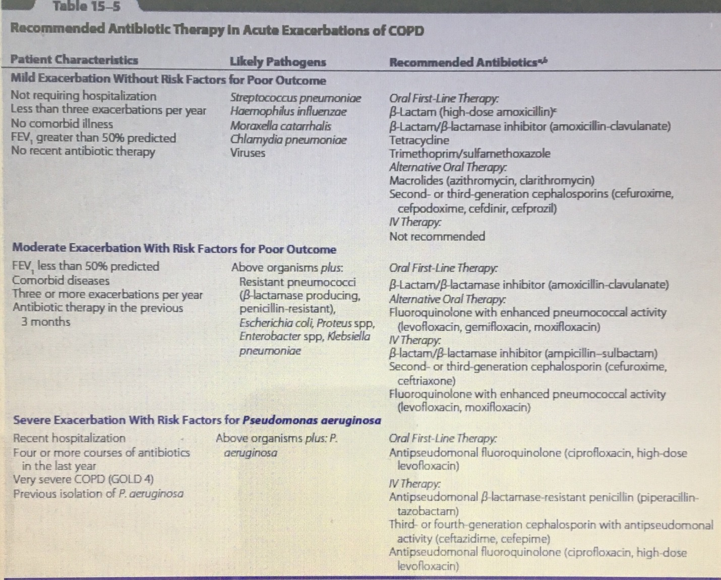
Oxygen
The goal of oxygen therapy is to maintain Pao2 above 60 mm Hg (7.98 kPa) or Sao2 above 90% to prevent tissue hypoxia and preserve cellular oxygenation. The GOLD guidelines recommend a target Sao2 of 88% to 92%. Increasing the Pao2 much further confers little added benefit and may increase the risk of CO2 retention, which may lead to respiratory acidosis. ABGs should be obtained after 30 to 60 minutes to assess for hypercapnia and acidosis.
In advanced COPD, caution should be used because overly aggressive administration of oxygen to patients with chronic hypercapnia may result in respiratory depression and respiratory failure. In these patients, mild hypoxemia, rather than CO2 accumulation, triggers their drive to breathe.

