Physiology worksheet (Lab-7)
Date---------- Names of the students:
Group--------

Name of the experiment:
Aim of the experiment:

Materials:

Results:
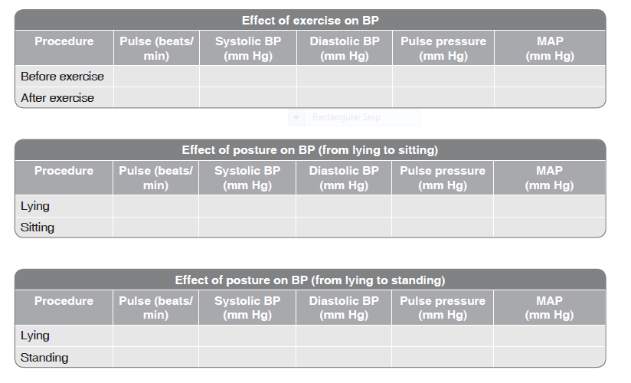
Discussion:
1. What are the BP changes you observe during exercise in the subjects?
2. What are the changes in heart rate you observe after exercise? What is the physiological basis for these changes? How are they mediated?
3. What is the physiological basis for postural hypotension?

