Rests and Rest Seats

Lec. 10

Lingual Rests (Cingulum Rest)
An occlusal rest seat on a posterior tooth is preferred over a cingulum or incisal rest seat on an anterior tooth. Because of its size and position, an occlusal rest seat permits forces to be directed along the long axis of the tooth in a better manner. Posterior teeth also present large divergent roots that can withstand more loading than the small conical roots of anterior teeth.
There are situations where a lingual rest is used because an anterior tooth may be the only abutment available for occlusal support of the denture. Also, an anterior tooth may be used as an indirect retainer or an auxiliary rest. In such cases a canine is preferred over an incisor for this purpose due to the greater root length, root surface area, and crown morphology.
Lingual rests are used primarily on maxillary canines. The normal crown morphology of a maxillary canine permits preparation of a satisfactory rest seat with minimal tooth reduction. Lingual rests are not usually placed on mandibular canines because of the lack of sufficient enamel thickness for appropriate preparation of the rest seat. Also, mandibular canines do not have a prominent cingulum and appropriate depth for a rest seat may expose the underlying dentine.
When a canine is not present, multiple rests over several incisor teeth are preferable to distribute the stresses over a number of teeth because a single incisor doesn't provide adequate support.
The preparation of an anterior tooth to receive a lingual rest is accomplished in two ways:
First method: A slightly rounded V-shape prepared on the lingual surface at the junction of the gingival and the middle one third of the tooth (Fig. 8). The apex of the
V is directed incisally. The mesio-distal length of the preparation should be a minimum of 2.5 to 3 mm, labio-lingual width about 2 mm, and incisal-apical depth a minimum of 1.5 mm. This preparation of the tooth starts with an inverted cone shaped bur and progresses to a smaller tapered bur with a round end to complete the preparation.
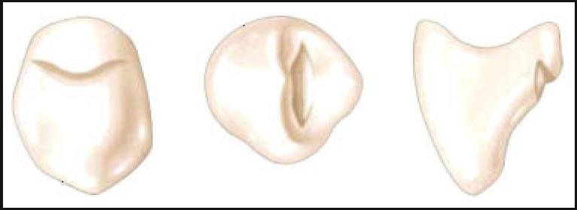
Figure 8: Three views of lingual rest seat prepared in enamel of the maxillary canine.
Second method: A ball type of rest may be used in a prepared seat (Fig. 9). Round rest seats are occasionally prepared on the mesial side of the canine when the use of a typical cingulum rest is contraindicated (i.e. large restoration, lack of clearance with

the opposing teeth, poorly developed cingulum). The seats of these rests are prepared in the same manner as that of the occlusal rest seats.
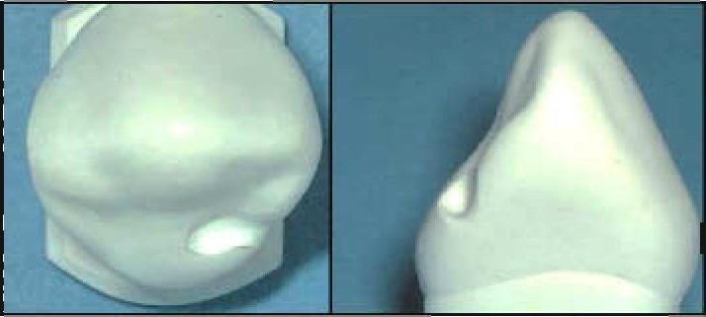
Figure 9: Ball type rest seat on canine.
There are several modifications to lingual rest seats prepared in natural teeth:
- Lingual (Cingulum) Rest Seat in a New Cast-Metal or Metal Ceramic Restoration Cast Restoration (Crown)
The most satisfactory lingual rest from the standpoint of support is one that is placed on a prepared rest seat in a cast restoration (crown). When a fixed restoration is to be placed on an anterior abutment, a cingulum rest seat should be incorporated into the wax pattern. This rest seat should exhibit ideal contours and should direct forces along the long axis of the abutment.
- Cast Alloy Rest Seat Forms
Also, individually cast alloy rest seat forms are used on teeth with unacceptable lingual contours using minimal tooth preparation. They are attached to lingual surfaces by the use of composite resin cements (Fig. 10).
A limited area on the lingual surface of the abutment is prepared to a depth of
0.5 to 0.7 mm. This minimizes tooth reduction and permits the surface of the casting to be positioned at the level of the adjacent tooth structure. Two or three circular indentations are then prepared within the borders of the tooth reduction. The

indentations assist in placement of the restoration and also provide vertical support for the cast. The casting is cemented using an appropriate luting agent.

- Bonded Composite Cingulum Rest Seats
Bonded composite cingulum rest seats with composite resin have also been successfully used as a conservative approach to forming rest seats (Fig. 11).
This is accomplished by bonding composite resin to the lingual surface of the tooth, then shaping the resin in the manner described for rest seats prepared in enamel. The disadvantage of these rest seats is that they are susceptible to wear and may lose their effectiveness over a relatively short period. Thus, they are not always desired.
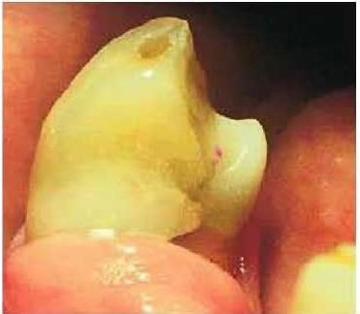
Figure 11: Composite
resin rest seat.

- An Alternative Cingulum Rest Seat
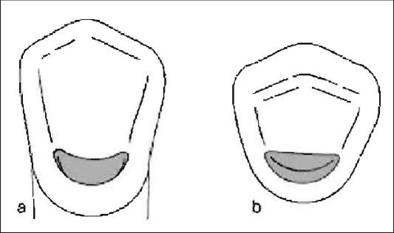
The alternative cingulum rest seat may be described as a crescent-shaped depression located in the middle and gingival thirds of the crown (Fig 12). This type can be used for mandibular canines with insufficient enamel that prevents preparation of conventional cingulum rest seats.
Figure 12: Alternative Cingulum Rest Seat.
Attempts to create adequate depth often result in exposure of the underlying dentin. Therefore, the alternative cingulum rest seat should be used very carefully.

Incisal Rests and Rest Seats
An incisal rest seat is usually placed on the disto-incisal angle for esthetic purposes, but the mesio-incisal may also be used (Fig. 13). It is predominantly used as an auxiliary rest or an indirect retainer.

An incisal rest is inferior to a lingual rest. 1) Esthetically, the metal of the rest shows at the incisal edge, 2) mechanically the lingual rest is placed nearer to the center of rotation of the tooth and has fewer tendencies to tip the tooth, 3) may interfere with

occlusion, and 4) has a higher possibility for breakage and distortion. Although, it may be used successfully for selected patients when the abutment is sound and when a cast restoration is not otherwise indicated.
Incisal rest seats are commonly used on mandibular canines, but may be used on other anterior teeth as well. The placement of incisal rest seats on incisors should be considered a last resort because of the esthetic and mechanical compromises that must be made.

The incisal rest seat is prepared in the form of a rounded notch at the incisal edge of the teeth, with the deepest portion of the preparation apical to the incisal edge. The rest seat should be approximately 2.5 mm wide and 1.5 mm deep so that the rest will be strong without having to exceed the natural contour of the incisal edge.
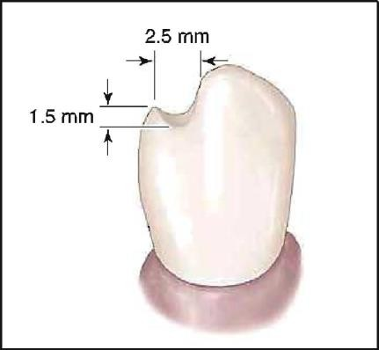
Figure 13: Incisal rest seat preparation and dimensions.
- Implants as a Rest
Implants can serve as a rest, since they resist tissue-ward movement and are useful for retentive needs as well. Their use allows a low profile connection (i.e., close to the ridge), and less torque to the implant

