Rests and Rest Seats
Lec. 9

The component of a partial denture on a tooth surface that provides vertical support is called a rest. The prepared surface of an abutment to receive the rest is called the rest seat. The topography of any rest should restore the topography of the tooth that existed before the rest seat was prepared.
The relationship between a rest and a rest seat must be such that forces transmitted from the prosthesis to an abutment are directed apically down the long axis of the tooth. In this manner, stress can be absorbed by the fibers of the periodontal ligament without damaging the ligament or the supporting bone.
A rest that is part of a retentive clasp assembly is referred to as a primary rest. The main purpose of a primary rest is to prevent vertical movement of a prosthesis toward the tissues and also helps transmit forces to the supporting teeth. A rest that is responsible for additional support or indirect retention is called an auxiliary rest or secondary rest.
The purposes of the rest in general are:
- Provide vertical support for the partial denture.
- Directs and distributes occlusal loads to abutment teeth.
- Maintains the components in their planned positions.
- Maintains occlusal relationship by preventing settling of the denture.
- Prevents impingement of soft tissue.
- In addition, a rest may be used to close a small space between teeth, thereby restoring continuity of the arch and preventing food impaction.
Rests are designated by the surface of the tooth prepared to receive them. Thus, they are named as follows:
  - Occlusal Rest:
    - Occlusal rest (conventional) 2. Extended occlusal rest
3. Interproximal occlusal rest 4. Internal occlusal rest
  - Lingual Rest (Cingulum Rest)
  - Incisal Rest
  - Implants as a Rest

Occlusal Rest
This rest is associated with the posterior teeth; molars & premolars. The Form of the
Occlusal Rest and Rest Seat should be as follows:

  - The outline form of an occlusal rest seat should be a rounded triangular shape with the apex toward the center of the occlusal surface (Fig. 1).
  - It should be as long as it is wide, and the base of the triangular shape (at the marginal ridge) should be at least 2.5 mm for both molars and premolars.
  - The marginal ridge of the abutment tooth at the site of the rest seat must be lowered to 1.5 mm to permit a sufficient bulk of metal for strength and rigidity of the rest and the minor connector. The most common mistake in occlusal rest seat preparation is insufficient reduction of the marginal ridge.
  - The floor of the occlusal rest seat should be apical to the marginal ridge and the occlusal surface and should be concave, or spoon shaped.
  - When viewed in cross section, the deepest part of an occlusal rest seat should be located near the center of the mesial or distal fossa. From its depth, the floor of the rest seat should rise gently toward the marginal ridge (Fig. 1).
  - The angle formed by the occlusal rest and the vertical minor connector from which it originates should be less than 90 degrees (Fig. 1). An angle greater than 90 degrees fails to transmit occlusal forces along the vertical axis of the abutment tooth. This also permits slippage of the prosthesis away from the abutment, with possible orthodontic tooth movement.
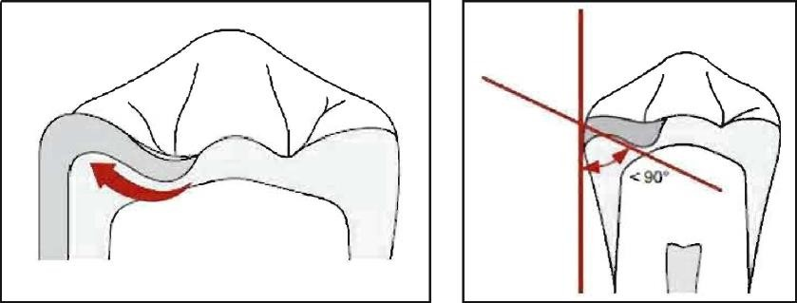

Figure 1: The deepest part should be should near the center of the mesial or distal fossa and should be inclined apically from the lowered marginal ridge with an angle less than 90 degrees.
When occlusal rest seats are prepared next to an edentulous space the morphology follows the conventional form (Fig. 2). On the other hand, when a single occlusal rest seat is prepared next to an adjacent tooth (Fig. 3) the lingual line angle is flared more to provide additional space for the minor connector.
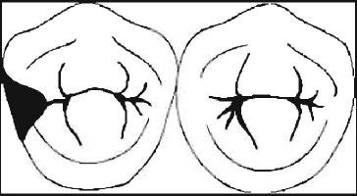
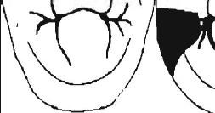
F i g u r e 2 : O c c l u s a l r e s t s e a t prepared next to an edentulous space
Figure 3: Single occlusal rest seat prepared next to an adjacent tooth

Extended Occlusal Rest
An extended occlusal rest should be used in situations in which the most posterior abutment is a mesially tipped molar, to minimize further tipping of the abutment and to ensure that the forces are directed down the long axis of the abutment. This rest should extend more than one-half the mesio-distal width of the tooth (Fig. 4).

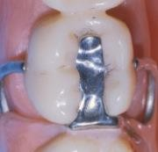
Figure 4: Extended occlusal rest seat on the mandibular first molar
Interproximal Occlusal Rest
The rest seats of this rest are prepared as individual occlusal rest seats (Fig. 5), with the exception that the preparations must be extended farther lingually and additional tooth structure is removed in the marginal areas to provide at least 1.5 mm of room for the embrasure clasps. The rest seats are flared more dramatically to the facial and the lingual line angles to provide additional space for the retentive aims and minor connector. The lingual interproximal area requires only minor preparation. Creation of a vertical groove must be avoided to prevent a torquing effect on the abutments by the minor connector. This is especially true for P_PDs with distal extension bases.
The advantages of such occlusal rests are: 1) Prevent interproximal wedging by the framework. 2) The joined rests shunt food away from contact points.

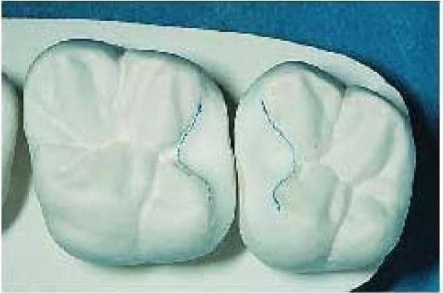
Internal Occlusal Rests

They are used for a partial denture that is totally tooth supported for both occlusal support and horizontal stabilization (Fig. 6). They must be used in association with a crown on the abutment tooth. An internal occlusal rest should not be confused with an internal attachment.

The main advantages of the internal rest are:
- The clasp arm buccally is not visible. Retention is provided by a lingual clasp arm.
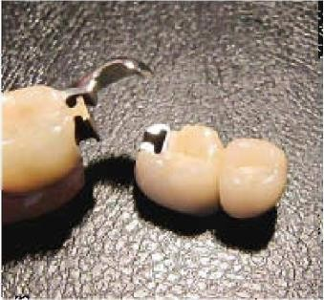
- Permits the location of the rest seat in a more favorable position in relation to the tipping axis (horizontal) of the abutment.
•

Figure 6: Maxillary tooth- supported removable partial denture utilizing internal occlusal rests.

Occlusal Rest Seat Preparation
Occlusal rest seats should have smooth gentle curves and any sharp angles, walls, and ledges must be avoided. Any portion of the rest seat that restricts movement of the rest may transmit undesirable horizontal forces to the tooth.
Rest seat preparations should be made in sound enamel and should follow preparation of proximal tooth surfaces that are necessary to provide proximal guiding planes and eliminate undesirable undercuts.
Occlusal rest seats in sound enamel may be prepared with burs and polishing points that leave the enamel surface as smooth as the original enamel. The larger round bur is used first to lower the marginal ridge and to establish the outline form of the rest seat. A slightly smaller round bur then is used to deepen the floor of the occlusal rest seat and form the desired spoon shape.
The anatomy and depth of the rest seat preparation can be evaluated by using sheet wax. A small piece is firmly pressed into the rest seat and the patient is asked to occlude on the wax while the wax is in the rest seat. The surface of the wax is inspected to determine the anatomy of the rest seat preparation. The depth of the rest seat is determined by carefully measuring the thickness of the wax. Any corrections can be accompanied and the process can be repeated.
The preparation is smoothed by a polishing point of suitable size and shape.
Fluoride gel should be applied to abutment teeth following enamel recontouring.

Occlusal Rests on Amalgam Restorations
It is always better to place an occlusal rest on sound enamel or cast restoration. Sometimes a conservative amalgam restoration may be used to support removable partial denture, but advantages and disadvantages of such treatment should be carefully considered.

As for a large amalgam restoration, it is easier to place an occlusal rest. cm a large amalgam restoration because an amalgam restoration costs less than a crown. How⁻ ever, the disadvantages are greater than the benefits SO this is not advisable.
The flow characteristics and poor tensile characteristics of amalgam increase the possibility of restoration failure. Amalgam alloys tend to deform when a sustained load is applied and this may result in fracture of the material and failure of the restoration. In addition, future replacement of a defective restoration under an existing removable partial denture is difficult, and the results are not always good. Re-treatment may need restoration of the abutment and a construction of a new removable partial denture.
Occlusal Rest. on Crowns
All restorations should not be used to support. removable partial dentures, via rests, because of the undesirable physical characteristics of ceramics.Ceramic materials are relatively strong in compression, but we in tension arid any wedging or elongation of a ceramic surface often lead to fracture. If the rests bind against. the walls of the rest seat, this will result in a wedging effect and create tensile forces that cause fracture of the ceramic. Also, the interaction between a ceramic rest. seat and the as metal rest. is not desirable because of the different material properties.
Metal-ceramic restorations can be used but it is recommended that rest seats be constructed entirely in metal. The metal borders should extend at least. 1 nun beyond the borders of the rest. (in all directions).
Occlusal rest. seat preparations in existing restorations (crown) may b e widened to compensate for shallowness, but the floor of the rest. seat should still be slightly inclined apically from the marginal ridge. When this is riot possible, a. secondary occlusal rest. should be used on the opposite side of the tooth to prevent slipping of the primary rest..
Occlusal rest seats that will be located in new restorations, crowns, and inlays should be known when the tooth is prepared so that sufficient clearance may be provided for the rest. seat within the preparation

